Exercise 1 - LinkedIn Connections

Sheida Majidi

2024-03-18

**Introduction:**

I am analyzing my LinkedIn connections to understand my network better, focusing on the distribution of connections across different employers and the network’s structure.

Data loading:

Starting with loading my LinkedIn connections data and perform initial cleaning and examination of the data.

file_path = "/Users/sheidamajidi/Desktop/Winter2024/Winter2024-2/ORGB672/Exercises/1/Connections.csv"  
connections = read_csv(file_path)

## Rows: 1413 Columns: 7  
## ── Column specification ────────────────────────────────────────────────────────  
## Delimiter: ","  
## chr (7): First Name, Last Name, URL, Email Address, Company, Position, Conne...  
##   
## ℹ Use `spec()` to retrieve the full column specification for this data.  
## ℹ Specify the column types or set `show_col_types = FALSE` to quiet this message.

head(connections)

## # A tibble: 6 × 7  
## `First Name` `Last Name` URL `Email Address` Company Position `Connected On`  
## <chr> <chr> <chr> <chr> <chr> <chr> <chr>   
## 1 Jeremy Huang http… <NA> Alpine… Researc… 15-Mar-24   
## 2 Ali Gorji http… <NA> iptiQ … Data En… 14-Mar-24   
## 3 Nima Akbarzadeh http… <NA> Mila -… Postdoc… 14-Mar-24   
## 4 Wenjie Zhan http… <NA> Desaut… Equity … 14-Mar-24   
## 5 Cynthia Dugal http… <NA> IVADO … Executi… 13-Mar-24   
## 6 Alara Buyukkorog… http… <NA> KPMG C… Consult… 13-Mar-24

**Data Analysis**

This is the analysis to count the number of contacts by their current employer and calculate the total number of contacts.

## # A tibble: 892 × 2  
## Company Count  
## <chr> <int>  
## 1 360insights.com 1  
## 2 3CS Customer Centralized Customs Services 1  
## 3 3SR Grenoble 1  
## 4 52 Capital 1  
## 5 5Y Capital 1  
## 6 A & A Industries Inc. 1  
## 7 AAVAA 1  
## 8 ABB 1  
## 9 ABRPPVM 1  
## 10 ACENSI 1  
## # ℹ 882 more rows

Frequency table and bar chart

For a better visualizations, I want to create a frequency table of the companies and visualize the top 15 companies with the most connections

| Company | Connections |
| --- | --- |
| McGill University - Desautels Faculty of Management | 48 |
| McGill University | 47 |
| Desautels Capital Management | 37 |
| IVADO Labs | 27 |
| Sharif University of Technology | 16 |
| TD | 14 |
| Pratt & Whitney Canada | 11 |
| BOMBARDIER | 10 |
| RBC | 10 |
| BNP Paribas | 9 |
| CN | 8 |
| Deloitte | 8 |
| Thinkr Consulting | 8 |
| Bell | 7 |
| KPI Digital Solutions | 7 |

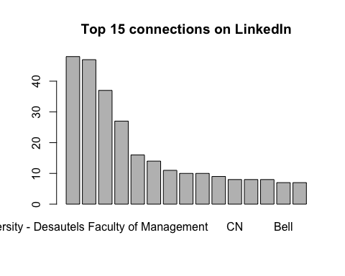

**Network creation**

Now I want to create nodes and edges for the network analysis. In this network, individuals are nodes and connections between individuals who work at the same company are edges.

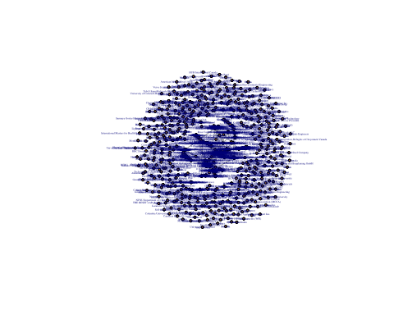

Figure 1. My network visualized by igraph library tool

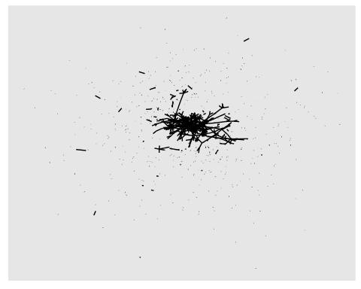

Figure 2 My network visualized by ggraph tool

Figure 3 My network visualized by vizNetwork library tool

**My Classmates and I**

Below shows my classmates and I are in gray, while our shared company “McGill University – Desautels Faculty of Management” is in red for a better visualization.

Figure 4 My classmates and I as a network within my LinkedIn network, showing in Red for our shared company "McGill University- Desautels Faculty of Management” and nodes are Grey as us