**NARAYANA IIT ACADEMY**

**INDIA**

**Section: Senior Date: 02-01-2015**

**Name of the student: I.D.No: Sec:**

**---------------------------------------------------------------------------------------------------------**

PREVIOUS MAINS QUESTIONS

1. The output of an OR gate is connected to both the inputs of a NAND gate. The combination will serve as a

(a) OR gate (b) NOT gate (c) NOR gate (d) AND gate

2. The combination of gates shown below yields

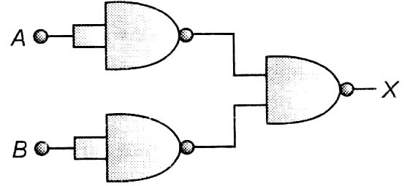

(a) OR gate (b) NOT gate

(c) XOR gate (d) NAND gate

3. A p-n junction (D) shown in the figure can act as a rectifier. An alternating current source (V) is connected in the circuit.

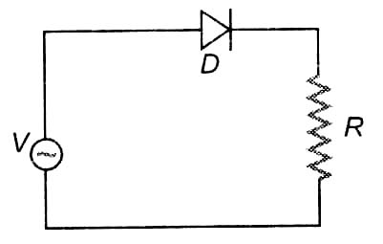

(a) up

in this

(b) here (c) there x=2 (d) none

4. In the adjacent circuit, A and B represent two inputs and C represents the output,

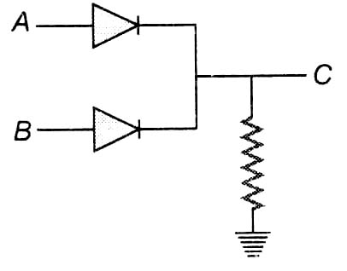

The circuit represents

(a) NOR gate (b) AND gate (c) NAND gate (d) OR gate

5. If in a p-n junction diode, a square input signal of 10V is applied as shown

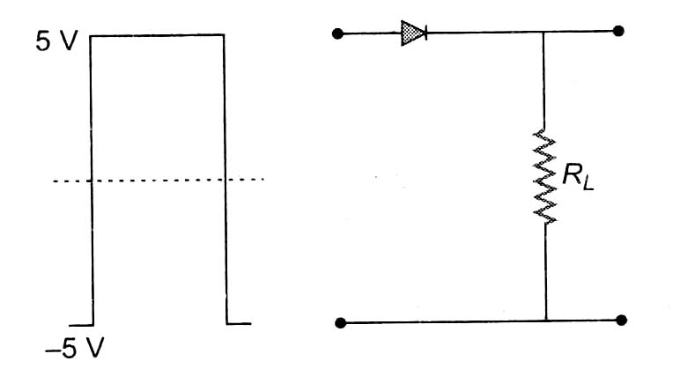

Then the output signal across  will be

(a) 10 (b) -10 (c) 5 (d) -5

6. Carbon, silicon and germanium have four valence electrons each. At room temperature which one of the following statements is most appropriate ?

(a) The number of free conduction electrons is significant in C but small in Si and Ge

(b) The number of free conduction electrons is negligibly small in all the three

(c) The number of free electrons for conduction is significant in all the three

(d) The number of free electrons for conduction is significant only in Si and Ge but small is C.

7. In a common-base mode of a transistor, the collector current is 5.488 mA for an emitter current of 5.06 mA . The value of the base current amplification factor  will be

(a) 49 (b) 50 (c) 51 (d) 48

8. If the lattice constant of this semiconductor is decreased, then which of the following is correct?

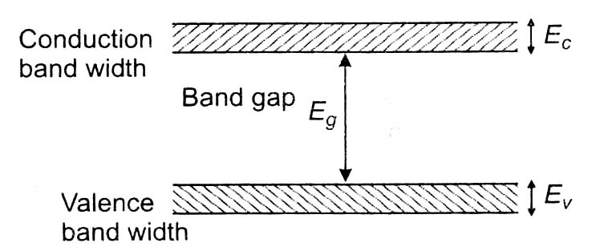

(a) All  increase (b)  and  increase, but  decrease

(c)  and  decrease, but  increase (d) All  decrease

9. A solid which is not transparent to visible light and whose conductivity increases with temperature is formed by

(a) ionic building (b) covalent binding

(c) van der Waals’ binding (d) metallic binding

10. If the ratio of the concentration of electrons to that of holes in a semiconductor is  and the ratio of current is , then what is the ratio of their drift velocities ?

(a)  (b)  (c)  (d) 

11. The circuit has two oppositely connected ideal diodes in parallel. What is the current flowing in the circuit ?

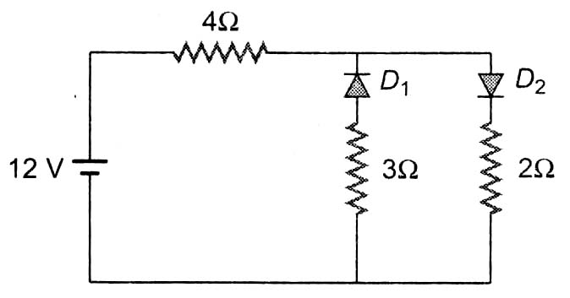

(a) 1.71 A (b) 2.00 A (c) 2.31 A (d) 1.33 A