**✅ Steps to Run the Customer Management Project**

**1. Clone or Download the Project**

* Download or clone the repository from GitHub.
* Open the solution in **Visual Studio** or your preferred IDE.

GitHub Link: <https://github.com/SheikGH/CustomerManagement>

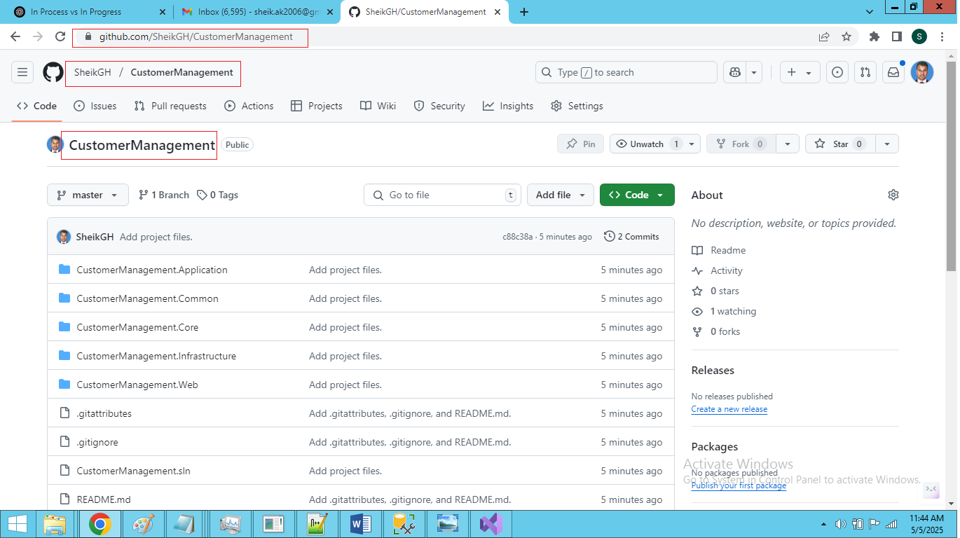

**2. Configure the Database Connection**

* Go to:  
  CustomerManagement\CustomerManagement.Web\appsettings.json
* Update the ConnectionStrings section with your **local SQL Server** instance and **database name**.

"ConnectionStrings": {

"DefaultConnection": "Server=YOUR_SERVER;Database=YOUR_DATABASE_NAME;Trusted_Connection=True;MultipleActiveResultSets=true"

}

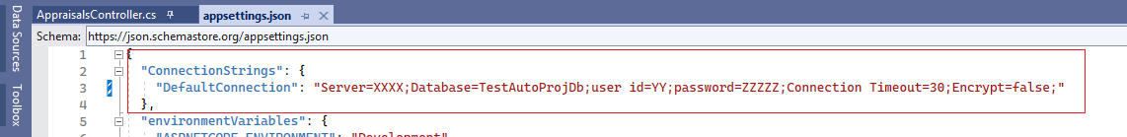

**3. Restore & Install Required NuGet Packages**

Ensure all NuGet packages are installed. If not, run the following commands from the terminal or Package Manager Console:

dotnet add CustomerManagement.Infrastructure package Microsoft.EntityFrameworkCore --version 7.0.20

dotnet add CustomerManagement.Infrastructure package Microsoft.EntityFrameworkCore.Design --version 7.0.20

dotnet add CustomerManagement.Infrastructure package Microsoft.EntityFrameworkCore.SqlServer --version 7.0.20

dotnet add CustomerManagement.Infrastructure package Dapper

dotnet add CustomerManagement.Web package Microsoft.EntityFrameworkCore.Tools --version 7.0.20

dotnet add CustomerManagement.Web package Microsoft.AspNetCore.Mvc.Razor.RuntimeCompilation --version 7.0.20

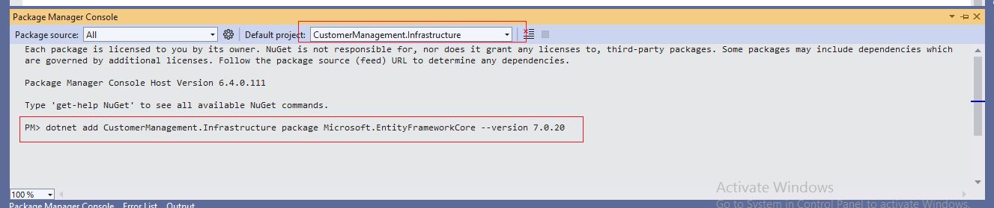

**4. Create Migrations and Update the Database**

Use the following EF Core CLI commands to create migrations and update your database:

dotnet ef migrations add InitialCreate -p CustomerManagement.Infrastructure -s CustomerManagement.Web

dotnet ef database update -p CustomerManagement.Infrastructure -s CustomerManagement.Web

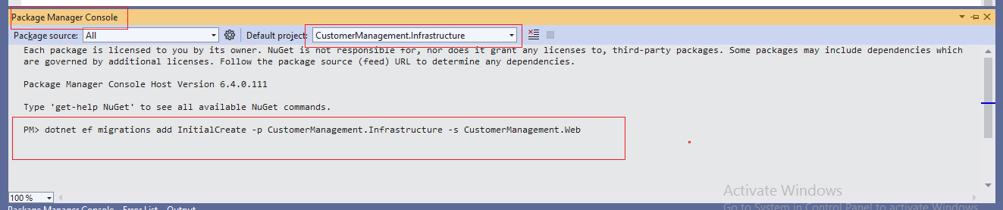

**5. Run the below Scripts to your database to create Stored Procedure**

CustomerManagement\CustomerManagement.Infrastructure\Scripts\

1. [dbo].[sp_AppraisalWorkflow].sql

2. [dbo].[sp_GetAppraisalBySearch].sql

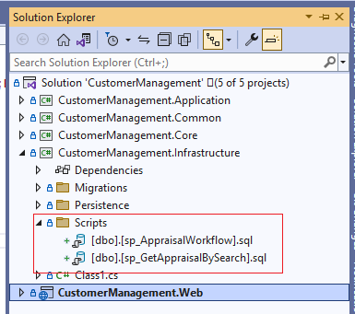

**6. Build and Run the Application**

* Build the solution using your IDE or CLI:

dotnet build

* Run the application:

dotnet run --project CustomerManagement.Web

**6. Test the Application**

* Open a browser and navigate to the URL where the app is running (e.g., https://localhost:5001).
* Test CRUD operations to ensure everything is working as expected.

GitHub Link: <https://github.com/SheikGH/CustomerManagement>



**Customer Management Module**

* **In this project, I craeted a single-page CRUD interface to optimize performance and user experience using dynamic content rendering. Refer below screenshot**

<http://localhost:5139/Customers/SPA>

**create new customer on the same page**

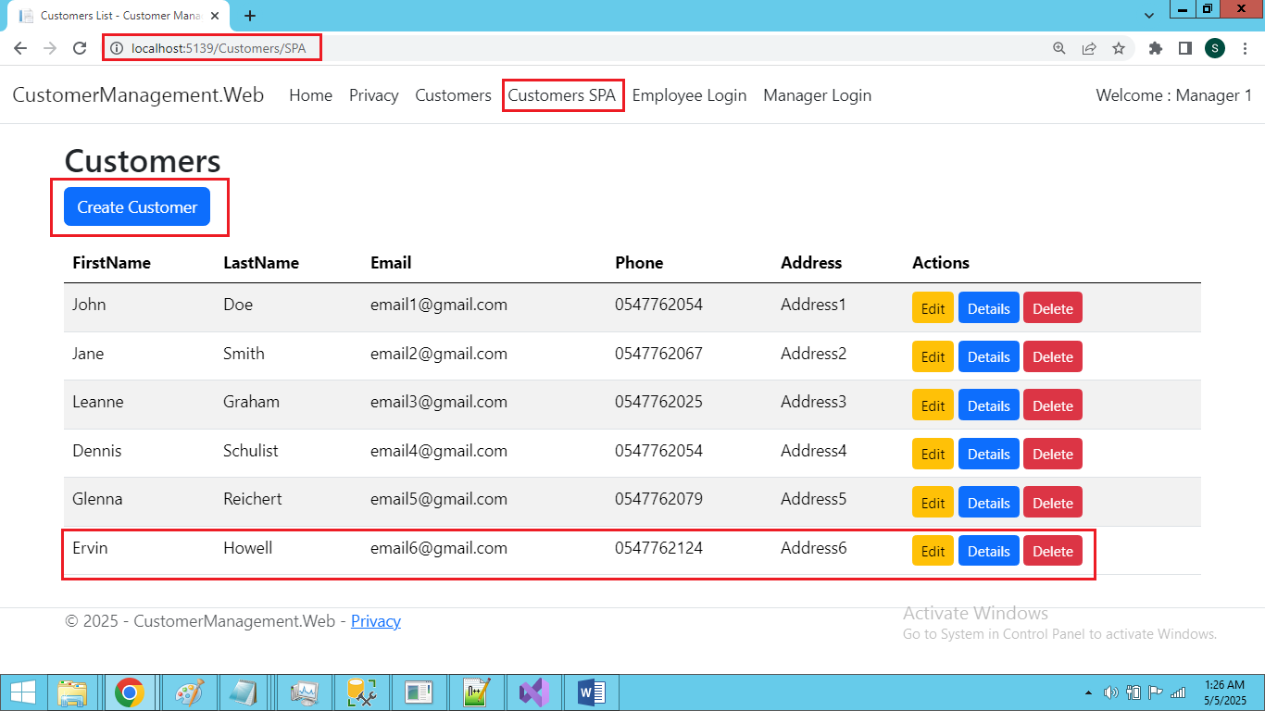

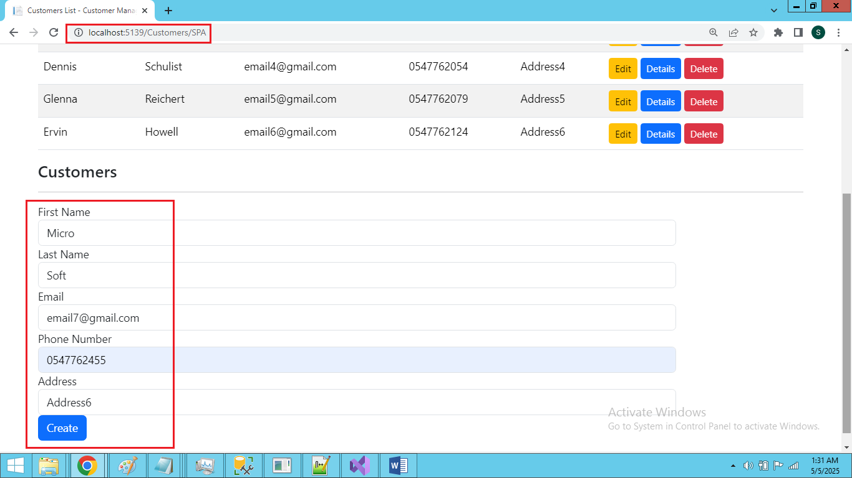

**Display newly created customer on the list on the same page**

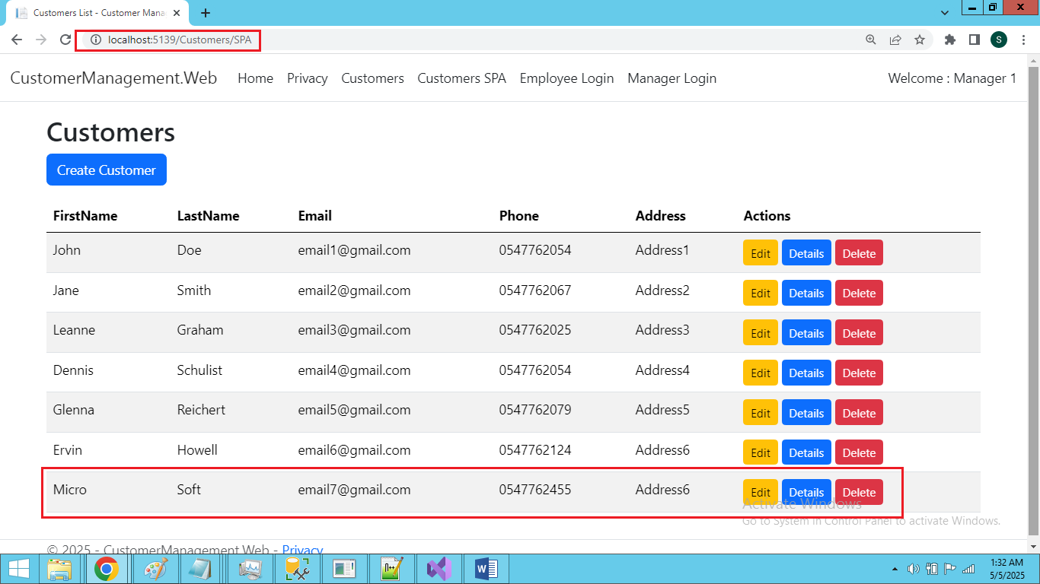

**Edit Customer:**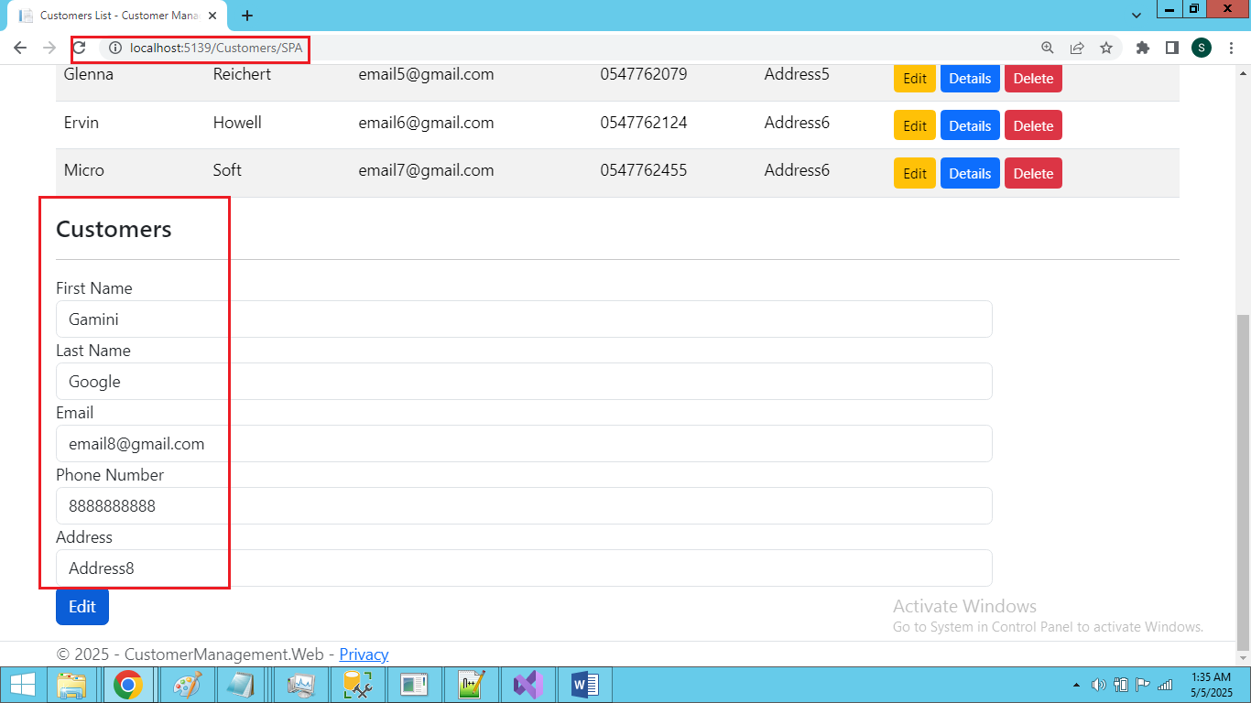

**Display the edited customer details in the list**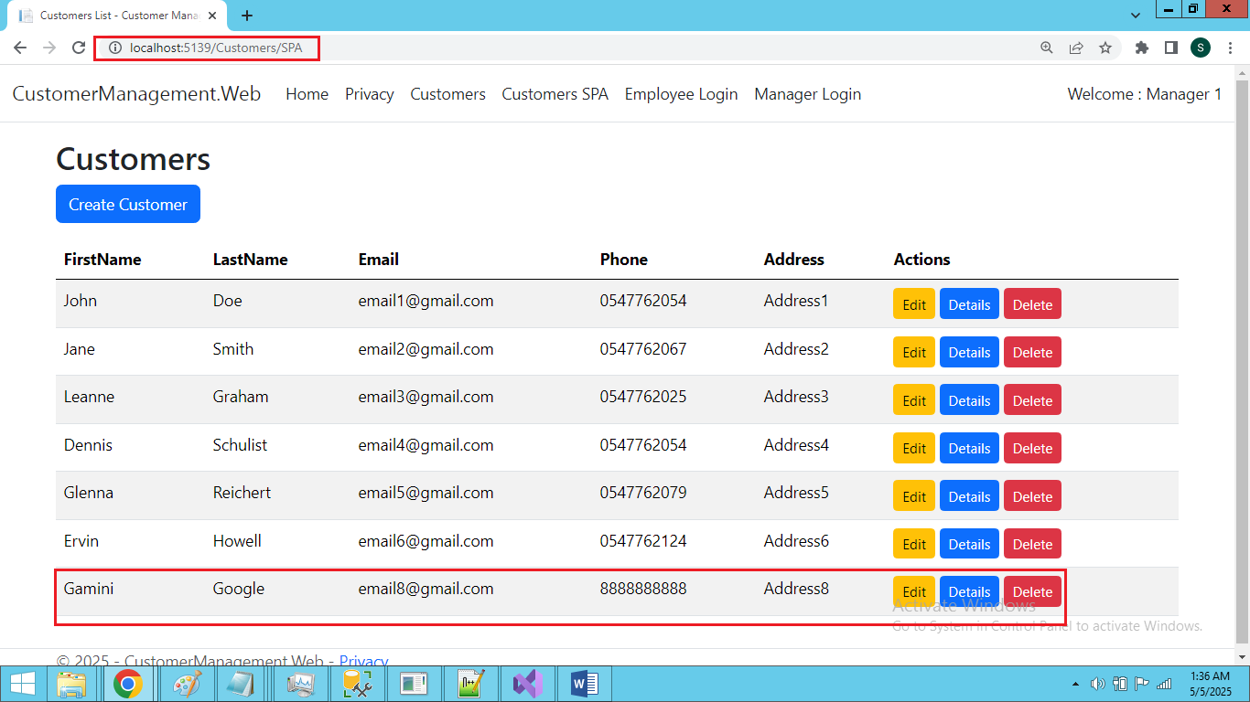

## 📋 ****Module: Appraisal Management****

This module follows a four-phase process involving Employees, Line Managers, and HR Managers to ensure a transparent and fair performance evaluation cycle.

### ****🔵 Phase 1: Performance Objection****

#### 👤 **Employee**

* Submits **Performance Objection** with:
  + Title
  + Message
  + Weight %

#### 👔 **Line Manager**

* **Reject:** Sends back the objection with comments to the employee.
* **Approve:** Accepts the objection and moves it to **Phase 2 - Achievement**.

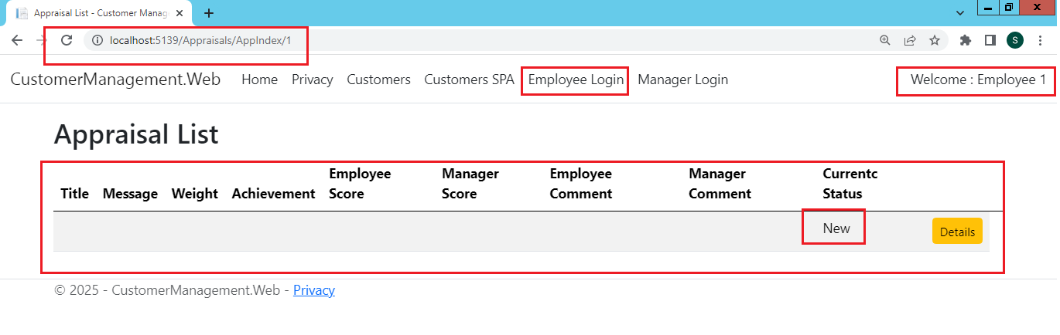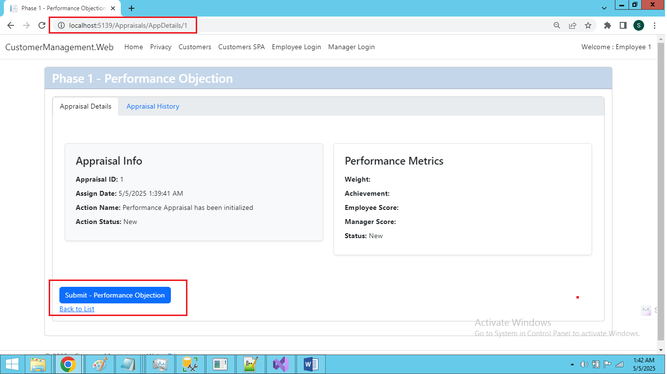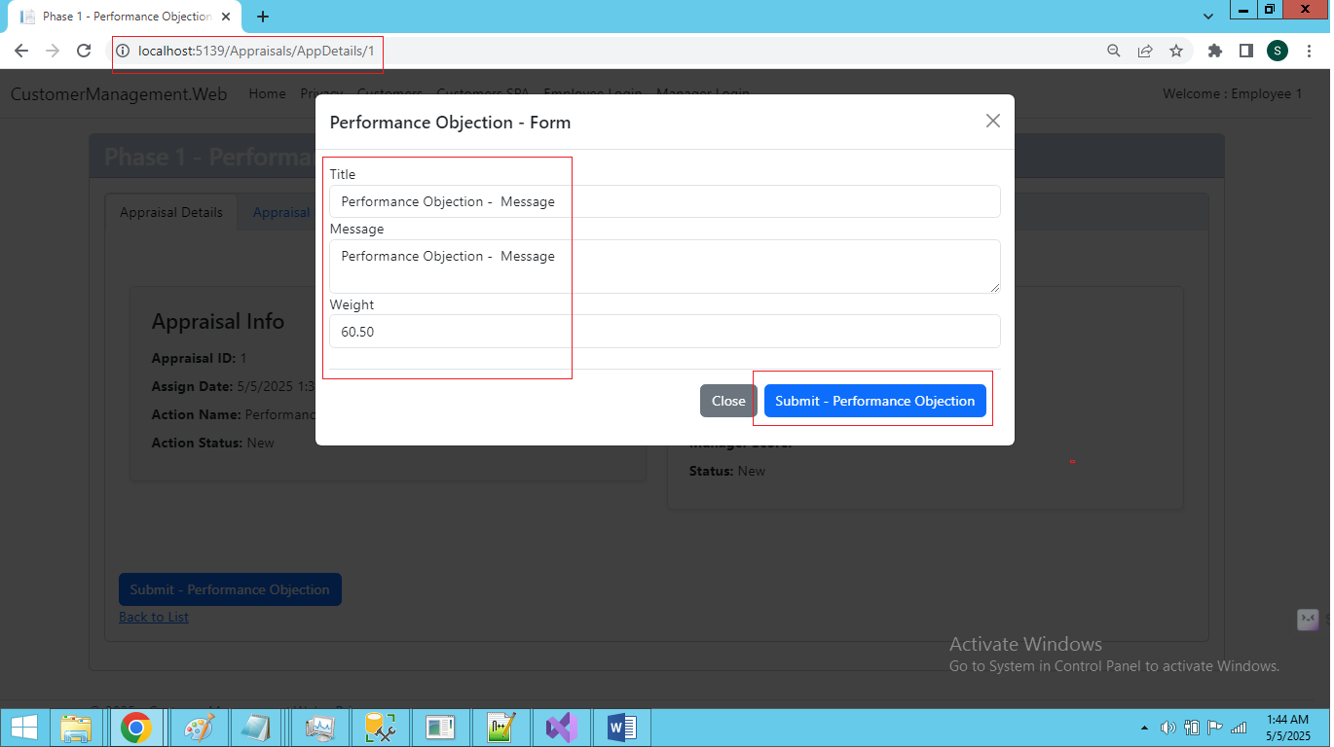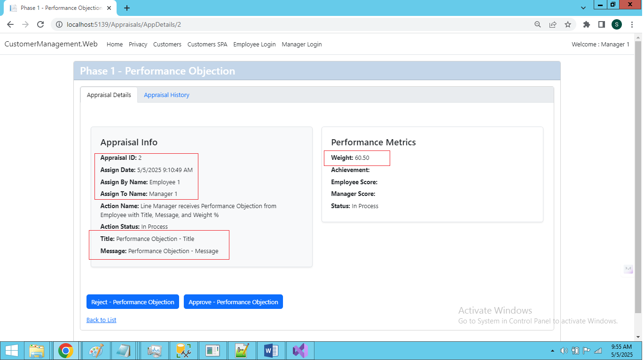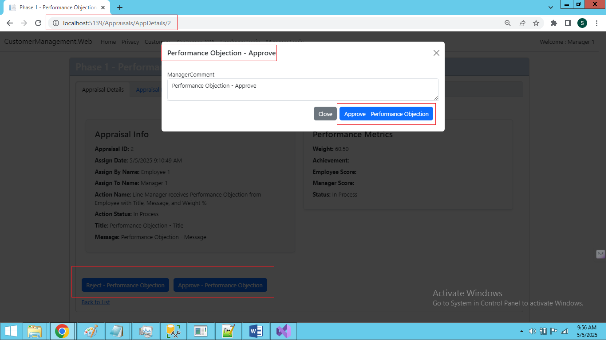

### ****🟢 Phase 2: Achievement****

#### 👤 **Employee**

* Submits **Achievement %** to Line Manager.

#### 👔 **Line Manager**

* **Reject:** Returns the achievement submission with comments to the employee.
* **Approve:** Accepts and forwards it to **Phase 3 - Score**.

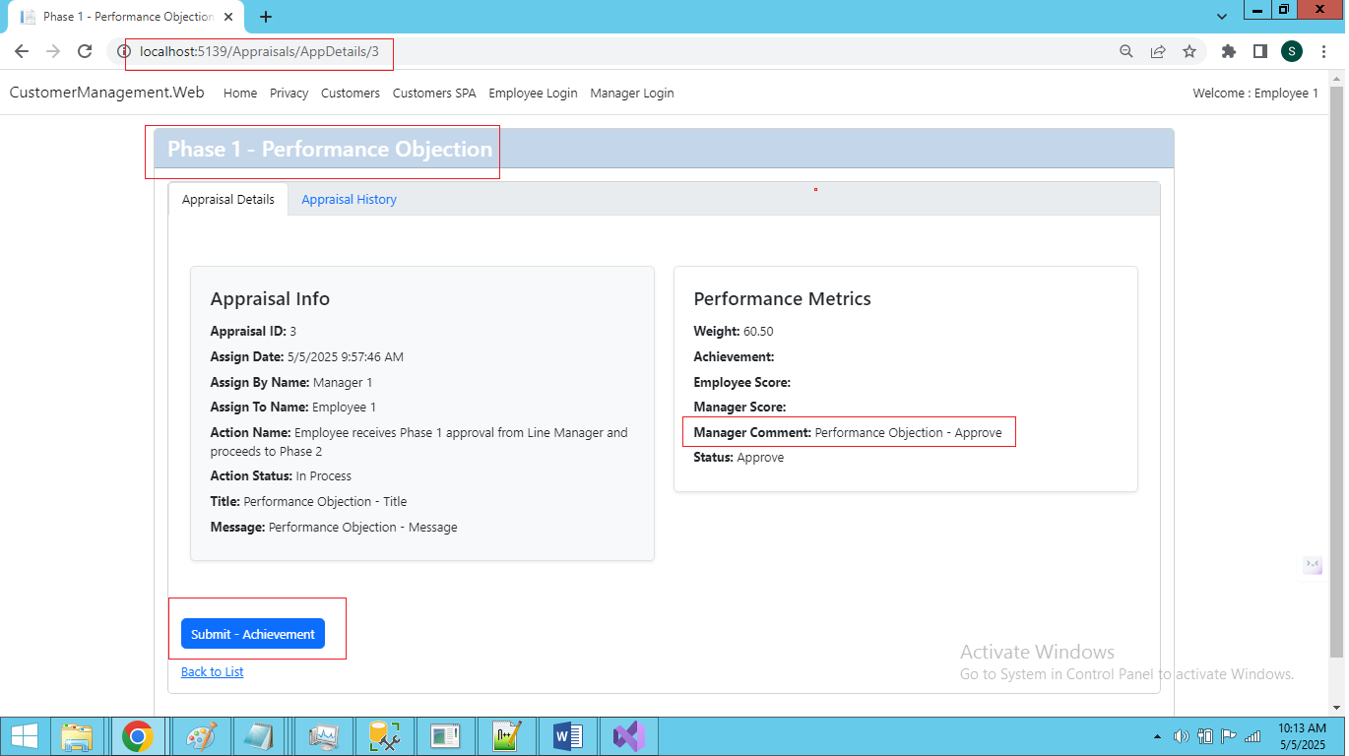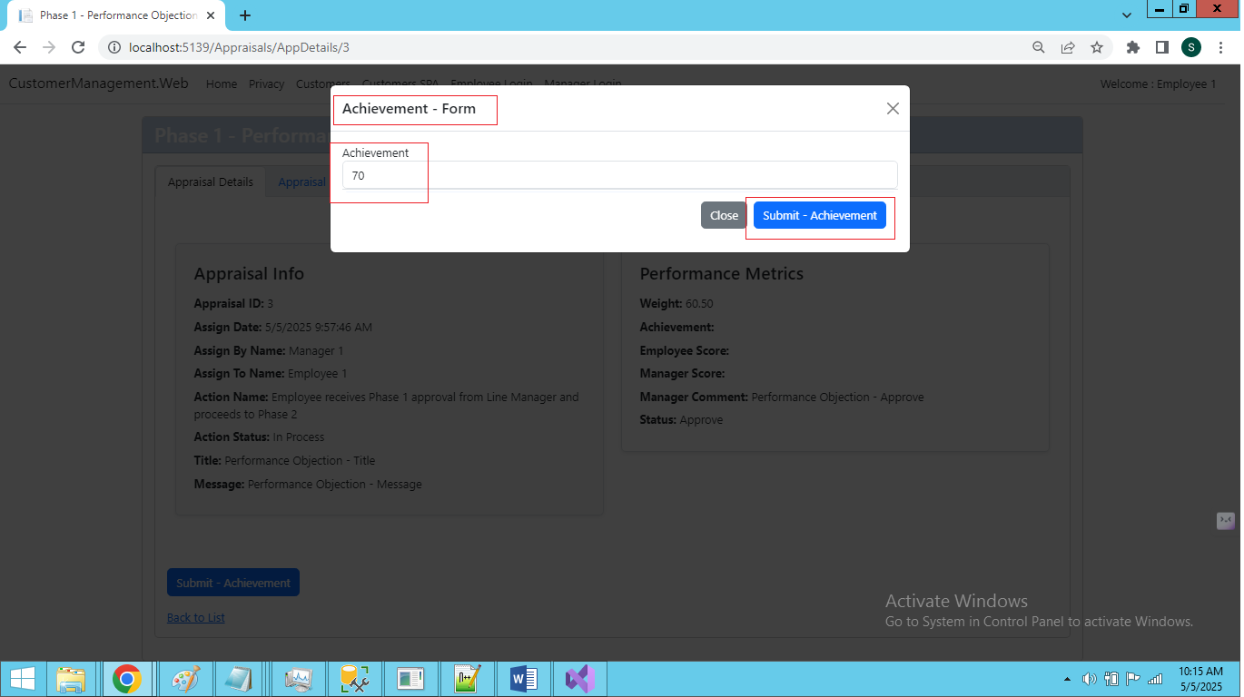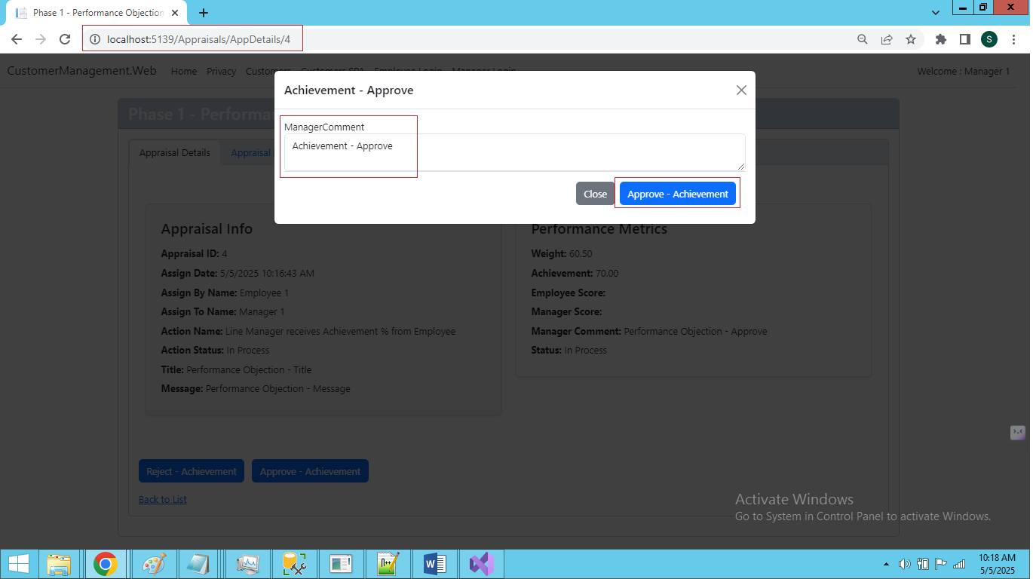

### ****🟠 Phase 3: Score****

#### 👤 **Employee**

* Submits **Score %** to Line Manager.

#### 👔 **Line Manager**

* **Reject:** Submits their own **Score %** along with comments to employee.
* **Approve:** Forwards the score to **Phase 4 - HR Review**.

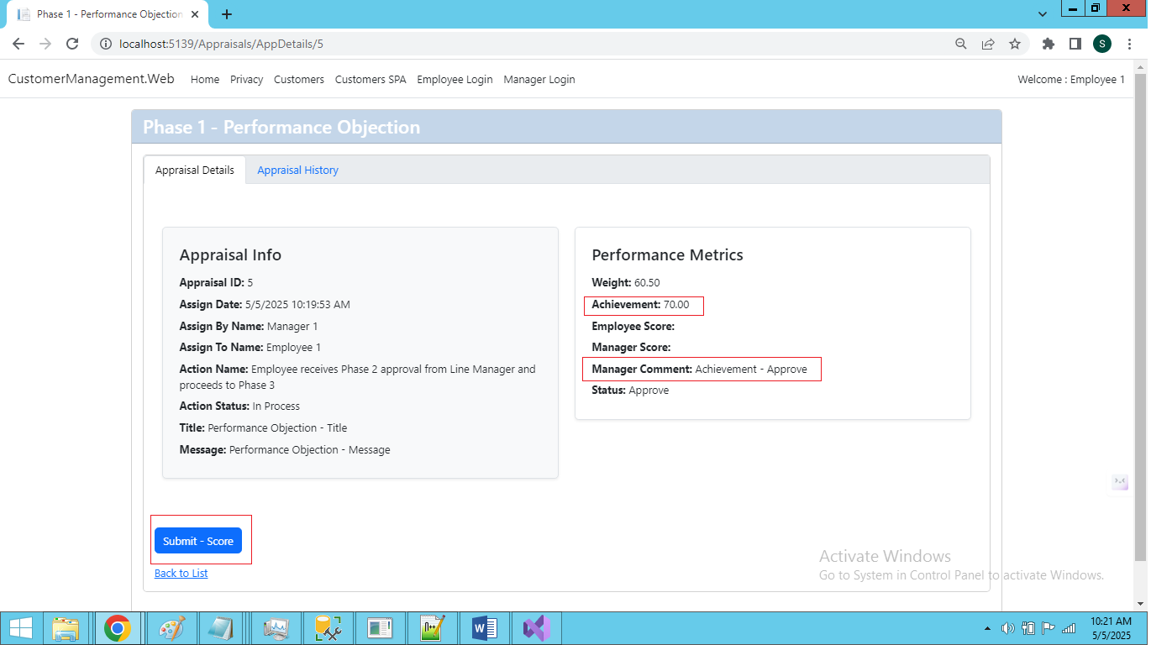

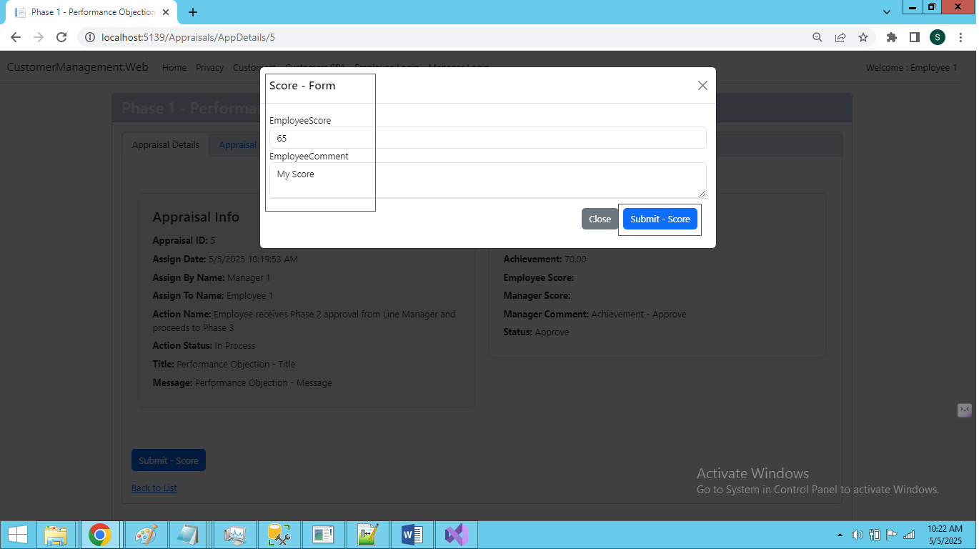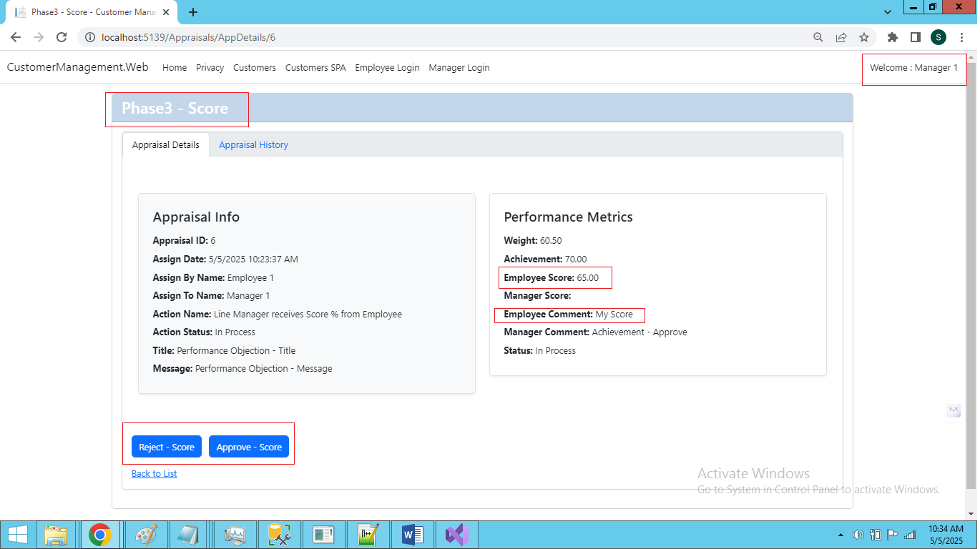

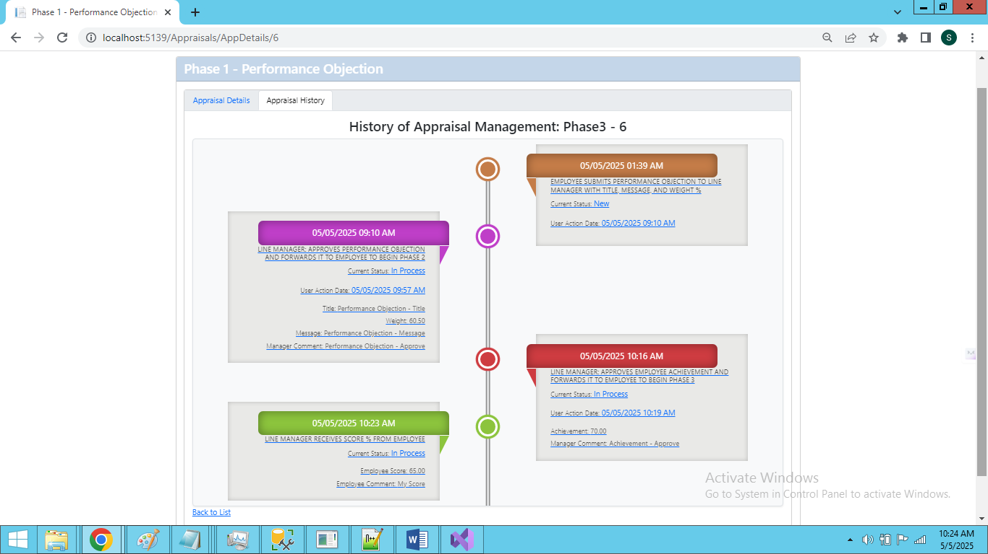

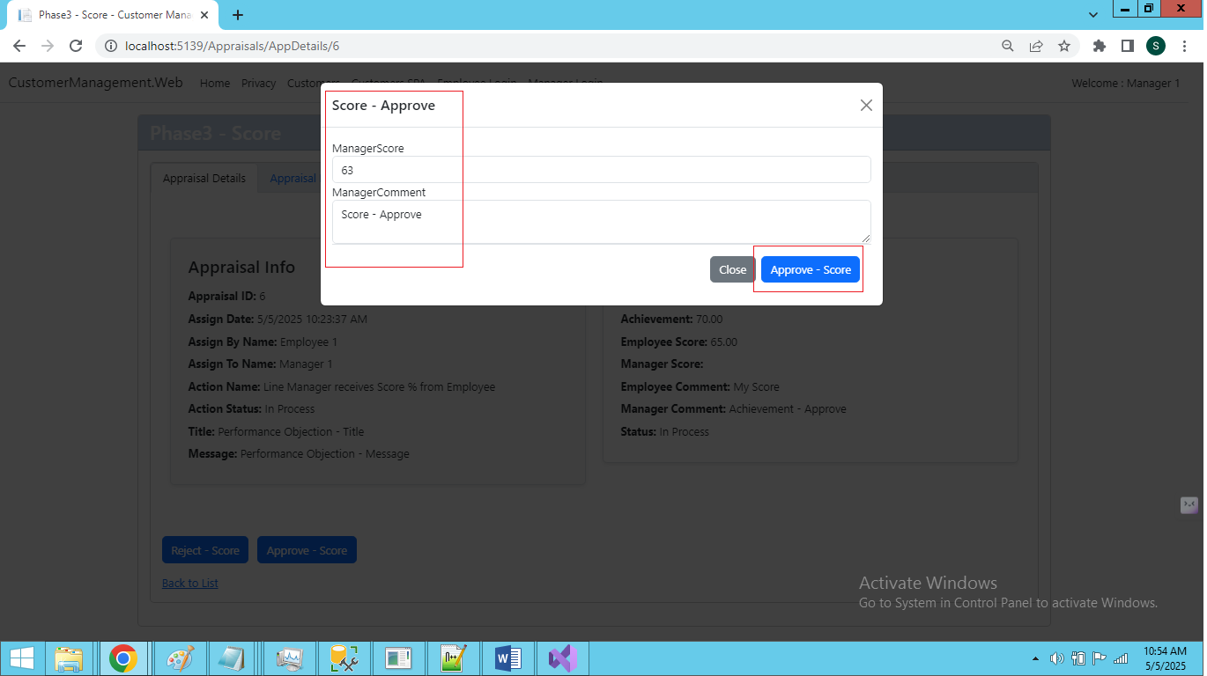

### ****🟣 Phase 4: HR Review****

#### 👔 **Line Manager**

* Adds final **comments** and submits to **HR Manager**.

#### 🧑‍💼 **HR Manager**

* **Reject:** Returns with comments to Line Manager for revision.
* **Approve:** Final approval, **Appraisal is closed**.

