Week 8 Assignment

Tutorial 1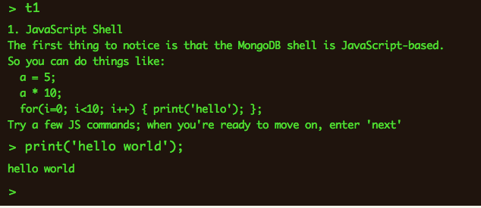

Tutorial 2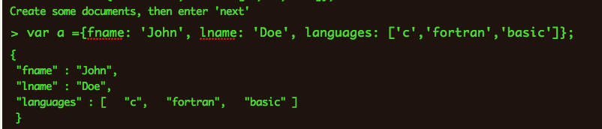

Tutorial 3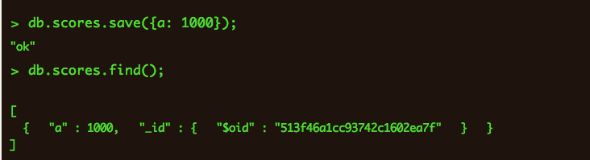

Tutorial 4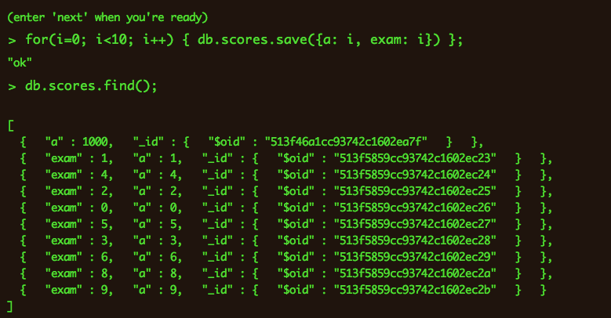

Tutorial 5