**Project Report**

**On**

**“Excellent Coaching ”**



**Aptech Computer Education – MSG-Karachi**

**Submitted By: Guided By**

1. Sheikh Abdullah Sir Zohaib Khan

2.Obaid Khan Teacher,

Aptech-MSG-Karachi

**CERTIFICATE**

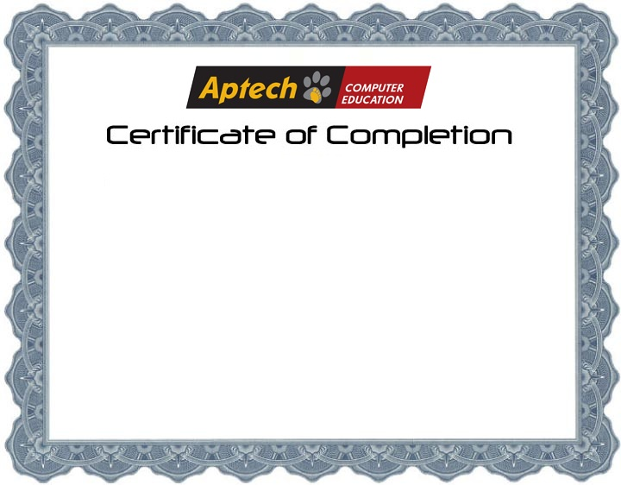

**This is to certify that Web Application for Coaching has been completed with all functionality by the students of**

**PR2-2023-095**

**Sheikh Abdullah, Obaid Khan**

**Introduction**

The thirst for learning, upgrading technical skills and applying the concepts in real life environment at a fast pace is what the industry demands from IT professionals today. However busy work schedules, far-flung locations, unavailability of convenient time-slots pose as major barriers when it comes to applying the concepts into realism. And hence the need to look out for alternative means of implementation in the form of laddered approach.

The above truly pose as constraints especially for our students too! With their busy schedules, it is indeed difficult for our students to keep up with the genuine and constant need for integrated application which can be seen live especially so in the field of IT education where technology can change on the spur of a moment. *Well, technology does come to our rescue at such times!!*

Keeping the above in mind and in tune with our constant endeavour to use Technology in our training model, we at Aptech have thought of revolutionizing the way our students learn and implement the concepts using tools themselves by providing a *live and synchronous eProject learning environment!*

**So, what is this eProject?**

eProject is a step-by-step learning environment that closely simulates the classroom and Lab based learning environment into actual implementation. It is a project implementation at your fingertips!! An electronic, live juncture on the machine that allows you to

* Practice step by step i.e. laddered approach.
* Build a larger more robust application.
* Usage of certain utilities in applications designed by user.
* Single program to unified code leading to a complete application.
* Learn implementation of concepts in a phased manner.
* Enhance skills and add value.
* Work on real life projects.
* Give a real-life scenario and help to create applications more complicated and useful.
* Mentoring through email support.

The students at the centre are expected to complete this eProject and send complete project along with the documentation to eProjects Team

Looking forward to a positive response from your end!!

**Objectives of the project**

The Objective of this program is to give a sample project to work on real life projects. These applications help you build a larger more robust application.

The objective is not to teach you JavaScript/Dreamweaver but to provide you with a real-life scenario and help you create basic applications using the tools.

You can revise the chapters before you start with the project.

This project is meant for students who have completed the module of ***Dreamweaver***. These programs should be done in the Lab sessions with assistance of the faculty if required.

It is very essential that a student has a clear understanding of the subject. Students should go through the project and solve the assignments as per requirements given.

Kindly get back to eProjects Team in case of any doubts regarding the application or its objectives.

**Hardware/ Software Requirements**

**Hardware**

* A minimum computer system that will help you access all the tools in the courses is a Pentium 166 or better
* 64 Megabytes of RAM or better

**Software *[Either or Combination as per Course/Sem]***

* Notepad/HTML editor/Coffee Cup
* Angular / Angular JS / React / Bootstrap
* Dreamweaver / Figma
* MS IE / Chrome / Firefox / Netscape /MS Edge

***User Guide***

***Homepage***

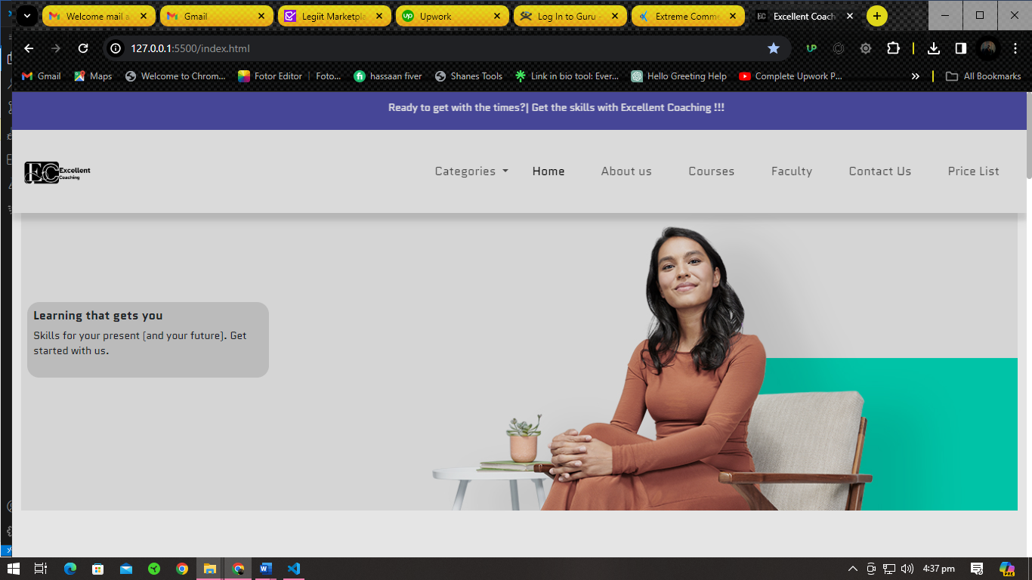

***About Page***



***Contact Us***

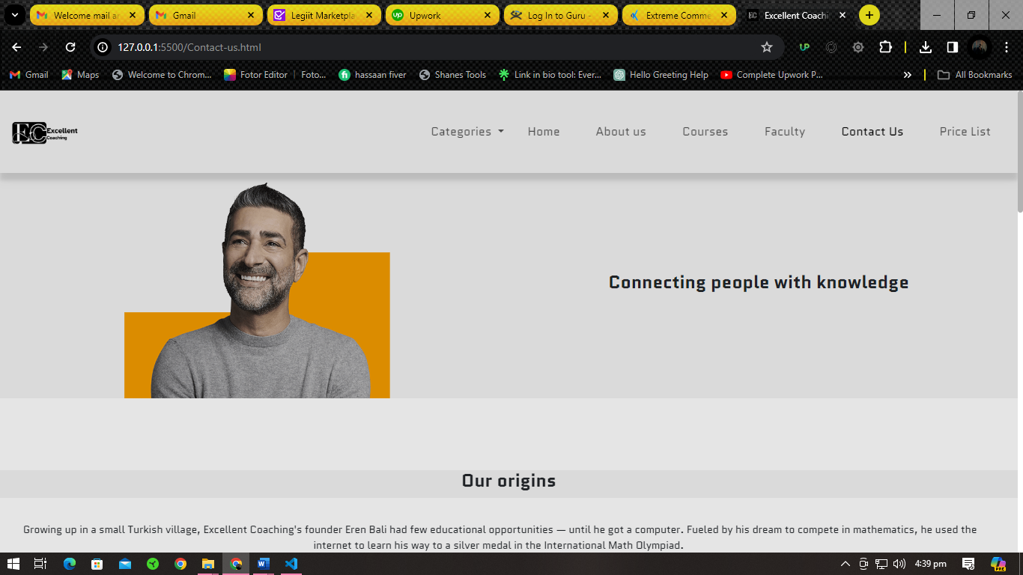

***Courses Page***

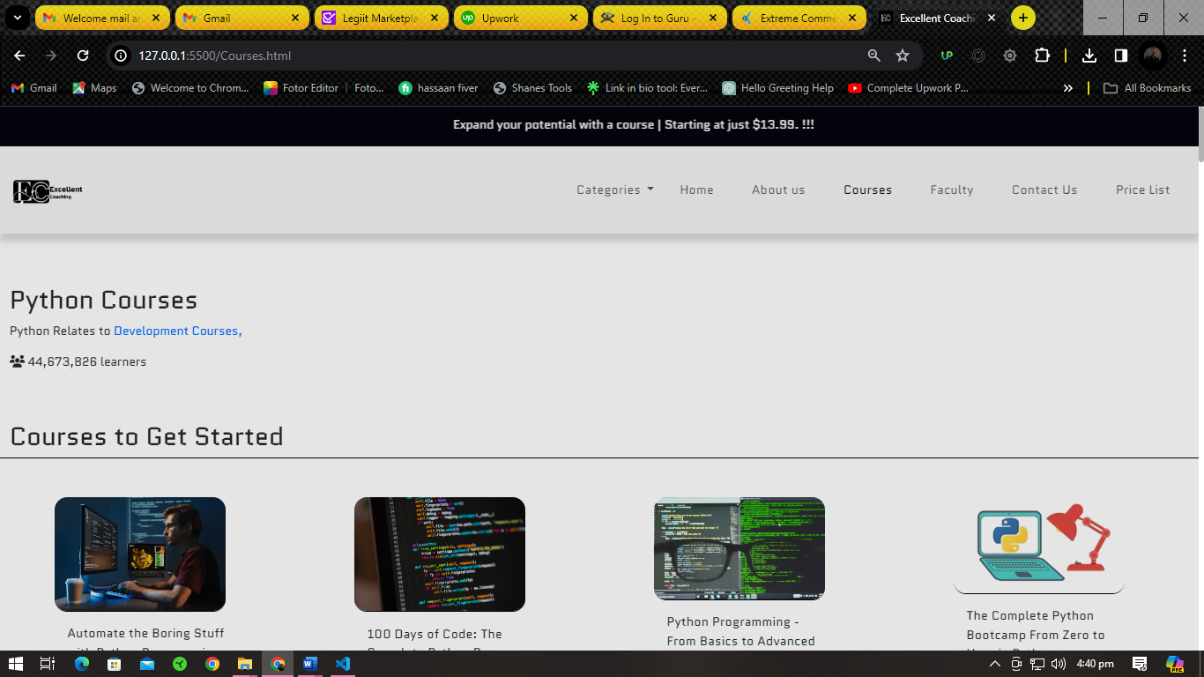

***Faculty***

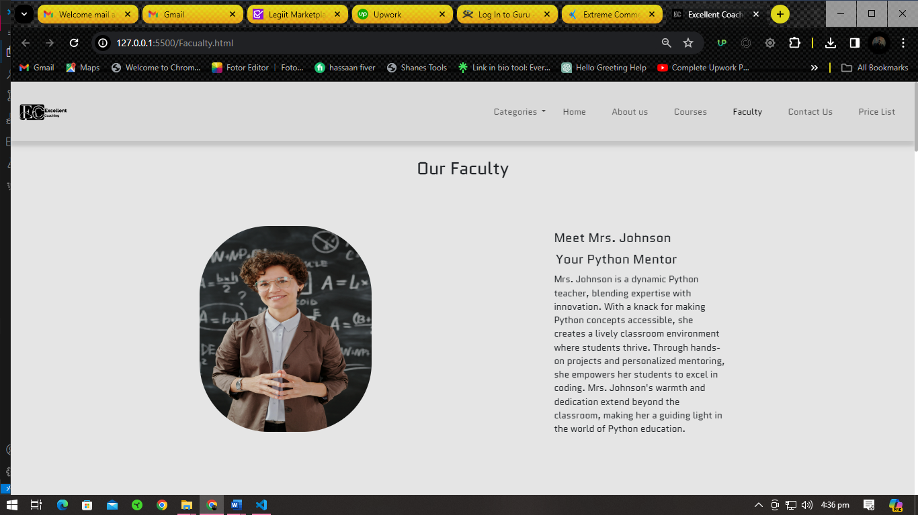

***Categories***

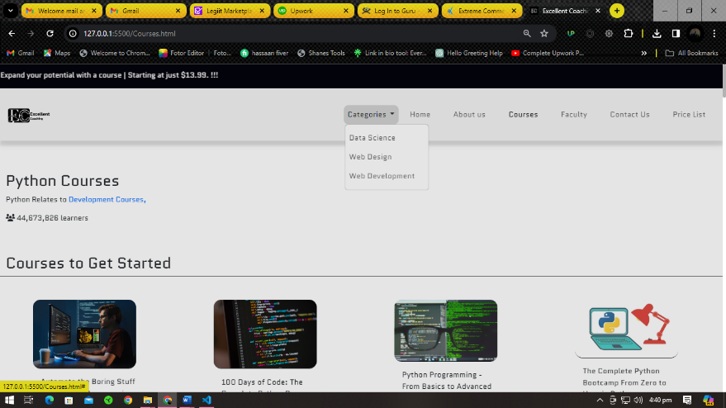

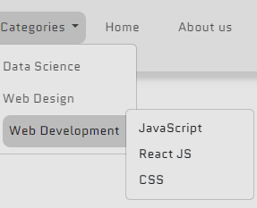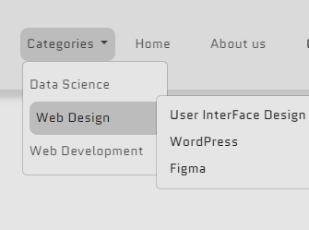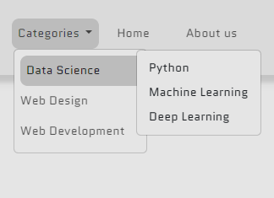

**FAQ**

**CONCLUSION :**

Our project is only a humble venture to satisfy the needs in a Coaching, user friendly coding have also adopted. This package shall prove to be a powerful package in satisfying all the requirements of the organization.

The objective of application planning is to provide a frame work that enables the manger to make reasonable estimates made within a limited time frame at the beginning of the software project and should be updated regularly as the project progresses. Last but not least it is no the work that played the ways to success but ALMIGHTY.