**Project- Name: Calculator.**

**By:- Sheikh Salman Shakir.**

**Batch:- 71- Full Stack Web Developement**

**Email:- sheikhsalmanshakir@gmail.com**

**Github link:-** **https://github.com/Sheikh-Salman-shakir/Second-project-Calculator.git**

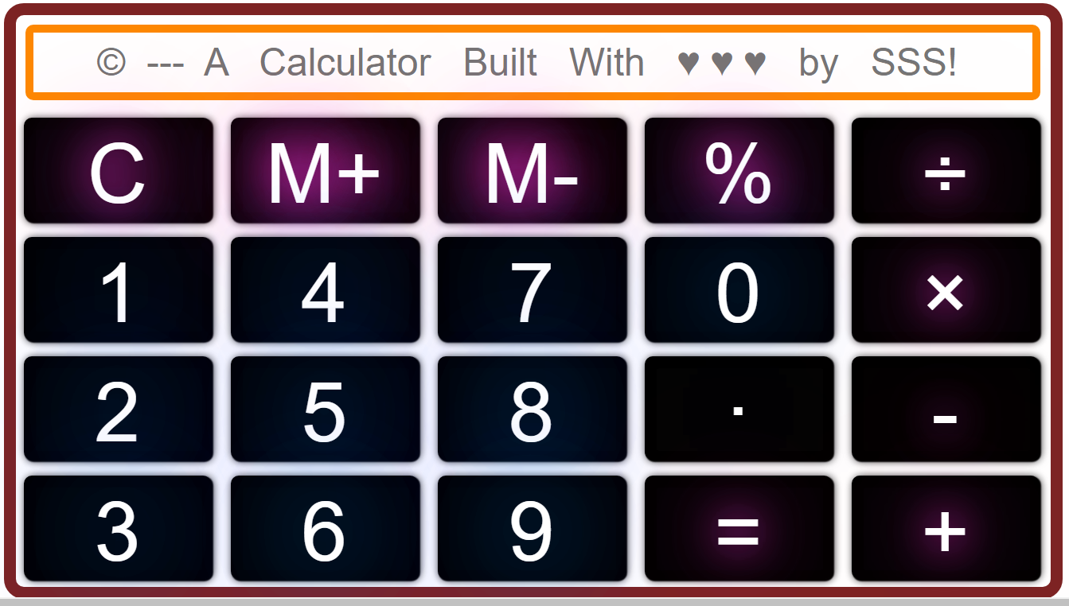

***OVERVIEW:*** A calculator is a device that performs arithmetic operations on numbers. Basic calculators can do only addition, subtraction, multiplication and division mathematical calculations.

***HOME PAGE:***

# Search bar.

# Numbers keys.

# Airthmatic Keys.

# Special Keys.

***MAIN PAGE:***

# Search Bar ( It as the secreen that displays the result )

# Number keys are used to type numbers and are 10 (0-9).

# Airthmatic keys are those keys that we use to doaddition, subtraction,

multiplication,and dividion.

# Special keys are those keys that we use to do some special functions

like ‘clear screen’ ‘memory keys’ etc.

***Technologies used in this calculator:***

1. Html.

2. Css.

3.Javascript.