

**DAWOOD UNIVERSITY OF ENGINEERING & TECHNOLOGY**

DEPARTMENT OF COMPUTER SYSTEMS ENGINEERING

**Assignment**

FOR

Software Engineering

5th SEMESTER 3rd YEAR BATCH 2016

|  |  |
| --- | --- |
| Submitted to: | Engr. Maria Bashir |
| Submitted by: | Sheikh Zubair Ahmed |
| Roll No: | 16-CS-16 |

Contents

1. Diabetes ……………………………………………………………………………………………………………………………………….03
   1. How it happens? ……………………………………………………………………………………………………………………03
   2. Types of diabetes……………………………………………………………………………………………………………………03
   3. Symptoms of diabetes…………………………………………………………………………………………………………….04
   4. How to prevent diabetes…………………………………………………………………………………………………………04
2. Insulin Pump…………………………………………………………………………………………………………………………………..04
   1. How insulin pump work? ………………………………………………………………………………………………………..04
   2. Insulin pump diagram……………………………………………………………………………………………………………..05
3. References……………………………………………………………………………………………………………………………………...05
4. Diabetes

Diabetes is a disease that occurs when glucose level in blood is too high.

Worldwide, it afflicts more than 422 million people. The World Health Organization estimates that by 2030, that number of people living with diabetes will more than double. Today diabetes take more lives than AIDS and Cancer combined. It is a leading cause of blindness, kidney failure, amputations, heart failure and stroke. [2]

* 1. How it happens?

Glucose is the main source of energy and it comes from the food we eat. Our body turns food into glucose and at that point, Pancreas releases Insulin, which act as the key to open cells and allow glucose to enter and make energy. If Pancreas does not make enough or any Insulin then glucose level in our blood increases. This increase of blood sugar is called Diabetes.

Sometimes people call diabetes “a touch of sugar” or “borderline diabetes.” These terms suggest that someone does not really have diabetes or has a less serious case, but every case of diabetes is serious. [1]

* 1. Types of diabetes

# Type 1 diabetes

If you have [type 1 diabetes](https://www.niddk.nih.gov/health-information/diabetes/overview/what-is-diabetes/type-1-diabetes), your body does not make insulin. Your [immune system](https://www.niddk.nih.gov/Dictionary/I/immune-system) attacks and destroys the cells in your pancreas that make insulin. Type 1 diabetes is usually diagnosed in children and young adults, although it can appear at any age. People with type 1 diabetes need to take insulin every day to stay alive.

# Type 2 diabetes

If you have [type 2 diabetes](https://www.niddk.nih.gov/health-information/diabetes/overview/what-is-diabetes/type-2-diabetes), your body does not make or use insulin well. You can develop type 2 diabetes at any age, even during childhood. However, this type of diabetes occurs most often in middle-aged and older people. Type 2 is the most common type of diabetes.

There are other types of diabetes as well which are less common.

* 1. Symptoms of diabetes
* Urinating often.
* Feeling very thirsty.
* Feeling very hungry - even though you are eating.
* Extreme fatigue.
* Blurry vision.
* Cuts/bruises that are slow to heal.
* Weight loss - even though you are eating more (type 1)
* Tingling, pain, or numbness in the hands/feet (type 2)
  1. How to prevent diabetes?
* Check risks of diabetes
* Manage weight
* Exercise regularly
* Eat a balanced and healthy diet
* Avoid fast foods
* Maintain water intake
* Quit smoking or avoid smoke (for non-smokers)
* Control blood pressure as prescribed by doctor

1. Insulin Pump

An insulin pump is an electronic device. The Insulin pump helps us more closely mimic the way a healthy pancreas functions. The pump, through a Continuous Subcutaneous Insulin Infusion (CSII), replaces the need for frequent injections by delivering precise doses of rapid-acting insulin 24 hours a day to closely match your body's needs.

* 1. How Insulin Pump work?

It drip feeds insulin into the body through the day and can deliver larger doses of insulin whenever needed, such as before meals. Insulin pumps can also be programmed to deliver specific doses at set times.[3]

* 1. Insulin pump diagram

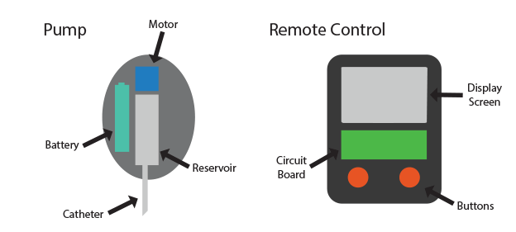

3. References

[1] <https://www.niddk.nih.gov/health-information/diabetes/overview/what-is-diabetes>

[2] <https://www.diabetesresearch.org/what-is-diabetes>

[3] <https://www.diabetes.co.uk/insulin/how-insulin-pumps-work.html>