Sets and Numbering Systems Topic 1

The study of Mathematics begins with a study of sets and the development of the numbering systems. Every mathematical system can be represented as a “set”; therefore, it is important for us to understand the definitions, notations and properties of “sets”

- Definition: A set is an unordered collection of distinct objects. Objects in the collection are called elements of the set.
- Examples:
  - The collection of persons living in Lahore is a set.
    - Each person living in Lahore is an element of the set.
  - The collection of all towns in the Punjab province is a set.
    - Each town in Punjab is an element of the set.
  - The collection of all quadrupeds is a set.
    - Each quadruped is an element of the set.
  - The collection of all four-legged dogs is a set.
    - Each four-legged dog is an element of the set.
  - The collection of counting numbers is a set.

    - Each counting number is an element of the set.
  - The collection of pencils in your bag is a set.

    - Each pencil in your bag is an element of the set.
- Notation: Sets are usually designated with capital letters. Elements of a set are usually designated with lower case letters.
  - D is the set of all four legged dogs.
  - An individual dog might then be designated by d.

- The roster method of specifying a set consists of surrounding the collection of elements with braces. For example the set of counting numbers from 1 to 5 would be written as
{1, 2, 3, 4, 5}.

- Set builder notation has the general form {variable | descriptive statement }.

The vertical bar (in set builder notation) is always read as “such that”.

Set builder notation is frequently used when the roster method is either inappropriate or inadequate.

For example, {x | x < 6 and x is a counting number} is the set of all counting numbers less than 6. Note this is the same set as {1,2,3,4,5}.

- Other Notation: If x is an element of the set A, we write this as x ∈ A. x ∉ A means x is not an element of A.

If A = {3, 17, 2 } then 3 ∈ A, 17 ∈ A, 2 ∈ A and 5 ∉ A.
If A = { x | x is a prime number } then 5 ∈ A, and 6 ∉ A.

- Definition: The set with no elements is called the empty set or the null set and is designated with the symbol ∅.

- Definition: The universal set is the set of all things pertinent to a given discussion and is designated by the symbol U

For example, when dealing with all the students enrolled at the Virtual University, the Universal set would be
U = {all students at the Virtual University}
Some sets living in this universal set are:
A = {all Computer Technology students}
B = {first year students}
C = {second year students}

- Definition: The set A is a subset of the set B, denoted A ⊆ B, if every element of A is an element of B.
If A is a subset of B and B contains elements which are not in A, then A is a proper subset of B. It is denoted by A ⊂ B.

If A is not a subset of B we write A ⊄ B to designate that relationship.

- Definition: Two sets A and B are equal if A ⊆ B and B ⊆ A. If two sets A and B are equal we write A = B to designate that relationship.
In other words, two sets, A and B, are equal if they contain the same elements
- Definition: The intersection of two sets A and B is the set containing those elements which are elements of A and elements of B. We write A ∩ B to denote A Intersection B.
- Example: If A = {3, 4, 6, 8} and B = { 1, 2, 3, 5, 6} then A ∩ B = {3, 6}
- Definition: The union of two sets A and B is the set containing those elements which are elements of A or elements of B. We write A ∪ B to denote A Union B.
- Example: If A = {3, 4, 6} and B = { 1, 2, 3, 5, 6} then A ∪ B = {1, 2, 3, 4, 5, 6}.
- Algebraic Properties of Sets:
  - Union and intersection are commutative operations. In other words, A ∪ B = B ∪ A and A ∩ B = B ∩ A
  - Union and intersection are associative operations. In other words,
(A ∪ B) ∪ C = A ∪ (B ∪ C) and (A ∩ B) ∩ C = B ∩ (A ∩ C)
Union and Intersection are distributive with respect to each other. In other words
A ∩ ( B ∪ C )= (A ∩ B) ∪ (A ∩ C) and A ∪ ( B ∩ C )= (A ∪ B) ∩ (A ∪ C)
- A few other elementary properties of intersection and union.
A ∪ ∅ =A, A ∩ ∅ = ∅, A ∪ A = A, A ∩ A = A.
- Numbering Systems:

- Counting numbers are called Natural numbers and the set of Natural numbers is denoted by N = {1,2,3…}
- Integers are Natural numbers, their opposites and zero. The set of integers is denoted by Z = {…-3, -2, -1, 0,1,2,3…}
- Rational numbers such as ²/₃, -3¹/₂ 0.3333, are numbers that can be written as a ratio of two integers. The set of rational numbers is denoted by Q. This set includes
  - Repeating decimals, terminating decimals and fractions
  - Integers are also rational numbers since every integer a can be written as a fraction a/1
- Irrational numbers are numbers that can’t be written as fractions.
  - 3. 45455455545555… has a pattern but doesn’t repeat. It isn’t rational. It can’t be written like a fraction.
  - Square root of 2, π (Pi) and e are also irrational.
- The Union of the set of rational numbers and the set of irrational numbers is the set of Real numbers, denoted by R
- N ⊂ Z ⊂ Q ⊂ R

- Definition: Cardinality refers to the number of elements in a set
  - A finite set has a countable number of elements
  - An infinite set has at least as many elements as the set of natural numbers

- Notation: |A| represents the cardinality of Set A

- History: Initially numbers were used for counting and the natural numbers did that job well. However there were no solutions for equations of the form x + 4 = 0.

To resolve this, the natural numbers were extended by inventing the negative integers.
This was done by attaching a symbol “-” (which we now call the minus sign) to each natural number and calling the new number the “negative” of the original number. This was further extended to all real numbers.

Now people had solutions for equations of the form x + 4 = 0, but equations of the form x² + 4 = 0 still had no solutions. There is no real number whose square is -4.

The numbering system had to be extended once again to accommodate for square roots of negative numbers. A symbol, , was invented and it was called the “imaginary unit”. The real numbers were extended by attaching this imaginary unit to each number and calling it the “imaginary copy” of the real numbers.

- Definition: Numbers of the form a + bi are called complex numbers.
  - a is the real part
  - b is the imaginary part
The set of complex numbers is denoted by C

- Examples : 2 - 4i , -3 + 5i and -5 + ³/₄i are all complex numbers

- Graphical Representation: Recall that real numbers are represented on a line. A complex number has a representation in a plane. Simply take the x-axis as the real numbers and y-axis as the imaginary numbers. Thus, giving the complex number a + bi the representation as point P with coordinates (a,b) as the following diagram shows:
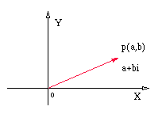
- Properties of Complex Numbers:
- Addition and Subtraction: For complex numbers a + bi and c + di, 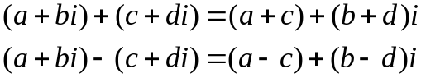
- Examples
    - (4 − 6i) + (−3 + 7i) = [4 + (−3)] + [−6 + 7]i = 1 + i
    - (10 − 4i) − (5 − 2i) = (10 − 5) + [−4 − (−2)]i = 5 − 2i
- Multiplication of Complex Numbers: For complex numbers a + bi and c + di,
- The product of two complex numbers is found by multiplying as if the numbers were binomials and using the fact that i² = −1.

- Example: (2 − 4i)(3 + 5i)

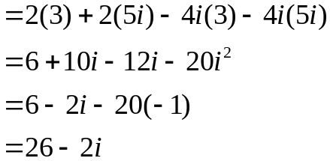

- Definition: Given a complex number z = a + ib, its conjugate is defined as z*= a – ib

- Properties of conjugates:
  - (z*)* = z
  - z.z* = a² + b² (real)
  - z + z* = 2a (real)
  - z - z* = 2ib (imaginary)

- Division of Complex Numbers: For complex numbers a + bi and c + di,
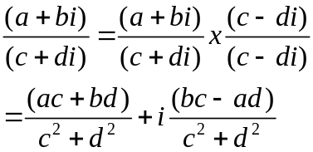
The quotient of two complex numbers is found by multiplying and dividing by the conjugate of the denominator.

- 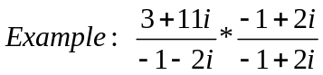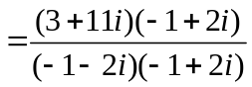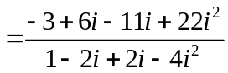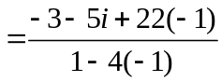

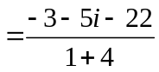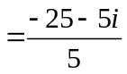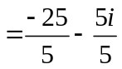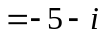

- Definition: The absolute value or modulus of a complex number is the distance the complex number is from the origin on the complex plane.
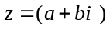
- If you have a complex number the absolute value can be found using
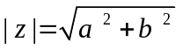
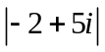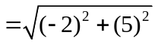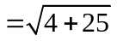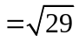
- Example:

