

Information Security

Dr. Muhammad Tayyab Ch



Section: B

FA19-BSE-004

Areeb Shehzad Zaman

**CSC432 Information Security**

**Quiz 1**

**Marks 5**

Question: You are required to perform encryption and decryption of plain text. Choose at least 5 words long text and use all the following ciphers:

1. Affine Cipher

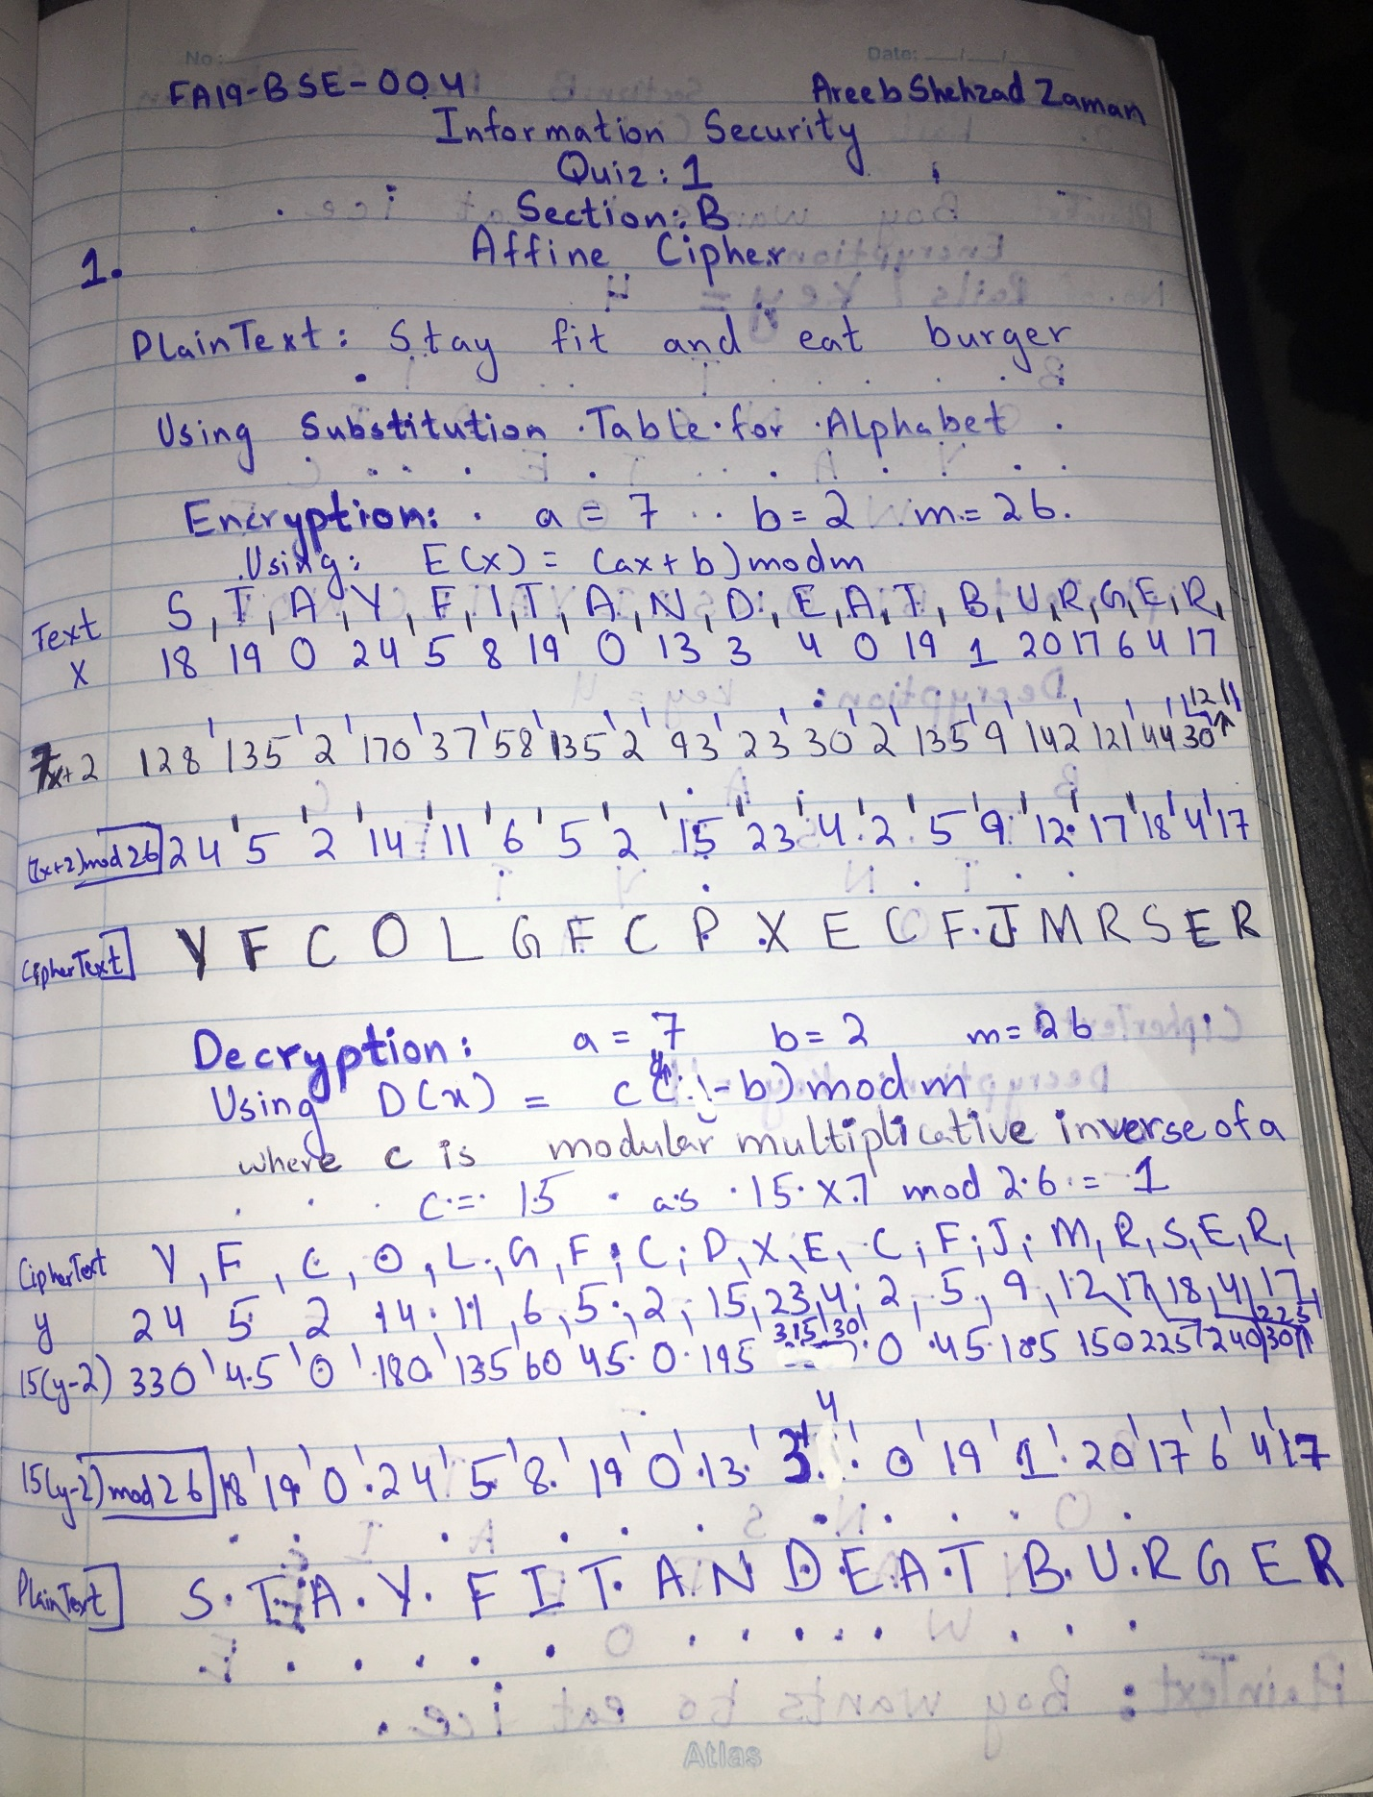

1. Rail Fence Cipher

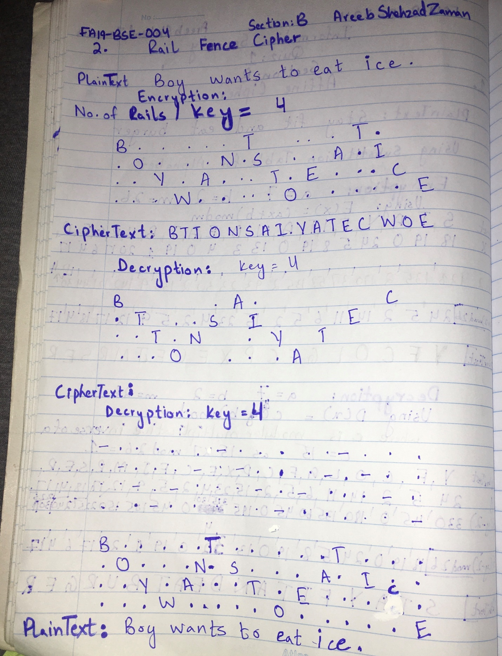

**Important**: Mention the key/s used. At most 1 students per submission. No submissions would be accepted after deadline. Plagiarism would result in loss of 4 marks out of 5. Neatly show the encryption and decryption portions of each cipher. Use different plain texts for each cipher.