

Software testing MidTerm Lab

Mam Sana Rizwan



Section: B

FA19-BSE-004 Areeb Shehzad Zaman

# Question 1:

## a.

### Conditions

* Preferred Customers: Y/N
* Order more than 1000: Y/N
* Charge Card: Y/N

### Actions

* Discount: Y/N
* Add. Discount: Y/N
* $25 coupon: Y/N
* $5 coupon: Y/N

### b. Decision Diagram

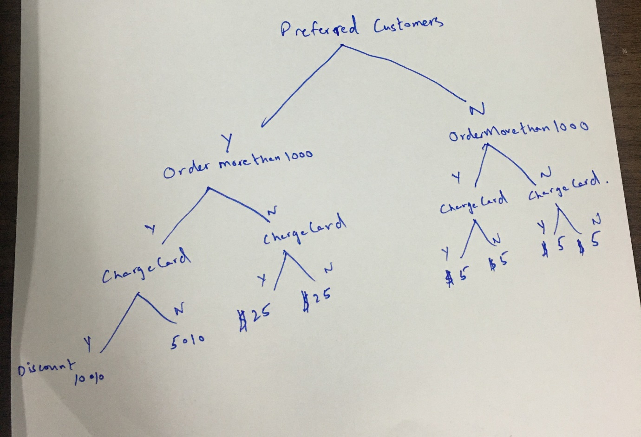

### c. Decision Table

|  |  |  |  |  |  |  |  |  |
| --- | --- | --- | --- | --- | --- | --- | --- | --- |
| **Conditions** |  |  |  |  |  |  |  |  |
| Preferred customer | Y | Y | Y | Y | N | N | N | N |
| Order more than 1000 | Y | Y | N | N | Y | Y | N | N |
| Charge Card | Y | N | Y | N | Y | N | Y | N |
| **Actions** |  |  |  |  |  |  |  |  |
| Discount 5% | N | Y | N | N | N | N | N | N |
| Discount 10% | Y | N | N | N | N | N | N | N |
| $25 coupon | N | N | Y | Y | N | N | N | N |
| $5 coupon | N | N | N | N | Y | Y | Y | Y |

### d. Test Cases

|  |  |  |  |  |  |  |  |  |  |  |
| --- | --- | --- | --- | --- | --- | --- | --- | --- | --- | --- |
| **Test Case ID** | | TC_001 | **Test Case Description** | | Test the Discount Functionality of the system | | | | | |
| **Created By** | | Abdul Raheem | **Reviewed By** | | Irfan | | **Version** | | 1.0 | |
|  |  |  |  |  |  |  |  |  |  |  |
| **QA Tester’s Log** | | Review comments from Areeb incorporate in version 2.1 | | | |  |  |  |  |  |
|  |  |  |  |  |  |  |  |  |  |  |
| **Tester's Name** | | Areeb | **Date Tested** | | 1-Jan-2017 | | **Test Case (Pass/Fail/Not Executed)** | | Pass | |
|  |  |  |  |  |  |  |  |  |  |  |
| **S #** | **Prerequisites:** | | |  | **S #** | **Test Data** | | | | |
| 1 | Access Chrome Browser | | |  | 1 | Preferred customer: Y, Order more than 1000: Y, Charge card: Y | | | | |
| 2 | Registered user | | |  | 2 |  | | | | |
| 3 |  | | |  | 3 |  | | | | |
| 4 |  | | |  | 4 |  | | | | |
|  |  |  |  |  |  |  |  |  |  |  |
| **Test Scenario** | Verify on entering discount to the system. | | | | | |  |  |  |  |
|  |  |  |  |  |  |  |  |  |  |  |
| **Step #** | **Step Details** | | **Expected Results** | | **Actual Results** | | | **Pass / Fail (Failure) / Not executed(showing error/ not executing like service unavailability etc) / Suspended(Wait and see)** | | |
|  |
| 1 | Enter discount = 5% | | Error: User gets more discount | | As Expected | | | Pass | | |  |
| 2 | Enter discount = 10% | | Prints discount coupon | | As Expected | | | Pass | | |  |
| 3 | Enter discount= $25 coupon | | Error: User gets more discount | | As Expected | | | Pass | | |  |
| 4 | Enter discount= $5 coupon | | Error: User gets more discount | | As Expected | | | Pass | | |  |
| **Test Case ID** | | TC_002 | **Test Case Description** | | Test the Discount Functionality of the system | | | | | |
| **Created By** | | Abdul Raheem | **Reviewed By** | | Irfan | | **Version** | | 1.0 | |
|  |  |  |  |  |  |  |  |  |  |  |
| **QA Tester’s Log** | | Review comments from Areeb incorporate in version 2.1 | | | |  |  |  |  |  |
|  |  |  |  |  |  |  |  |  |  |  |
| **Tester's Name** | | Areeb | **Date Tested** | | 1-Jan-2017 | | **Test Case (Pass/Fail/Not Executed)** | | Pass | |
|  |  |  |  |  |  |  |  |  |  |  |
| **S #** | **Prerequisites:** | | |  | **S #** | **Test Data** | | | | |
| 1 | Access Chrome Browser | | |  | 1 | Preferred customer: N, Order more than 1000: N, Charge card: Y | | | | |
| 2 | Registered user | | |  | 2 |  | | | | |
| 3 |  | | |  | 3 |  | | | | |
| 4 |  | | |  | 4 |  | | | | |
|  |  |  |  |  |  |  |  |  |  |  |
| **Test Scenario** | Verify on entering discount to the system. | | | | | |  |  |  |  |
|  |  |  |  |  |  |  |  |  |  |  |
| **Step #** | **Step Details** | | **Expected Results** | | **Actual Results** | | | **Pass / Fail (Failure) / Not executed(showing error/ not executing like service unavailability etc) / Suspended(Wait and see)** | | |
|
| 1 | Enter discount = 5% | | Error: User gets more discount | | As Expected | | | Pass | | |
| 2 | Enter discount = 10% | | Error: User gets more discount | | As Expected | | | Pass | | |
| 3 | Enter discount= $25 coupon | | Error: User gets more discount | | As Expected | | | Pass | | |
| 4 | Enter discount= $5 coupon | | Prints discount coupon | | As Expected | | | Pass | | |

# Question: 2

## Diagram

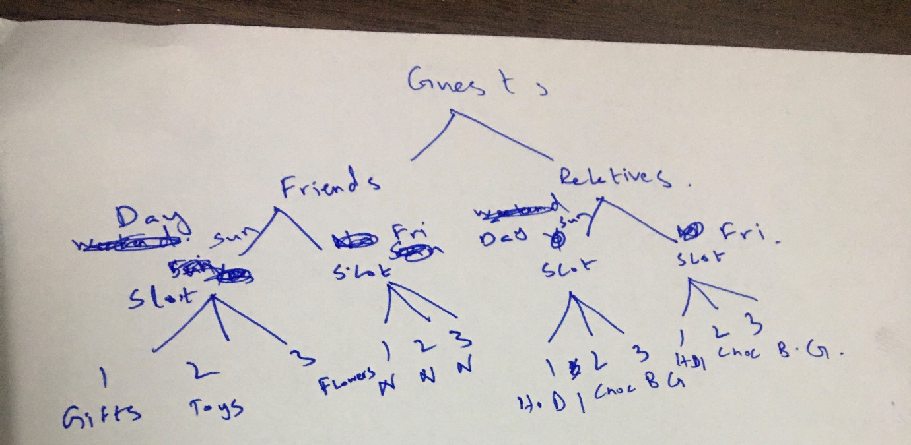

## Test Case Scenario

### Scenario: 1

1. Guest: Friend
2. Day: Friday
3. Slot: 1
4. Enter gift: (Any)

Result: Invalid

### Scenario: 2

1. Guest: Friend
2. Day: Friday
3. Slot: 2
4. Enter gift: (Any)

Result: Invalid

### Scenario: 3

1. Guest: Friend
2. Day: Friday
3. Slot: 3
4. Enter gift: (Any)

Result: Invalid

### Scenario: 4

1. Guest: Friend
2. Day: Sunday
3. Slot: 1
4. Enter gift: Candies

Result: Valid

1. Enter gift: Toys, Flowers, Home décor, Chocolates, Board Games

Result: Invalid

### Scenario: 5

1. Guest: Friend
2. Day: Sunday
3. Slot: 2
4. Enter gift: Toys

Result: Valid

1. Enter gift: Candies, Flowers, Home décor, Chocolates, Board Games

Result: Invalid

### Scenario: 6

1. Guest: Friend
2. Day: Sunday
3. Slot: 3
4. Enter gift: Flowers

Result: Valid

1. Enter gift: Candies, Toys, Home décor, Chocolates, Board Games

Result: Invalid

### Scenario: 7

1. Guest: Relatives
2. Day: Sunday
3. Slot: 1
4. Enter gift: Home décor

Result: Valid

1. Enter gift: Candies, Toys, Flowers, Chocolates, Board Games

Result: Invalid

### Scenario: 8

1. Guest: Relatives
2. Day: Sunday
3. Slot: 2
4. Enter gift: Chocolates

Result: Valid

1. Enter gift: Candies, Toys, Flowers, Home décor, Board Games

Result: Invalid

### Scenario: 9

1. Guest: Relatives
2. Day: Sunday
3. Slot: 3
4. Enter gift: Board Games

Result: Valid

1. Enter gift: Candies, Toys, Flowers, Home décor, Chocolates

Result: Invalid

### Scenario: 10

1. Guest: Relatives
2. Day: Friday
3. Slot: 1
4. Enter gift: Home décor

Result: Valid

1. Enter gift: Candies, Toys, Flowers, Chocolates, Board Games

Result: Invalid

### Scenario: 11

1. Guest: Relatives
2. Day: Friday
3. Slot: 2
4. Enter gift: Chocolates

Result: Valid

1. Enter gift: Candies, Toys, Flowers, Home décor, Board Games

Result: Invalid

### Scenario: 12

1. Guest: Relatives
2. Day: Friday
3. Slot: 3
4. Enter gift: Board Games

Result: Valid

1. Enter gift: Candies, Toys, Flowers, Home décor, Chocolates

Result: Invalid

# Question: 3

