RESEARCH PAPER
Short-Term Ferry Ticket Demand Forecasting
and Predictive Decision Support System
Toronto Island Park Ferry Service
Prepared for: Toronto Parks, Forestry & Recreation
Moving ferry operations from reactive analytics to predictive operational intelligence
Abstract
The Toronto Island Park ferry service holds roughly a decade of ticket transaction data, yet congestion at the terminal has historically been handled reactively, by watching queue length. This paper documents an end-to-end project that converts that data into a forward-looking decision support tool. Raw sales and redemption records were audited, resampled into 15-minute intervals, and explored to identify seasonal, weekly, hourly and peak-event structure. Autoregressive and rolling-window features were then engineered, and six forecasting approaches (Naïve, Moving Average, SARIMA, Facebook Prophet, Random Forest and XGBoost) were compared under a chronological train-test split. The tuned XGBoost model performed best, with a Mean Absolute Error (MAE) of 16.90 tickets and a Root Mean Squared Error (RMSE) of 62.49 per 15-minute interval, and was deployed in a Streamlit dashboard offering 15-minute to 2-hour forecasts, 95% confidence bands and traffic-light readiness alerts. The paper closes with operational recommendations and an honest account of the model’s limitations, chiefly its tendency to under-predict extreme surges.
Keywords: time-series forecasting, XGBoost, demand prediction, ferry operations, feature engineering, decision support, Streamlit

1. Introduction

1.1 Background and Problem Statement
The Toronto Island Park ferry is a seasonal, weather-sensitive service with sharply peaked demand. On a summer weekend, thousands of passengers can arrive at the terminal within a few hours, while winter days may see only a handful of tickets sold per hour. Staffing and vessel deployment decisions are therefore difficult: too little capacity creates long queues and safety risk, while too much wastes crew and fuel.
Operations has so far relied on reactive measures, responding to congestion once it is visible at the gate. Although a decade of ticketing data exists, it had not been turned into a forecast. The central question of this project is therefore:
Can historical ticket data be used to predict passenger demand 15 minutes to 2 hours ahead, accurately enough to trigger staffing and capacity decisions before the queue forms?

1.2 Objectives
- Audit and prepare the historical ticket data for time-series modelling.
- Characterise demand patterns (seasonal, weekly, hourly, peak and momentum effects) through exploratory data analysis (EDA).
- Engineer features that let machine-learning models learn those patterns without target leakage.
- Benchmark statistical and machine-learning models and select the best forecaster.
- Operationalise the chosen model in a dashboard usable by gate managers, and derive evidence-based recommendations.

1.3 Project Workflow
The project followed a standard data-science pipeline, summarised below. Each stage is described in the sections that follow.
Table 1. Project pipeline
Stage | Activity | Outcome
1 | Data cleaning | Zero missing values, zero duplicates; structure and data types verified
2 | Resampling | Sales and redemptions aggregated into continuous 15-minute intervals
3 | Exploratory analysis | Daily, hourly, weekday, peak, correlation and rolling-window insights
4 | Feature engineering | Time encodings, lag features and rolling statistics saved to engineered_ferry.csv
5 | Model building | Six models compared; XGBoost selected
6 | Hyperparameter tuning | RandomizedSearchCV with TimeSeriesSplit (60 fits)
7 | Deployment | Streamlit dashboard with confidence bands and alerts

2. Data Preparation

2.1 Data Quality Audit
After loading the raw dataset into the project’s source folder, four standard checks were run before any analysis, so that later findings could be trusted:
Table 2. Data quality checks
Check | Method (pandas) | Result
Missing values | df.isnull().sum() | 0 missing values
Duplicate records | df.duplicated().sum() | 0 duplicates
Summary statistics | df.describe() | Mean, std, min, max and count reviewed
Data types and size | df.info() | Types and row count confirmed

The dataset was therefore structurally clean, and no imputation or de-duplication was required.

2.2 Resampling to 15-Minute Intervals
Raw ticket records are event-based, meaning rows exist only when a transaction happens. Forecasting models need a regular time grid, so Sales Count and Redemption Count were aggregated into 15-minute buckets. A 15-minute resolution was chosen because it is fine enough to capture surges at the gate yet coarse enough to reduce noise. After resampling, the total number of observations, the start and end dates, the average observations per day, and a describe() summary for each column were recorded.
The data were then also summarised at daily and hourly level to study long-term and intraday behaviour.

3. Exploratory Data Analysis

3.1 Long-Term Seasonality
Daily sales and redemptions were computed and plotted across the full history (Figure 1).
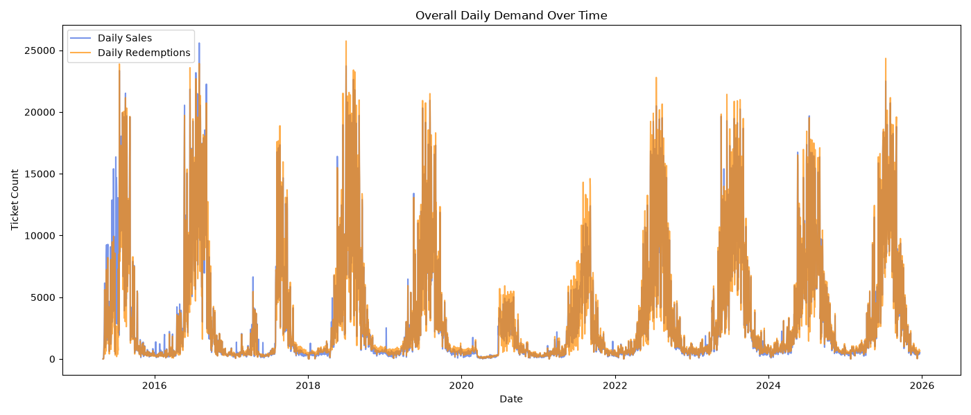
Figure 1. Overall daily demand (sales and redemptions) over time.
Interpretation: Demand is strongly seasonal. Every year shows a dense cluster of high-volume days in the summer, with daily totals frequently between 15,000 and 25,000 tickets, followed by a near-zero baseline through winter. The 2020 season is a marked exception: the pandemic suppressed volumes to a few thousand tickets a day. The 2021 season recovered only partially, and from 2022 onward peaks return to the 17,000–25,000 range. Sales and redemptions overlap almost perfectly at this scale.

3.2 Intraday (Hourly) Patterns
Average ticket volume per 15-minute interval was then examined by hour of day, separately for sales and for redemptions (Figures 2 and 3).
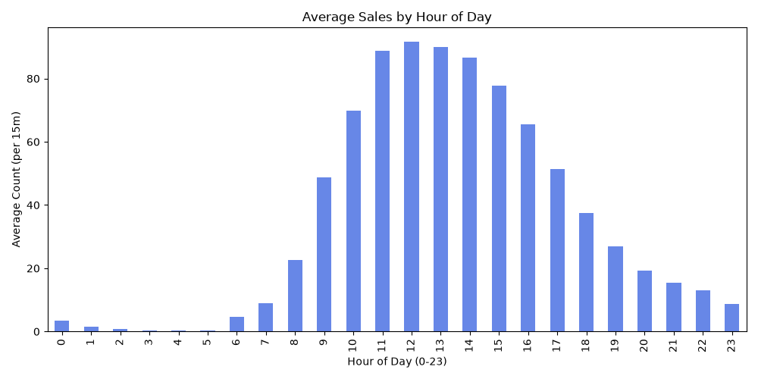
Figure 2. Average ticket sales by hour of day (per 15-minute interval).
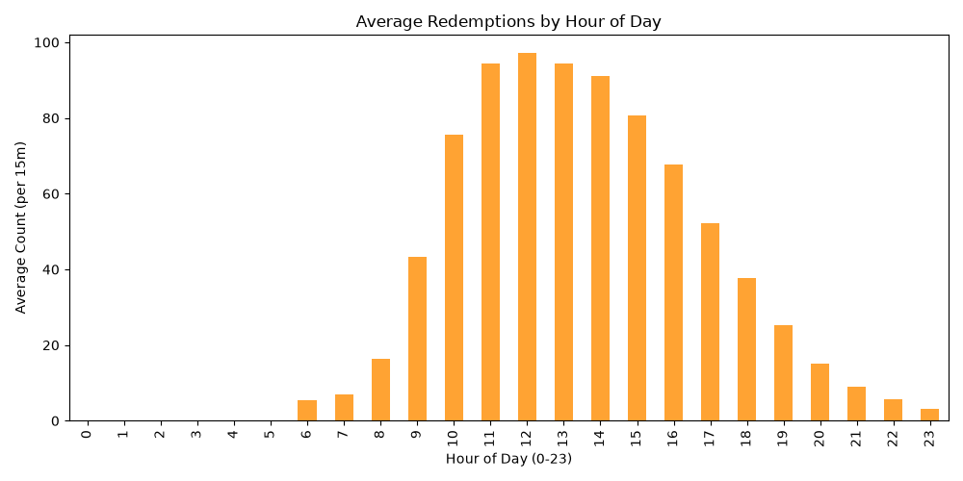
Figure 3. Average ticket redemptions by hour of day (per 15-minute interval).
Interpretation: Both series rise rapidly after about 08:00–09:00, peak between roughly 11:00 and 13:00 at about 90–97 tickets per 15 minutes, and taper off through the late afternoon and evening. Redemptions are essentially zero before 06:00, whereas sales show small non-zero values overnight (hours 0–2 and 21–23). A plausible explanation, not tested here, is that some tickets are bought online ahead of travel and redeemed later at the gate.

3.3 Day-of-Week Effects
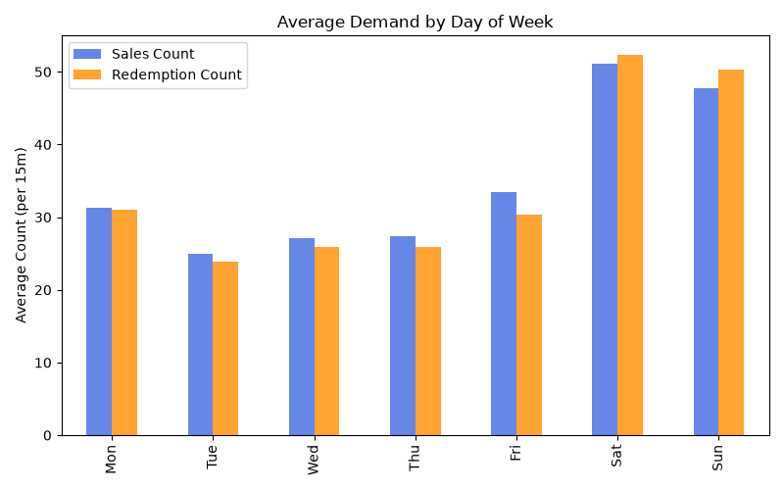
Figure 4. Average demand by day of week (per 15-minute interval).
Interpretation: Utilisation is strongly weighted to the weekend. Saturday averages about 51 sales and 52 redemptions per interval and Sunday about 48 and 50, while Tuesday to Thursday sit near 24–27 and Monday and Friday near 30–33. Weekend volume is therefore roughly 1.6 to 2 times a typical weekday, with the largest gap against Tuesday.

3.4 Peak-Demand Clustering
To understand when the highest operational risk occurs, the 95th percentile of demand was used as the threshold for a “peak” interval, and the hour of day of every peak was counted (Figure 5).
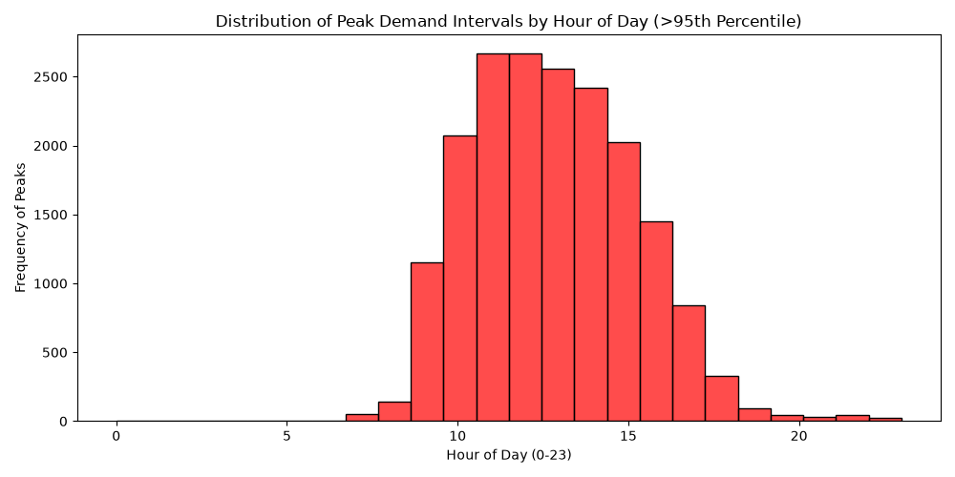
Figure 5. Distribution of peak-demand intervals (above the 95th percentile) by hour of day.
Interpretation: Peaks are overwhelmingly a midday phenomenon. The histogram is highest at 11:00 and 12:00 (about 2,650 peak intervals each), remains above 2,000 through 15:00, and is negligible before 08:00 or after 19:00. Critical congestion risk is therefore concentrated in a window of about four hours.

3.5 Sales–Redemption Relationship
The relationship between tickets sold and tickets redeemed in the same interval was measured with the Pearson correlation coefficient, which ranges from −1 to +1.
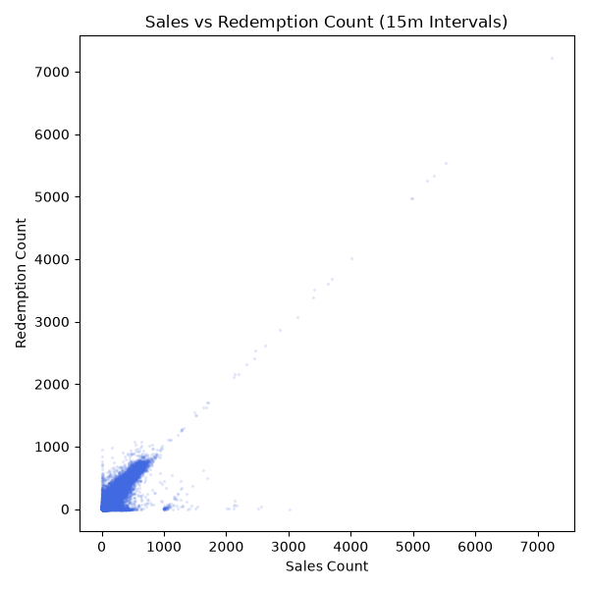
Figure 6. Sales Count versus Redemption Count (15-minute intervals).
Interpretation: The correlation is +0.92, indicating a very strong linear relationship. The dense diagonal band shows that most buyers use their ticket almost immediately, so “walk-up” volume drives gate congestion. A few points lie far off the diagonal (for example, around 1,000–3,000 sales with near-zero redemptions), which look like data-recording or system events rather than true demand and are worth investigating.

3.6 Rolling Momentum
Rolling averages over 1 hour (4 intervals), 2 hours and 1 day were applied to the series. Figure 7 shows a sample summer slice (July 2023).
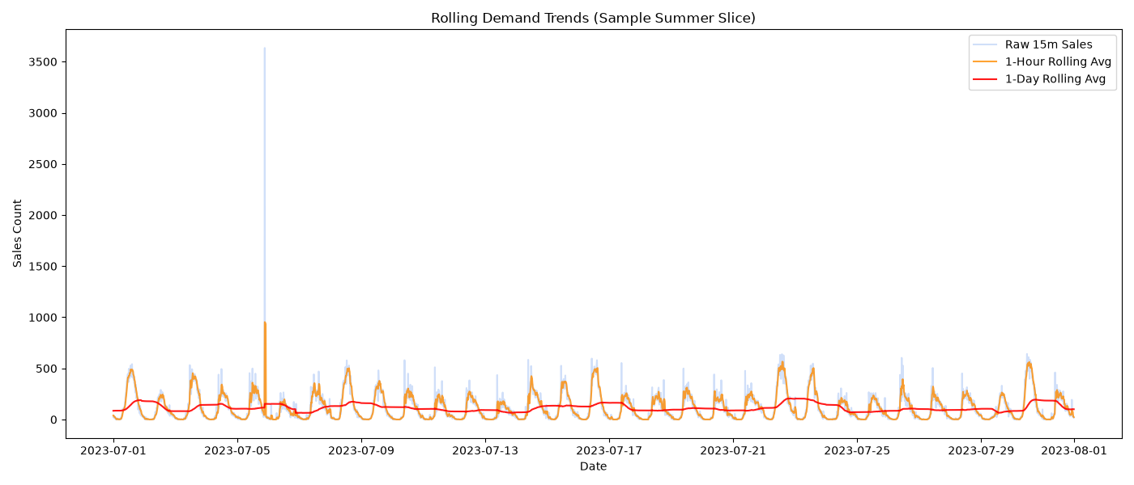
Figure 7. Rolling demand trends for July 2023: raw 15-minute sales, 1-hour and 1-day rolling averages.
Interpretation: Each day shows a clear bell-shaped surge, and the 1-hour average follows the raw series closely while smoothing single-interval noise. Spikes are generally part of a sustained one-to-two-hour wave rather than isolated events, which is what makes short-horizon forecasting feasible. The one-day average moves slowly and separates busy days from quiet ones. The very large spike near 6 July 2023 (over 3,500 sales in one interval) is an extreme outlier and is the kind of event a model cannot be expected to anticipate.

4. Feature Engineering
Once EDA was complete, the unneeded columns of the resampled data frame were dropped, and an autoregressive feature function was written to prepare the model inputs. The result was saved as engineered_ferry.csv in the processed-data folder. Three families of features were built to encode the patterns found in Section 3.
Table 3. Engineered features
Feature family | Features | Motivation (EDA link)
Temporal encodings | Hour of day, day of week, month, weekend flag | Seasonality, intraday and weekend effects (Figs 1–3)
Lag features | t−1, t−2, t−4, t−8 (15 min, 30 min, 1 h, 2 h earlier) | Recent demand predicts near-term demand (Fig 7)
Rolling statistics | 1-hour and 2-hour rolling mean and standard deviation | Crowd momentum and volatility

Avoiding target leakage. Rolling statistics were computed on shifted data, meaning the window ends at the previous interval. This ensures the model never sees the value it is trying to predict, so reported accuracy reflects what is achievable in live use.

5. Predictive Modelling and Evaluation

5.1 Experimental Design
Six models were evaluated using a chronological train-test split, so that models are trained on the past and tested on the future, as in real deployment. Random shuffling was deliberately avoided, since it would leak future information. Two metrics were reported:
- MAE (Mean Absolute Error): the average size of the error, in tickets per 15 minutes. It reflects typical day-to-day accuracy.
- RMSE (Root Mean Squared Error): penalises large errors more heavily, and so reflects performance during surges.

5.2 Models Compared
The candidate set spans simple baselines, classical statistical models and machine-learning models: a Naïve baseline (next value equals the last value), a 1-hour Moving Average, SARIMA, Facebook Prophet, Random Forest and XGBoost.

5.3 Benchmark Results
Table 4. Model performance on the held-out test set (lower is better)
Model | MAE | RMSE
SARIMA | 50.16 | 112.54
Facebook Prophet | 40.45 | 81.32
Naïve Baseline (t−1) | 21.42 | 86.27
Moving Average Baseline (1H) | 19.49 | 69.75
Random Forest | 17.39 | 63.25
XGBoost (baseline) | 16.90 | 63.02
XGBoost (optimised) | 16.90 | 62.49

Why the statistical models struggled. SARIMA and Prophet scored worse than the simple Naïve baseline. These methods assume smooth, regular oscillations, whereas 15-minute ferry data consists of long runs of near-zero activity broken by sudden, large surges. The ML models, which can use lag and rolling features directly, adapt much better. Prophet’s MAE of 40.45 is about 2.4 times XGBoost’s.

5.4 Visual Comparison on a 48-Hour Test Slice
To see the differences concretely, forecasts were plotted against actual sales for a 48-hour slice of the test period (23–26 December). Note that this is a winter, low-demand window; the line segments that look straight and flat are gaps where the ferry was not operating and no data exist.
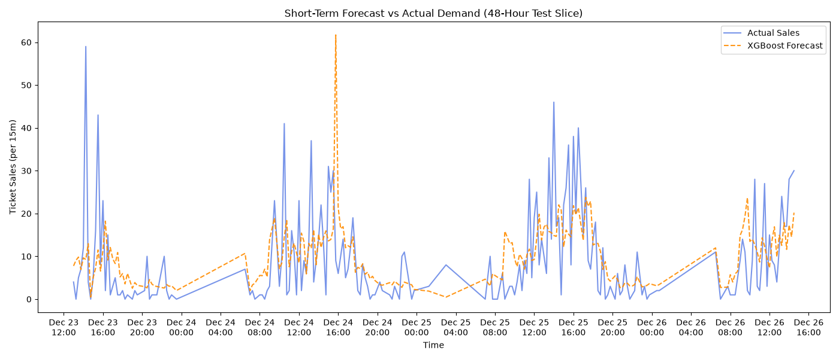
Figure 8. XGBoost forecast versus actual ticket sales on a 48-hour test slice.
Interpretation: The XGBoost forecast follows the general level and rhythm of demand, rising in the late morning and falling in the evening. It tends to smooth individual spikes, however: it underestimates the largest isolated bursts (for example, an actual value near 59 on 23 December) and also produces one over-prediction (about 62 against an actual value near 30 on 24 December afternoon). This behaviour is typical of models optimised for average error, and it is the reason why a confidence band is provided alongside the point forecast.
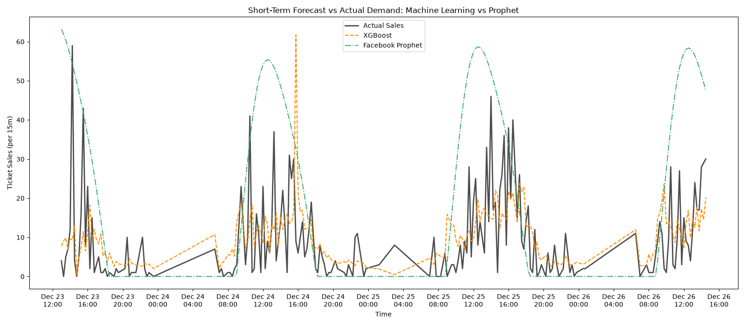
Figure 9. Machine learning (XGBoost) versus Facebook Prophet against actual sales.
Interpretation: Prophet produces a smooth daily curve that predicts demand peaks of 55–65 tickets on every day, even on winter days when actual demand is far lower. It cannot respond to the current conditions. XGBoost, which uses recent lags, adjusts to the real level of activity. This visual explains the large gap in MAE between the two approaches in Table 4.

5.5 Hyperparameter Optimisation
Because XGBoost performed best at capturing non-linear surges, it was tuned with RandomizedSearchCV combined with TimeSeriesSplit. Time-series cross-validation preserves chronological order in every fold. In total, 20 parameter combinations were tried across 3 folds, giving 60 model fits.
Table 5. Optimal XGBoost hyperparameters
Parameter | Value | Role
n_estimators | 500 | Number of boosted trees
max_depth | 5 | Maximum depth of each tree
learning_rate | 0.01 | Step size; small values learn slowly but generalise better
subsample | 0.8 | Fraction of rows used per tree
colsample_bytree | 0.7 | Fraction of features used per tree
min_child_weight | 3 | Minimum weight in a leaf; limits overfitting

The optimised model kept an MAE of 16.90 and lowered RMSE slightly from 63.02 to 62.49. The MAE gain over the baseline XGBoost was only 0.01, which shows that the default model was already close to the best achievable with this feature set, and that further improvement is more likely to come from new features than from more tuning.

5.6 Interpreting the Error Levels
An MAE of 16.90 is substantially lower than every other model, but it should be read in context. The average demand per interval is about 25–50 tickets (Figure 4), so the typical error is a meaningful fraction of normal volume. The RMSE is almost four times the MAE, which tells us that most errors are small but a minority, concentrated in rare surges such as the July 2023 outlier, are very large. Both numbers should be considered when planning operations.

6. Operational Deployment
The optimised XGBoost model and its feature pipeline were serialised with joblib and embedded in a Streamlit web application. The dashboard turns the model’s output into information that a gate manager can act on in seconds.
Table 6. Dashboard capabilities
Capability | Description
Forecast horizons | Predictions from the next 15 minutes up to 2 hours ahead
Confidence intervals | A 95% band computed from the model RMSE, used to estimate the “Worst-Case Peak Risk” for each interval
Automated readiness | Forecasts translated to directives: NORMAL (green), ELEVATED (yellow) or CRITICAL (red, deploy the secondary ferry)

A note on the confidence band: because it uses an RMSE of roughly 62, a 95% band (about ±1.96 × RMSE) is very wide, around ±120 tickets. This is cautious, and is useful for flagging worst-case risk, but it may trigger alerts too often during quiet periods. Section 8 suggests a refinement.

7. Strategic Recommendations

7.1 Protect the Midday Window
Demand ramps up from about 09:00 and peaks at 11:00–13:00 (Figures 2–5). Staff shift changes and lunch breaks should not be scheduled between 10:30 and 13:00, particularly on weekends, when volumes are the highest (Figure 4).

7.2 Deploy the Dashboard to Gate Managers
The dashboard should be mounted on a tablet at the main gate. Decisions should shift from reacting to the visible queue towards acting on the 1-hour forecast, since the queue is the late signal of a surge that the model sees earlier.

7.3 Act on the Upper Confidence Bound
When the 95% upper bound crosses terminal or vessel capacity, secondary ferry crews should be put on standby immediately. The +0.92 sales–redemption correlation (Figure 6) shows that tickets sold now become gate volume within about 15 minutes, so the lead time is short and a standby crew costs far less than a delayed response.

7.4 Smooth Peaks with Incentives
Consider dynamic pricing or targeted promotions for weekend departures before 10:00 or after 15:00, aiming to move some of the walk-up volume out of the 11:00–13:00 peak. A small pilot with measurement would show how price-sensitive demand is before wider rollout.

7.5 Review Data Anomalies
The off-diagonal points in Figure 6 and the extreme spike in Figure 7 should be reviewed with the ticketing-system owners. If they are system artefacts, filtering them from the training data would likely lower RMSE.

8. Limitations and Future Work
- Under-prediction of extreme surges. The model smooths isolated spikes (Figure 8). Quantile regression or models trained on peak events specifically could improve the upper tail.
- No external drivers. Weather, public holidays, events and ferry schedule/capacity were not used. These are likely to explain much of the unexplained variance, especially for summer weekends.
- Confidence band method. Using one global RMSE gives the same width in all conditions. Quantile or conformal prediction intervals that vary with demand level would be tighter at night and in winter.
- Pandemic-era data. The 2020–2021 seasons are structurally different (Figure 1); testing with and without them would show their effect on accuracy.
- Evaluation window. Visual checks used a winter slice. A summer-peak evaluation, reported separately, would show how the model performs where operational risk is the highest.
- Further models. LightGBM, LSTM or temporal-fusion networks may be tested against the XGBoost baseline using the same split.

9. Conclusion
This project showed that a decade of ferry ticket data can support practical short-term demand forecasting. A clean, 15-minute dataset exposed strong seasonal, weekly and midday structure, with a sales–redemption correlation of +0.92 confirming that walk-up passengers drive gate congestion. Using lag and rolling features, a tuned XGBoost model reached an MAE of 16.90 tickets per interval, clearly better than SARIMA (50.16), Prophet (40.45) and the naïve baseline (21.42). Deployed through a Streamlit dashboard with confidence bands and traffic-light alerts, it gives operations a way to anticipate congestion rather than react to it. The next phase of work should add external drivers, improve the handling of extreme surges and refine the uncertainty estimates.

Appendix A. Reproducibility Summary
Table 7. Key artefacts and settings
Item | Detail
Time resolution | 15-minute intervals (4 per hour)
Target variable | Ticket Sales Count per interval
Lag steps | t−1, t−2, t−4, t−8
Rolling windows | 1 hour and 2 hours (mean and standard deviation, on shifted data)
Validation | Chronological split; TimeSeriesSplit with 3 folds
Search | RandomizedSearchCV, 20 candidates × 3 folds = 60 fits
Final model | XGBoost, MAE 16.90, RMSE 62.49
Serialisation | joblib (model and feature pipeline)
Deployment | Streamlit dashboard

