PROJECT:
Movie Booking System

Group members:

Faculty Name | SIR Susheel
Batch : | 2308a01
Group : | Student Attendance Data Analiys
Serial No. | Student ID. | Student Name.
1. | 1510011 | SHEIKH HUZAIFA FAROOQI
2. | 1500814 | YASHAB GAUHAR
3. | 1353144 | MUHAMMAD WAHIB
4. | 1486786 | MUHAMMAD HAMZA
5. | 1486784 | MUHAMMAD MAAZ

Acknowledgement
We would like to express our sincere gratitude to our respected teacher, Sir Susheel, for his valuable guidance, continuous support, and encouragement throughout the development of this project. His insightful suggestions and motivation helped us complete this project successfully within the given time frame.
We are also thankful to the e-project team at Aptech Head Office for providing us with the opportunity to work on this informative and innovative project, EduPredict. Their support and resources greatly contributed to the successful completion of this project.
Task Sheet
Project |  | Project Title | Date Of preparation Of Activity Plan
No. | Task |  | Actual  Start Date | Actual Days | Team-Mate  Name | Status
01. | Template Integrate |  | 2  7  -  A  P  R  -  2  0  2  6 | 3  0  -  D  A  Y  S  - | YASHAB
02. | Login and Registration Page |  |  |  | WAHIB
03. | Admin Dashboard |  |  |  | HUZAIFA
04. | Documentation |  |  |  | HAMZA

Problem Statement

Introduction : –

Education institutions worldwide face numerous challenges, such as declining student retention
rates, inefficient resource allocation, and the need to personalize learning experiences. At the
same time, advancements in technology and data availability present significant opportunities
to address these challenges through data-driven approaches.
By leveraging the capabilities of Hadoop and predictive analytics, EduPredict aims to overcome
these challenges, capitalize on data-driven opportunities, and ultimately enhance the
educational experience for the students.
Proposed Solution : –
EduPredict is a web-based educational analytics system designed to help educational institutions improve student performance, increase retention rates, and optimize resource allocation through predictive analytics and big data technologies.
The system leverages the power of Hadoop and data-driven analysis to collect, process, and analyze large volumes of student-related data such as attendance records, academic performance, assignment submissions, examination results, and learning activities.
Using predictive analytics techniques, EduPredict can identify students who are at risk of poor academic performance or dropping out. This allows teachers and administrators to take early actions and provide personalized support to improve student success.
The platform also helps institutions make better decisions regarding resource management by analyzing trends and patterns in student behavior and academic outcomes. Administrators can monitor overall institutional performance through interactive dashboards and reports.
System Users: –

1. Students / Registered Users
Students are the primary users of the EduPredict system. They can access the portal to monitor their academic performance and receive personalized learning insights.

Roles of Students / Registered Users:
- Students need to register and log in to access the system.
- Students can view their academic performance, attendance records, and progress reports.
- Students can receive personalized learning recommendations based on predictive analytics.
- Students can track assignment submissions, quiz results, and examination performance.
- Students can identify areas where improvement is needed through performance analysis.
- Students can access educational resources and learning support materials recommended by the system.

2. Admin / Educational Institution Management
The admin is responsible for managing and maintaining the EduPredict portal and monitoring institutional performance.

Roles of Admin:
- Admin acts as the main authority of the system.
- Admin can add, edit, and manage student records and academic data.
- Admin can monitor student performance and retention statistics.
- Admin can analyze predictive reports generated by the system.
- Admin can manage courses, departments, and faculty information.
- Admin can track students who are at risk of poor performance or dropping out.
- Admin can generate institutional reports for better decision-making.
- Admin can manage system users and monitor portal activities.

EduPredict System Features
- User Registration and Login System.
- Student Performance Monitoring.
- Attendance Tracking and Analysis.
- Predictive Analytics for Student Success and Retention.
- Early Identification of At-Risk Students.
- Personalized Learning Recommendations.
- Big Data Processing using Hadoop.
- Interactive Dashboard for Students and Admin.
- Report Generation and Data Visualization.
- Course and Academic Record Management.
- Secure Data Storage and Management.
- Admin Dashboard for Institutional Monitoring.
- Performance Trends and Analytical Insights.
- Scalable system for handling large educational datasets.

ADMIN PANNEL:
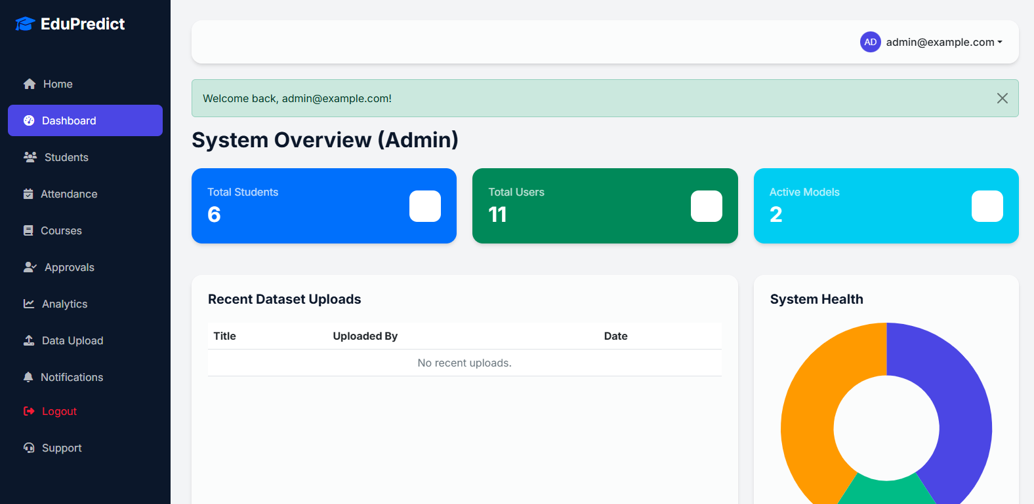

STUDENT MANAGEMENT:
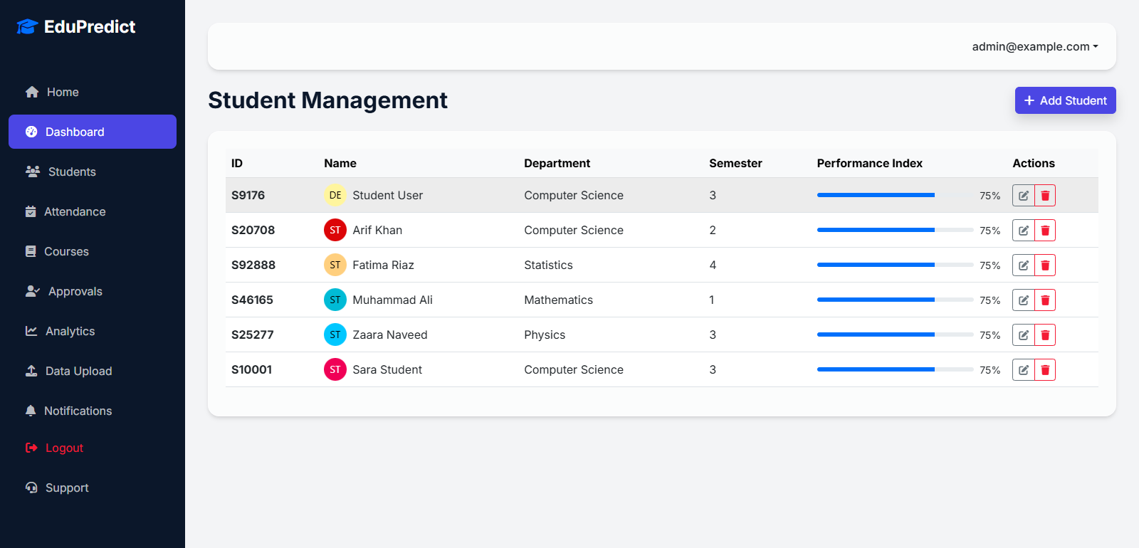

ATTENDANCE TRACKING:
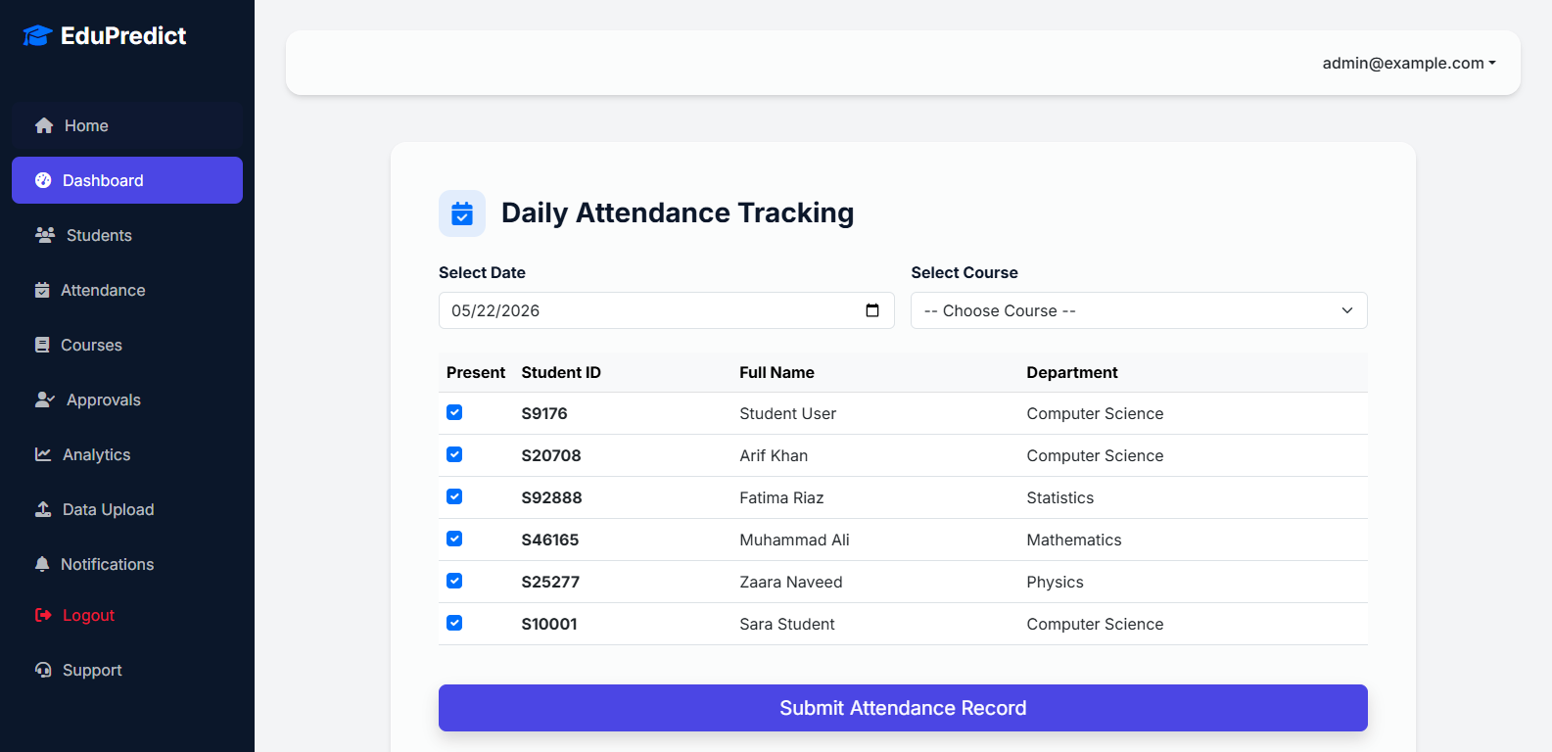

COURSE MANAGEMENT:
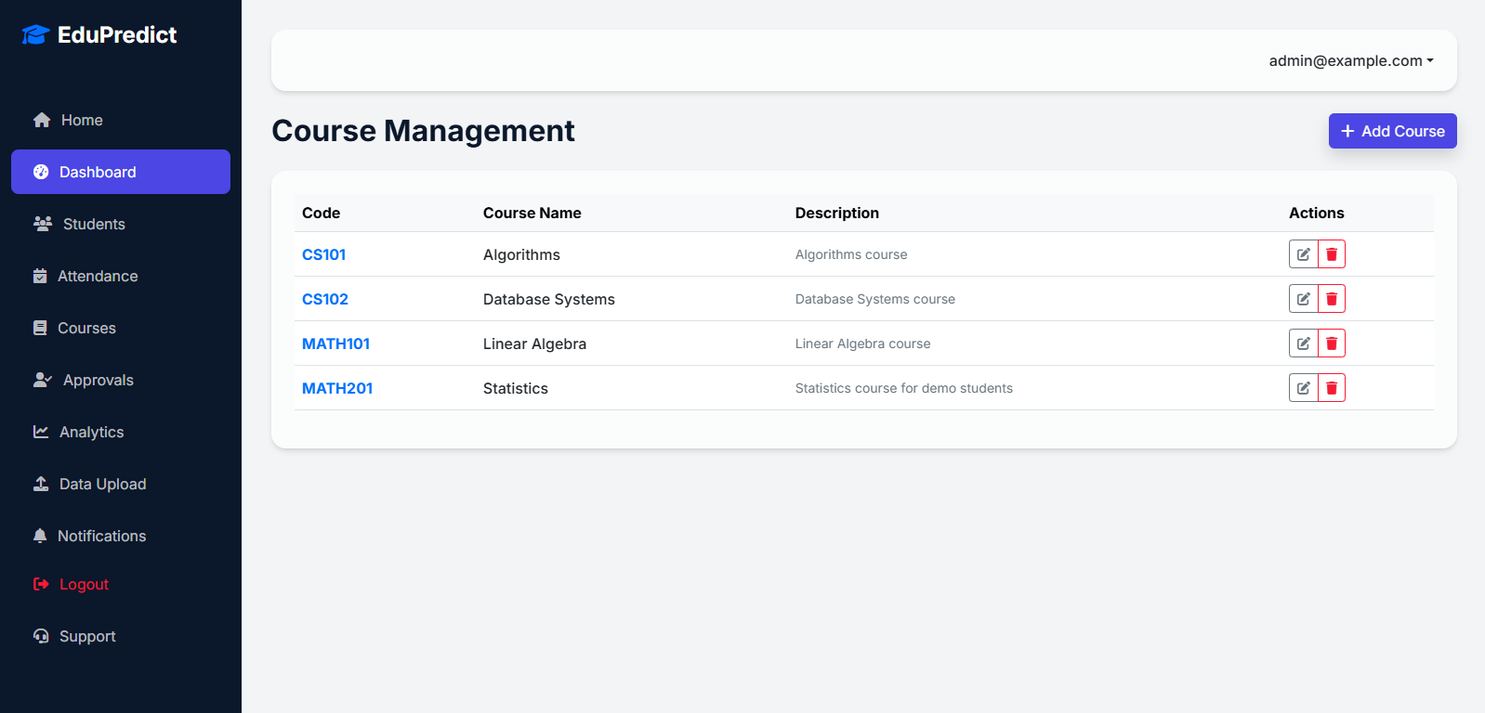

APPROVALS:
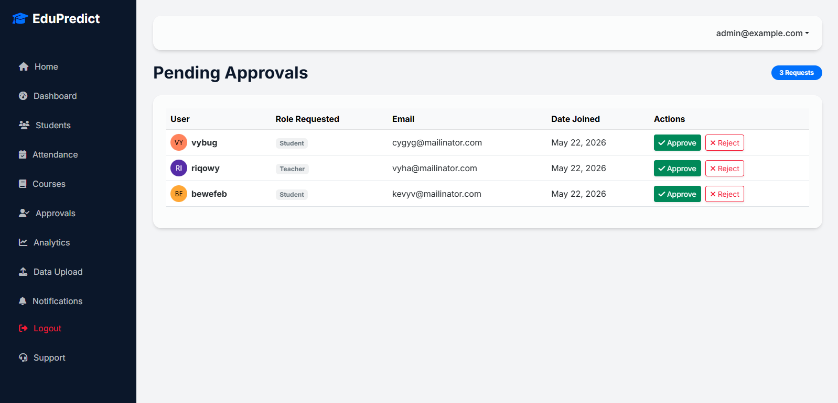

STUDENT ANALYSIS:
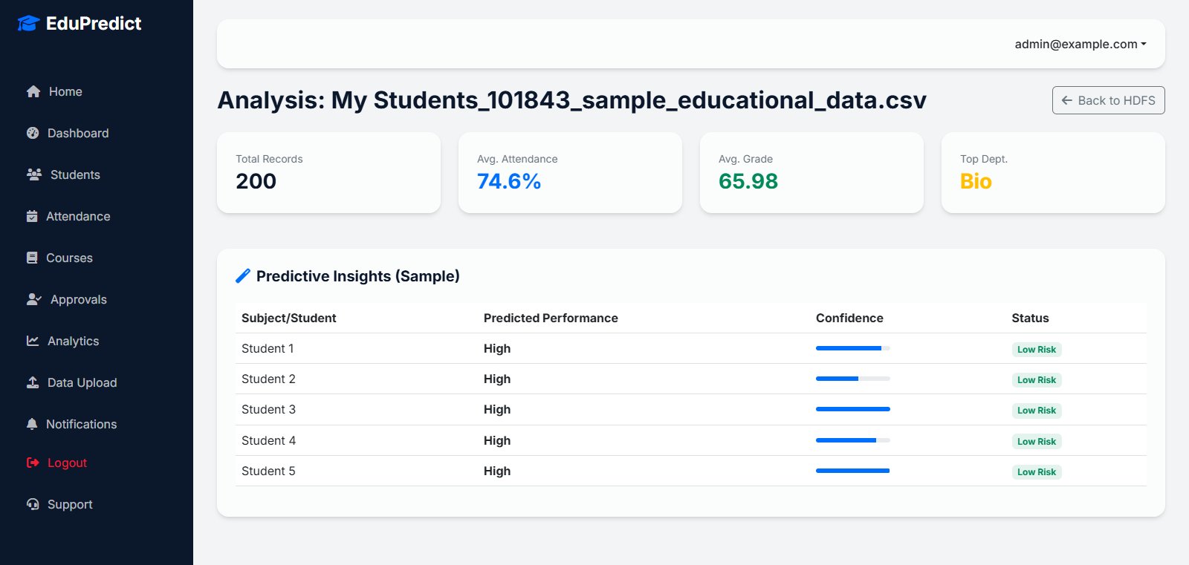

DATA INGESTION
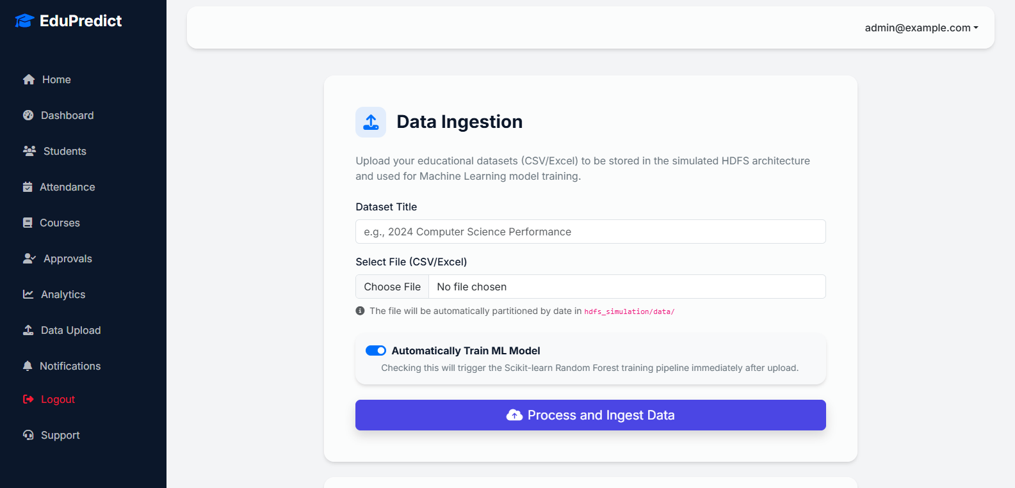

NOTIFICATIONS:
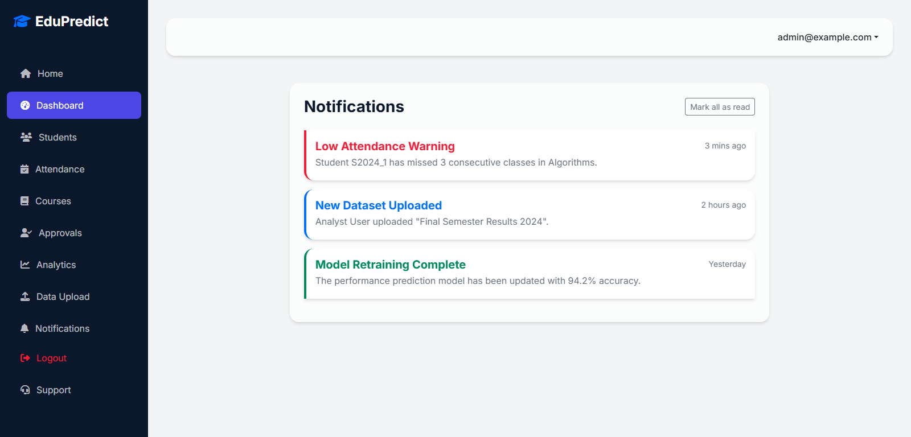

SIGN IN:
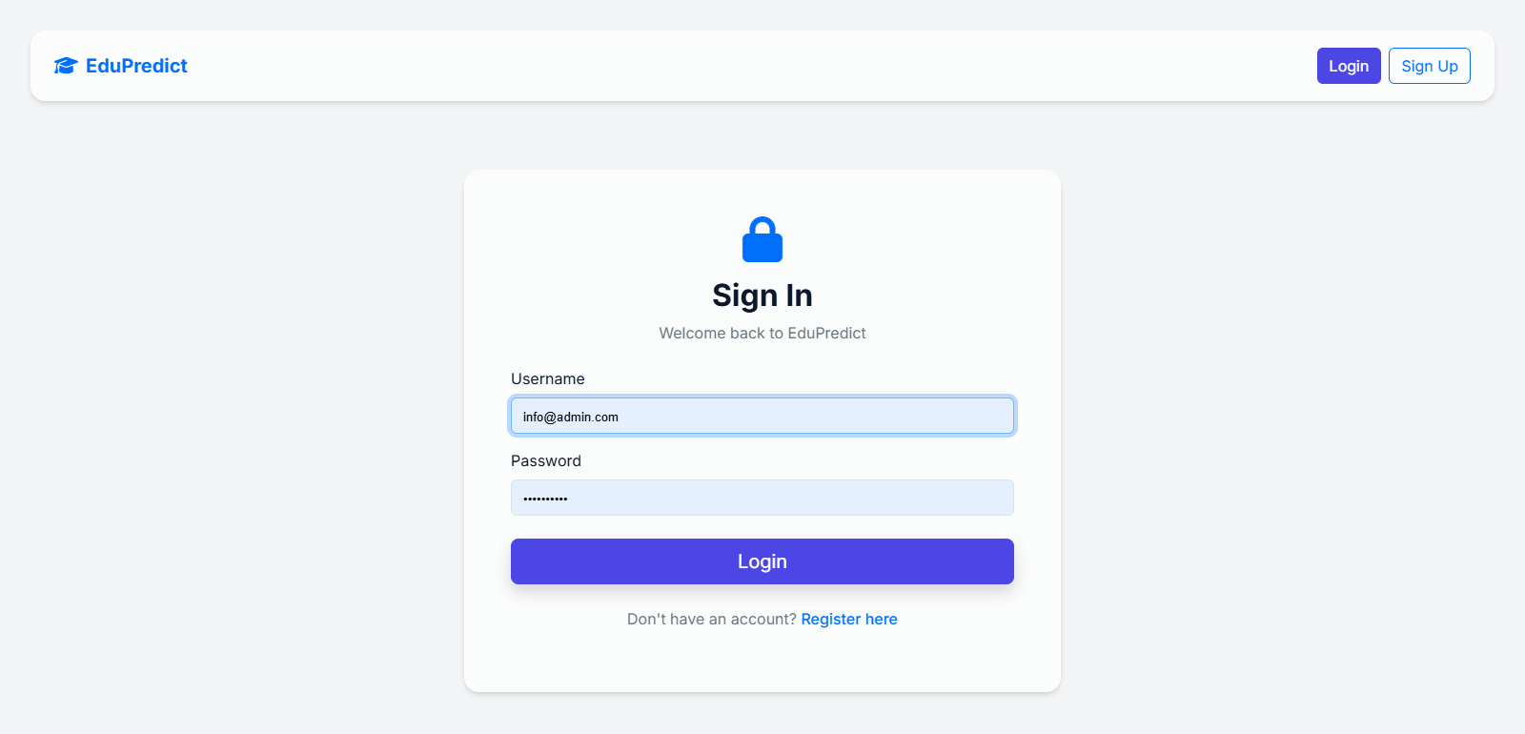

SIGNUP:
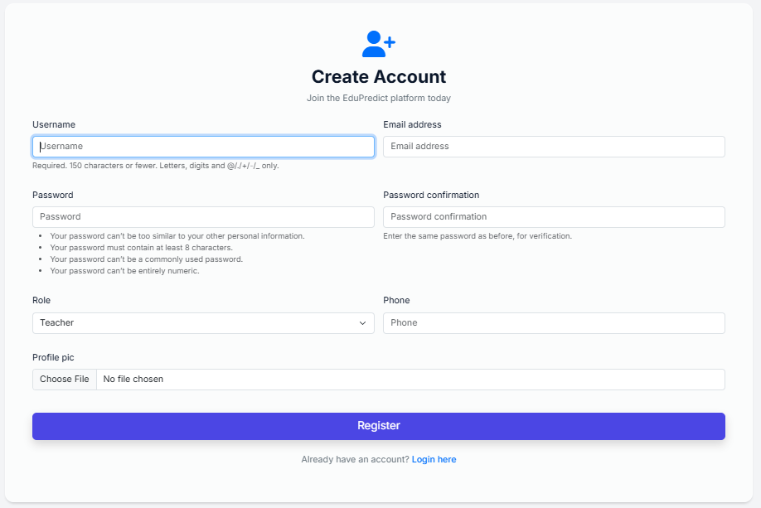

TEACHER DASHBOARD:
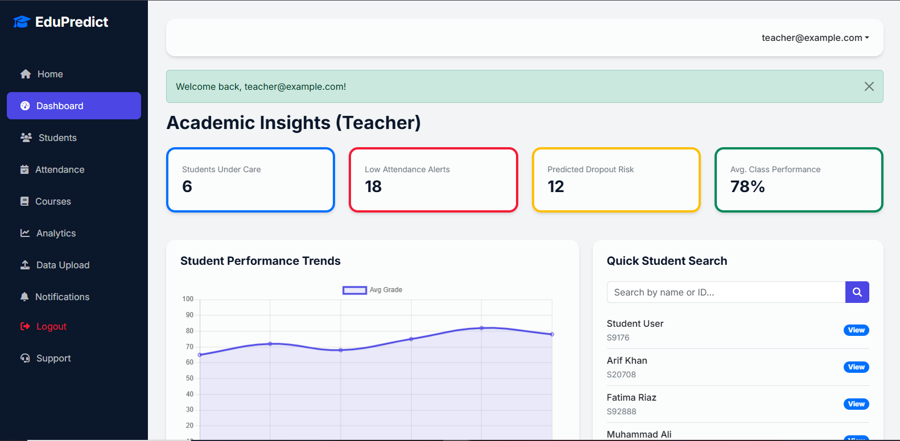
STUDENT DASHBOARD:
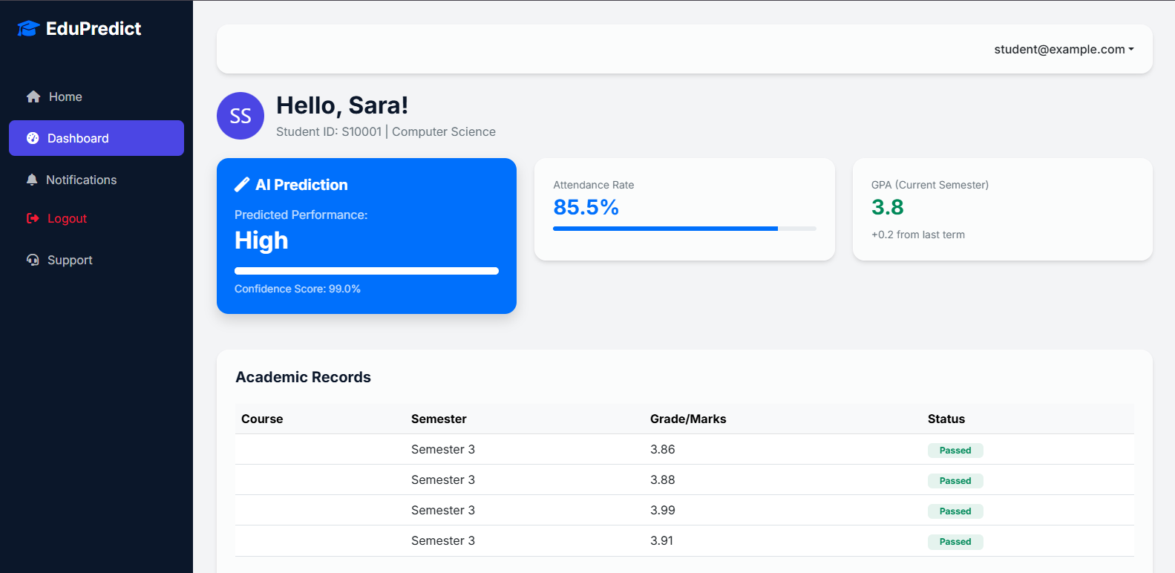

Big Data Insights (Analyst) DASHBOARD:

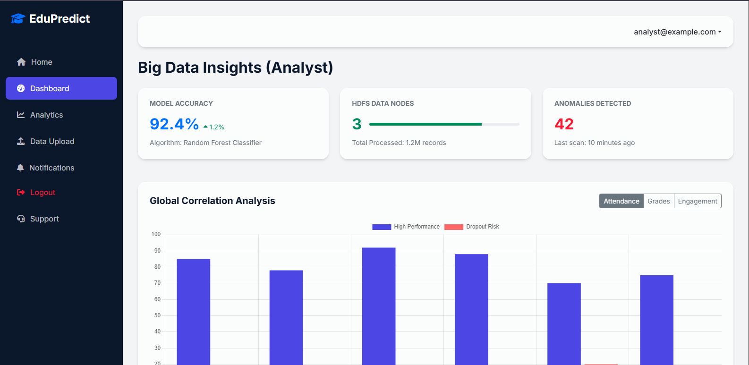

HOME PAGE:

