Create a word document that contains Question wise answer and chart for your findings.

1. CREATE A BAR CHART (10 PTS)

Which Region has the highest Revenue?

**Ans) West**

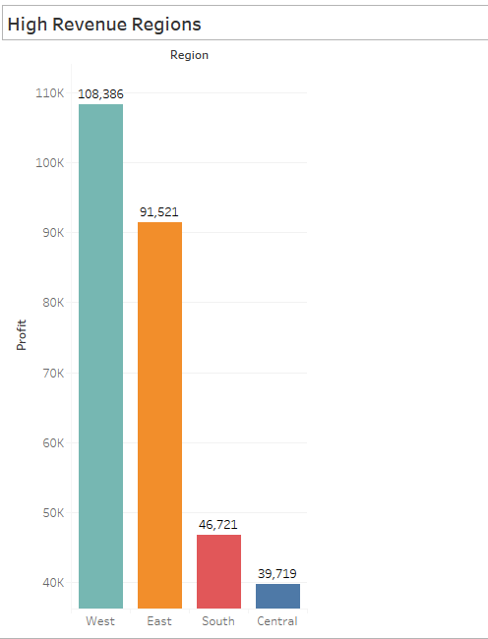

What is the lowest Revenue generating Sub-Category in above Region? – (Filter Down)

**Ans) Bookcases**

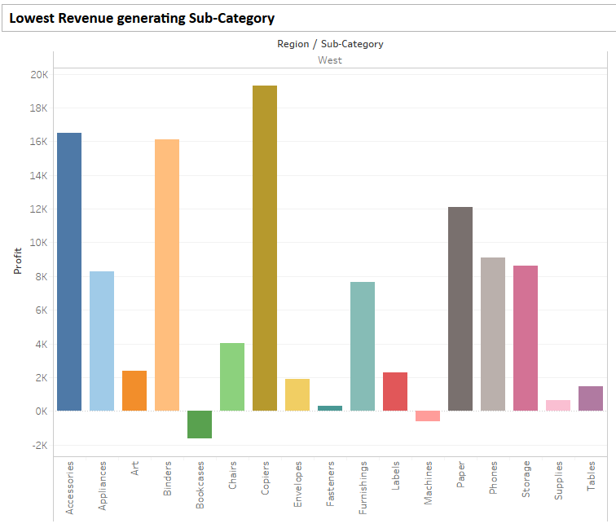

Which Manufacturer has the highest share of Revenue in the above Sub-Category? – (Filter Down)

**Ans) Rush**

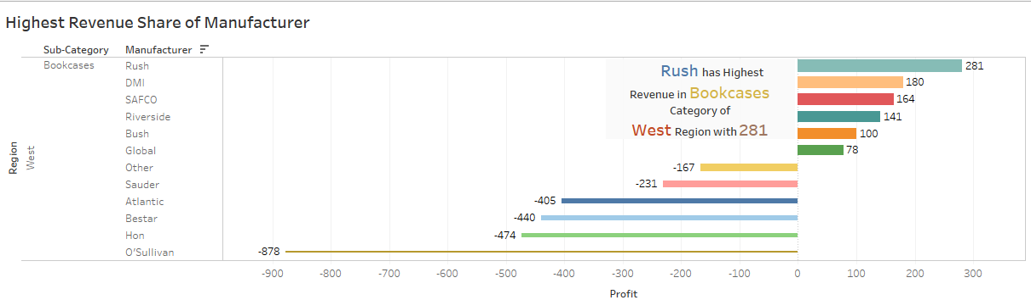

2. CREATE A DRILL DOWN TEXT TABLE (10 PTS)

Which Category in the West Region generates the lowest Profit?

**Ans) Furniture**

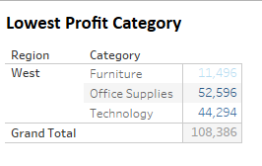

Which Sub-Category in Technology Produces the highest Profit?

**Ans) Copiers**

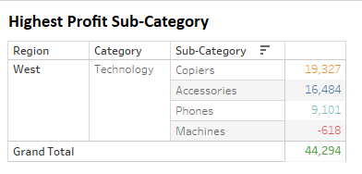

1. CREATE A SCATTER PLOT (10 PTS)
2. Reveal the order with the highest Profit and Revenue combination?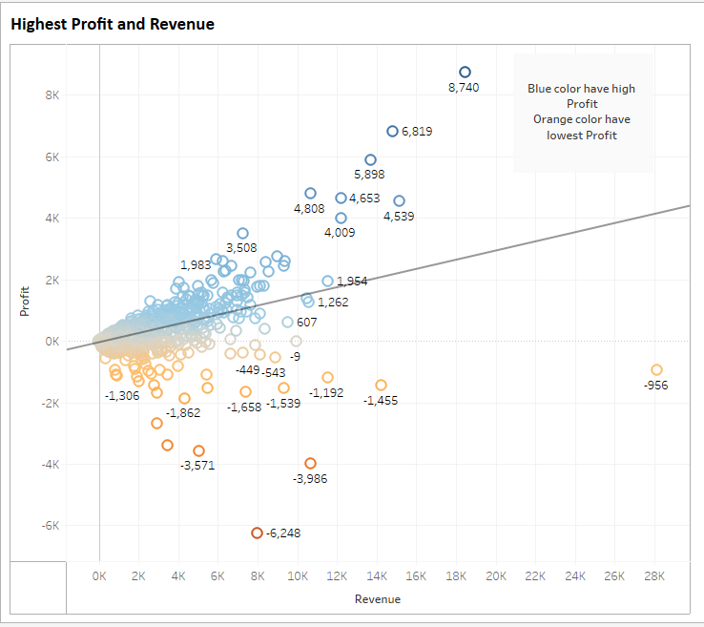

Is there a correlation between profit and discount?

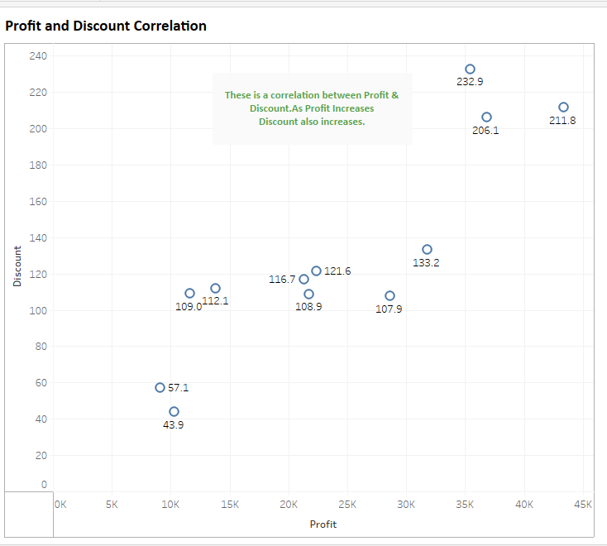

4. CREATE A DONUT CHART (10 PTS)

- Now create a group from Sub-Category called “Category Custom”

- Furniture --> Bookcases,Chairs,Furnishings

- Office Supplies --> Appliances,Art,Binders,Envelopes,Fasteners,Labels,Paper

- Technology --> Accessories,Copiers,Machines

- Remaining classified as Others Automatically.

Which “Category Custom” has the contributes the most to revenue?

**Ans) Others**

Can you show the total revenue in the center of donut?

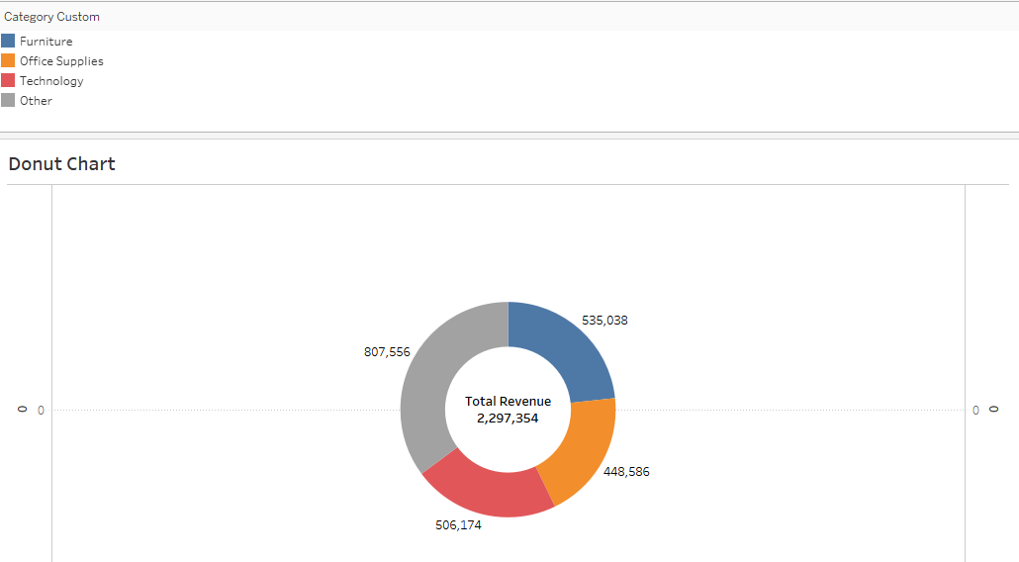

5. CREATE A HIGHLIGHT TABLE (10 PTS)

-Visually highlight with colors the most loss making manufacturer in the Central Region’s Office Supplies Segment in Technology Category in 2018?

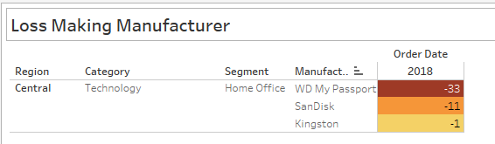

Answer the above question for South Region via showing filters (drop down style)

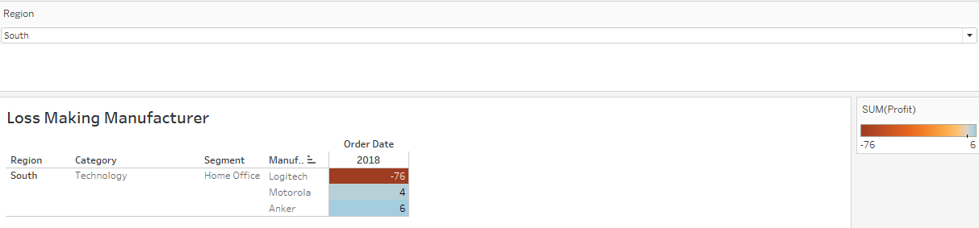

6. CREATE A HISTOGRAM (10 PTS)

Visualize order quantity histogram for each Category Remember to keep bin size “1”

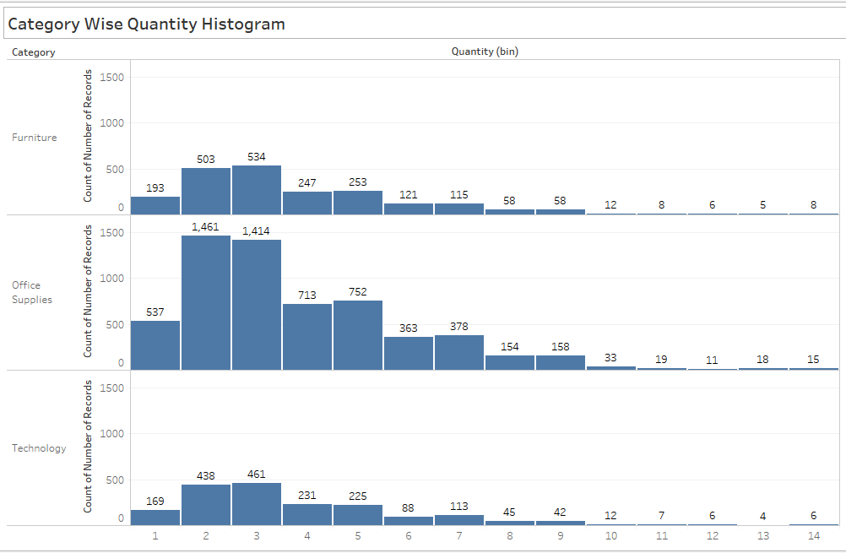

In above chart can you tell what order quantity size is the highest and belongs to which category?

**Ans) Office Supplies Category have highest 1461 counts having quantity of 2 Items.**

7. CREATE A LINE CHART (10 PTS)

Show the profitability over the period. Which year was the highest profit making?

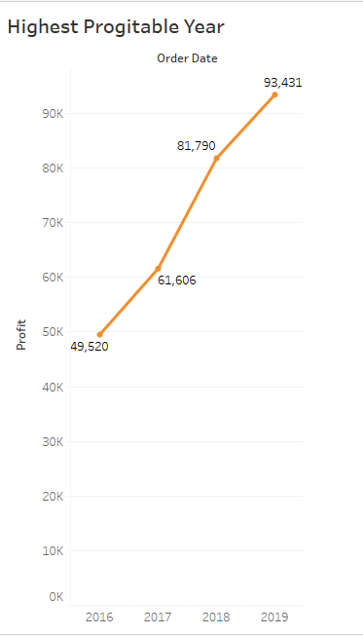

**Ans) 2019 was Highest profitable Year**

Can you tell by category which Sub-Category has seen the declining Profitability trend over the years?

Ans) In Furniture Table Sub-Category is declining in Profit.

In Office Supplies Supplies Sub-Category us declining in Profit.

In Technology Machine Sub-Category is declining in Profit.

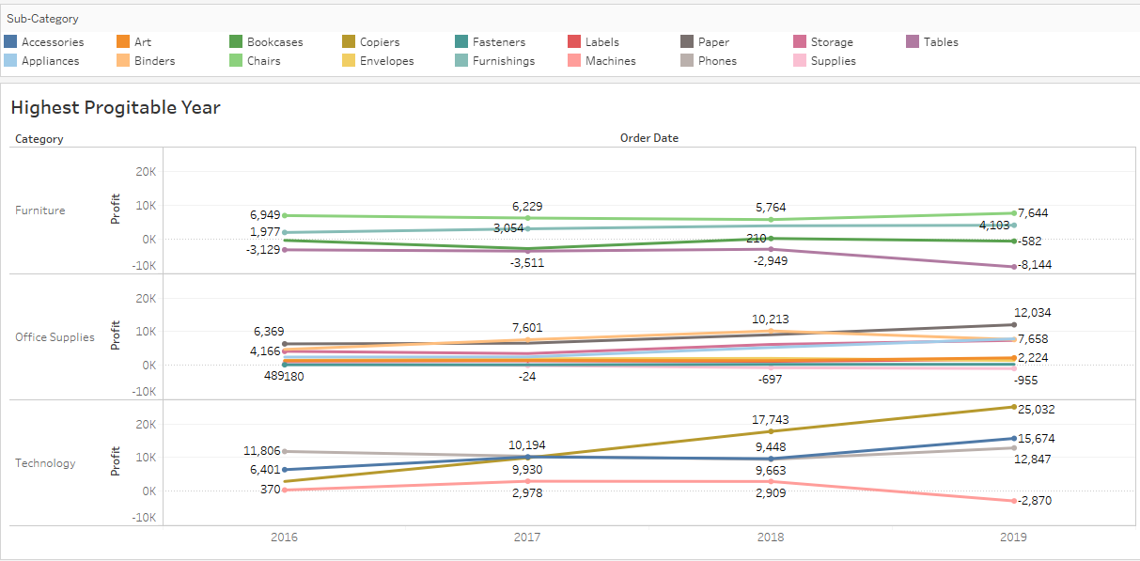

8. CREATE A GEOGRAPHICAL MAP (10 PTS)

Can you show up the top 3 most profitable country on the map? And name the 1 of the most lost making country.

Ans) Washington , California and New York makes highest Profit.

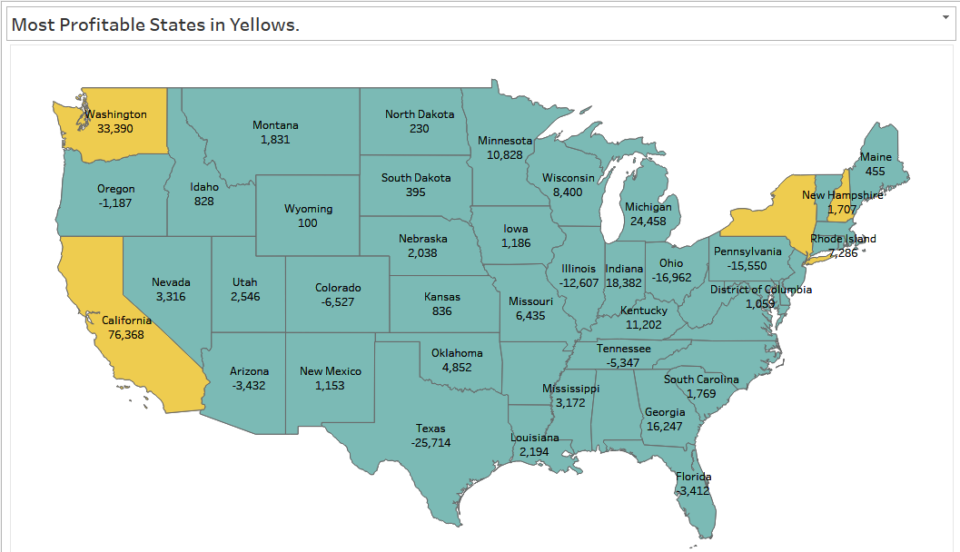

Drill down to state level and provide the name of most lost making state from the above lost making country.

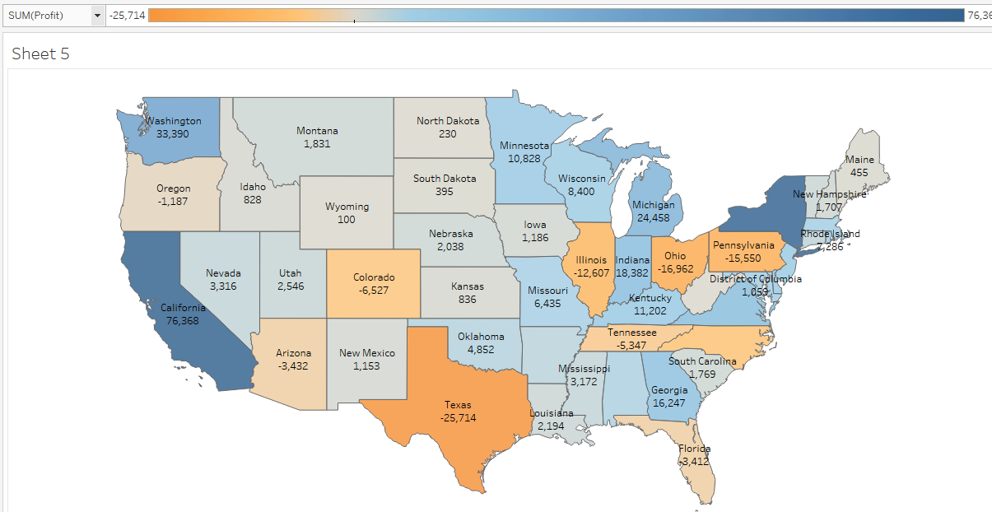

Ans) Texas is Most lost Making State.

9. CREATE A TREEMAP (10 PTS)

In a heatmap, uncover the highest profit making category over the years.

Ans) Technology is the most Technology Category over the Years

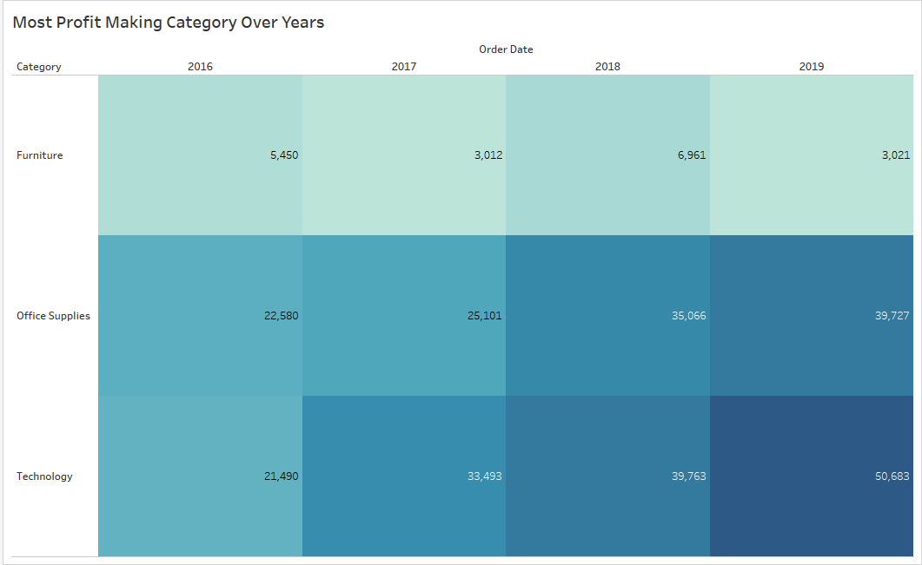

Explore the highest contribution maker product from above category.

Ans) Canon ImageCLASS 2200 Advanced Copier

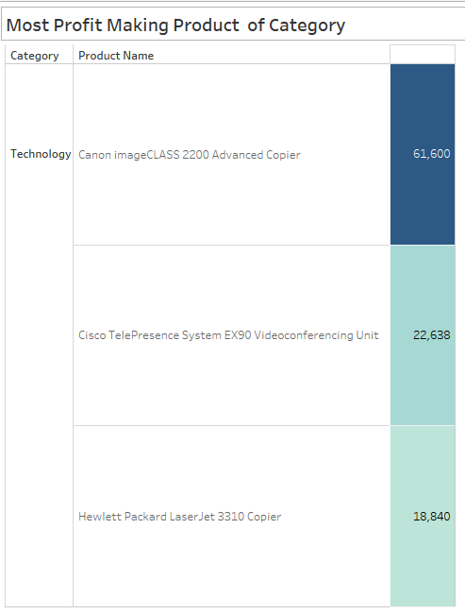

10. Presentation and Formatting Document (10 PTS)