

**Resume**

Of

**Md. Nazmul Hossain Robiul**

**Mobile : +8801779481336**

E-mail: hasanmohammadnazmul49@gmail.com

**Career Objective :**

To archive a challenging position in Company and to use my technical communication and interpersonal skills for the growth of the organization.

**Career Summary :**

* An enthusiastic fresher with highly motivated and leadership skills having of Diploma in Power Engineering.
* Motivation to Hard Working attitude for Technological Jobs.
* Eager to learn new technologies and methodologies.
* Always willing to innovate the new things which can improve the existing technology.

**Special Qualifications :**

* Highly motivated and eager to learn new things.
* Strong motivational and leadership skills.
* Ability to produce best result in pressure situation.
* Excellent communication skills.
* Ability to work as individual as well as in group.

**Educational Qualifications**

* **Diploma in Engineering**

Institution : Pabna Polytechnic Institute, Pabna

CGPA : 3.45

Year : 2021

Board : Bangladesh Technical Education Board Dhaka

Technology : Power Technology

Duration of Study : 4 Years

* **Secondary School Certificate(SSC)**

Institution : Bera High School, Bera, Pabna

Group : Business Studies

GPA : 4.18 (Out of 5.00)

Year : 2017

Board : Rajshahi

* **Training Summary:**

Institution : Ranks Motors workshop limited

Training Title : The Industrial Attachment Training Programme

Year : 2021

Duration : 3 Month

**Computer Skill**

* Operating System : Windows XP, Windows Vista,Windows 7.Windows 8 Windows 10
* Application  **:** MS Word, MS Excel, Power Point

**Personal Information :**

* Name : Md. Nazmul Hossain Robiul
* Father’s Name : Late. Abdul Mannan
* Mother’s Name : Mst. Rubia Khatun
* Permanent Address : Village- Shumvopur, P.O- Bera, P.S.- Bera, Dist.- Pabna
* Nationality : Bangladeshi by birth
* Date of Birth : 11-11-2001
* Sex : Male
* Marital status : Single
* Religion : Islam
* Height : 5.5 Inc

**Experience :**

Name of Company : Northen Tosrifa Group, Tosrifa Industrial Limited

Post : Sub- Assistant Engineer (till now)

6 month Experience Northen Tosrifa Group, Tosrifa Industrial Limited.

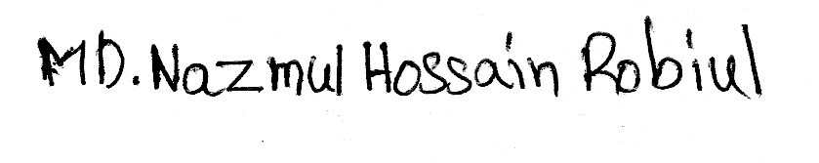

**Date :**  **Signature**