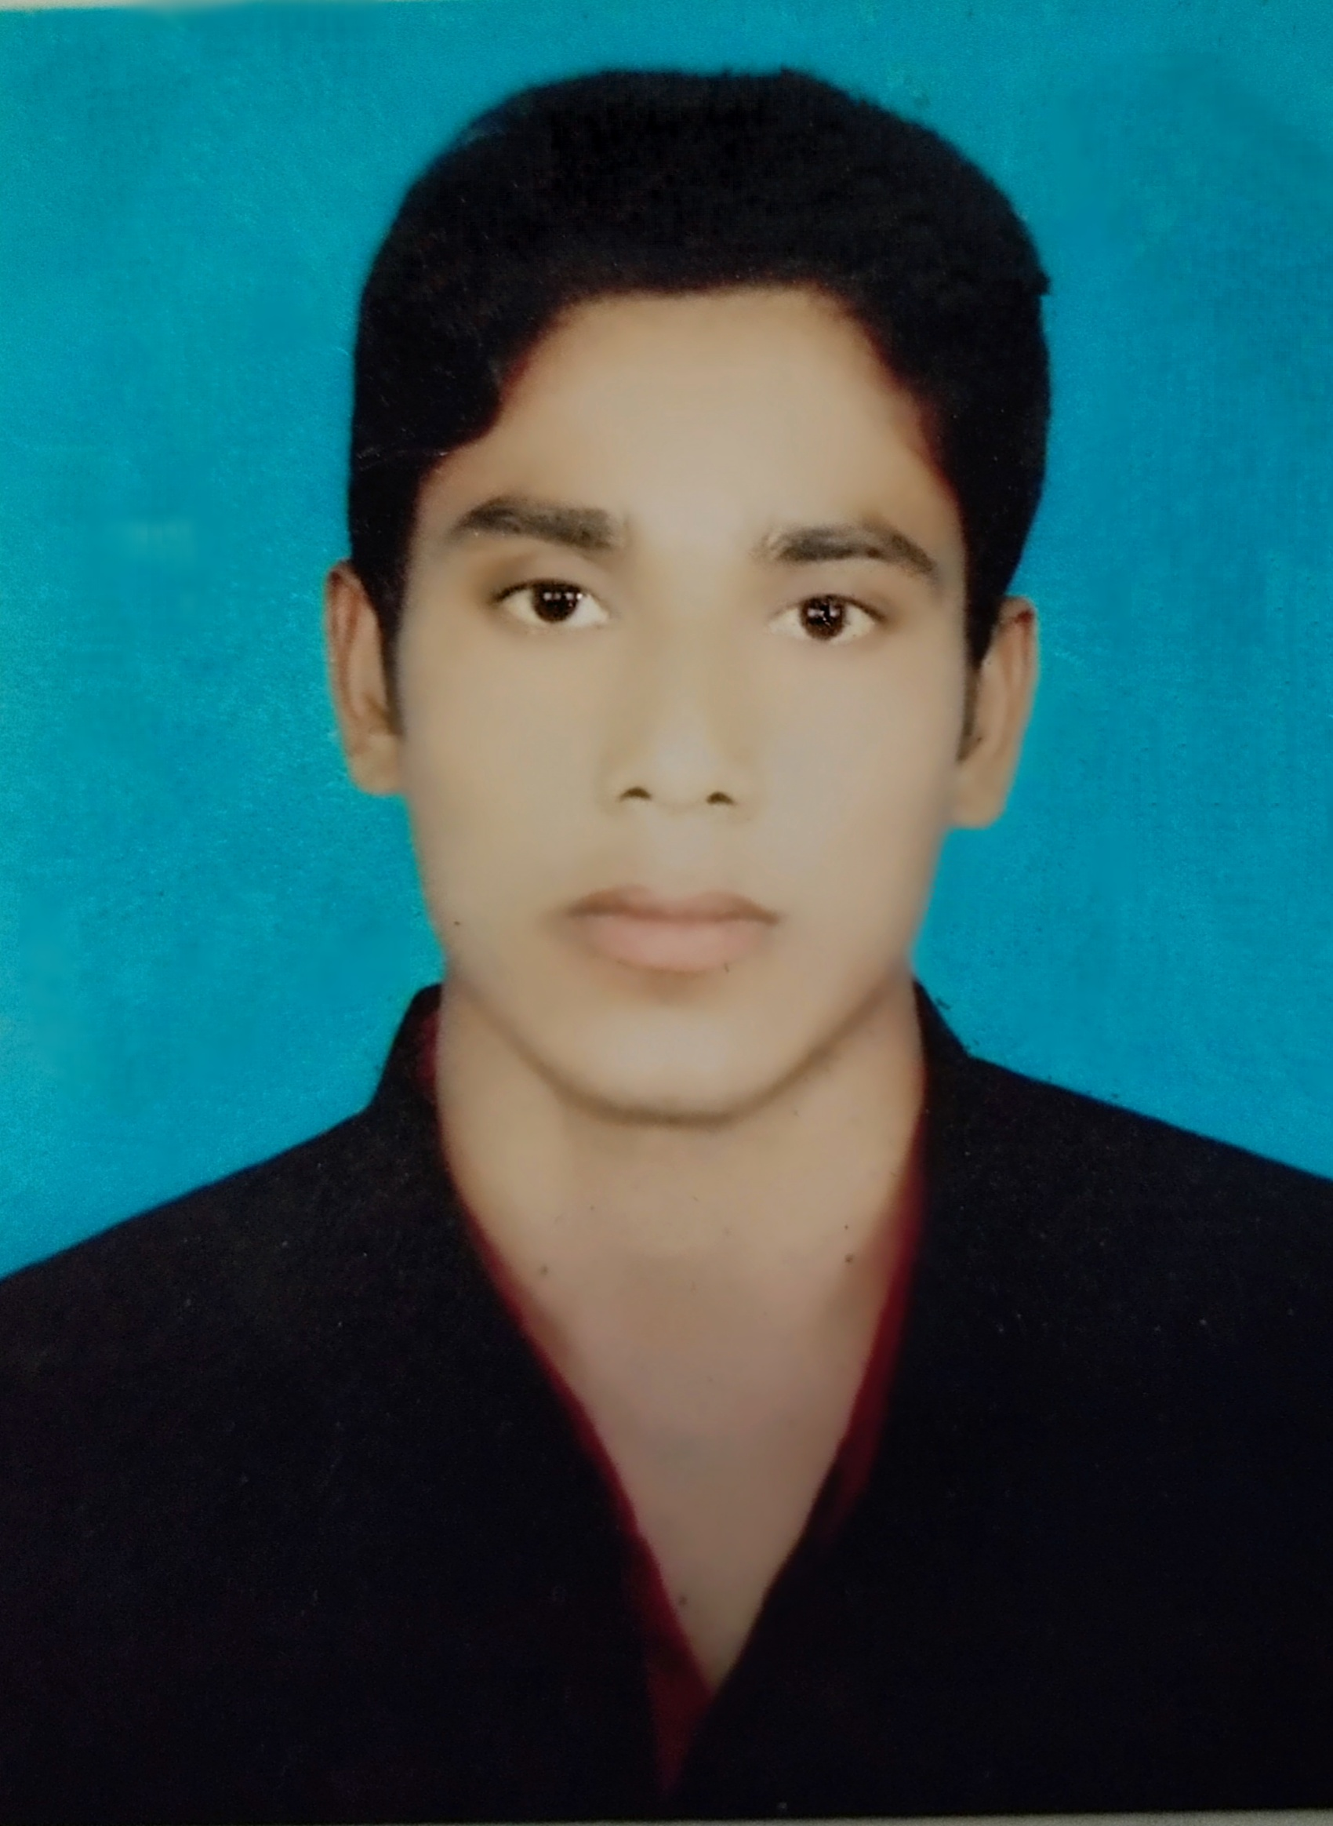 **Name:-** Md Aminul Islam

**Email:-** [mdaminul579@gmail.com](mailto:mdaminul579@gmail.com)

**Phone:-** +8801303285601

**Address:-** Laloich, Hatra-6220, Mohanpur, Rajshahi.

**Education:**

**Diploma in Engineering**

Rajshahi Polytechnic Institute, 2015, Power, CGPA-3.12.

**SSC**

Borail High School, 2010, Science, CGPA-4.38.

**Experience:**

1. Served as Workshop Manager at Brothers Automobile and Auto Parts Terokhadia Dabtola, Rajshahi Since 01 August 2021 to Continuing.

2. Served as Service Engineer at Car Care Center Boalia, Rajshahi Since 01 December 2017 to 31 December 2020.

3. Served as Purchas & Store In charge at Car Care Center Boalia, Rajshahi since 01 November 2016 to 30 November 2017.

**Job Responsibilities:**

1. As a Workshop Manager: - Maintenance all kind of service in a workshop like Accounts, Marketing, Servicing, Store and Purchase, Customer Relations.

2. As a Service Engineer: - Monitoring all car Receive and Delivery in time. Engine Overhauling. All Electric system Scanning by Scanner(X-431v+). Suspension system Overhauling. A/C system Overhauling. Wheel Balancing. Wheel Alignment. Injector Testing by Machine.

3. Purchas & Store In charge: - Management of spare parts inventory. Order of spare parts on time. Distribute spare parts properly to the floor. Monitor of spare parts. Prepare of costing spare parts.

**Training Summary:**

1. Database Programming, Mohanpur Computer Training Institute, Mohanpur, Rajshahi, 2016, 6 Months.

2. Automobile Trouble Shooting, Nitol Tata Mechanics Training School, Bondor, Modonpur, Naraongonj, 2015, 3 Months.

**Skills:**

**Computer Skills:** MS Word, MS Excel, MS PowerPoint, Internet Browsing, Mailing, Downloading.

**Personal Details:**

Father’s Name : Md. Abdus Samad.

Mother’s Name : Most. Fayma Bibi.

Date of Birth : 25 December 1994.

Marital Status : Unmarried.

National ID : 5065928524.

Blood Group : O+ve

Permanent Address : Vill:- Laloich, P.o:- Hatra-6220, P.s:- Mohanpur, Dist:- Rajshahi.

**Reference:**

**Reference: 01 Reference: 02** Md. Mesbaur Rahman Md. Tareq Onius

Head of Service DUET

Car Care Center 01711345048

01710550526



(Md. Aminul Islam)