Reconnaissance & Intelligence Assessment
Target: bizzlearning.in
Passive Reconnaissance Report | project 1

1. Executive Summary
- A passive reconnaissance assessment was performed against bizzlearning.in using only publicly available DNS and WHOIS data. No active scanning, exploitation, or intrusive testing was performed.
- DNS queries (dig) and nslookup returned different IPv4 addresses for the same domain. This inconsistency is the most significant open finding and needs confirmation.
- No MX record is published, so email routing for the domain cannot be confirmed from DNS alone.
- No TXT record exists, meaning no SPF/DKIM/DMARC anti-spoofing policy is currently published.
- Nameservers (aurora.dns-parking.com, nebula.dns-parking.com) follow a parking-service naming pattern, which should be confirmed as intentional.
- WHOIS confirms registration through Hostinger, registrant organization "Visystems", based in Uttar Pradesh, India; DNSSEC is unsigned.
- The website footer explicitly discloses the CMS (WordPress) and the specific commercial theme in use ("Grocery Store WordPress Theme by WP Radiant"), and still shows the default "Hello World" post — both indicate the site has not been fully reviewed since installation.
- Document metadata inspection (Task 5) is not yet complete and is marked as pending in this report.
Overall risk rating: Low–Medium. No evidence of active compromise was found. Findings are limited to DNS configuration hygiene and unresolved informational gaps.

2. Scope and Authorization (Task 1)
This assessment was self-authorized by the assessor as the owner/administrator of the target domain. Only passive, non-intrusive techniques were used.
Field | Value
Target domain | bizzlearning.in
Ownership | Assessor-owned domain
Permitted actions | Passive DNS queries (dig, nslookup), WHOIS lookup, public website review, document metadata inspection
Excluded | Port scanning, vulnerability scanning, exploitation, brute-force, social engineering, testing of third-party shared infrastructure
Tools used | dig, nslookup, whois, exiftool (pending), browser
Test window | 24 October 2026

3. Review of Supplied Public Information (Task 2)
Status: COMPLETE. The full homepage of bizzlearning.in was reviewed by the assessor using a browser only — no tools were used. Observations below are drawn directly from the supplied screenshot.

3.1 Observation Table
# | Observation | Source | Category | Confidence | Attacker misuse potential
1 | Footer states "Grocery Store WordPress Theme By WP Radiant | Proudly powered by WordPress" | Footer bottom bar | Technology clue | Fact | Lets an attacker search known CVEs for WordPress core and this specific theme directly
2 | Header navigation includes a "Get Pro" link | Header nav | Technology clue | Fact | Confirms a commercial theme is in use; reinforces observation #1
3 | Blog shows one unedited default post, "Hello World!", by author "Admin", dated 18/10/2026 | News & Blogs section | Technology clue / hygiene gap | Fact | Confirms the default WordPress install was never cleaned up; the "Admin" display name may hint at the admin login username (needs confirmation)
4 | Footer contact email is listed as info@example.com | Footer — Contact Us | Contact channel | Fact | Not a functioning contact address; shows template/demo content is still live, not finalized
5 | Header phone "+12 01234567890" and footer phone "+1 (143) 456-7897" use invalid/placeholder-style formats | Header & footer | Contact channel | Fact (format) / Assumption (placeholder) | Low — mainly confirms unmodified template content
6 | Footer address listed as "123 Glassford Street, New York, USA" | Footer | Contact info | Assumption | Low — common placeholder pattern, not independently confirmed as fake
7 | About Us and testimonial sections use literal Lorem Ipsum text and generic names (Jordan Blake, Taylor Reed, Casey Bennett) with manager-style titles | About Us / Testimonials | Content | Assumption | Low direct risk; indicates these are not reliable sources for a real-staff phishing pretext
8 | FAQ content describes a generic "Agency" (e.g. "Do You Manage Social Media Accounts?") despite the site being a grocery storefront | FAQ section | Content mismatch | Fact | Confirms template content was not customized; suggests other default/demo content may still be live and unreviewed

3.2 Supporting Screenshots

Figure 8a: Header and navigation — call-us number and "Get Pro" link visible.

Figure 8b: Blog section showing the unedited default "Hello World!" post by "Admin".

Figure 8c: Footer showing placeholder contact details and the WordPress/theme credit line.

4. DNS Record Inspection (Task 3)
The following records were queried directly against bizzlearning.in and verified from the assessor's own terminal screenshots (dig and nslookup, run on Kali Linux, 24 October 2026).

4.1 DNS Table
Record Type | Value | TTL | Status
A (dig, confirmed) | 93.127.173.62 / 88.222.243.31 | 60 | Needs Confirmation — mismatch with nslookup
A (nslookup) | 147.79.69.113 / 93.127.173.3 | — | Needs Confirmation — mismatch with dig A
AAAA (nslookup, IPv6) | 2a02:4780:20:407a:b858:12db:c0fd:62b6 / 2a02:4780:3c:a695:2cb7:c34d:ed70:74b8 | — | Needs Confirmation
MX | None (0 answers); SOA shown in authority section | 600 | Needs Confirmation
NS | nebula.dns-parking.com / aurora.dns-parking.com | 86400 | Needs Confirmation
TXT | None (0 answers); SOA shown in authority section | 600 | Needs Confirmation
SOA | aurora.dns-parking.com. dns.hostinger.com. serial 2026102201 | 600 | Expected

4.2 Plain-Language Explanation
- A record: maps the domain name to an IPv4 address — tells a browser which server to connect to.
- MX record: tells other mail servers which server handles incoming email for the domain. None is published here.
- NS record: identifies the authoritative DNS servers for the domain's zone.
- TXT record: free-text record commonly used for SPF/DKIM/DMARC email-authentication policies. None is published here.

4.3 Key Observation — dig vs nslookup Mismatch
The dig A query returned 93.127.173.62 and 88.222.243.31 (confirmed by screenshot, Figure 6). The nslookup screenshot shows a different set: 147.79.69.113 and 93.127.173.3, plus two IPv6 addresses. This is a FACT (directly observed in both screenshots). The cause is an ASSUMPTION pending verification — possible explanations include resolver-level caching differences, a multi-IP/round-robin configuration, or a change in records between queries. Recommended next step: re-run dig against a fixed public resolver (e.g. dig @8.8.8.8 bizzlearning.in A) and compare directly against nslookup run at the same time.
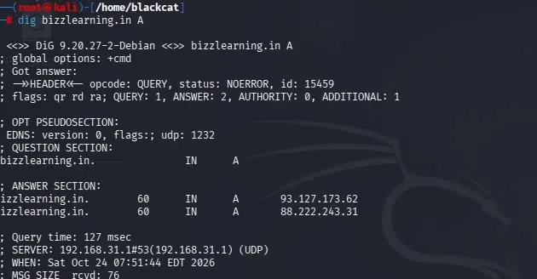
Figure 6: dig A query confirming 93.127.173.62 and 88.222.243.31 — does not match the nslookup result in Figure 2.

4.4 WHOIS Findings
Field | Value
Registrar | HOSTINGER operations, UAB (IANA ID 1636)
Registrar WHOIS Server | whois.hostinger.com
Creation Date | 2026-05-08
Updated Date | 2026-05-13
Registry Expiry Date | 2029-05-08
Registrant Organization | Visystems
Registrant State/Province | Uttar Pradesh
Registrant Country | IN
Domain Status | clientTransferProhibited (standard anti-hijack lock, not a finding)
Name Servers | aurora.dns-parking.com, nebula.dns-parking.com
DNSSEC | unsigned
Registrar Abuse Contact | domains@hostinger.com / +3.7068424669
Note: all registrant personal fields (Name, Street, City, Postal Code, Phone, Fax, Email) are redacted by the registry under ICANN's Temporary Specification for gTLD Registration Data and were not retrievable — this is standard WHOIS privacy, not a finding.

5. Asset Inventory (Task 4)
Hostname | IP / Value | Service | Source | Confidence
bizzlearning.in | 93.127.173.62, 88.222.243.31 | Web | dig A screenshot | High
bizzlearning.in | 147.79.69.113, 93.127.173.3 | Web | nslookup screenshot | High
bizzlearning.in | 2 x IPv6 addresses | Web (IPv6) | nslookup screenshot | High
nebula.dns-parking.com | Not resolved in this run | DNS (NS) | dig NS / WHOIS screenshots | High
aurora.dns-parking.com | Not resolved in this run | DNS (NS) + SOA | dig NS / MX / TXT / WHOIS | High
mail.bizzlearning.in | Not observed | Mail | — (no MX found) | N/A
Open item: which IP set (dig-reported vs nslookup-confirmed) reflects the current production address is unresolved and is the top item in the risk register below.

6. Document Metadata Inspection (Task 5)
Status: BLOCKED. No sample PDF/DOCX files or exiftool output have been supplied or captured yet. This section will be completed once files are available, using: exiftool filename.pdf and exiftool filename.docx. Sanitization guidance for later use: run exiftool -all= on a copy before publishing, or use Word's Inspect Document feature to remove personal information.

7. Risk Register (Task 6)
# | Item | Likelihood | Impact | Score | Priority
1 | dig vs nslookup IP mismatch | 3 | 4 | 12 | High
2 | No TXT/SPF record published | 3 | 3 | 9 | Medium-High
3 | No MX record / unclear email hosting | 2 | 3 | 6 | Medium
4 | DNSSEC unsigned | 2 | 3 | 6 | Medium
5 | Parking-style nameservers unconfirmed | 2 | 2 | 4 | Low
6 | Document metadata exposure | — | — | N/A | Pending (Task 5)
7 | CMS + commercial theme name disclosed in site footer | 4 | 3 | 12 | High
8 | Default WordPress demo content still live (Hello World post, Lorem Ipsum sections, placeholder contact info) | 3 | 2 | 6 | Medium
Top priorities: the dig/nslookup IP mismatch (Item 1, score 12) and the CMS/theme disclosure in the footer (Item 7, score 12) are tied for highest priority — the first determines the real attack surface, the second gives an outsider a direct, specific starting point for vulnerability research. Item 2 (missing SPF, score 9) is the next highest-confidence, lowest-effort fix.

8. Recommendations (Task 7)
# | Recommendation | Addresses | Priority
1 | Re-query dig against fixed public resolvers (8.8.8.8, 1.1.1.1) and reconcile against nslookup | Item 1 | High
2 | Publish an SPF record (v=spf1 -all, or scoped to actual mail provider if one exists) | Item 2 | High
3 | Confirm with Hostinger whether parking-style nameservers reflect intended configuration | Item 5 | Medium
4 | Enable DNSSEC signing through the DNS provider | Item 4 | Medium
5 | Supply sample documents and run exiftool; sanitize metadata before any public release | Item 6 | High (once unblocked)
6 | Remove or customize the theme/CMS credit line in the footer; keep WordPress core and theme updated | Item 7 | Medium-High
7 | Replace all default demo content (Hello World post, Lorem Ipsum sections, generic testimonials, placeholder contact info) with real, reviewed content; confirm "Admin" is not the live login username | Item 8 | High

9. Evidence Index
Figure | Description | Status
Fig. 1 | dig bizzlearning.in TXT — terminal screenshot | Captured
Fig. 2 | nslookup bizzlearning.in — terminal screenshot | Captured
Fig. 3 | dig bizzlearning.in MX and NS — terminal screenshot | Captured
Fig. 4 | whois bizzlearning.in (part 1) — terminal screenshot | Captured
Fig. 5 | whois bizzlearning.in (part 2) — terminal screenshot | Captured
Fig. 6 | dig bizzlearning.in A — terminal screenshot | Captured
Fig. 7 | exiftool output on sample document(s) | Pending — files not yet supplied
Fig. 8a-c | Website review screenshots (header/nav, blog, footer) — see Section 3.2 | Captured
Fig. 9 | Signed scope document | Pending

10. Appendix — Screenshot Evidence
The following terminal screenshots were supplied by the assessor and support the findings in Section 4.

Figure 1 — dig bizzlearning.in TXT
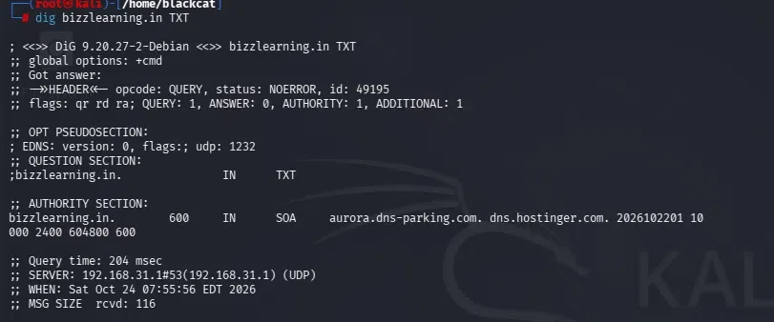
Figure 1: TXT query returning zero answers; SOA shown in authority section.

Figure 2 — nslookup bizzlearning.in
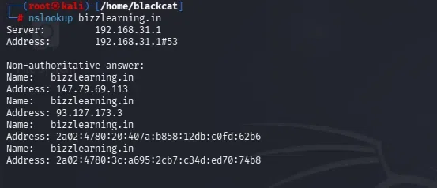
Figure 2: nslookup output showing IPv4/IPv6 addresses that differ from the dig A results.

Figure 3 — dig bizzlearning.in MX and NS
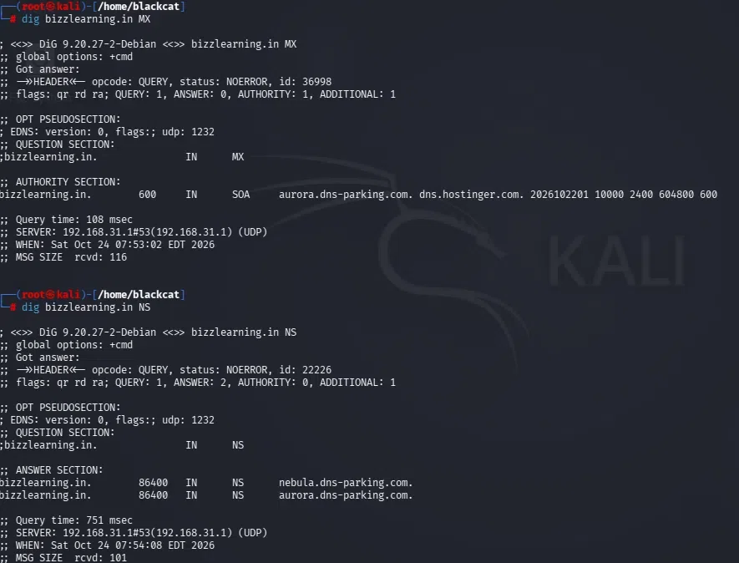
Figure 3: MX query (zero answers) and NS query showing two parking-style nameservers.

Figure 4 — whois bizzlearning.in (part 1)
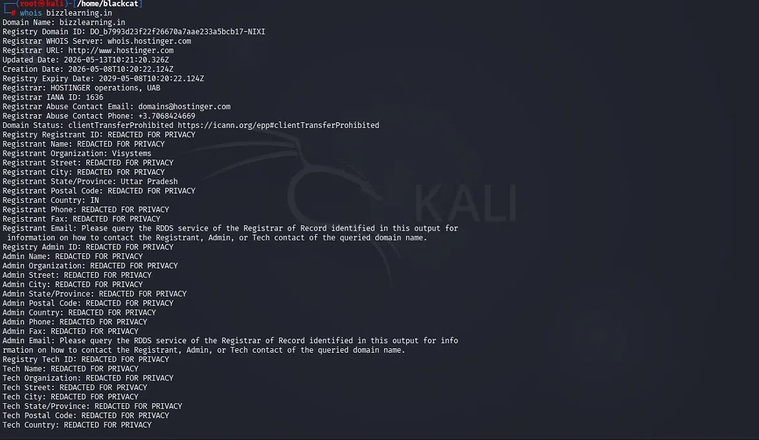
Figure 4: WHOIS output showing registrar, registrant organization, and domain status.

Figure 5 — whois bizzlearning.in (part 2)
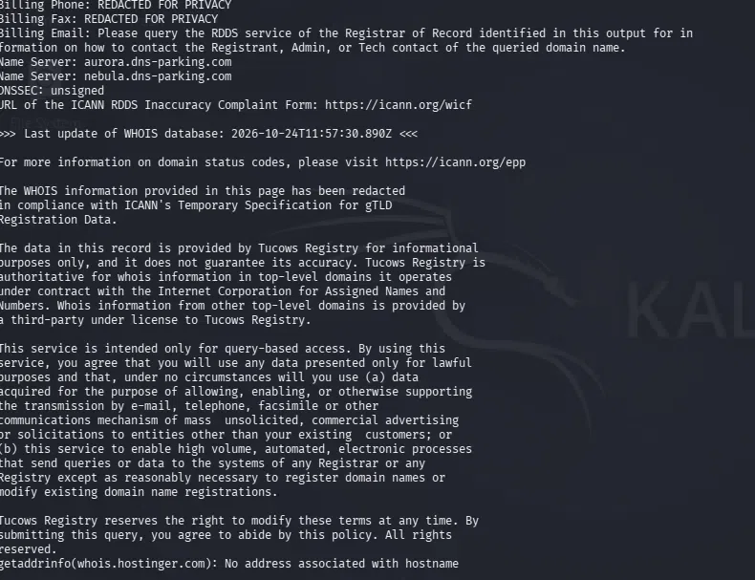
Figure 5: WHOIS output continued — name servers, DNSSEC status, and registry terms.

11. Conclusion
Based on the passive DNS, WHOIS, and website evidence collected and verified by screenshot, bizzlearning.in shows no evidence of active compromise. The most significant open items are the unresolved mismatch between dig and nslookup results and the direct disclosure of the CMS and commercial theme in the site footer, both scoring highest in the risk register. Secondary findings — missing SPF record, unsigned DNSSEC, and leftover default WordPress demo content — are standard, low-effort hygiene gaps. The assessment will be finalized once Task 5 data is supplied and the IP mismatch is reconciled.

