AI V2 ONLINE

The term AI was introduced by Prof. John McCarthy at a conference at Dartmouth College in 1956. McCarthy defines AI as the “science and engineering of making intelligent machines, especially intelligent computer programs”.

AI is a sub field of computer science that aims at building computer systems that can perform tasks that normally require human intelligence.

AI research uses techniques from many fields, such as linguistics, economics, and psychology. These techniques are used in applications, such as control systems, natural language processing, facial recognition, speech recognition, business analytics, pattern matching, and data mining.

Eras of computing
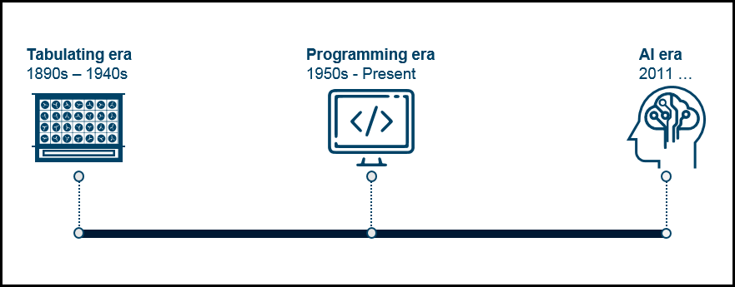

Tabulating era (1890s – 1940s)
The first era of computing consisted of single-purpose electromechanical systems that used punched cards to input and store data that instructed the machine what to do. These tabulation machines were essentially calculators that counted and summarized information. They did this task well, but only this task.
These machines supported the scaling of business and society and were used in government applications, such as processing population census data, and business applications, such as accounting and inventory control. Tabulating machines evolved to a class of machines that were known as unit record equipment, which were instrumental in starting the data processing industry.

Programming era (1950s – present)
This era started with the shift from mechanical tabulators to electronic systems. It began during World War II and was driven by military and scientific needs. Following the war, digital “computers” evolved rapidly and moved into businesses and governments. The programmable computing era began.
The significant change of this era is the introduction of general-purpose computing systems that are programmable: They can be reprogrammed to perform different tasks and solve multiple problems in business and society. However, they must be programmed and are still constrained in their interaction with human beings. Everything we now know as a computing device, such as the mainframe, personal computer, smartphone, and the tablet, is a programmable computer. Some experts believe that this era of computing will continue to exist indefinitely.

AI era (2011 – future)
AI systems are a natural evolution of programmable computing. AI systems exhibit characteristics of human intelligence. They can understand and reason and learn and improve their performance overtime.
Dr. Kelly in the white paper Computing, cognition and the future of knowing defines cognitive computing as follows:
“Cognitive computing refers to systems that learn at scale, reason with purpose and interact with humans naturally. Rather than being explicitly programmed, they learn and reason from their interactions with us and from their experiences with their environment.”
Strong AI
- Weak AI
The first approach builds systems that can act and think intelligently like people do. This approach simulates human reasoning and cognition in general tasks and is called strong AI. Most of these projects are in the small-to-medium size range. The three largest projects are DeepMind, the Human Brain Project (an academic project that is based in Lausanne, Switzerland), and OpenAI.
The second approach is not concerned about whether the AI systems display human-like cognitive functions; the focus is on AI systems that perform specific tasks accurately and correctly. This approach is called weak AI. An example of weak AI is a chatbot, which is trained to answer a specific set of questions about a domain. A chatbot does not have self-awareness or genuine intelligence.

A good example of current AI is advanced natural language generation.

Evolution of artificial intelligence types
On the other hand, from the scope perspective, Ray Kurszweil, a futurist currently working for Google, identified three levels of AI:

- Artificial Narrow Intelligence (ANI)
ANI, which belongs to the weak AI school, refers to applying AI techniques to narrow problems. It focuses on a specific task. The strength of ANI is that it focuses on doing something extremely well, sometimes exceeding a human’s capabilities. ANI is a good fit for automating simple and repetitive tasks.
Examples of ANI are bots and virtual assistants, such as Siri, Microsoft Cortana, Amazon book recommendations that are customized for each user, restaurant recommendations, weather updates, Watson DeepQA, and customer services chatbots for answering simple and repetitive customer inquiries.
These AI implementations excel in their defined areas, but if you try to start a conversation with a virtual assistant, you clearly see how “narrow” its intelligence is.

- Artificial General Intelligence (AGI)
AGI belongs to the strong AI school. It refers to computer systems that exhibit capabilities of the human brain. AGI refers to systems or machines that can generally perform any intellectual task that a human can do.

- Artificial Super Intelligence (ASI)
ASI refers to machines that surpass humans in general intelligence. Nick Bostrom, a leading AI thinker, in the paper How Long Before Superintelligence?, defines ASI as “an intellect that is much smarter than the best human brains in practically every field, including scientific creativity, general wisdom and social skills.”
Regarding ASI, many prominent scientists and technologists have ethical concerns about the future of humanity and intelligent life. The unique capabilities of the human brain are the reason why humans have a dominant position over other species. Super-intelligent machines might surpass the human brain in general intelligence.
ASI (Artificial Super Intelligence) ; when the system has capabilities of self awareness.

How humans think
The goal of many researchers is to create strong and general AI that learns like a human and can solve general problems like the human brain does. Achieving this goal might require many more years.
How does a human being think? Intelligence or the cognitive process is composed of three main stages:
- Observe and input the information or data in the brain.
- Interpret and evaluate the input that is received from the surrounding environment.
- Make decisions as a reaction towards what you received as an input and interpreted and evaluated.
AI researchers are simulating the same stages in building AI systems or models. This process represents the main three layers or components of AI systems.

Mapping human thinking to artificial intelligence components
Because AI is the science of simulating human thinking, it is possible to map the human thinking stages to the layers or components of AI systems.
In the first stage, humans acquire information from their surrounding environments through human senses, such as sight, hearing, smell, taste, and touch, through human organs, such as eyes, ears, and other sensing organs, for example, the hands.
In AI models, this stage is represented by the sensing layer, which perceives information from the surrounding environment. This information is specific to the AI application. For example, there are sensing agents such as voice recognition for sensing voice and visual imaging recognition for sensing images. Thus, these agents or sensors take the role of the hearing and sight senses in humans.

The second stage is related to interpreting and evaluating the input data. In AI, this stage is represented by the interpretation layer, that is, reasoning and thinking about the gathered input that is acquired by the sensing layer.

The third stage is related to taking action or making decisions. After evaluating the input data, the interacting layer performs the necessary tasks. Robotic movement control and speech generation are examples of functions that are implemented in the interacting layer.

Integral components of artificial intelligence systems
Consumer-oriented AI systems such as Google Assistant, Siri, and Microsoft Cortana are adopting the three AI components or layers that are described in the previous section: Sensing, interpretation, and interacting.
These systems, and any AI system in general, are not built on a single component. They are composed of multiple components and approaches for thinking and reasoning, and simulating human thinking. These combinations represent the identity of the AI system and distinguish one AI system from others.

Humans are constantly observing what is happening around them, what it means, and what will happen next. For any intelligent system, including human beings, the ability to assess and understand what is happening right now, make inferences about it, and predict what is going to happen next is essential for assessing current situations and predicting the convenient or appropriate action or decision.

For AI systems to be able to assess data, there must be enough data with which to work. Using a large volume of data can support the learning process of even a weak AI algorithm to identify the relevant data and discard the “noise” or irrelevant data. Availability, variety, and volume of data are factors that contribute to enhancing the learning process and produce more accurate results.

Many AI systems focus on prediction. To predict an outcome, AI systems use data mining or machine learning algorithms. There are different techniques that are used for prediction, such as regression analysis, which is a set of statistical processes for estimating the relationship among variables. AI systems build rules that can be used to predict the events of interest before they take place.

According to the type of predicted outcome, AI systems can be categorized into the following two categories:
- Deterministic systems
- Probabilistic systems

Deterministic versus probabilistic systems
A deterministic system is a system that does not include randomness in the development of the system’s future states. The model always produces the same output from a certain input, starting condition, or initial state. A deterministic system is one in which the occurrence of all events is known with certainty.
Conversely, a probabilistic system depends on the confidence values of returned responses. Unlike deterministic systems, probabilistic systems rely on statistical models.

After exploring the three integral components of AI systems, we can conclude that the dynamic combination of these components (assessing data, inferring knowledge, and predicting output) represents the core components of many AI systems. Therefore, intelligent systems are built on a foundation of processes that are simple and understandable. There is no “smart box” at the heart of these systems. AI is not magic, but is the application of a collection of processes and algorithms that is powered by data, scale, and processing power. These factors and others can be considered AI systems influencers. We describe more about AI influencers in the next section.

Influencers of artificial intelligence
As explained earlier, AI is not a new concept, but the ideas behind it have started to materialize in the last years. This section explores some of the reasons why AI is taking off now.
The following influencers of AI are described in this section:
- Big data: Structured data versus unstructured data
- Advancements in computer processing speed and new chip architectures
- Cloud computing and APIs
- Emergence of data science

Big Data
Big data refers to huge amounts of data. Big data characteristics are defined by the three Vs:
- Variety
- Volume
- Velocity
Later, more Vs were added, such as veracity and visibility.
Big data requires innovative forms of information processing to draw insights, automate processes, and help decision making. Big data can be structured data that corresponds to a formal pattern, such as traditional data sets and databases.
Also, big data includes semi-structured and unstructured formats, such as word-processing documents, videos, images, audio, presentations, social media interactions, streams, web pages, and many other kinds of content. Figure 1 depicts the rapid change of the data landscape.

Structured data versus unstructured data
Traditionally, computers primarily process structured data, that is, information with an organized structure, such as a relational database that is searchable by simple and straightforward search engine algorithms or SQL statements.
But, real-world data such as the type that humans deal with constantly, does not have a high degree of organization. For example, text that is written or spoken in natural language (the language that humans speak) does not constitute structured data.
Unstructured data is not contained in a regular database and is growing exponentially, making up most of the data in the world. The exponential growth of unstructured data that is shown in Figure 2 drives the need for a new kind of computer system.

Advancements in computer processing speed, new chip architectures, and big data file systems.
Significant advancements in computer processing and memory speeds enable us to make sense of the information that is generated by big data more quickly.
In the past, statisticians and early data scientists were limited to working with sample data sets. In recent years, big data and the ability to process a large amount of data at high speeds have enabled researchers and developers to access and work with massive sets of data. Processing speeds and new computer chip architectures contribute to the rapid evolution of AI applications.

The meaning of big data expanded beyond the volume of data after the release of a paper by Google on MapReduce and the Google File System (GFS), which evolved into the Apache Hadoop open source project. The Hadoop file system is a distributed file system that may run on a cluster of commodity machines, where the storage of data is distributed among the cluster and the processing is distributed too. This approach determines the speed with which data is processed. This approach includes an element of complexity with the introduction of new, structured, unstructured, and multi-structured data types.
Large manufacturers of computer chips such as IBM and Intel are prototyping “brain-like” chips whose architecture is configured to mimic the biological brain’s network of neurons and the connections between the called synapses.

Cloud computing and application programming interfaces
Cloud computing is a general term that describes delivery of on-demand services, usually through the internet, on a pay-per-use basis. Companies worldwide offer their services to customers over cloud platforms. These services might be data analysis, social media, video storage, e-commerce, and AI capabilities that are available through the internet and supported by cloud computing.
In general, application programming interfaces (APIs) expose capabilities and services. APIs enable software components to communicate with each other easily. The use of APIs as a method for integration injects a level of flexibility into the application lifecycle by making the task easier to connect and interface with other applications or services. APIs abstract the underlying workings of a service, application, or tool, and expose only what a developer needs, so programming becomes easier and faster.

AI APIs are usually delivered on an open cloud-based platform on which developers can infuse AI capabilities into digital applications, products, and operations by using one or more of the available APIs.
All the significant companies in the AI services market deliver their services and tools on the internet through APIs over cloud platforms, for example:
- IBM delivers Watson AI services over IBM Cloud.
- Amazon AI services are delivered over Amazon Web Services (AWS).
- Microsoft AI tools are available over the MS Azure cloud.
- Google AI services are available in the Google Cloud Platform.
These services benefit from cloud platform capabilities, such as availability, scalability, accessibility, rapid deployment, flexible billing options, simpler operations, and management.

Emergence of data science
Data science has emerged in the last few years as a new profession that combines several disciplines, such as statistics, data analysis, machine learning, and others. The goal of data science is to extract knowledge or insights from data in various forms, either structured or unstructured, which is like data mining.
After you collect a large enough volume of data, patterns emerge. Then, data scientists use learning algorithms on these patterns. Data science uses machine learning and AI to process big data.

Applications of artificial intelligence in different industries
Note: The information in this section is based on the Stanford University One Hundred Year Study on Artificial Intelligence (AI100). For more information refer to this Stanford University study.
Applications of AI research and practice share common technologies, but they also vary considerably in different sectors of the economy and society. These sectors are called domains. The Stanford University study focuses on some of these domains, which are described in the following sections.

Transportation
Autonomous transportation refers to self-driven vehicles, such as driverless cars and unmanned ground vehicles (UGVs), which are vehicles that can sense their environment and navigate without human input. Autonomous transportation will soon be commonplace, and likely include cars, trucks, flying vehicles, and personal robots.

Home services and robots
Home services and robots have already entered people’s homes in the form of vacuum cleaners and personal assistants. Better chips, low-cost 3D sensors, cloud-based machine learning, and advances in speech understanding will enhance future robots’ services and their interactions with people. Special purpose robots will clean offices, and enhance security. Drones are already being used to deliver packages.

Healthcare
In healthcare, there has been a huge forward leap in collecting useful data from personal monitoring devices and mobile apps, electronic health records (EHRs) in clinical settings, surgical robots that assist with medical procedures, and service robots that support hospital operations. AI applications can generate new insights that speed up matching subjects to clinical studies, identify promising targets for research, reduce drug discovery times, and provide virtual assistance to patients.

Education
Even when quality education will always require active engagement by human teachers, AI can enhance education at all levels, especially by providing personalization at scale. Interactive machine tutors are now being matched to students for teaching science, math, language, and other disciplines. Natural Language Processing, machine learning, and crowdsourcing have boosted online learning and enabled teachers in higher education to multiply the size of their classrooms while addressing individual students’ learning needs and styles.

Public Safety and Security
AI technologies are already in use in North America for border administration and law enforcement. By 2030, the government will rely heavily upon them, including improved cameras and drones for surveillance, algorithms to detect financial fraud, and predictive policing.

Employment and workplace
AI is poised to replace people in certain jobs, such as driving taxis and trucks. However, in many realms, AI will likely replace tasks rather than jobs in the near term, and also create new jobs. But the new jobs that emerge are harder to imagine in advance than the existing jobs that will likely be lost.

Entertainment
Entertainment has been transformed by social networks and other platforms for sharing and browsing blogs, videos, and photos, which rely on techniques actively developed in Natural Language Processing, information retrieval, image processing, and machine learning. Some traditional sources of entertainment have also embraced AI to compose music, create stage performances, and even to generate 3D scenes from natural language text. AI will increasingly enable entertainment that is more interactive, personalized, and engaging.
The AI domains listed in this section are those selected by the Stanford University One Hundred Year Study on Artificial Intelligence (AI100). However, AI can be applied to almost every government and industry domain. Other examples of AI solutions for industry vertical sectors include the following ones:
- Agriculture
- Banking, Financial Services and Insurance (BFSI)
- Manufacturing
- Oil and Gas

New partnership for artificial intelligence
From Siri to self-driving cars, AI is progressing rapidly. Although science fiction often portrays AI as robots with human-like characteristics, AI encompasses things such as Google’s search algorithms, IBM Watson, and autonomous weapons.
The goal of keeping the impact of AI on society beneficial raised concerns around the impact of AI on the job market, or whether self-driven cars will crash into people as they drive on the roads. In September 2016, IBM, Google, Amazon, Facebook, and Microsoft announced a “Partnership on AI to benefit people and society”. The five companies set up a consortium to study and formulate best practices of AI technologies to advance the public’s understanding of AI and serve as an open platform for discussion and engagement about AI and its influences on people and society.

Artificial intelligence fundamental research areas
At a high level, the AI field is related to the following subfields of research:
- Machine learning
Machine learning is a methodology of taking large amounts of data and finding a reasonably “optimal” mathematical solution that can be used to predict results given future data.
This methodology is not seen as “proper” AI because it is more a mathematical and statistical technique or algorithm. However, this technique can produce impressive results when it is used to train computer systems that “learn” from training data.
Machine learning is used to support the other AI subfields, including natural language processing (NLP) and computer vision (CV).
- Natural language processing (NLP)
NLP is the subfield of AI that applies computational techniques to analyze and synthesize human natural language and speech.
NLP is the study of the computational treatment of natural (human) language. It is the branch of science that deals with analyses of text, whether they are in emails, human speech, social media and more. It allows machines to understand human communication to extract different information that was so far, the exclusive privilege of humans.
NLP is found today in the following types of applications:
  - Machine translation
  - Search engines, such as Google and Baidu
  - Spell checkers
  - IBM Watson, where it famously won Jeopardy! against the best human contestants
  - Natural language assistants, such as Siri
  - Translation systems, such as Google translate
  - News digest, such as Yahoo
- Computer vision (CV)
CV is the subfield of AI that applies computational techniques to understand and process images in pictures and videos. CV uses deep learning algorithms to analyze images for scenes, objects, faces, and other content in videos, photos and pictures in general.
- Business analytics
Business analytics solutions provide organizations with actionable insights for smarter decisions and better business outcomes.

AI INNOVATIONS THAT WILL CHANGE OUR LIVES

In five years, what we say and write will be indicators of our mental health and physical well-being. Patterns in our speech and writing that are analyzed by AI systems will enable doctors and patients to predict and track early-stage developmental disorders, mental illness, and degenerative neurological diseases more effectively.

Analytics approaches
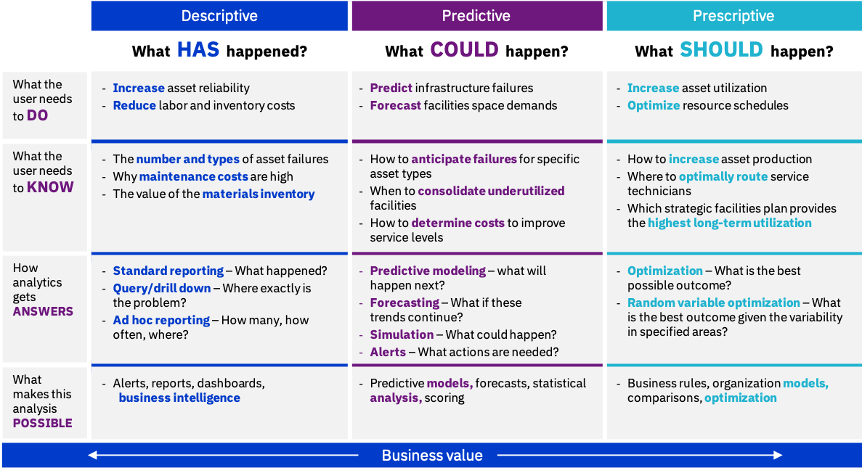

Introduction to business analytics
Analytics is a process that requires collaboration across a team of data scientists, data engineers, business analysts, and business leaders. The power of analytics is in collaboration that focuses on defining and solving business problems.
There is no debate that existing business leaders are facing new and unanticipated competitors. These business leaders are looking at new strategies that can prepare them for the future.
The goal of any analytics solution is to provide the organization with actionable insights for smarter decisions and better business outcomes. Therefore, analytics can help technical and business leaders to know how to anticipate and predict the future. With the appropriate analytics, organizations can continually predict changes in the business so that they can have a competitive advantage.
Analytics follows a process that is like the data scientific method. The analytics process always starts with a business process as the first step to identify a business problem. The next step is to plan the work, including analyzing the problem and building a business case. In summary, the analytics process uses tools and techniques to turn data into meaningful business insights.
Figure 1 shows that business analytics involve using tools and techniques to turn data into business insights.
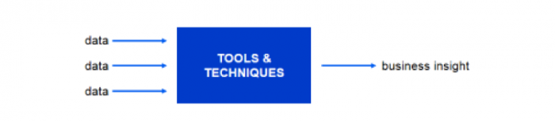
There are different approaches depending on the industry, the type of data that the organization is dealing with, and the type of results that you want to achieve. The following sections show three approaches of advanced analytics.

Descriptive analytics
Descriptive analytics is the analytical models that uses data mining and business intelligence to provide trending information about the historical events that can help the business analysts understand the context of the current business and evaluate the current state. In summary, it provides insights into the past and answers the question of “What has happened?”
Descriptive analytics drills down into data and uses key performance indicators (KPIs), such as frequency of events, cost of operations, and the root cause of failures. All these KPIs help in measuring the business growth.
Descriptive analytics is the most commonly adopted model by companies and organizations. It helps them to visualize the results as reports and dashboards. Also, it can discover data patterns that indicate that a problem might arise and automatically issue alarms.

Predictive analytics
Predictive analytics applies advanced statistical analysis and data mining to validate assumptions and test hypothesis. This approach provides a solid, data-based foundation that can raise the business owners’ confidence regarding conclusions.
Predictive analytics helps business owners to anticipate likely scenarios so that they can plan rather than react to what has happened. A predictive analytics tool requires constantly feeding the model with new data that reflects business changes to provide the business with actionable insights based on data.
The foundation of predictive analytics is based on statistics and probability. Predictive analytics combines historical data from different sources to identify patterns in the data and apply statistical models and algorithms to fill in the missing data with best guesses. It is about understanding the future and answers the question of “What could happen?” It also helps in predicting the missing information.
Data scientists and business analysts are constrained to make predictions that are based on analytical models that are based on historical data. However, there are always unknown factors that can have a significant impact on future outcomes. Companies must build predictive models that can react and change when there are changes to the business environment.
Good examples of predictive analytics include predicting which customers are likely to terminate their contract with their current business provider (churn analysis), which customers are likely to buy a new product or service from their current service provider (cross-sell analysis), or predicting the future prices of assets such as real estate or commodities.

Prescriptive analytics
Prescriptive analytics is mainly about providing advice regarding the possible outcomes to solve complex optimization problems involving tradeoffs between business goals and constraints.
Prescriptive analytics goes beyond descriptive and predictive analytics by recommending one or more possible actions. Prescriptive analytics predicts what will happen and why by providing recommendations regarding actions that take advantage of the predictions. Prescriptive analytics answer the question of “What should we do?”
Prescriptive analytics use a combination of techniques and tools that are applied against input from many different data sets, including historical and transactional data, real-time data feeds, and big data. Prescriptive analytics are relatively complex to administer, and most companies are not yet using them daily.
Large companies use prescriptive analytics to make sure that they are delivering the correct products at the correct time and optimizing the customer experience.
Good examples of prescriptive analytics include optimizing the maintenance of production line equipment to reduce the costs of downtime and planning effective marketing campaigns by distributing resources across multiple channels to target as many customers as possible to maximize the revenue.

Deploying the appropriate analytics approach
There are different types of analytics that provide different types of insights. Thus, it is important for business analysts and data scientists to understand what each analytics type delivers and to match analytics functions to the organization’s operational capabilities.
The role of analytics in an organization’s operational processes has changed significantly over the past years. Companies are experiencing a progression in analytics maturity levels ranging from descriptive to predictive and prescriptive analytics. Companies have been successful at using analytics to understand both where they have been and how they can learn from the past to anticipate the future. They can describe how various actions and events will impact outcomes. Although the knowledge from this analysis can be used to make predictions, typically these predictions are made through a lens of preconceived expectations.
To apply analytics techniques to support business strategy, data scientists and business analysts must understand the business problem and goals. They also must determine what data sources and types are best suited to solve the business problem.
Most companies have important data that is stored in silos across different business units. Some of the important data might be found in social media sources and other unstructured data sources, such as documents that are related to new research findings. Data is also found in semi-structured sources such as sensor and IoT-based systems. Data scientists and business analysts must understand the data and search for opportunities and threats in the data. They must make sure that the data that is available is ready to perform analytics by using the most recent data from the correct sources. They must use all the sources of data because most of the time the data that is required to assess the future exists but was never used to make sense of the business.

An effective strategy must be in place to select a meaningful problem that has an impact on the business. The problem must be tackled on a small scale to deliver rapid results.
Organizations should match their infrastructure, technologies, and processes to the level of analytics maturity that they can perform and the goals that they want to accomplish. In parallel, the organization should put in place advanced technologies and processes to support more complex analytics later.
There are different architectural examples of advanced analytics, according to the type of data.

Example 1: Traditional Analytics
This example is for large structured implementations that support a large demand, as shown in Figure 1.
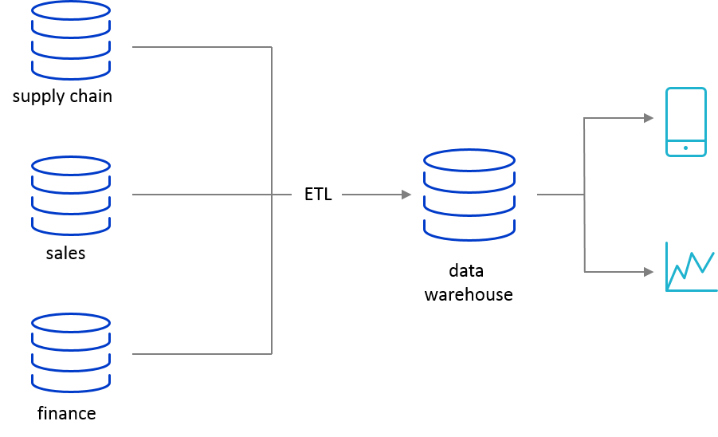
This architecture is rigid, so getting responses quickly can be difficult. The data should be guaranteed to have quality and be secure. There should be some sort of control and governance in place to make sure that the data is seen only by the people that are authorized to access the data.
In this architecture, data is pulled from transactional systems, such as a supply chain, points of sale, or finance systems. The data is extracted, transformed, and loaded (by using ETL tools) into a data warehouse, where the reporting data is stored. Then, reporting and analytics tools point to the reporting data to visualize the data through dashboards and graphs.

Example 2: Big data analytics
This example demonstrates big data analytics. Big data analytics support large unstructured implementations and high demand and can be fast. Figure 2 shows the architecture for this example.
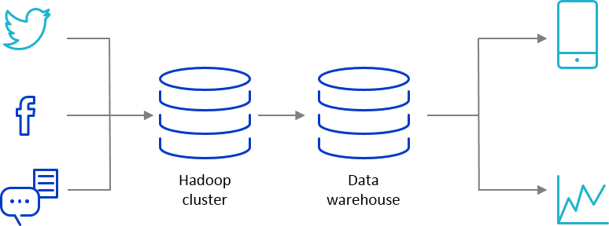
In this example, the data is pulled from Twitter, Facebook, messaging applications, and websites, and then the data is pulled into a Hadoop cluster. Hadoop can ingest large volumes of unstructured data. A subset of the data (after cleaning) which now might be structured, is pulled into a data warehouse that is like the one that is described in Example 1. The reporting data that is stored in the data warehouse is accessed by the reporting tools to visualize the data through dashboards and graphs.

