**Introduction**

The Library Management System (LMS) is a web-based application designed to help libraries manage their day-to-day operations efficiently. This system provides functionalities such as book management, user registration, and borrowing/returning books. Users can browse the catalog, search for books by title, category, or author, and view availability. For library staff, the system offers an administrative interface to manage inventory, update book details, and monitor user activities. The LMS simplifies the management of library resources while providing users with an intuitive and accessible way to engage with the library online.

An essential feature of the LMS is its ability to classify books into categories like Fiction, Comedy, Thriller, and more, enabling better organization of the library’s collection. The LMS ensures accurate tracking of borrowed books and the status of available books, reducing errors and improving efficiency.

An essential feature of the LMS is its ability to classify books into categories like Fiction, Comedy, Thriller, and more, enabling better organization of the library’s collection. The LMS ensures accurate tracking of borrowed books and the status of available books, reducing errors and improving efficiency.

Overall, the Library Management System is designed to enhance user experience, increase operational efficiency, and create a more organized environment for managing a library's resources.

**Requirements**

**1.User Account**

The **User Account** in the Library Management System (LMS) plays a central role in managing interactions between the users and the system. The system aims to create a seamless experience by enabling easy registration, profile management, and access to key library services such as borrowing, reserving, and viewing book details.

#### **Registered Users:**

* **Profile Creation**: Users must register to gain full access to the system's functionalities. During registration, the user is required to provide personal details such as name, email address, contact information, and a password. Upon successful registration, a user profile is created and stored in the database.
* **Login & Authentication**: A registered user can log in with their credentials (username and password). The system securely verifies the credentials before granting access. A registered user can borrow books, view their borrowing history, reserve books, and manage their account details.
* **Borrowing & Reserving Books**: Once logged in, registered users can borrow or reserve available books. They can view their current borrowed books, due dates, and any associated late fees within their account.
* **Account Management**: Registered users can update their profile details, including contact information, password, and preferences. The system provides an option to reset the password in case the user forgets it.

The **User Account** feature ensures that the system remains secure while providing users with personalized services and access to the library’s resources based on their role.

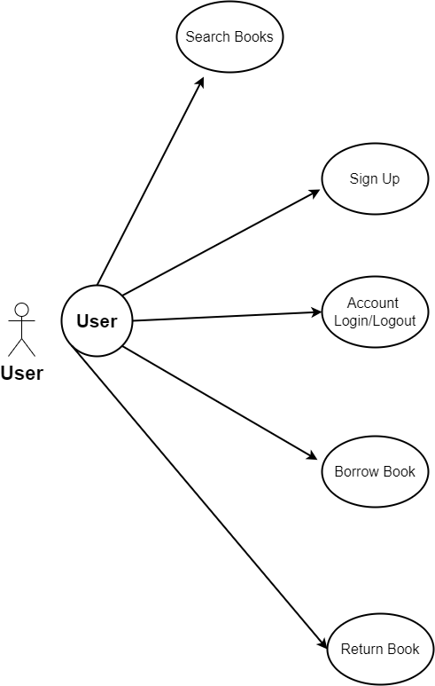

### **2.Registration and User Profile**

The Registration and User Profile feature ensures that only registered users can borrow books. During registration, users are required to provide essential information such as their name, email address, physical address, and a password.

This information is stored securely in the system, creating a personalized user profile. Once registered, users can log in with their credentials to borrow books, view their borrowing history, reserve books, and manage their account details. The profile can be updated to reflect changes in personal information as needed.

### **3.Book Management**

The Book Management module forms the core of the Library Management System, providing essential features for organizing, maintaining, and updating the library's collection. This module ensures that the library’s resources are systematically categorized, allowing for easy access and retrieval of books by both library staff and users.

#### **Key Features:**

1. **Book Categorization**: Books can be classified into various categories like Fiction, Comedy, Thriller, and more, making it easier for users to browse and locate books by genre or category. This structured classification enhances the organization and discoverability of books.
2. **Book Inventory Management**: Library staff have access to an intuitive administrative interface where they can add, update, or remove books from the system. This includes adding new titles, modifying existing entries (such as changing the author, title, or category), and deleting outdated or unavailable books from the catalog.
3. **Tracking Availability**: The system keeps track of each book's status (available, borrowed, reserved) and updates it in real-time. Users can see if a book is currently available for borrowing or reserved by another user, and library staff can monitor the overall inventory and adjust as necessary.
4. **Book Search**: Users can search for books by various attributes such as title, author, ISBN, or category. The search function is optimized to return accurate and quick results, improving the overall user experience.
5. **Borrowing History**: For each book, the system maintains a record of its borrowing history. This feature enables staff to view previous borrowers and understand the book's demand. Users can also see their own borrowing history, ensuring transparency.
6. **Book Details**: Detailed information about each book is available within the system, including the title, author, publication date, genre, description, and current availability. Users can easily access this information when browsing the catalog or searching for specific titles.

The Book Management module significantly improves the efficiency of handling library resources, streamlining operations, and enhancing user satisfaction by providing a well-organized and easily accessible collection.

### **4.Search and Filtering**

The search and filtering feature in the Library Management System (LMS) is designed to enhance user interaction by making it easier to locate specific books in a vast collection. This functionality provides both basic and advanced search options, enabling users to find books based on various criteria such as title, author, category, or other relevant attributes.

**Basic Search:** Users can perform a quick search by entering keywords related to the title or author of a book. The system will scan the database and present a list of matching results. The search results page displays essential book details such as title, author, category, and availability.

**Filtering Options:** Once a search has been performed, users can further refine the results using filtering options. These filters dynamically adjust based on the available books and criteria chosen, such as:

Users can also sort results by factors like publication date, title, or popularity. The filtering options help users quickly find the books that best suit their needs without sifting through irrelevant entries.

### **Implementation**

Behind the scenes, the LMS uses efficient database queries and indexing to support these search and filtering functions. When users perform a search, the system generates SQL queries that pull data from the database in real-time. The results are then displayed to the user in a clean, organized manner, helping them make informed decisions about which books to borrow or reserve.

### **Benefits**

The search and filtering system significantly improves the user experience by reducing the time it takes to find desired books. It also improves the organization of the library's resources by making them more accessible to both regular users and staff.

### **Reporting and Analysis**

The **Reporting and Analysis** feature of the Library Management System (LMS) provides valuable insights into library operations by generating comprehensive reports that track various aspects of library usage and performance. This functionality is crucial for library staff, as it enables them to monitor key metrics, make informed decisions, and improve library services.

#### **Key Reporting Features**

1. **User Activity Reports:** The LMS can generate reports on user activity, such as the number of books borrowed, books returned, overdue books, and reservations made by each user. These reports help librarians keep track of frequent users, assess borrowing patterns, and identify users who may need reminders about overdue books or upcoming due dates.
2. **Borrowing and Circulation Reports:** These reports offer insights into the borrowing habits of users, highlighting trends such as the most popular books, genres, or authors. They can show which categories of books (e.g., Fiction, Thriller, Comedy) are in high demand, as well as seasonal borrowing trends. This helps in optimizing the library’s collection and improving user engagement.
3. **Book Inventory Reports:** Book inventory reports provide detailed information about the library's collection, including the total number of books available, books currently borrowed, damaged or lost books, and newly acquired books. This allows library staff to maintain accurate inventory records, identify gaps in the collection, and make decisions about future acquisitions.
4. **Late Returns and Fine Reports:** The system generates reports that track overdue books and associated fines. It allows staff to monitor users with frequent late returns, calculate accumulated fines, and manage fine collections. These reports also help in identifying areas where lending policies might need adjustment to minimize overdue occurrences.
5. **Financial Reports:** Financial reports provide insights into the library’s income from fines, membership fees, and other revenue streams. These reports help staff manage the library’s budget, assess financial performance, and allocate resources effectively.

### **User Roles and Permissions**

The **User Roles and Permissions** feature of the Library Management System (LMS) is designed to manage user access to different system functionalities based on their roles. By defining specific roles and assigning corresponding permissions, the LMS ensures that each user interacts with the system in accordance with their responsibilities and authority level, which helps maintain security, organization, and operational efficiency.

#### **Key User Roles in the LMS**

1. **Administrator (Admin):**
   * **Role Overview:** Librarians are responsible for the day-to-day management of the library, including assisting users, managing inventory, and handling book circulation. Their role is central to maintaining the smooth operation of the library services.
   * **Permissions:**
     + Add, update, and delete book records, including availability and status of books.
     + Assist users with book borrowing, returns, and reservations.
     + View and manage user accounts and borrowing history.
     + Handle overdue books and apply fines or issue reminders to users.
     + Generate standard reports related to book circulation, user activity, and reservations (but may not have access to higher-level financial or strategic reports).
     + Manage book reservations and notify users when reserved books are available.
     + Update and maintain the classification of books into categories.

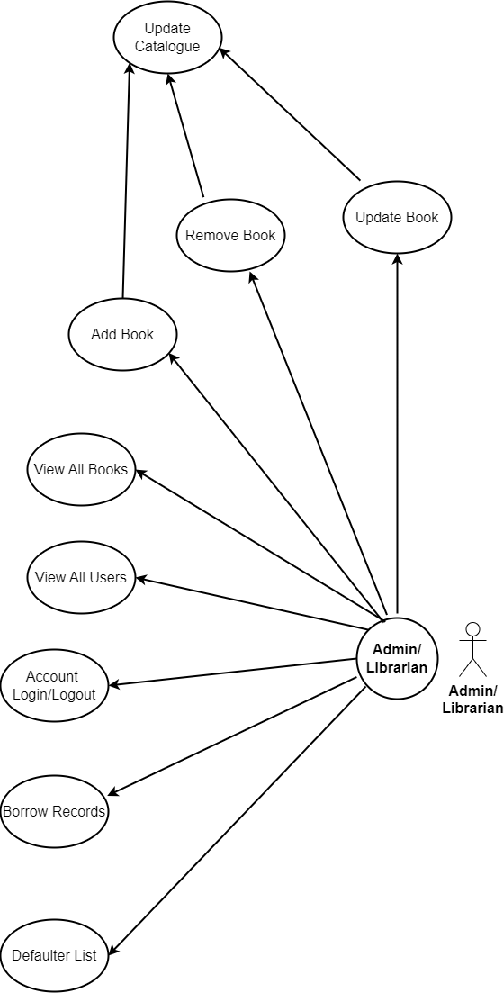

1. **Registered User (Member):**
   * **Role Overview:** Registered Users are library patrons who have created an account in the system. Their primary interaction with the LMS involves browsing the catalog, borrowing books, and managing their personal account.
   * **Permissions:**
     + Browse the library catalog and search for books by title, author, or category.
     + View detailed book information and availability status.
     + Borrow and return books based on their membership privileges.
     + Reserve books that are currently unavailable and receive notifications when they become available.
     + View their own borrowing history, due dates, and any associated late fees.
     + Update personal account details, such as name, address, and password.
     + Pay fines for overdue books if applicable.
     + Submit feedback or requests for new books or services to the library staff.
2. **Guest (Visitor):**
   * **Role Overview:** Guests are users who have not registered an account with the library but may still access limited functionalities within the LMS. Their interaction with the system is typically restricted to browsing and searching the catalog.
   * **Permissions:**
     + Browse the library’s catalog to view available books.
     + Search for books by title, author, or category.
     + View basic information about books but cannot access detailed information like availability status or borrow books.
     + Create an account to transition into a registered user with full access.

#### **Permission Management**

1. **Role-Based Access Control (RBAC):** The LMS typically employs Role-Based Access Control (RBAC), a method that assigns permissions based on roles rather than individuals. This simplifies the process of managing user access, as roles are predefined with their corresponding permissions, and users are assigned roles based on their responsibiities. For example, when a new librarian joins the library, they can be immediately assigned the Librarian role, which automatically grants them the relevant permissions without manual customization.
2. **Security and Accountability:** By implementing strict role-based permissions, the LMS enhances system security. It ensures that users only have access to the features and data they need to fulfill their roles, thereby preventing unauthorized actions like data tampering or access to confidential information. Additionally, assigning specific permissions to each role creates accountability, as user activities are logged and traceable to individual roles.
3. **Custom Roles (Optional):** Some LMS implementations allow for the creation of custom roles, which can be tailored to meet the specific needs of the library. For example, a "Junior Librarian" role might be created with limited permissions compared to a full Librarian, restricting them from deleting books or accessing certain reports.

#### **Benefits of User Roles and Permissions**

1. **Improved Security:** Role-based permissions reduce the risk of unauthorized access to sensitive data and critical system functions, ensuring that only authorized personnel can perform specific tasks.
2. **Operational Efficiency:** By defining roles clearly, the system ensures that users can quickly and efficiently perform their assigned tasks without being overwhelmed by irrelevant features.
3. **User Accountability:** The LMS tracks user actions, providing a clear audit trail that can help resolve disputes, monitor system usage, and identify areas for improvement.
4. **Tailored User Experience:** Each user role is provided with a personalized interface and access to relevant tools, making the system easier to navigate and use effectively.
5. **Scalability:** As the library grows, the RBAC system can easily scale by assigning roles to new staff or modifying existing roles to meet evolving needs without the need for extensive manual configuration.

In summary, the User Roles and Permissions feature of the LMS plays a critical role in organizing the system's access control structure, ensuring secure, efficient, and customized interactions for different user groups within the library.

### **2.2 Non-Functional Requirements**

#### **2.2.1 Interface**

Refer to **Appendix B** for detailed user interfaces.

#### **2.2.2 Performance**

* **Number of Concurrent Users**:  
  The LMS shall be able to handle at least 1000 transactions or inquiries per second. This includes simultaneous user activities such as searching, borrowing, returning, and managing book inventories without performance degradation.
* **System Resilience**:  
  The system is designed to be robust even in the event of temporary server failures. Leveraging the strengths of technologies like Struts 2 and Hibernate, the LMS ensures that transactions (such as borrowing or returning books) can be completed without data loss, even in the case of network or server interruptions. The system will continue its operation seamlessly upon reconnection.

#### **2.2.3 Constraints**

* The LMS shall be capable of handling at least 1000 transactions or inquiries per second without compromising on performance.

#### **2.2.4 Other Requirements:**

* **Hardware Interfaces**:  
  The LMS is expected to function on a system with an Intel Pentium III 900 MHz processor equivalent or above, 128 MB RAM, and 20 GB hard drive space or higher.
* **Software Interfaces**:  
  The LMS shall be compatible with the Microsoft Windows operating system family, including Windows 98, Windows NT Workstation, Windows 2000, and Windows XP. It will be configured to work with an Oracle database and operate on an Apache Tomcat server. The system will also support web browsers such as Internet Explorer 5.0 and above. IIS 5.0 or equivalent servers can also be used for deployment.

3.DESIGN

## 3.1 Database Design

Table1:

Table2:

Table3:

Table4:

Table5:

Table6:

Table7:

.