Homework_5

Shekeira Bryan Oki

11/21/2021

## Load libraries

library(tidyverse)

## -- Attaching packages --------------------------------------- tidyverse 1.3.1 --

## v ggplot2 3.3.5 v purrr 0.3.4  
## v tibble 3.1.5 v dplyr 1.0.7  
## v tidyr 1.1.4 v stringr 1.4.0  
## v readr 2.0.2 v forcats 0.5.1

## -- Conflicts ------------------------------------------ tidyverse_conflicts() --  
## x dplyr::filter() masks stats::filter()  
## x dplyr::lag() masks stats::lag()

library(viridis)

## Loading required package: viridisLite

## Warning: package 'viridisLite' was built under R version 4.1.2

library(tigris)

## To enable   
## caching of data, set `options(tigris_use_cache = TRUE)` in your R script or .Rprofile.

library(sf)

## Linking to GEOS 3.9.1, GDAL 3.2.1, PROJ 7.2.1

library(ggplot2)

##Load data

homicide <- read.csv("homicide-data.csv")

##Chicago homicides

chic_homicide <- homicide %>%  
 filter(city == "Chicago")

##Identify longitude and latitude of Chicago homicides

chic_homs <- st_as_sf(chic_homicide, coords = c("lon", "lat")) %>%  
 st_set_crs(4269)

##Create map of Chicago using SF function

chic_map <- counties(state = "IL", cb = TRUE, class = "sf")

## | | | 0% | | | 1% | |= | 1% | |= | 2% | |== | 2% | |== | 3% | |== | 4% | |=== | 4% | |=== | 5% | |==== | 5% | |==== | 6% | |===== | 7% | |===== | 8% | |====== | 8% | |====== | 9% | |======= | 9% | |======= | 10% | |======= | 11% | |======== | 11% | |======== | 12% | |========= | 12% | |========= | 13% | |========== | 14% | |========== | 15% | |=========== | 15% | |=========== | 16% | |============ | 16% | |============ | 17% | |============ | 18% | |============= | 18% | |============= | 19% | |============== | 19% | |============== | 20% | |=============== | 21% | |=============== | 22% | |================ | 22% | |================ | 23% | |================= | 24% | |================= | 25% | |================== | 25% | |================== | 26% | |=================== | 27% | |=================== | 28% | |==================== | 28% | |==================== | 29% | |===================== | 29% | |===================== | 30% | |===================== | 31% | |====================== | 31% | |====================== | 32% | |======================= | 32% | |======================= | 33% | |======================= | 34% | |======================== | 34% | |======================== | 35% | |========================= | 35% | |========================= | 36% | |========================== | 37% | |========================== | 38% | |=========================== | 38% | |=========================== | 39% | |============================ | 40% | |============================= | 41% | |============================= | 42% | |============================== | 42% | |============================== | 43% | |============================== | 44% | |=============================== | 44% | |=============================== | 45% | |================================ | 45% | |================================ | 46% | |================================= | 47% | |================================= | 48% | |================================== | 48% | |================================== | 49% | |=================================== | 49% | |=================================== | 50% | |=================================== | 51% | |==================================== | 51% | |==================================== | 52% | |===================================== | 52% | |===================================== | 53% | |====================================== | 54% | |====================================== | 55% | |======================================= | 55% | |======================================= | 56% | |======================================== | 57% | |======================================== | 58% | |========================================= | 58% | |========================================= | 59% | |========================================== | 59% | |========================================== | 60% | |========================================== | 61% | |=========================================== | 61% | |=========================================== | 62% | |============================================ | 62% | |============================================ | 63% | |============================================= | 64% | |============================================= | 65% | |============================================== | 65% | |============================================== | 66% | |=============================================== | 67% | |=============================================== | 68% | |================================================ | 68% | |================================================ | 69% | |================================================= | 69% | |================================================= | 70% | |================================================= | 71% | |================================================== | 71% | |================================================== | 72% | |=================================================== | 72% | |=================================================== | 73% | |==================================================== | 74% | |==================================================== | 75% | |===================================================== | 75% | |===================================================== | 76% | |====================================================== | 77% | |====================================================== | 78% | |======================================================= | 78% | |======================================================= | 79% | |======================================================== | 79% | |======================================================== | 80% | |======================================================== | 81% | |========================================================= | 81% | |========================================================= | 82% | |========================================================== | 82% | |========================================================== | 83% | |========================================================== | 84% | |=========================================================== | 84% | |=========================================================== | 85% | |============================================================ | 85% | |============================================================ | 86% | |============================================================= | 86% | |============================================================= | 87% | |============================================================= | 88% | |============================================================== | 88% | |============================================================== | 89% | |=============================================================== | 90% | |================================================================ | 91% | |================================================================ | 92% | |================================================================= | 92% | |================================================================= | 93% | |================================================================== | 94% | |================================================================== | 95% | |=================================================================== | 95% | |=================================================================== | 96% | |==================================================================== | 96% | |==================================================================== | 97% | |==================================================================== | 98% | |===================================================================== | 98% | |===================================================================== | 99% | |======================================================================| 99% | |======================================================================| 100%

chic_map <- chic_map %>%  
 filter(COUNTYFP == "031")

##Create plot

ggplot() +  
 geom_sf(data = chic_map) +  
 geom_sf(data = chic_homs, aes(color = disposition))

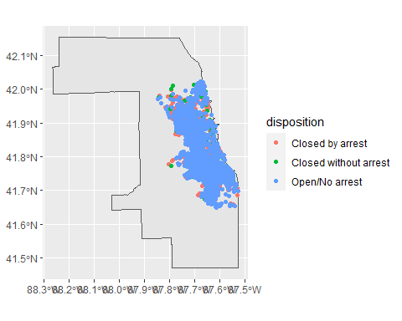 ##Load forcats

library(forcats)

#Map of 3 race groups with highest homicides

chic_homs %>%  
 mutate(victim_race = fct_lump(victim_race, n = 3)) %>%  
 ggplot +  
 geom_sf(data = chic_map) +  
 geom_sf(aes(color = victim_race))

