**Experiment No. 2(B)**

**Title:** Using a Network Simulator (e.g. packet tracer) Configure Routing Protocols

b) OSPF – Explore Neighbor-ship Condition and Requirement, Neighbor-ship states, OSPF Metric Cost Calculation

**Aim** :Study and configuration of OSPF routing protocol.

**Objective:** configuration of OSPF routing protocol using Packet Tracer.

**Theory** **:**

OSPF :

**Open Shortest Path First** (**OSPF**) is a [routing protocol](https://en.wikipedia.org/wiki/Routing_protocol) for [Internet Protocol](https://en.wikipedia.org/wiki/Internet_Protocol) (IP) networks. It uses a [link state routing](https://en.wikipedia.org/wiki/Link-state_routing_protocol) (LSR) algorithm and falls into the group of [interior gateway protocols](https://en.wikipedia.org/wiki/Interior_gateway_protocol) (IGPs), operating within a single [autonomous system](https://en.wikipedia.org/wiki/Autonomous_system_(Internet)) (AS).

OSPF gathers link state information from available routers and constructs a topology map of the network. The topology is presented as a routing table to the [Internet Layer](https://en.wikipedia.org/wiki/Internet_Layer) for routing packets by their destination [IP address](https://en.wikipedia.org/wiki/IP_address). OSPF supports [Internet Protocol Version 4](https://en.wikipedia.org/wiki/IPv4) (IPv4) and [Internet Protocol Version 6](https://en.wikipedia.org/wiki/IPv6) (IPv6) networks and supports the [Classless Inter-Domain Routing](https://en.wikipedia.org/wiki/Classless_Inter-Domain_Routing) (CIDR) addressing model.

OSPF is an [interior gateway protocol](https://en.wikipedia.org/wiki/Interior_gateway_protocol) (IGP) for routing [Internet Protocol](https://en.wikipedia.org/wiki/Internet_Protocol) (IP) packets within a single routing domain, such as an [autonomous system](https://en.wikipedia.org/wiki/Autonomous_system_(Internet)). It gathers link state information from available routers and constructs a topology map of the network. The topology is presented as a routing table to the [Internet Layer](https://en.wikipedia.org/wiki/Internet_Layer) which routes packets based solely on their destination [IP address](https://en.wikipedia.org/wiki/IP_address).

OSPF detects changes in the topology, such as link failures, and [converges](https://en.wikipedia.org/wiki/Convergence_(routing)) on a new loop-free routing structure within seconds. It computes the [shortest-path tree](https://en.wikipedia.org/wiki/Shortest-path_tree) for each route using a method based on [Dijkstra's algorithm](https://en.wikipedia.org/wiki/Dijkstra%27s_algorithm). The OSPF routing policies for constructing a route table are governed by link [metrics](https://en.wikipedia.org/wiki/Metrics_(networking)) associated with each routing interface. Cost factors may be the distance of a router ([round-trip time](https://en.wikipedia.org/wiki/Round-trip_time)), data throughput of a link, or link availability and reliability, expressed as simple unitless numbers. This provides a dynamic process of traffic load balancing between routes of equal cost.

OSPF divides the network into routing *areas* to simplify administration and optimize traffic and resource utilization. Areas are identified by 32-bit numbers, expressed either simply in decimal, or often in the same octet-based [dot-decimal notation](https://en.wikipedia.org/wiki/Dot-decimal_notation) used for IPv4 addresses. By convention, area 0 (zero), or 0.0.0.0, represents the core or *backbone* area of an OSPF network. While the identifications of other areas may be chosen at will, administrators often select the IP address of a main router in an area as the area identifier. Each additional area must have a connection to the OSPF backbone area. Such connections are maintained by an interconnecting router, known as an area border router (ABR). An ABR maintains separate link-state databases for each area it serves and maintains [summarized routes](https://en.wikipedia.org/wiki/Route_summarization) for all areas in the network.

OSPF runs over [Internet Protocol Version 4](https://en.wikipedia.org/wiki/IPv4) (IPv4) and [Internet Protocol Version 6](https://en.wikipedia.org/wiki/IPv6) (IPv6), but does not use a [transport protocol](https://en.wikipedia.org/wiki/Transport_protocol), such as [UDP](https://en.wikipedia.org/wiki/User_datagram_protocol) or [TCP](https://en.wikipedia.org/wiki/Transmission_control_protocol). It encapsulates its data directly in IP packets with [protocol number 89](https://en.wikipedia.org/wiki/List_of_IP_protocol_numbers). This is in contrast to other routing protocols, such as the [Routing Information Protocol](https://en.wikipedia.org/wiki/Routing_Information_Protocol) (RIP) and the [Border Gateway Protocol](https://en.wikipedia.org/wiki/Border_Gateway_Protocol) (BGP). OSPF implements its own transport error detection and correction functions. OSPF uses [multicast](https://en.wikipedia.org/wiki/Multicast) addressing for distributing route information within a broadcast domain. It reserves the [multicast addresses](https://en.wikipedia.org/wiki/Multicast_address) 224.0.0.5 (IPv4) and FF02::5 (IPv6) for all SPF/link state routers (AllSPFRouters) and 224.0.0.6 (IPv4) and FF02::6 (IPv6) for all Designated Routers (AllDRouters). For non-broadcast networks, special provisions for configuration facilitate neighbor discovery. OSPF multicast IP packets never traverse IP routers, they never travel more than one hop. The protocol may therefore be considered a link layer protocol, but is often also attributed to the application layer in the TCP/IP model

OSPF Characteristics:

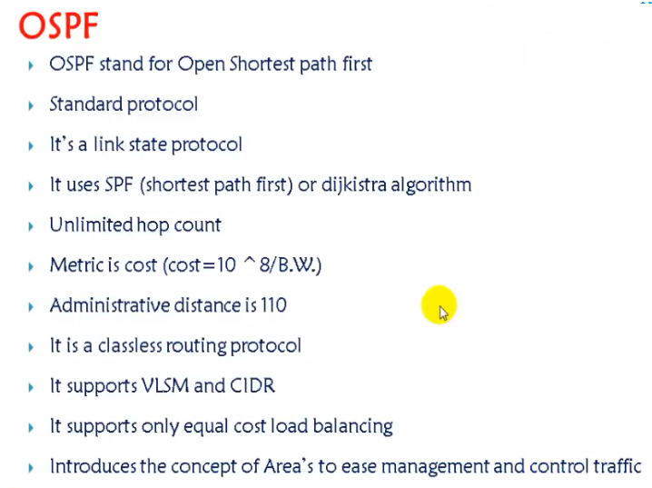

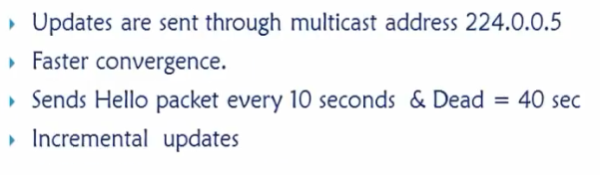

Administrative distance (AD) or route preference is **a number of arbitrary unit assigned to dynamic routes, static routes and directly-connected routes**. The value is used in routers to rank routes from most preferred (low AD value) to least preferred (high AD value).

Administrative Distance (AD) is **used to rate the trustworthiness of routing information received from the neighbor router**. The route with the least AD will be selected as the best route to reach the destination remote network and that route will be placed in the routing table.

The range for administrative distance is 0–255. The default value is **120 for RIP routes** and 110 for OSPF routes.

**OSPF Basic Process:**

The entire OSPF process goes from 7 Stages.

1.Down Stage

2.Init

3.Two-way

4.ExStart

5.Exchange

6.Loading

7.Full

1.Down State- In this stage both router A and B do not know about each other.

2.Init State: Here both routers advertize themselves on interfaces using commands. Both routers send and receive HELLO Messages to each other.

3.Two Way State: Here both routers established neighborship relationship and build neighbor Table.To verify this we can use router# sh ip ospf neighbor command.

Before we move to next state , we must understand the concept of Router ID.

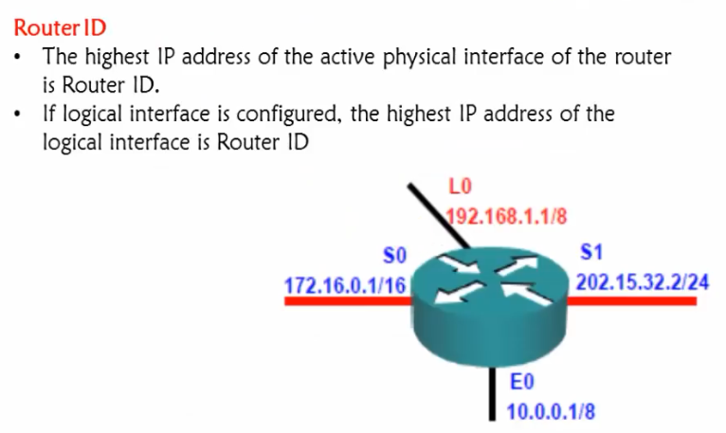

Her we have three physical interface S0,S1,E0.S1 has highest physical address and that is Router ID (202.15.32.2).

Here L0 is the logical interfaces.in such situation it takes manual ip as router id . If Manually ip is not given then it takes highest loop back ip as router id.

If there is no Manual ip ,no loop back ip then it will take highest ip of Physical interface as router id.Router id is a name which unique in OSPF database. In whatever direction we interact with router,the name(router id) remain the same.

4.ExStart State:

Here both router wants to start the communication and send message to other that I will start exchange because my router id is X.x.x.x.

Then here these router decides who will start to send message based on their router id. The router with highest router id will start to send message. Here it is router B with router id 172.16.5.3 which highest.

In stage routers not actually exchange the messages but they decide to exchange the messages.

DBD means Database description.

5. Exchange stage:

Actual transmission is happened in exchange state.Thet exchange summary of their own Linj state databases (LSDB). Her router B sends first and then A sends.

6.Loading State.:

In this stage each router A and B compares its own database with received information of neighbors . Both routers ensures they have same synchronized database. If there is any extra entry in any side then that router request that additional information from other side.

This process happened at both routers side.

Here router A request (LSR-Link state Request) for information for 172.16.6.0 from B and then B sends as LSU (Link state Update) to A. A then send LSACK to B.

7. Full State: Here both routers have same synchronized database. Based on this database it will going to calculate Best route.The formula is 10^8/BW.

Best route =10^8/BW.

Writing that best route in routing table and based on this forwarding happened.

**OSPF Tables:**

NNeOther

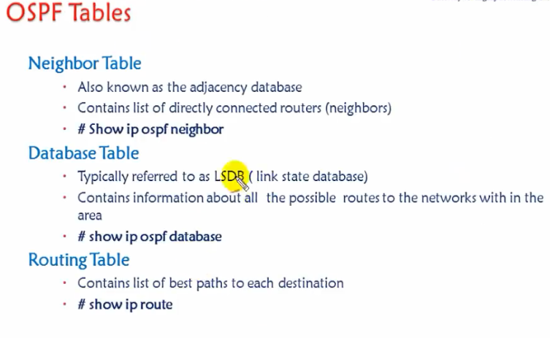

**Other Tables explanation is same as that of EIGRP but only difference in Database table. So we will discuss Database table here.**

**Database table:**

**Here Database table contains all routes .**

Here in OSPF neighbor exchange all routes. But in EIGRP neighbor exchange only best route.This is the difference.In OSPF, all routers must have same database maintained at their side.

OSPF is Link State routing protocol so maintained all link info.

This is the major difference between OSPF Database Table and EIGRP Topology Table.

**Concept of OSPF Areas:**

* All routers must maintain same database.
* Any change impact all the routers
* Area is logical grouping of routers

Why we require Areas:

Some times routers running out of memory so they may go down.So if this happened we are unable to communicate. So to avoid this we use concept of Areas.

Also When we make any change like adding new router ,so this we need to tell all the routers this will create problem like routers need to recalculate route etc . so to avoid this we need to use Areas.

Solution is grouping routers logically as follows-

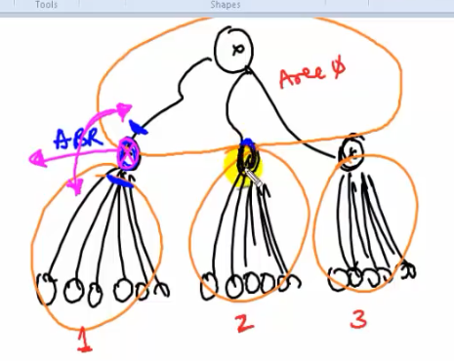

Here Area 1 ,router only take care of those area routers,so it minimizes the size of database and cjange will be restrcuted to that area only.

ABR means Area border router. We must have atleast one ABR.

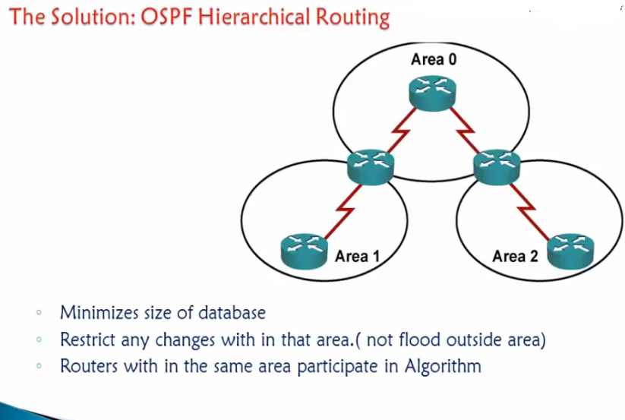

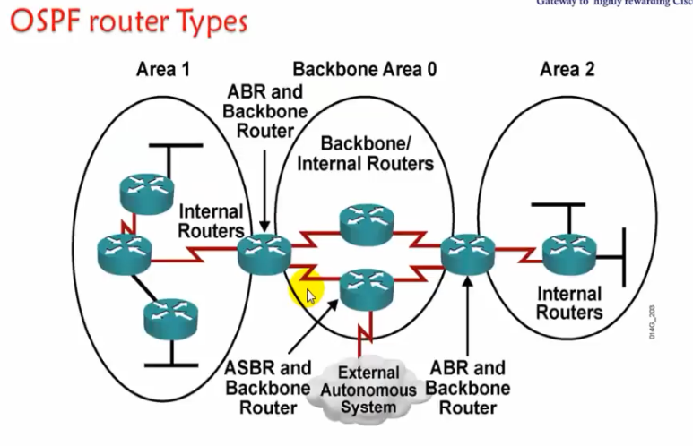

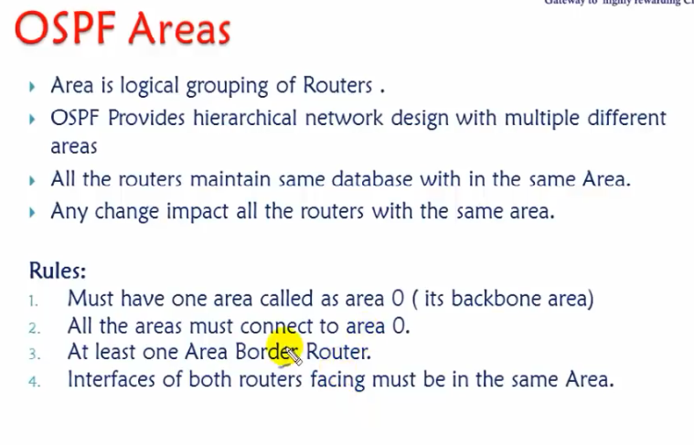

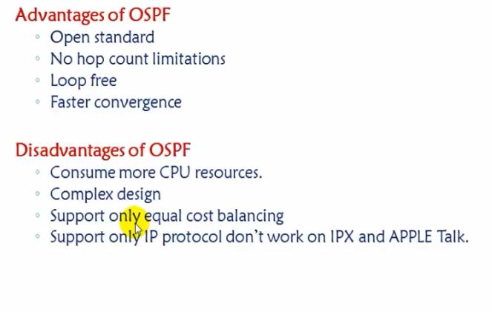

**Our Practical Example/Scenario**

**1.Consider following network design**

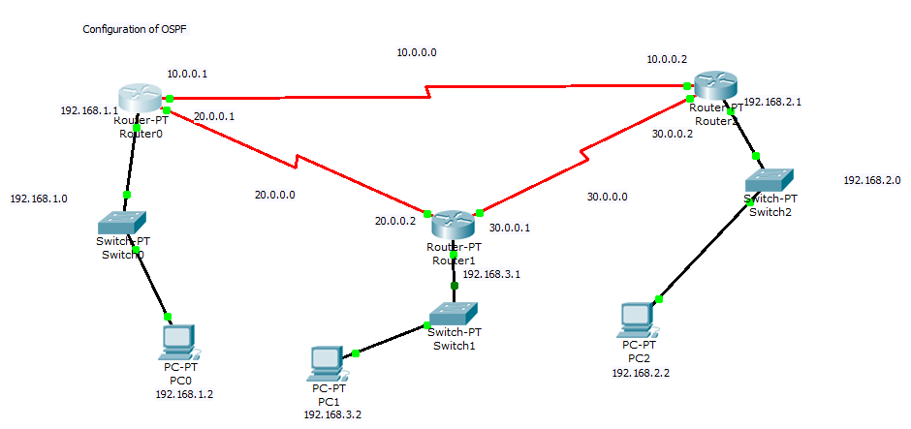

**OUTPUTs:**

Now to very the neighborship, go to router 1 and very neighborship.

Router#sh ip ospf neighbor

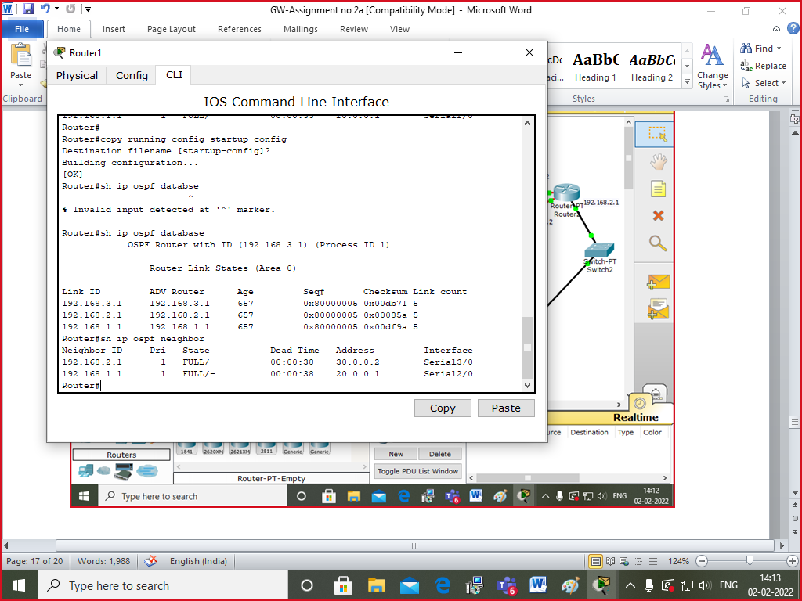

It shows following output-

Neighbor ID Pri State Dead Time Address Interface

192.168.1.1 1 FULL/- 00:00:34 20.0.0.1 Serial2/0

192.168.2.1 1 FULL/- 00:00:39 30.0.0.2 Serial3/0

Router#

Router#

There are two neighbors. Here it takes highest ip address from interfaces. That’s why is 192.168.1.1 and 192.168.2.1 and they are router ids.

4. Now to check the metric and cost

Click on router 0->

**Router#sh ip route**

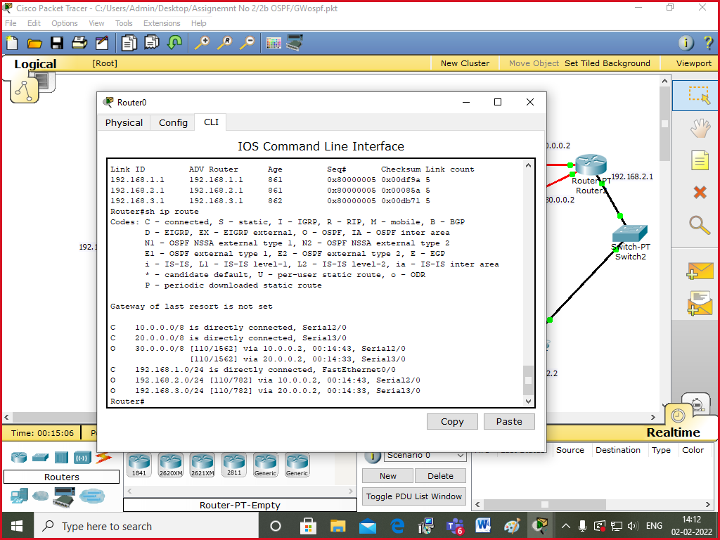

Following output came.

Codes: C - connected, S - static, I - IGRP, R - RIP, M - mobile, B - BGP

D - EIGRP, EX - EIGRP external, O - OSPF, IA - OSPF inter area

N1 - OSPF NSSA external type 1, N2 - OSPF NSSA external type 2

E1 - OSPF external type 1, E2 - OSPF external type 2, E - EGP

i - IS-IS, L1 - IS-IS level-1, L2 - IS-IS level-2, ia - IS-IS inter area

* - candidate default, U - per-user static route, o - ODR

P - periodic downloaded static route

Gateway of last resort is not set

C 10.0.0.0/8 is directly connected, Serial2/0

C 20.0.0.0/8 is directly connected, Serial3/0

O 30.0.0.0/8 [110/1562] via 20.0.0.2, 00:12:50, Serial3/0

[110/1562] via 10.0.0.2, 00:09:08, Serial2/0

C 192.168.1.0/24 is directly connected, FastEthernet0/0

**O**  192.168.2.0/24 [**110/782**] via 10.0.0.2, 00:09:19, Serial2/0

O 192.168.3.0/24 [110/782] via 20.0.0.2, 00:13:12, Serial3/0

Router#

Here,

O means it leans through OSPF.

Here ,110 is the administrative distance and 782 is the cost based on bandwidth.

Cost is calculated as 10^8/BW.

5. We can very database table at router0.

**Router#sh ip ospf database**

**This is the output-**

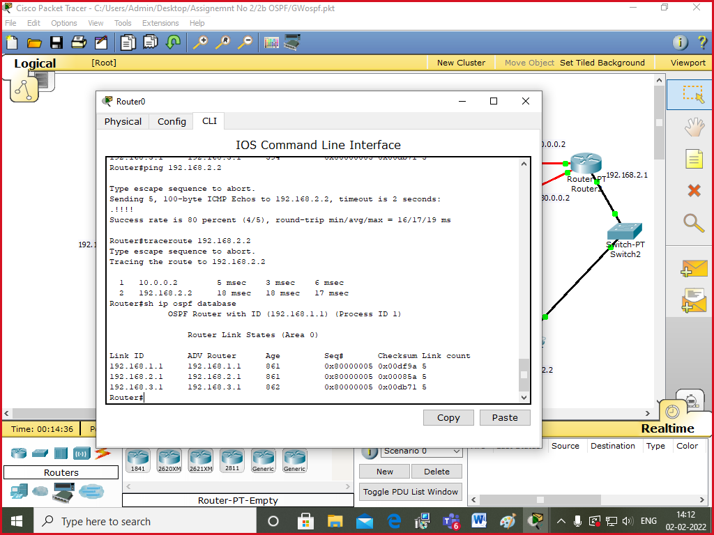

OSPF Router with ID (192.168.1.1) (Process ID 1)

Router Link States (Area 0)

Link ID ADV Router Age Seq# Checksum Link count

192.168.1.1 192.168.1.1 851 0x80000005 0x00d9a0 5

192.168.2.1 192.168.2.1 832 0x80000005 0x00085a 5

192.168.3.1 192.168.3.1 832 0x80000005 0x00bd8f 5

Router#

This means that router 0 belongs to Area 0 , so it maintains the database of area0.

Router id of router 0 is 192.168.1.1 and runs process-id 1.

6. you can go to router0 and ping 192.168.2.2

Router# ping 192.168.2.2

It will show success.

Router#traceroute 192.168.2.2

Output :

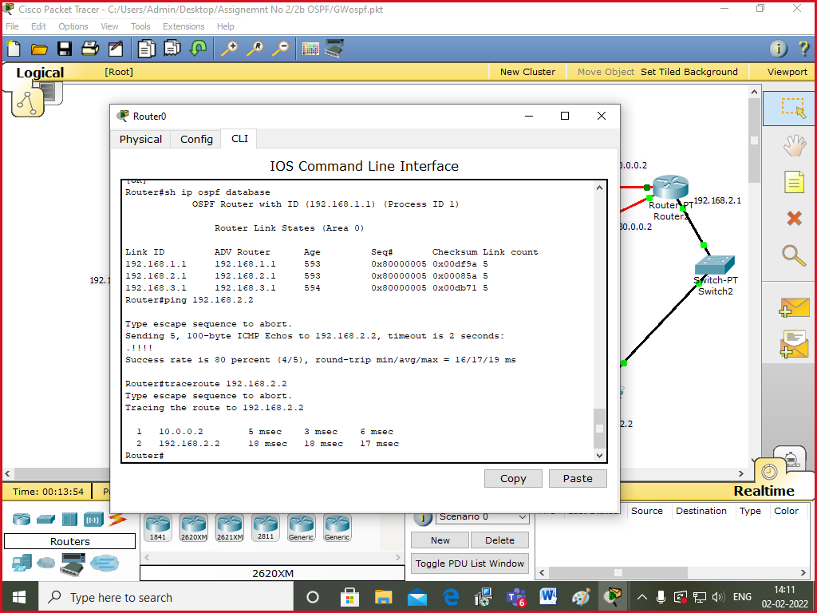

Input: Packet

Output: Packet Reached to destination using OSPF routing protocol giving the route to destination and cost value.

Conclusion: Designed network using packet tracer to configure OSPF routing protocol.