1. A toy vendor supplies three types of toys: Battery Based Toys, Key-based Toys, and Electrical Charging Based Toys. The vendor gives a discount of 10% on orders for battery-based toys if the order is for more than Rs. 1000. On orders of more than Rs. 100 for key-based toys, a discount of 5% is given, and a discount of 10% is given on orders for electrical charging based toys of value more than Rs. 500. Assume that the numeric codes 1,2 and 3 are used for battery based toys, key-based toys, and electrical charging based toys respectively. Write a program that reads the product code and the order amount and prints out the net amount that the customer is required to pay after the discount.

* **Program:**

|  |  |
| --- | --- |
| * **With if-elif:**   print (“To buy battery based toys enter code 1.”)  print (“To buy key based toys enter code 2.”)  print (“To buy electrically chargeable toys enter code 3.”)  code = int(input(“Please enter a toy code: “))  amount = int(input(“Please enter order amount in Rs: “))  # For battery based toys  if code == 1:  print (“You are buying battery based toys.”)  if code == 1 and amount > 1000:  print(“You get 10% discount. Bill amount is Rs: “, amount – (amount * 0.1))  else:  print (“Bill amount is Rs: “, amount)  # For key based toys  elif code == 2:  print (“You are buying key based toys.”)  if code == 2 and amount > 100:  print(“You get 10% discount. Bill amount is Rs: “, amount – (amount * 0.05))  else:  print (“Bill amount is Rs: “, amount)  # For electrically chargeable toys  elif code == 3:  print (“You are buying electrically chargeable toys.”)  if code == 3 and amount > 500:  print(“You get 10% discount. Bill amount is Rs: “, amount – (amount * 0.1))  else:  print (“Bill amount is Rs: “, amount)  else:  print (“No entry found in product data base”) | * **With function:**   print ("To buy battery based toys enter code 1.")  print ("To buy key based toys enter code 2.")  print ("To buy electrically chargeable toys enter code 3.")  code = int(input("Enter the toy code: "))  amount = int(input("Please enter order amount in Rs: "))  def discount():  if code == 1:  if amount > 1000:  a = amount * 0.1  else:  a = 0  elif code == 2:  if amount > 100:  a = amount * 0.05  else:  a = 0  elif code == 3:  if amount > 500:  a = amount * 0.1  else:  a = 0  else:  print ("No entry found in product data base")  return a    net_amount= amount - discount()  print ("Bill amount is Rs: ", net_amount) |
| * **Output:**   To buy battery based toys enter code 1.  To buy key based toys enter code 2.  To buy electrically chargeable toys enter code 3.  Please enter a toy code: 3  Please enter order amount in Rs: 550  You get 10% discount. Bill amount is Rs: 495.0 | * **Output:**   To buy battery based toys enter code 1.  To buy key based toys enter code 2.  To buy electrically chargeable toys enter code 3.  Enter the toy code: 1  Please enter order amount in Rs: 2100  Bill amount is Rs: 1890.0 |

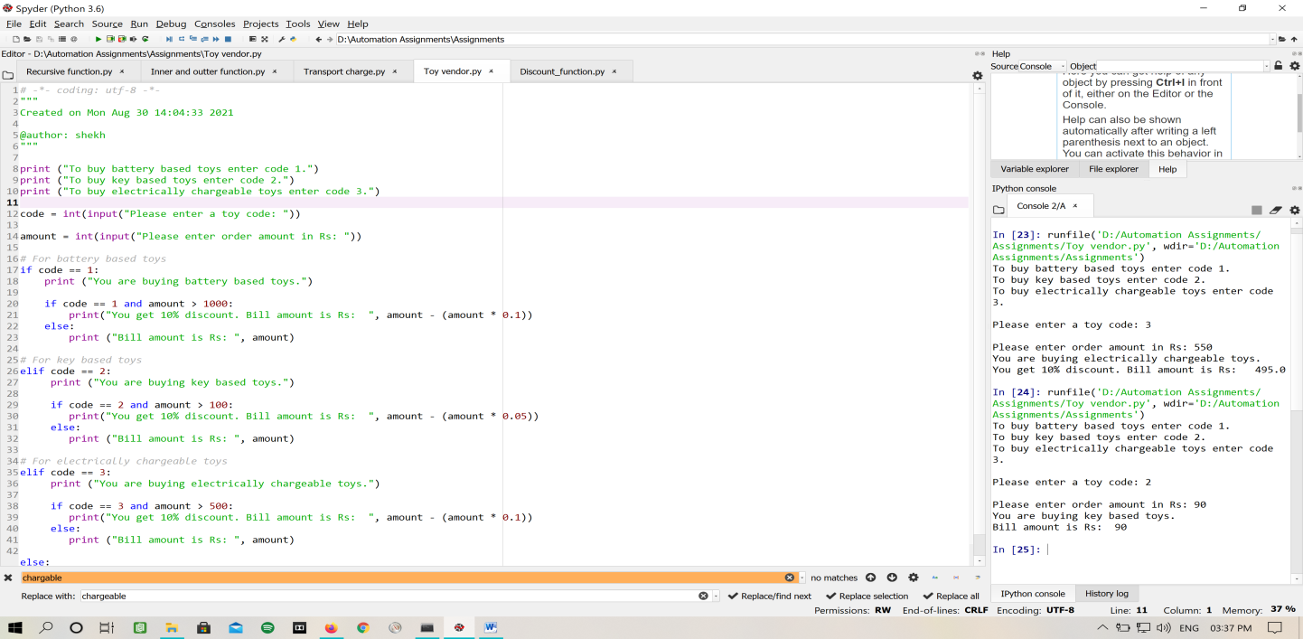

Figure : If-elif

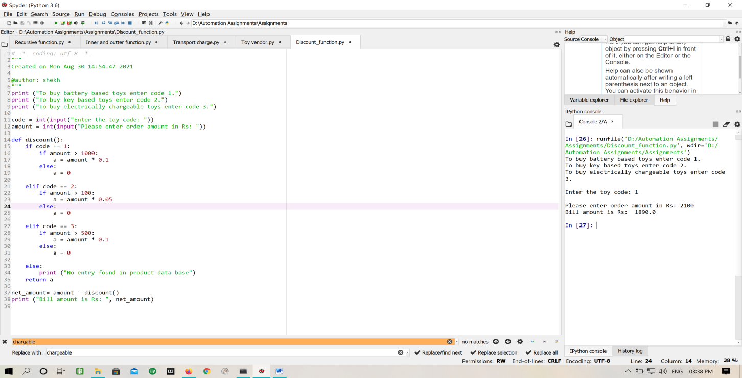

Figure : With Function

2. A transport company charges the fare according to following table:

|  |  |
| --- | --- |
| Distance | Charges |
| 1-50 | 8 Rs./Km |
| 51-100 | 10 Rs./Km |
| > 100 | 12 Rs/Km |

Ask user to enter the distance and compute the fare.

* **Program:**

km = int(input("Please enter the distance in kilometers to calculate fare: "))

if km in range(1,50):

print("The fare is: ", km * 8)

elif km in range(51,100):

print("The fare is: ", km * 10)

elif km > 100:

print("The fare is: ", km * 12)

else:

print("Please enter a valid number")

* **Output:**

Please enter the distance in kilometers to calculate fare: 52

The fare is: 520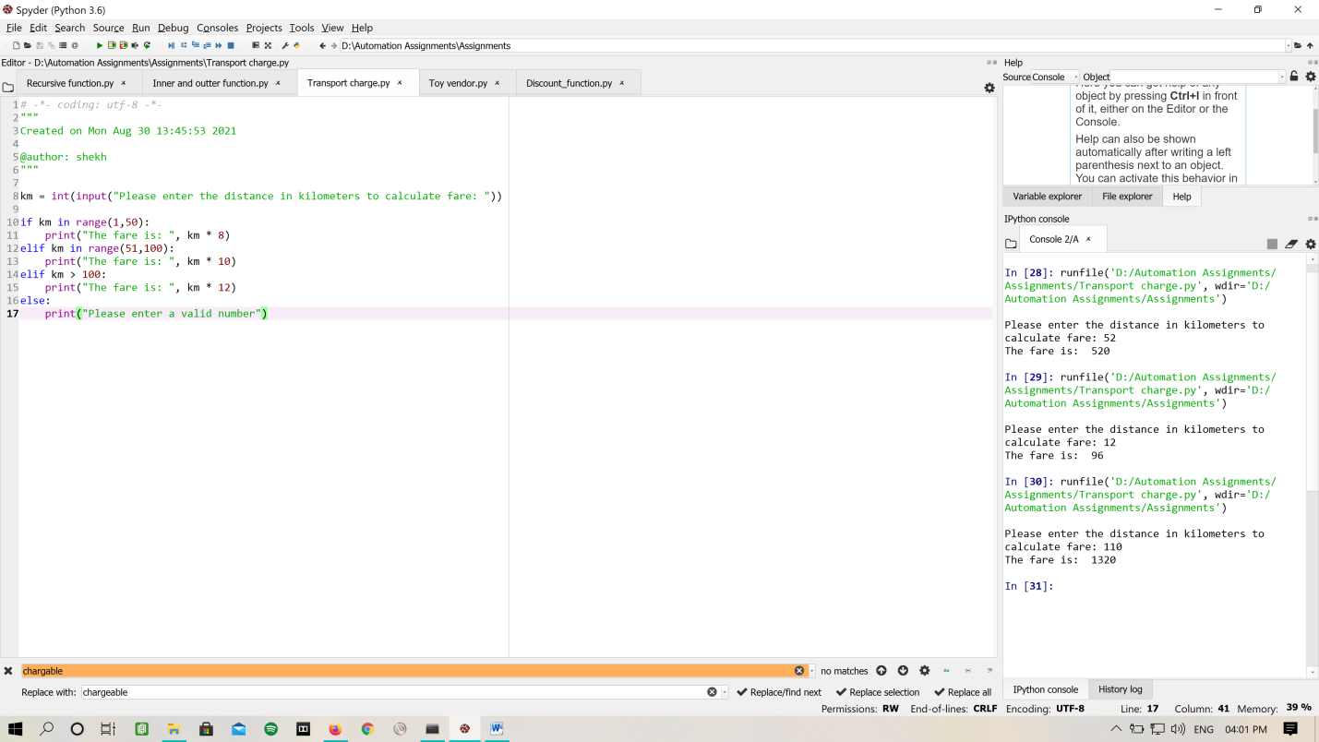

Figure : Travel Fare

3. Create an inner function to calculate the addition in the following way

* Create an outer function that will accept two parameters, a and b
* Create an inner function inside an outer function that will calculate the addition of a and b
* At last, an outer function will add 5 into addition and return it
* **Program:**

num1 = int(input("Enter first number: "))

num2 = int(input("Enter second number: "))

def out_fun(a, b):

def in_fun(a,b):

return a + b

return in_fun(a,b) + 5

print ("The sum of two number with increment of 5 is: ", out_fun(num1, num2))

* **Output:**

Enter first number: 2

Enter second number: 3

The sum of two numbers with increment of 5 is: 10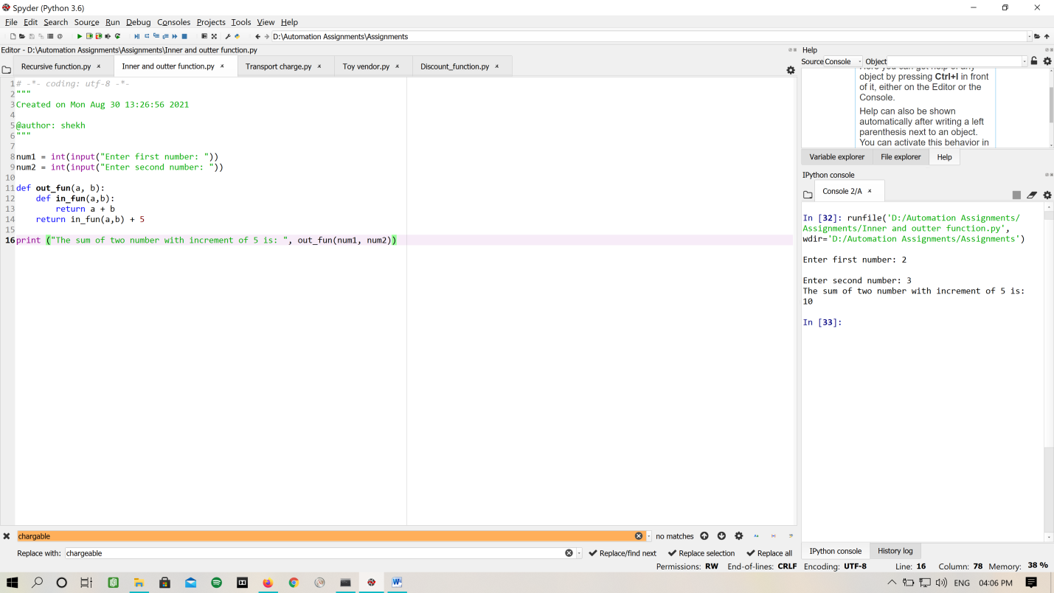

Figure : Inner-Outer Function

4. Write a recursive function to calculate the sum of numbers from 0 to 10

Expected Output:

55

* **Program:**

a = int(input("Please enter a number: "))

def recursive(a):

if a == 1:

return a

else:

return a + recursive(a - 1)

print("The sum is: ", recursive(a))

* **Output**

Please enter a number: 10

The sum is: 55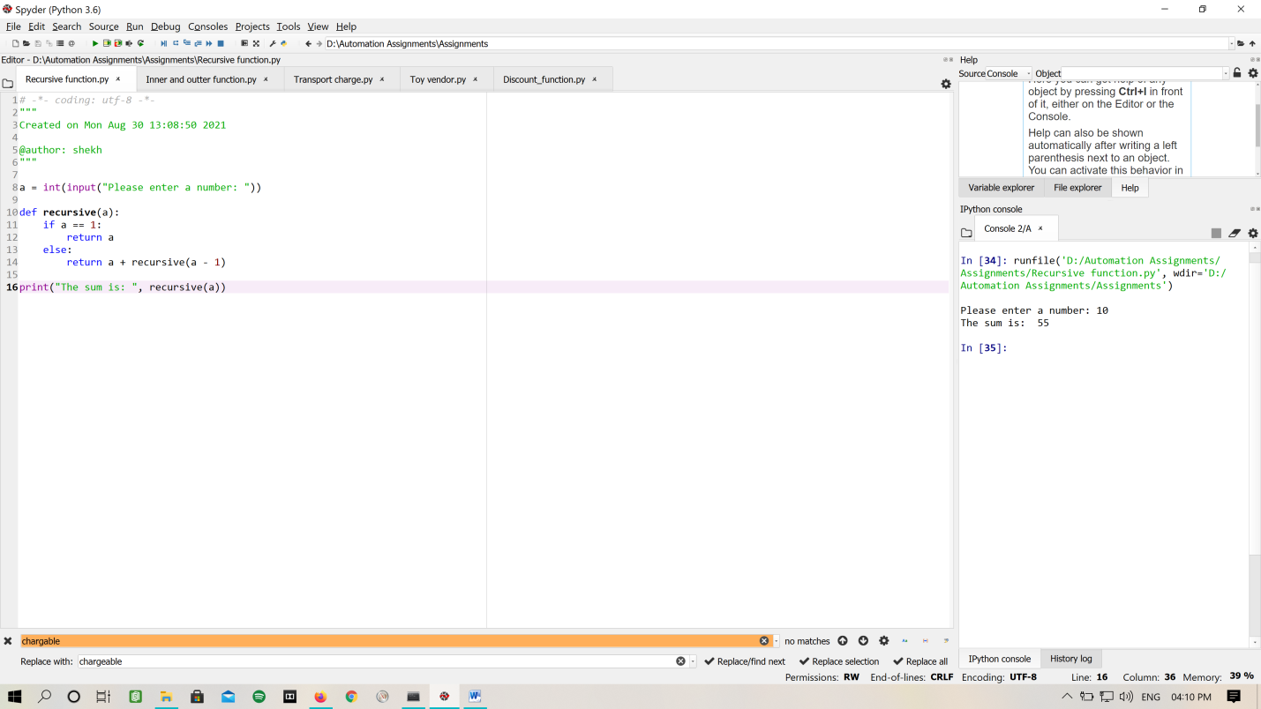

Figure : Recursive Function