**Assignment 1: Selenium IDE practice**

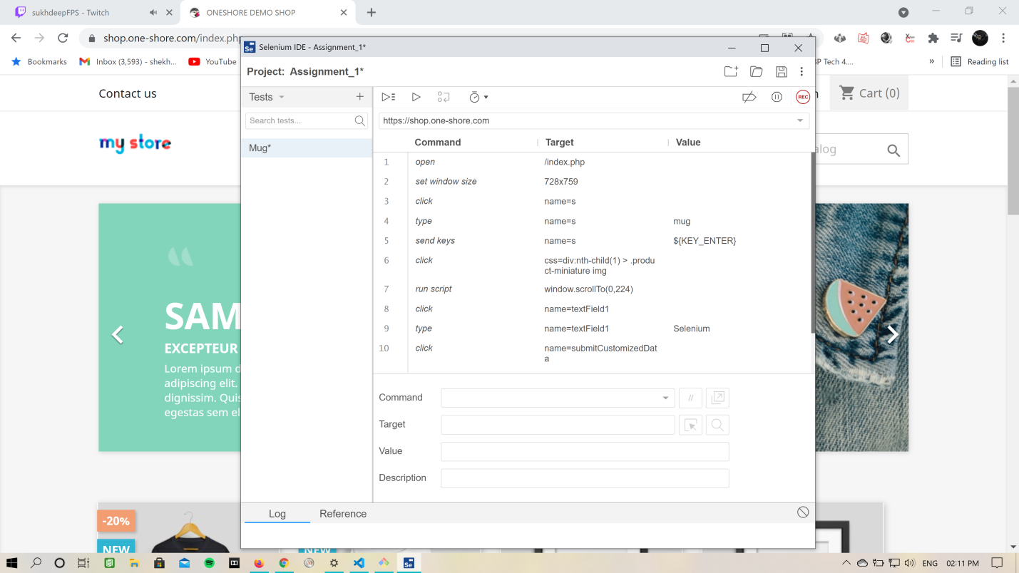

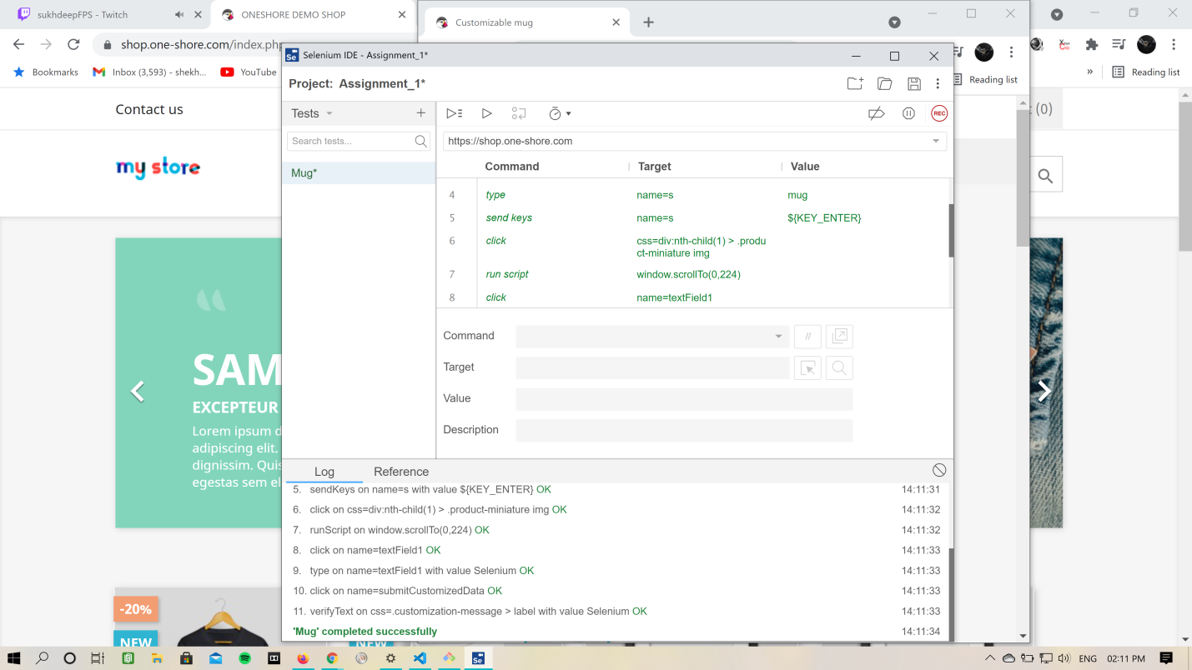

# Generated by Selenium IDE

import pytest

import time

import json

from selenium import webdriver

from selenium.webdriver.common.by import By

from selenium.webdriver.common.action_chains import ActionChains

from selenium.webdriver.support import expected_conditions

from selenium.webdriver.support.wait import WebDriverWait

from selenium.webdriver.common.keys import Keys

from selenium.webdriver.common.desired_capabilities import DesiredCapabilities

class TestMug():

def setup_method(self, method):

self.driver = webdriver.Chrome()

self.vars = {}

def teardown_method(self, method):

self.driver.quit()

def test_mug(self):

self.driver.get("https://shop.one-shore.com/index.php")

self.driver.set_window_size(728, 759)

self.driver.find_element(By.NAME, "s").click()

self.driver.find_element(By.NAME, "s").send_keys("mug")

self.driver.find_element(By.NAME, "s").send_keys(Keys.ENTER)

self.driver.find_element(By.CSS_SELECTOR, "div:nth-child(1) > .product-miniature img").click()

self.driver.execute_script("window.scrollTo(0,224)")

self.driver.find_element(By.NAME, "textField1").click()

self.driver.find_element(By.NAME, "textField1").send_keys("Selenium")

self.driver.find_element(By.NAME, "submitCustomizedData").click()

assert self.driver.find_element(By.CSS_SELECTOR, ".customization-message > label").text == "Selenium"