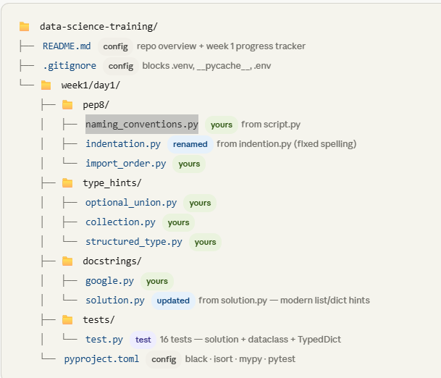

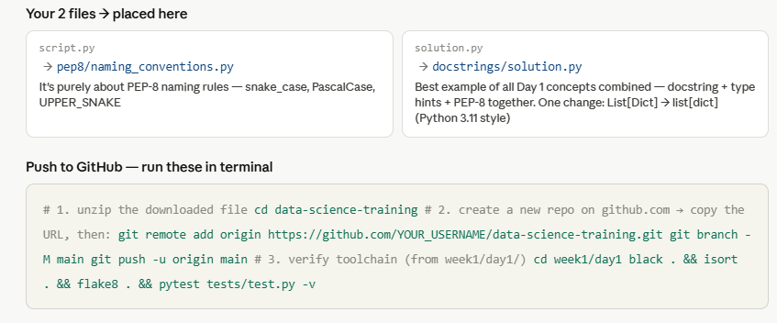

git remote add origin https://github.com/YOUR_USERNAME/data-science-training.git git branch -M main git push -u origin main
flake8 — linter (read-only, never changes your code)
Reads your code and reports every PEP-8 violation, undefined name, and unused import. It never changes anything — it only tells you what's wrong, and where. You fix it manually or let black fix the style issues.

Real-world analogy: A spell-checker that underlines mistakes in red but doesn't auto-correct. You still have to fix them.

Commands
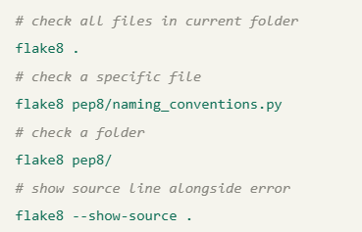

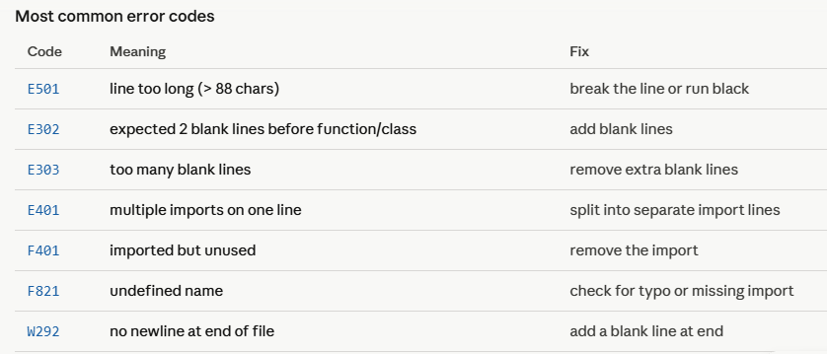

The key mental model to remember:
black and isort are fixers — they modify your files automatically. Run them first. flake8 and mypy are reporters — they only tell you what's wrong, never change anything. Run them after. pre-commit is the enforcer — it runs all four automatically before every git commit so nothing bad ever reaches GitHub.
The correct order every time is always: black → isort → flake8 → mypy. Never the other way around, because running flake8 before black means you'd manually fix errors that black would have auto-corrected in 2 seconds.

# 1. create virtual environment
python -m venv .venv

# 2. activate it
.venv\Scripts\Activate.ps1

# 3. install all tools inside it
pip install flake8 black isort mypy pytest

# 4. now run flake8
flake8 script.py

Set-ExecutionPolicy -ExecutionPolicy RemoteSigned -Scope CurrentUser

black script.py
Black will add all the blank lines and the end-of-file newline in one shot. Then rerun flake8 to confirm:

flake8 script.py
No output = all 6 errors fixed. ✅

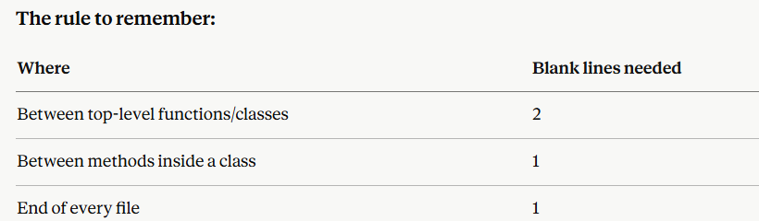

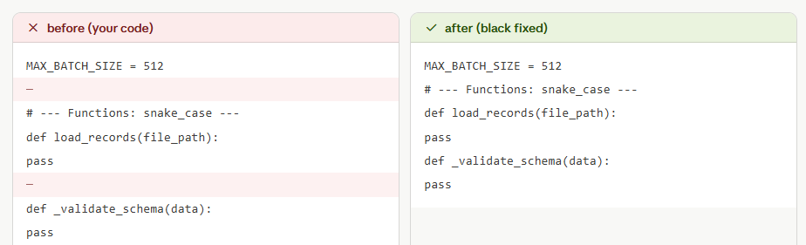

============================================================================
Black
black — auto-formatter (modifies your files)
Rewrites your code to follow a consistent style — line length, quotes, spacing, trailing commas. Zero configuration, zero debate. What black decides is the answer. Run it and your file is instantly PEP-8 compliant for style issues.
Real-world analogy: Auto-correct that actually works — it rewrites the sentence correctly without asking you. You never argue about whether to use single or double quotes again.

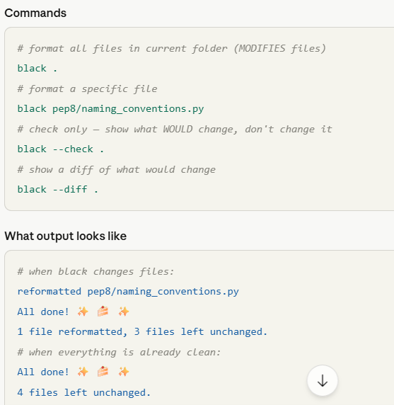

Always run black before flake8. Black fixes most style errors automatically, so flake8 will then only show the real logic issues like unused imports.

Isort

isort — import sorter (modifies your files)
Sorts your import statements into three groups: standard library → third-party packages → local project imports. Each group separated by a blank line, sorted alphabetically within. Configured with profile = "black" so it never conflicts with black's output.
Real-world analogy: A librarian who automatically puts books back in the right section (fiction/non-fiction/reference) and then alphabetises within each section.

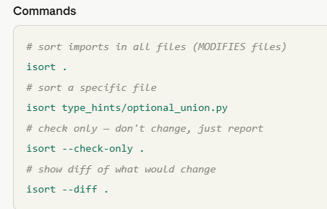

mypy — static type checker (read-only)
Reads your type hints and checks that every function is called with the right argument types, and that return values are used correctly. Catches bugs before you even run the code. Never modifies files.
Real-world analogy: A compiler warning system — like a senior developer who reads your code and says "you're passing a string here but this function expects an int — that will crash at runtime."

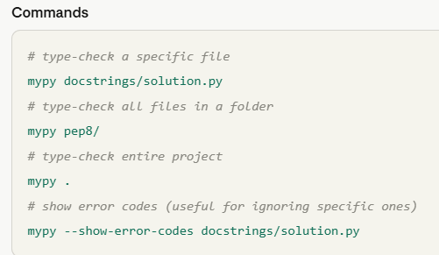

pre-commit — git hook runner (automated)
Runs black, isort, and flake8 automatically every time you do git commit. If any tool fails, the commit is blocked until you fix the issues. You set it up once and never think about it again.
Real-world analogy: A security guard at the office door — your code cannot leave your machine unless it passes inspection. No one can accidentally push unformatted code to GitHub.

