Classification

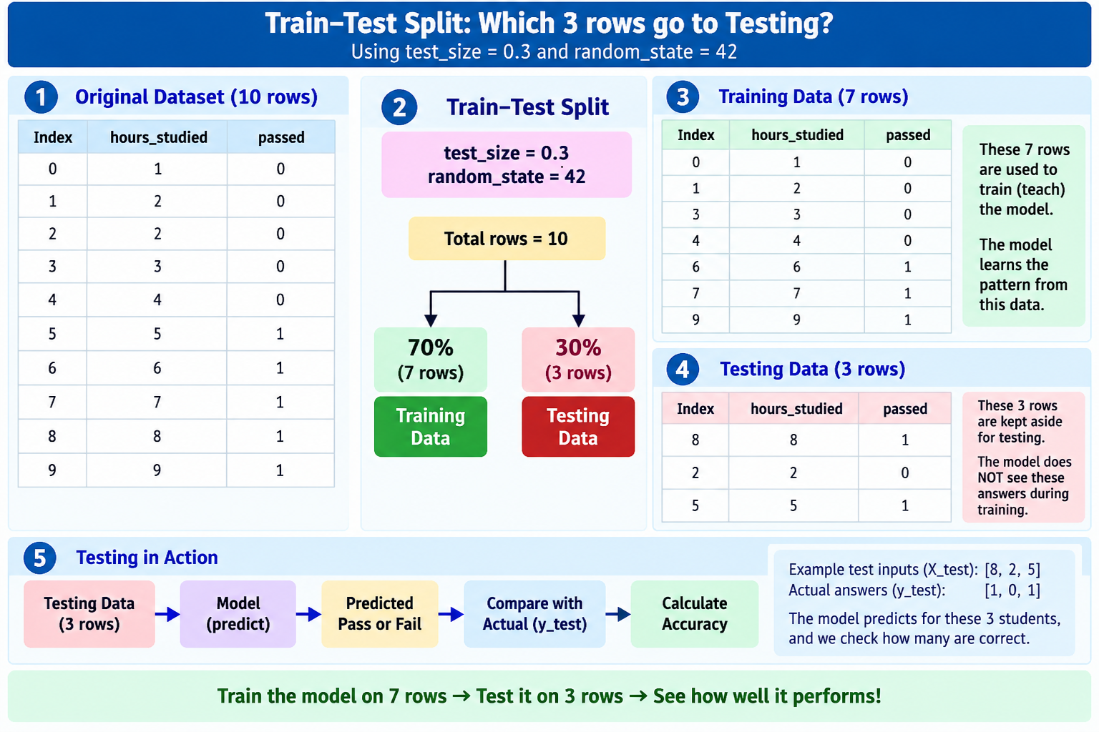
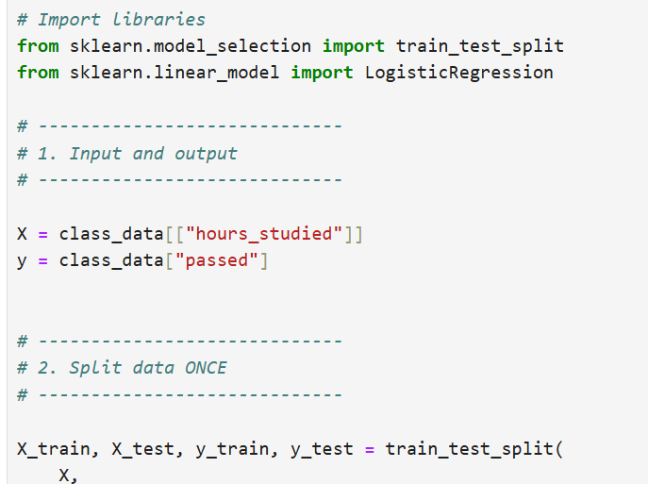

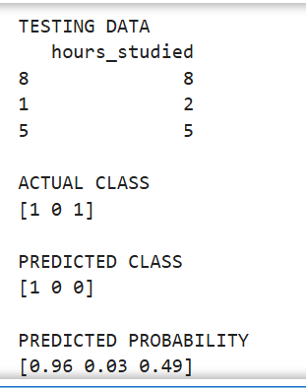

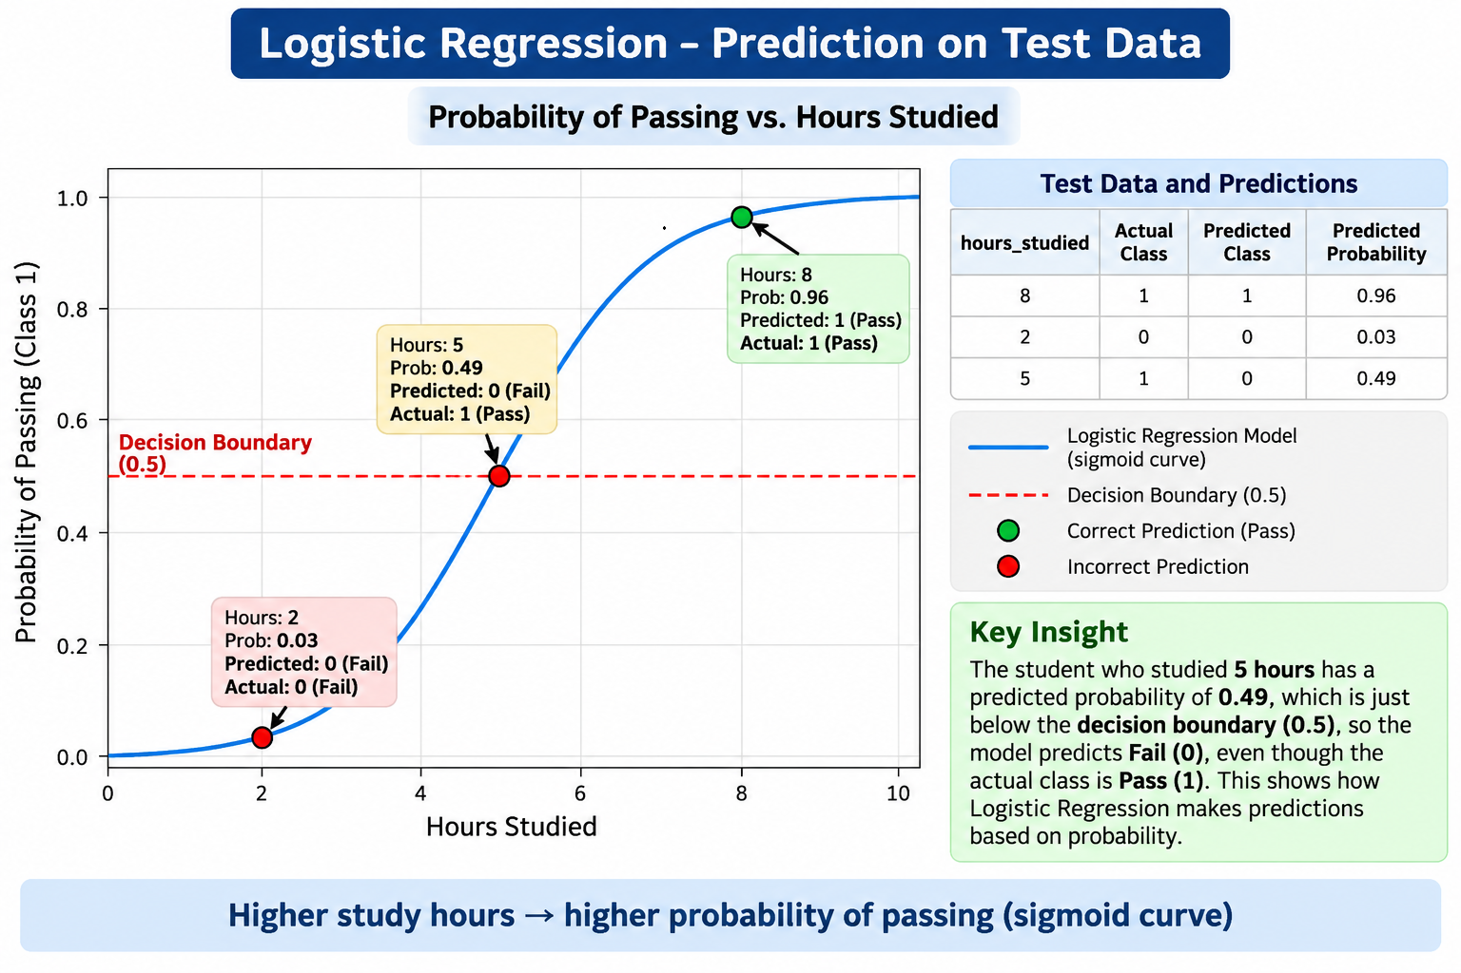

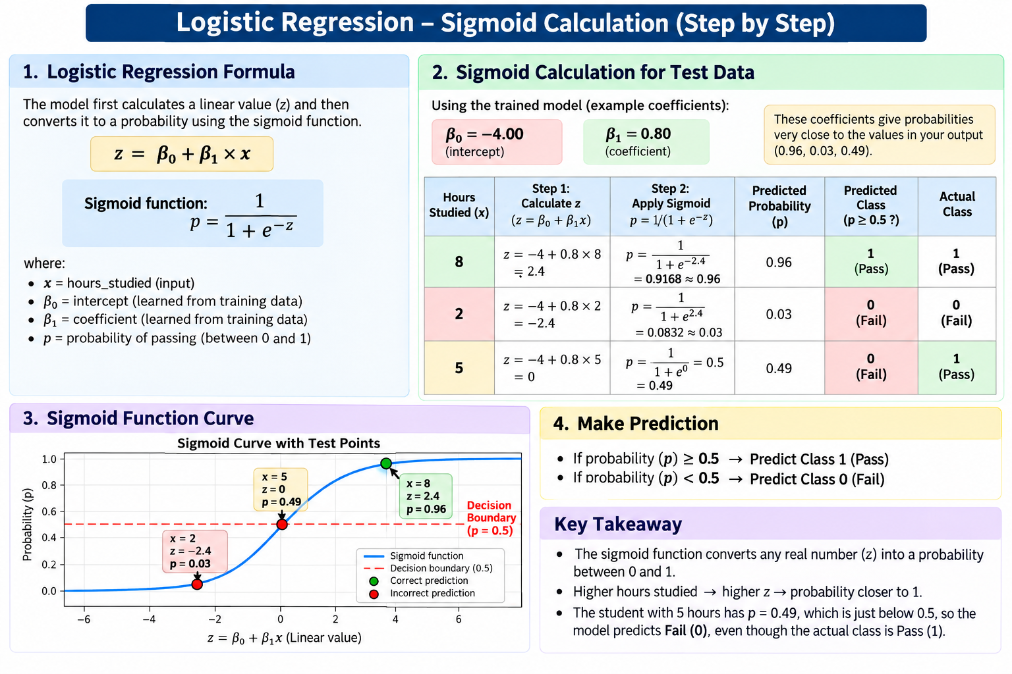

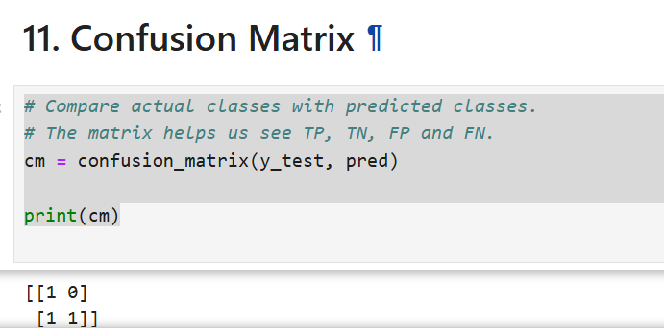

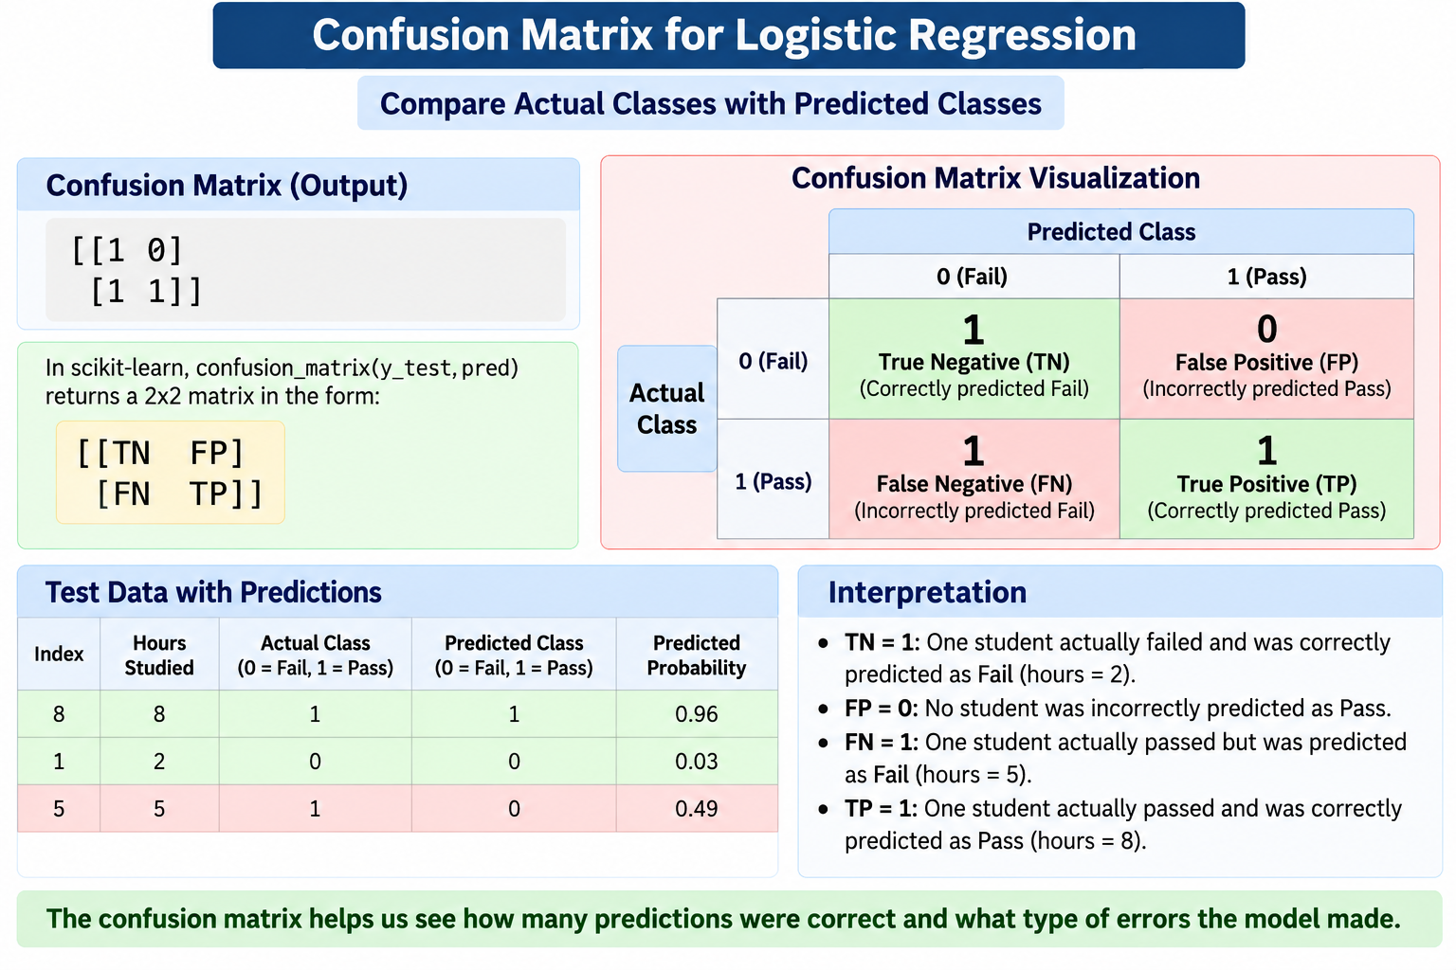
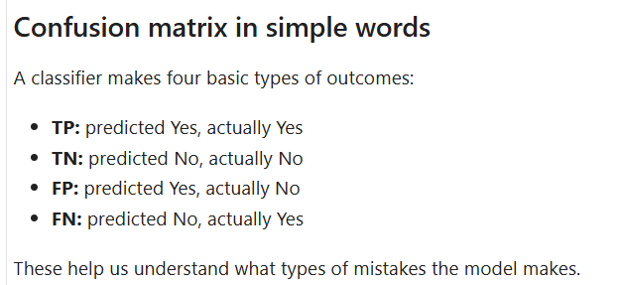

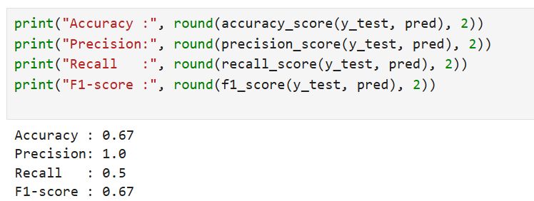

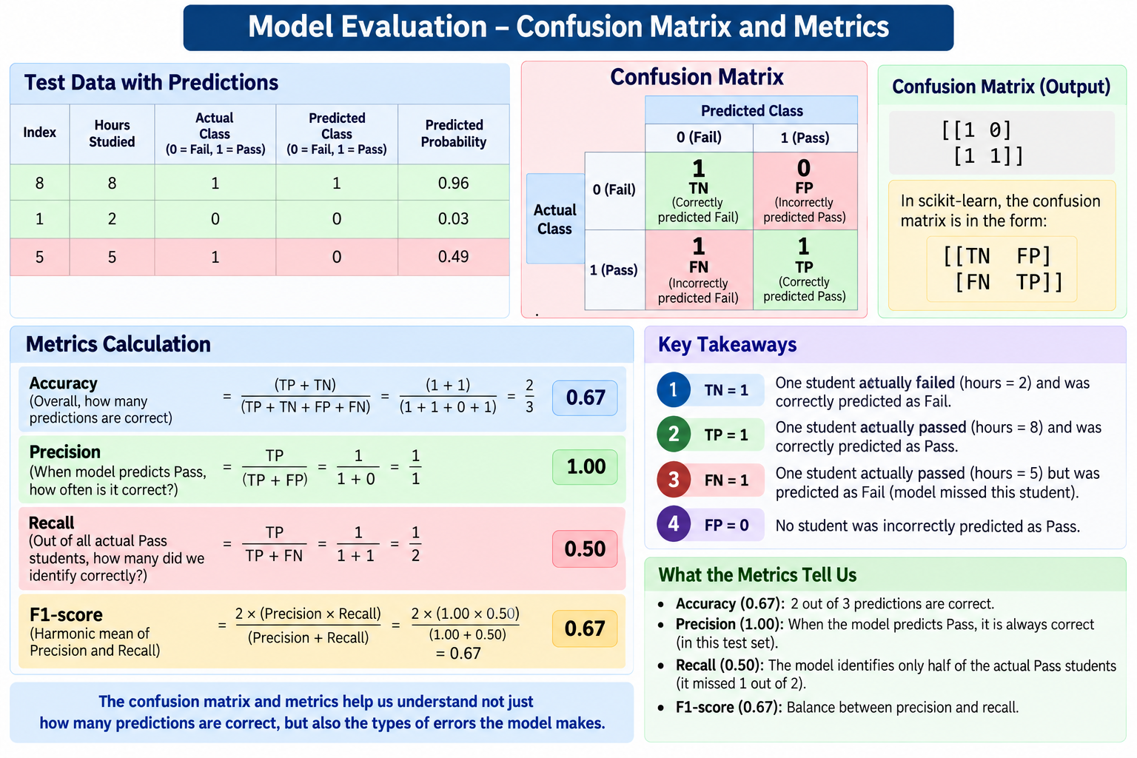

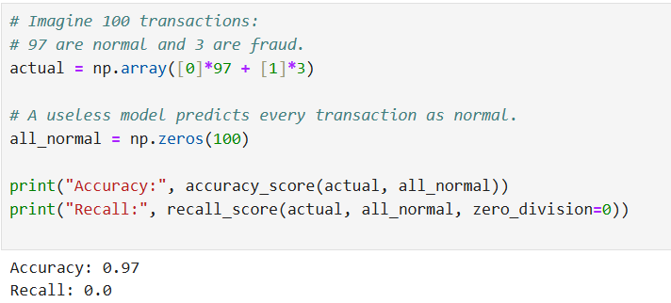

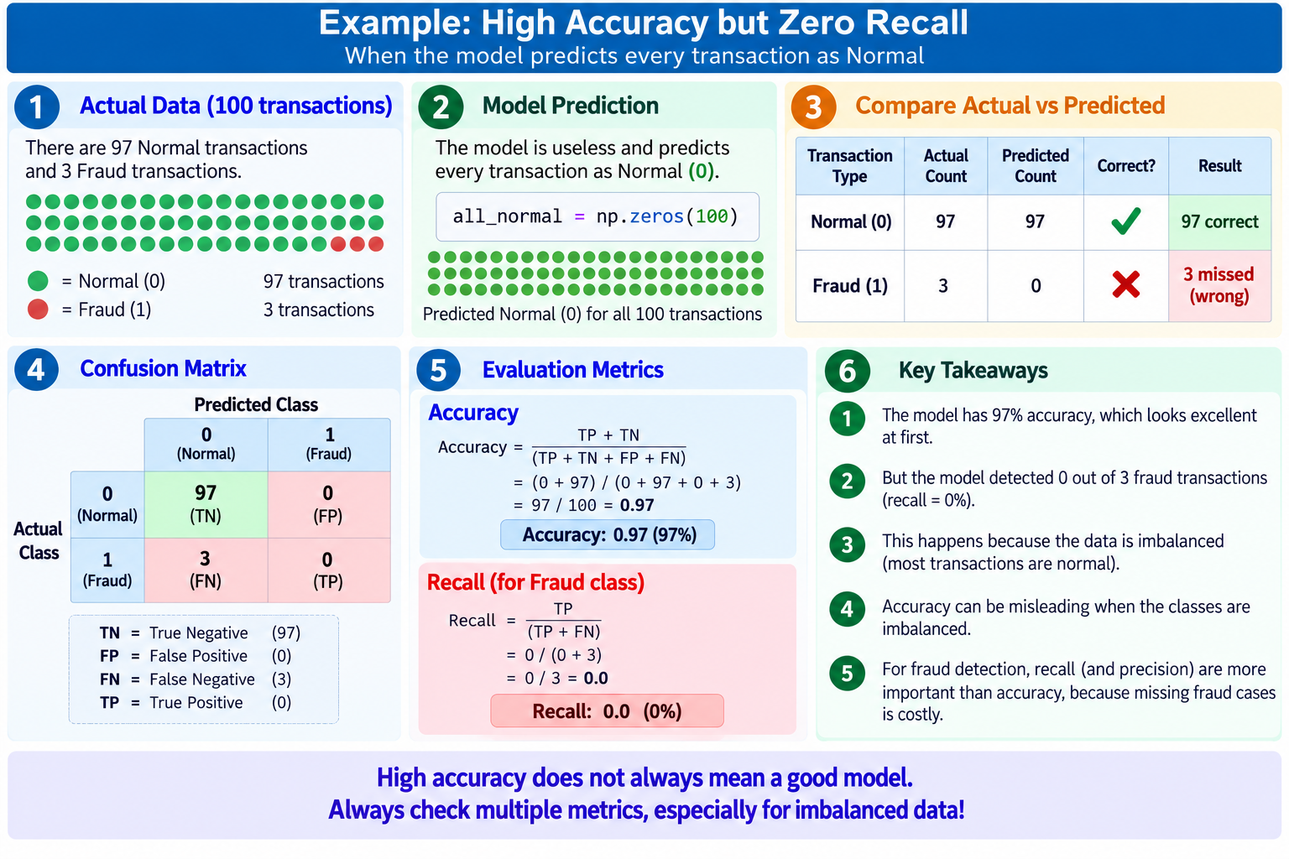

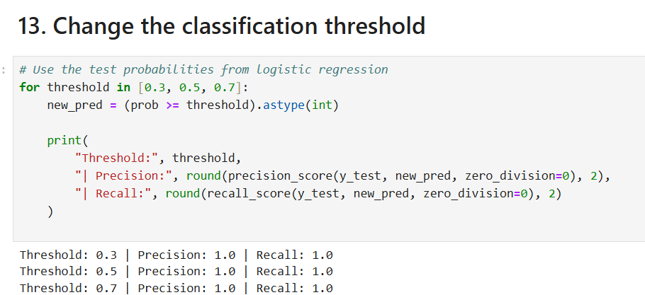

This particular example does not demonstrate the effect of changing the threshold very well, because the probabilities 0.02, 0.18, and 0.99 are far away from the thresholds.
For your agenda, which specifically asks to "show how moving the threshold changes outcomes," you should use probabilities such as:
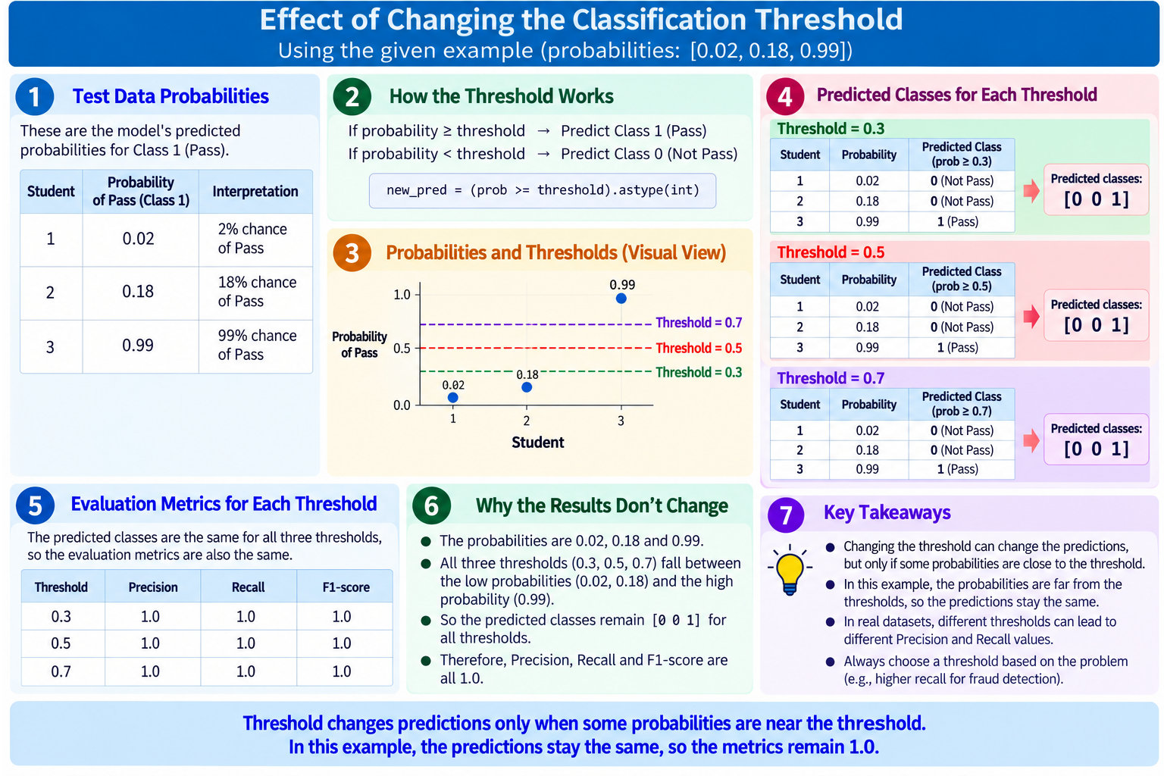

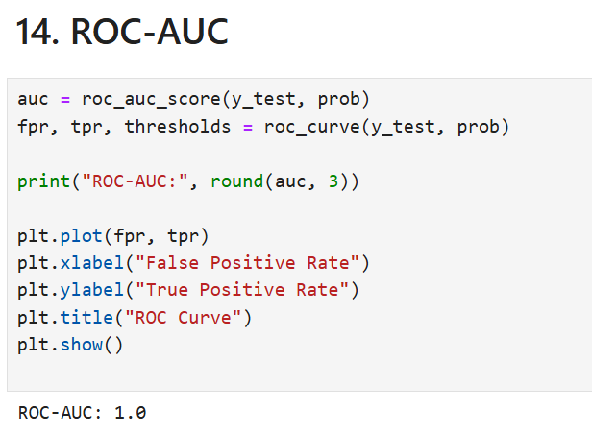

What is ROC?
ROC = Receiver Operating Characteristic
The ROC curve checks how well the model can distinguish:
- Class 0 = Not Pass
- Class 1 = Pass
It does this by trying different probability thresholds.
Instead of using only:
0.50 → Pass/Not Pass
ROC asks:
"What happens if I use 0.1? 0.2? 0.3? 0.5? 0.7? 0.9?"

What does AUC = 1.0 mean?
AUC means:
Area Under the Curve
Your output is:
ROC-AUC: 1.0

ROC curve shows how the model's ability to find positives changes when we change the decision threshold.
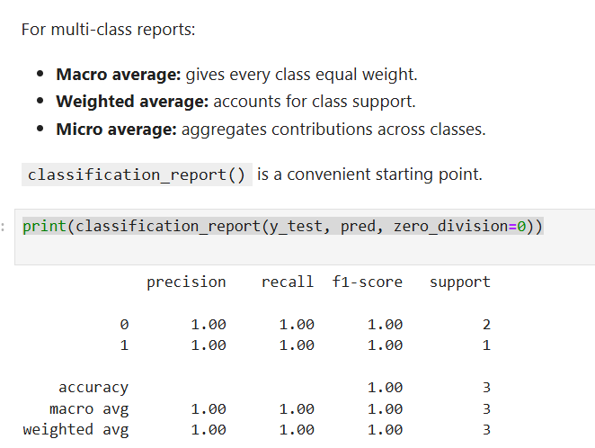

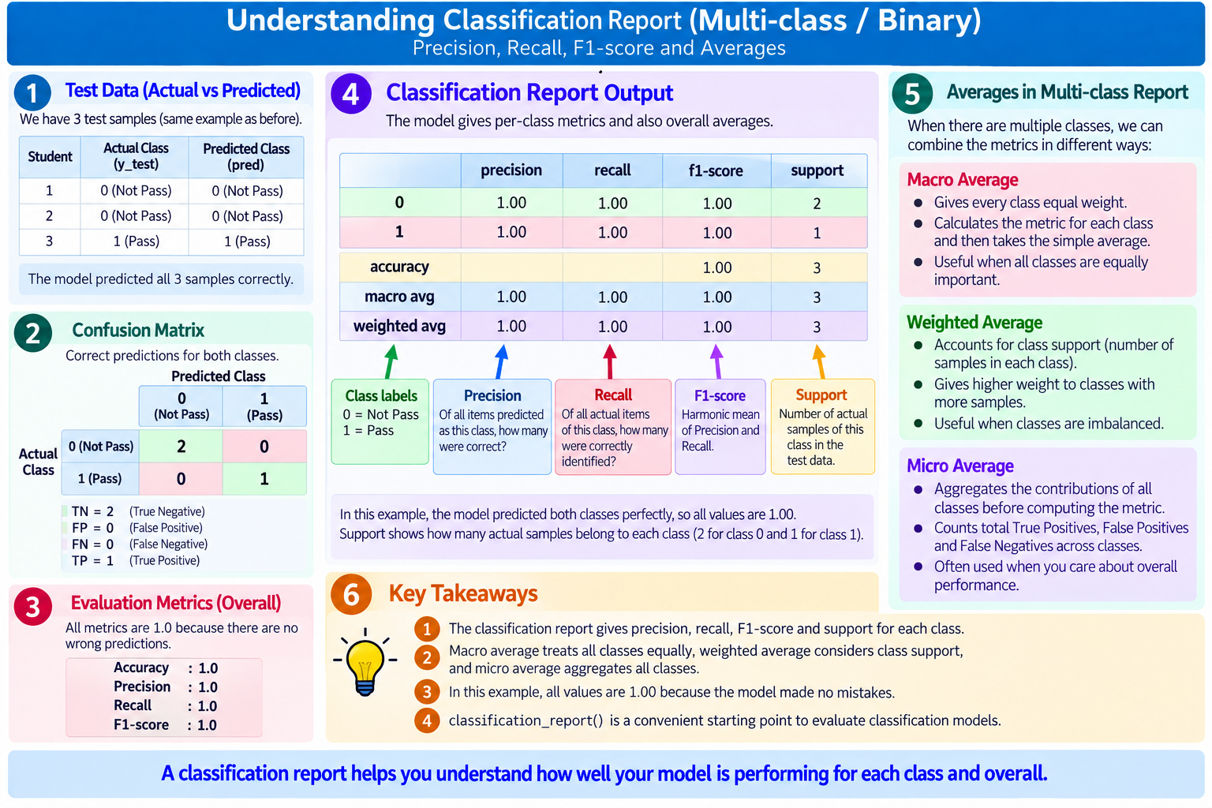

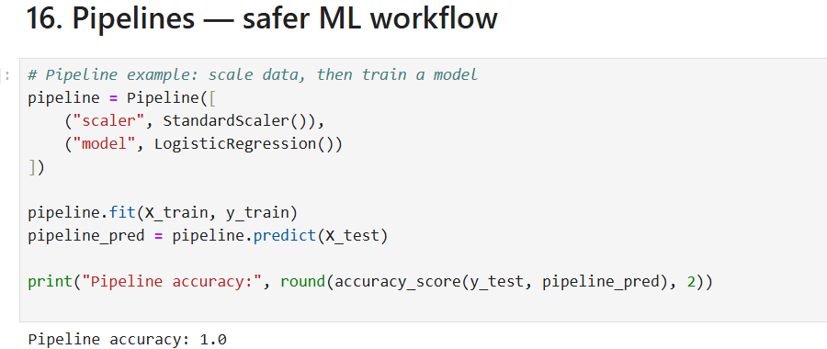

1. What is a Pipeline?
Think of a pipeline like an assembly line:
X data
↓
StandardScaler
↓
LogisticRegression
↓
Prediction
Instead of manually scaling the data and then training the model, the Pipeline connects these steps together.

Pipeline connects preprocessing and the ML model into one workflow. It makes sure the same preprocessing is applied consistently and helps prevent accidental data leakage.

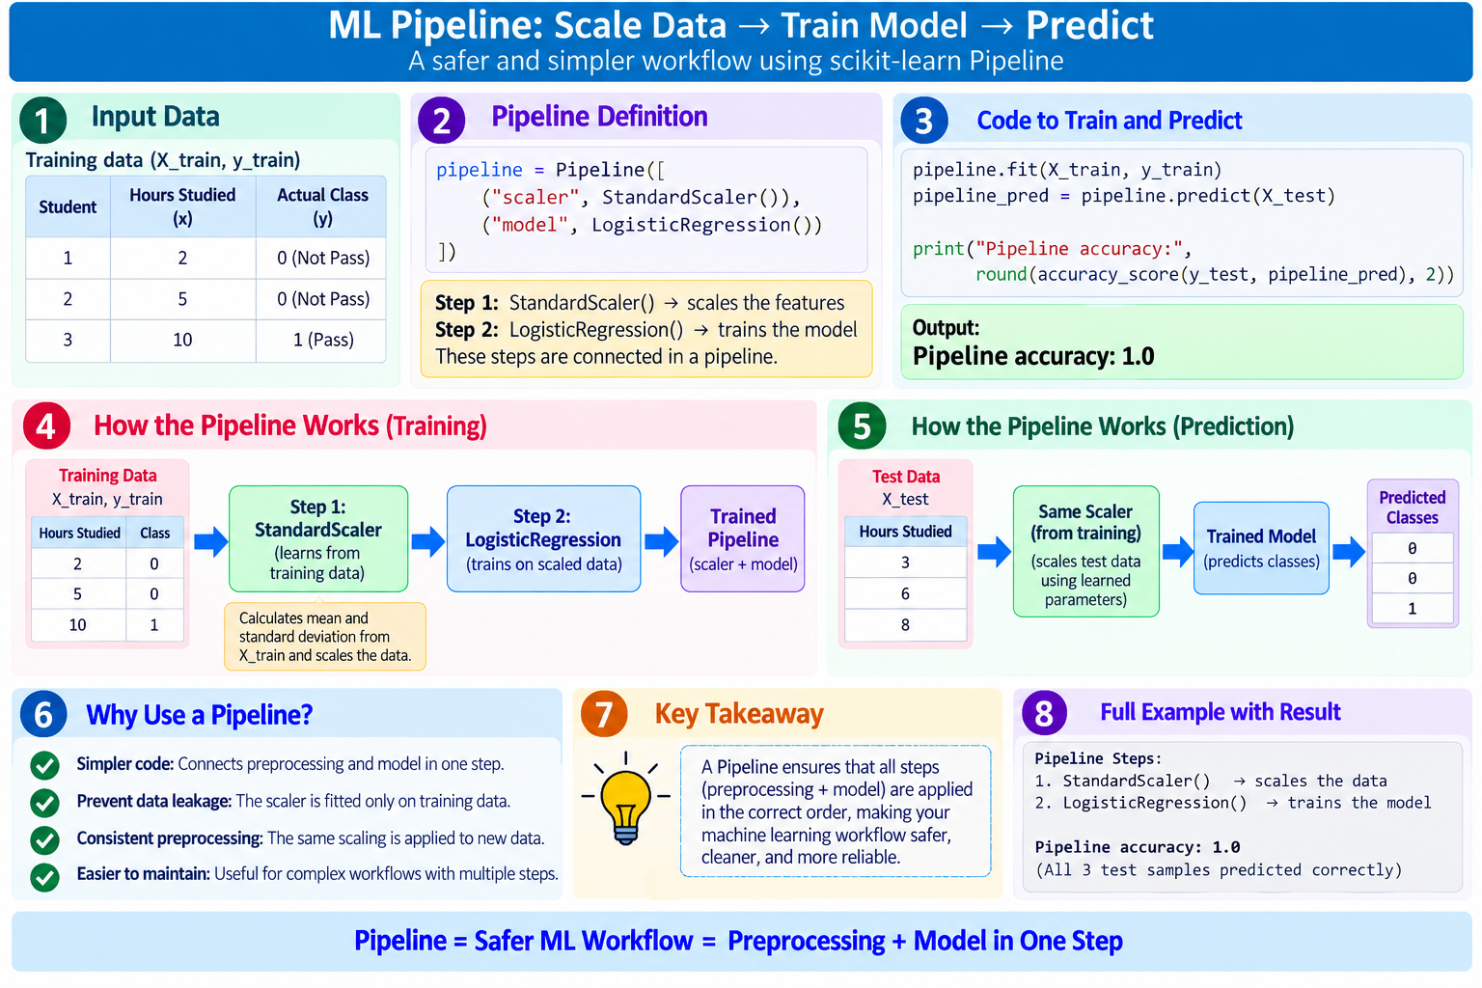

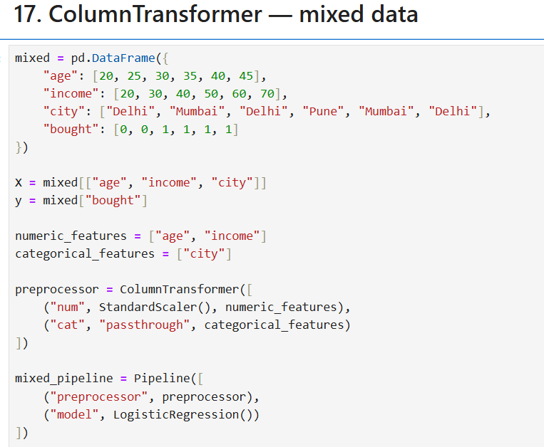
ColumnTransformer + Pipeline structure created.
This output means the ColumnTransformer + Pipeline has been successfully created. It has not trained the model yet.

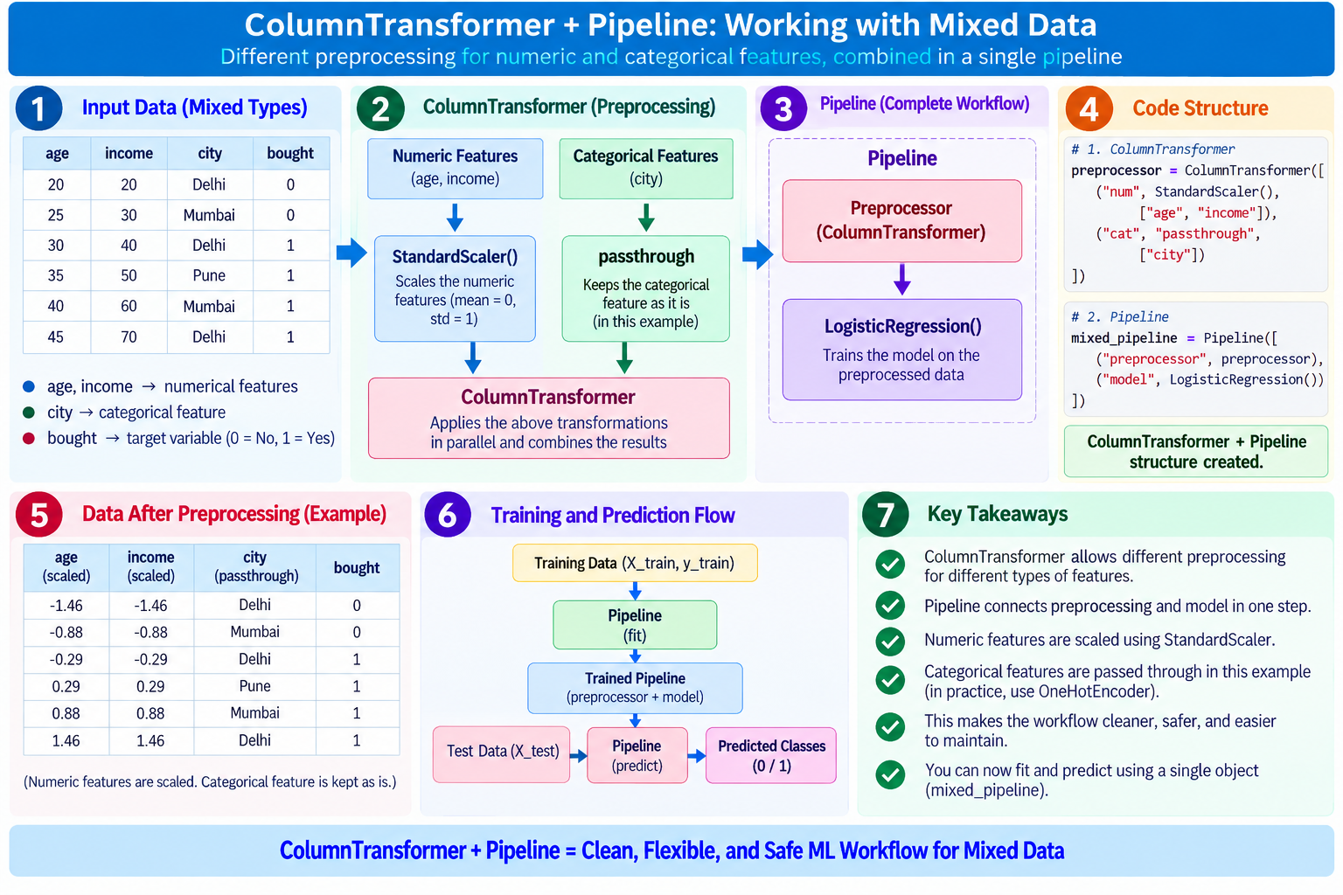

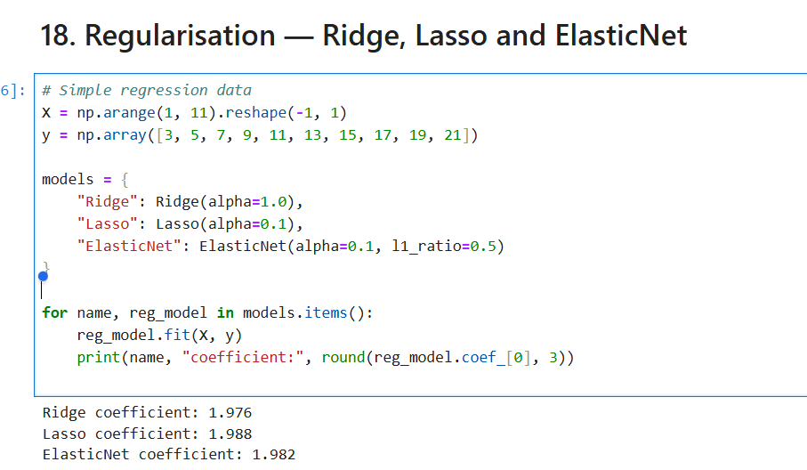

Sure. This example demonstrates Regularisation using three models:
- Ridge
- Lasso
- ElasticNet
The main idea is: regularisation controls the size of model coefficients to reduce overfitting.

1. First, look at the data
x = np.arange(1, 11).reshape(-1, 1)

y = np.array([3, 5, 7, 9, 11, 13, 15, 17, 19, 21])
So the data is:
X | Y
1 | 3
2 | 5
3 | 7
4 | 9
... | ...
10 | 21
You can see that approximately:
Y = 2X + 1
For example:
X = 1 → Y = 3
X = 2 → Y = 5
X = 3 → Y = 7
So the normal linear regression coefficient would be around 2.

2. Three regularised models
models = {
"Ridge": Ridge(alpha=1.0),
"Lasso": Lasso(alpha=0.1),
"ElasticNet": ElasticNet(alpha=0.1, l1_ratio=0.5)
}
Think of alpha as the strength of regularisation.
No regularisation
↓
Coefficient can become large
↓
Possible overfitting

Regularisation
↓
Controls coefficient size
↓
Can improve generalisation

3. What does Ridge do?
Ridge(alpha=1.0)
Ridge applies L2 regularisation.
It tries to keep coefficients from becoming too large.
Your result:
Ridge coefficient: 1.976
So approximately:
Normal coefficient ≈ 2.000
Ridge coefficient ≈ 1.976
It has been slightly reduced.

4. What does Lasso do?
Lasso(alpha=0.1)
Lasso uses L1 regularisation.
Your result:
Lasso coefficient: 1.988
Again, the coefficient is close to 2, but slightly adjusted.
One important advantage of Lasso is that with stronger regularisation it can make some coefficients exactly 0, which can effectively perform feature selection.

5. What does ElasticNet do?
ElasticNet(alpha=0.1, l1_ratio=0.5)
ElasticNet combines:
L1 regularisation
+
L2 regularisation
↓
ElasticNet
Your result:
ElasticNet coefficient: 1.982
So all three are giving coefficients very close to 2 because this dataset is extremely simple and follows a nearly perfect linear relationship.

6. What is this loop doing?
for name, reg_model in models.items():
reg_model.fit(x, y)
print(name, "coefficient:", round(reg_model.coef_[0], 3))
It simply goes through each model:
Ridge
↓
fit(X, Y)
↓
get coefficient
↓
print

Lasso
↓
fit(X, Y)
↓
get coefficient
↓
print

ElasticNet
↓
fit(X, Y)
↓
get coefficient
↓
print

Your output
Ridge coefficient: 1.976
Lasso coefficient: 1.988
ElasticNet coefficient: 1.982

⭐ Beginner takeaway
Imagine the original coefficient is:
2.000
Regularisation says:
"Don't allow coefficients to become unnecessarily large."
So we get:
Original 2.000
↓
Ridge 1.976
Lasso 1.988
ElasticNet 1.982
The differences are small here because the data is very clean and simple.
Most important: Regularisation is not mainly about making the coefficient different. Its purpose is to control model complexity and help prevent overfitting, especially when there are many features or noisy data.

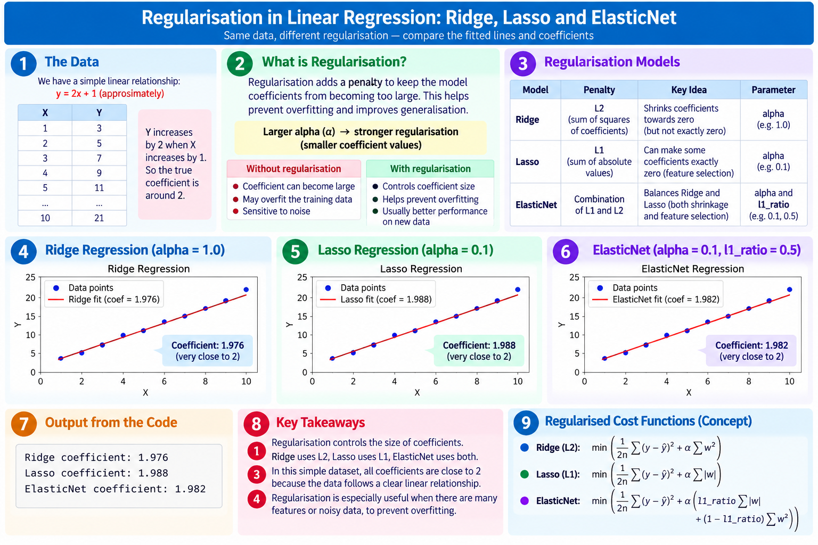

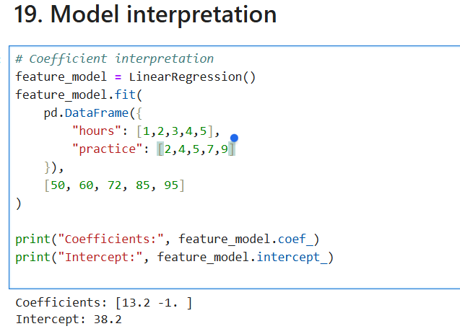

Sure. This example is about model interpretation — understanding what the model has learned from each feature.
Your data is:
Hours | Practice | Actual Result
1 | 2 | 50
2 | 4 | 60
3 | 5 | 72
4 | 7 | 85
5 | 9 | 95
The model uses two input features:
- hours
- practice
and predicts the result.

1. What does this output mean?
Coefficients: [13.2 -1.]
Intercept: 38.2
There are two coefficients because there are two input features.
The order is important:
hours practice
↓ ↓
Coefficients: [13.2 -1.0]
So:
Hours coefficient = +13.2
Practice coefficient = -1.0

2. The model's equation
The model has learned:
Result = 38.2 + 13.2 × Hours - 1.0 × Practice
Or:
ŷ = 38.2 + 13.2(Hours) - 1(Practice)
Here ŷ means predicted result.

3. What does 13.2 mean?
The coefficient for hours is:
+13.2
It means:
If practice stays the same, increasing study hours by 1 hour increases the predicted result by about 13.2 points.
The + sign means a positive relationship.
Hours ↑
↓
Predicted Result ↑

4. What does -1.0 mean?
The coefficient for practice is:
-1.0
It means:
If hours stay the same, increasing practice by 1 unit decreases the predicted result by about 1 point according to this fitted model.
The negative sign means:
Practice ↑
↓
Predicted Result ↓
⚠️ This does not necessarily mean practice is bad. It means that in this small dataset, after accounting for hours, the fitted linear model assigned practice a negative coefficient.

5. What is 38.2?
Intercept = 38.2
The intercept is the predicted result when:
Hours = 0
Practice = 0
Put them into the equation:
Result = 38.2 + 13.2(0) - 1(0)

= 38.2
So:
(Hours=0, Practice=0)
↓
Predicted Result
↓
38.2
Again, this is a mathematical starting point of the fitted model; it may not have a meaningful real-world interpretation if 0 hours/0 practice is outside the relevant data range.

⭐ Complete picture
INPUT FEATURES
│
┌────────────┴────────────┐
↓ ↓
Hours Practice
+13.2 -1.0
│ │
└────────────┬────────────┘
↓
Linear Regression
│
↓
Result = 38.2 + 13.2×Hours
- 1×Practice
│
↓
Predicted Result
So the easiest way to remember it is:
Coefficient = how much that feature influences the prediction, while keeping the other features constant.
Intercept = the model's predicted value when all input features are zero.
