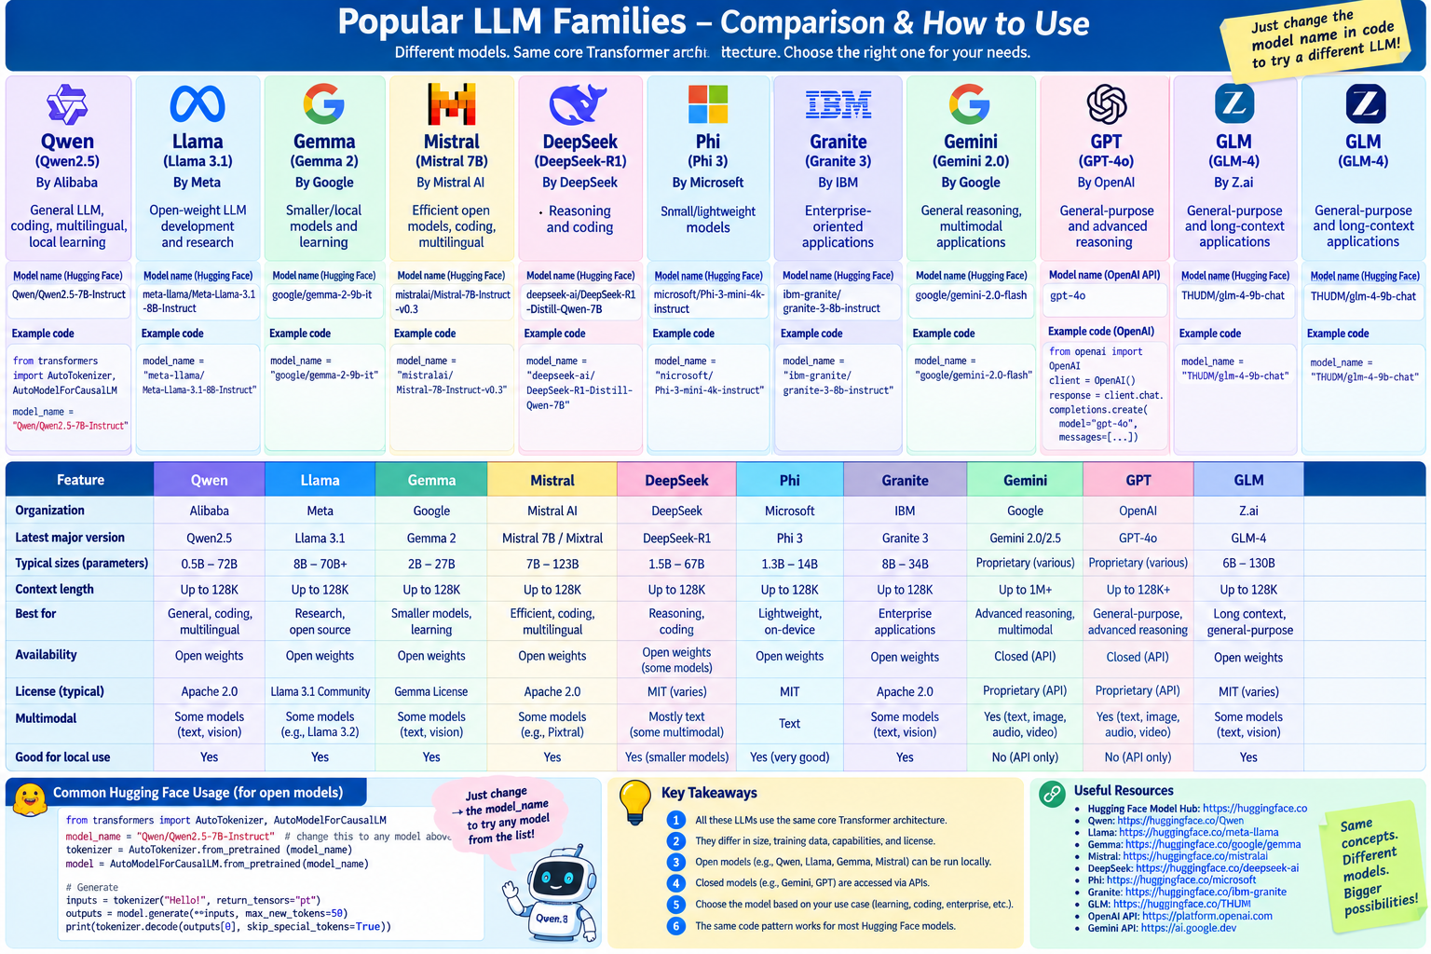

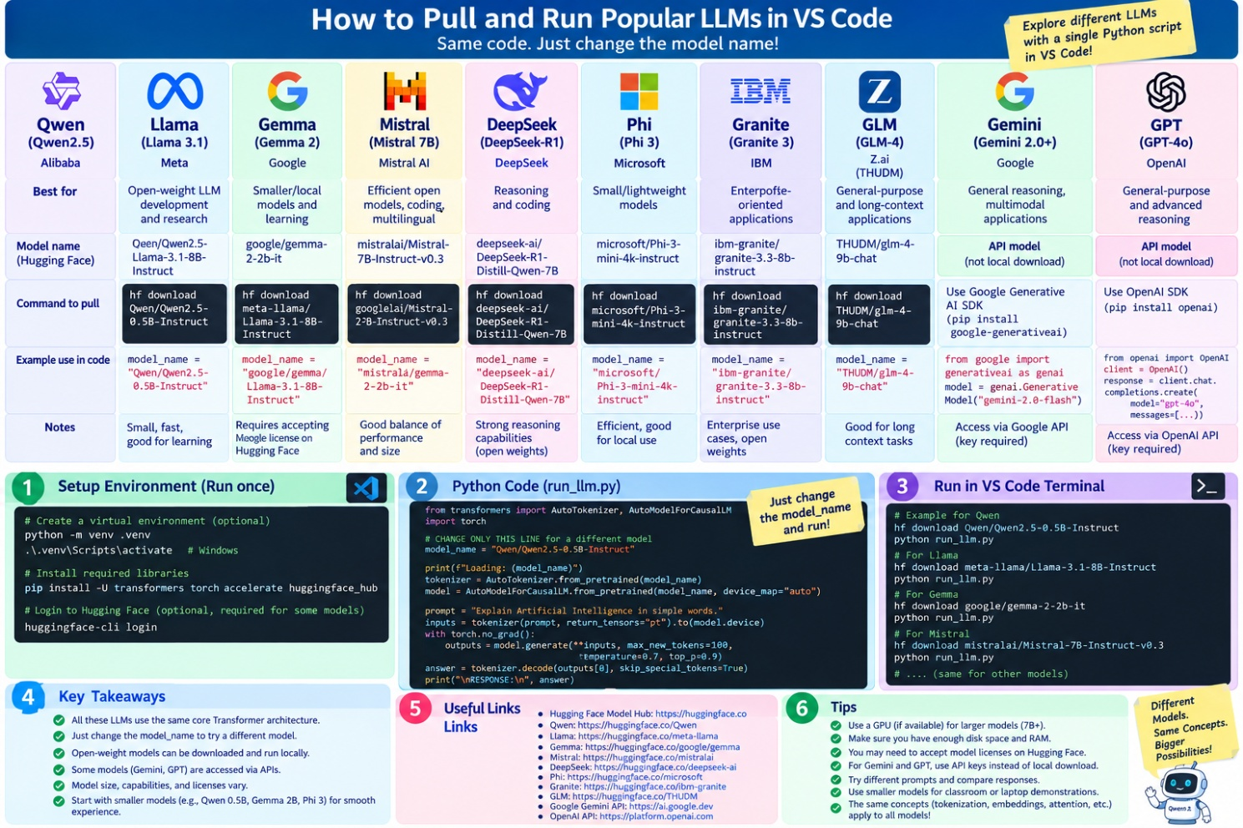

# Qwen
ollama pull qwen2.5:0.5b
ollama run qwen2.5:0.5b

# Llama
ollama pull llama3.1:8b
ollama run llama3.1:8b

# Gemma
ollama pull gemma2:2b
ollama run gemma2:2b

# Mistral
ollama pull mistral:7b
ollama run mistral:7b

# DeepSeek
ollama pull deepseek-r1:7b
ollama run deepseek-r1:7b

# Phi
ollama pull phi3:mini
ollama run phi3:mini

# Granite
ollama pull granite3:8b
ollama run granite3:8b

# GLM
ollama pull glm4:9b
ollama run glm4:9b

# 1. Qwen
model_name = "Qwen/Qwen2.5-0.5B-Instruct"

# 2. Llama
model_name = "meta-llama/Llama-3.1-8B-Instruct"

# 3. Gemma
model_name = "google/gemma-2-2b-it"

# 4. Mistral
model_name = "mistralai/Mistral-7B-Instruct-v0.3"

# 5. DeepSeek
model_name = "deepseek-ai/DeepSeek-R1-Distill-Qwen-7B"

# 6. Phi
model_name = "microsoft/Phi-3-mini-4k-instruct"

# 7. Granite
model_name = "ibm-granite/granite-3.0-8b-instruct"

# 8. GLM
model_name = "THUDM/glm-4-9b-chat"

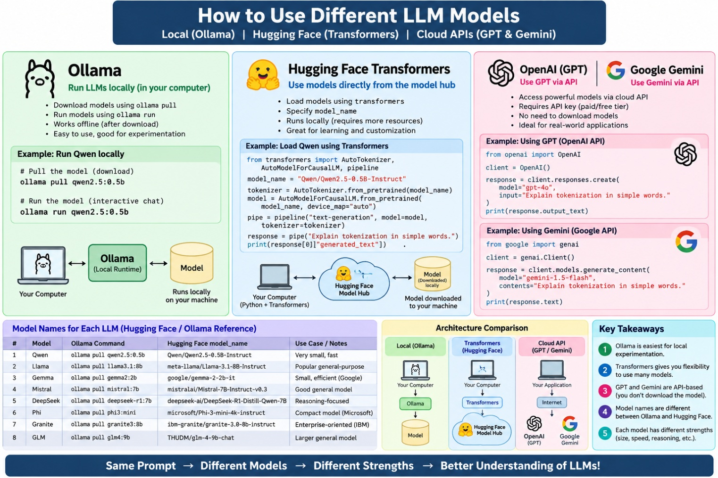

Simple comparison
Requirement | Ollama | Hugging Face Transformers
Easy to use | ⭐⭐⭐⭐⭐ | ⭐⭐⭐
Run models locally | ✅ | ✅
Offline after download | ✅ | ✅
Chat with LLM | Excellent | Good
Beginners | Best | Moderate
Tokenization teaching | Good | Excellent
Hidden states / vectors | Limited | Excellent
Fine control over model | Moderate | Excellent
Model experimentation | Good | Excellent
Production/API-style local service | Excellent | Good
Understand LLM internals | ⭐⭐⭐ | ⭐⭐⭐⭐⭐

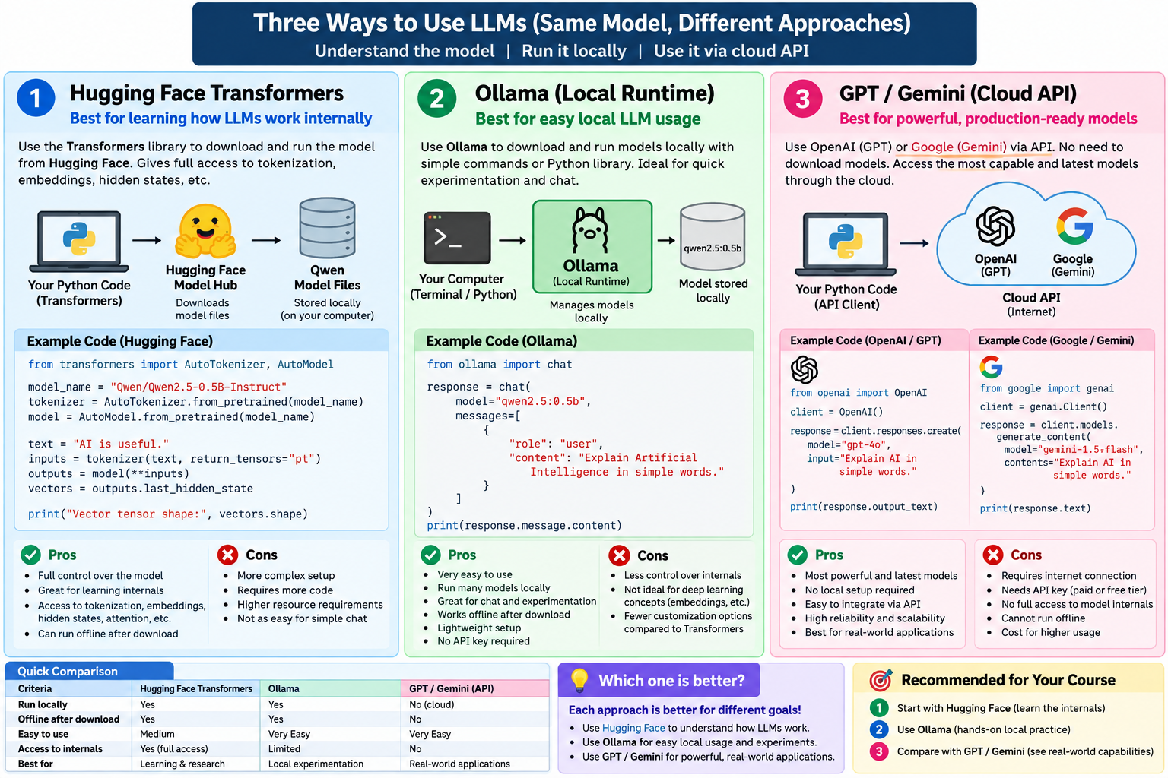

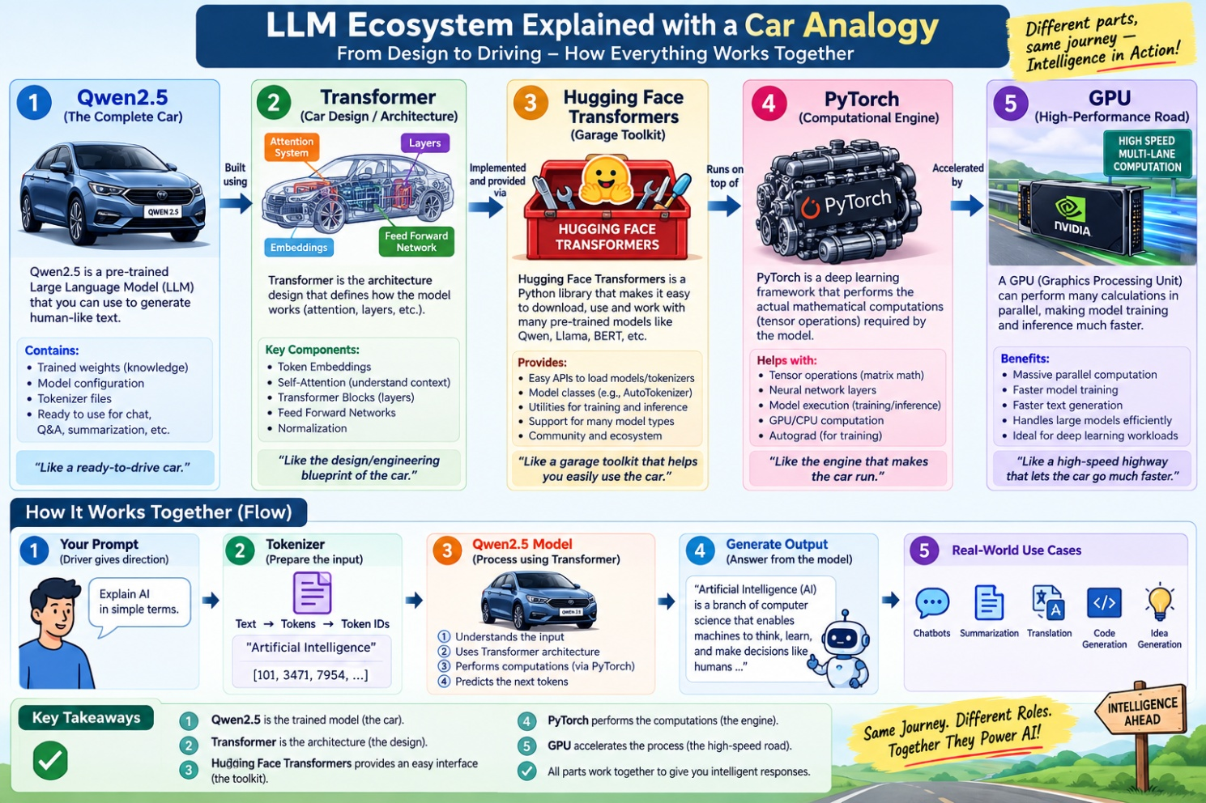

Tokenization

# Import AutoTokenizer from the Hugging Face Transformers library.
# AutoTokenizer is used to convert human text into tokens and token IDs.
from transformers import AutoTokenizer

# Name of the Qwen tokenizer/model.
# We are using Qwen2.5 0.5B Instruct.
model_name = "Qwen/Qwen2.5-0.5B-Instruct"

# Load the tokenizer associated with the Qwen model.
# IMPORTANT:
# At this point, we are NOT loading the Qwen LLM itself.
# We are only loading its tokenizer.
tokenizer = AutoTokenizer.from_pretrained(model_name)

# Text that we want to tokenize.
text = "Artificial Intelligence is amazing!"

# Convert the text into tokens.
# Tokens are the smaller pieces of text that an LLM processes.
tokens = tokenizer.tokenize(text)

# Convert the text into numerical token IDs.
# LLMs work with numbers rather than directly processing human-readable text.
ids = tokenizer.encode(text)

# Display the original text.
print("Text:", text)

# Display the tokens created by the tokenizer.
print("\nTokens:")
print(tokens)

# Display the numerical IDs corresponding to the tokens.
print("\nToken IDs:")
print(ids)

# Count the number of token IDs.
print("\nNumber of tokens:", len(ids))

# Count the number of words using Python's split() function.
# This is NOT the same as token count.
print("Number of words:", len(text.split()))

# Key concept:
# LLMs process tokens, not complete words directly.
print("\nIdea: LLMs process tokens, not whole words directly.")

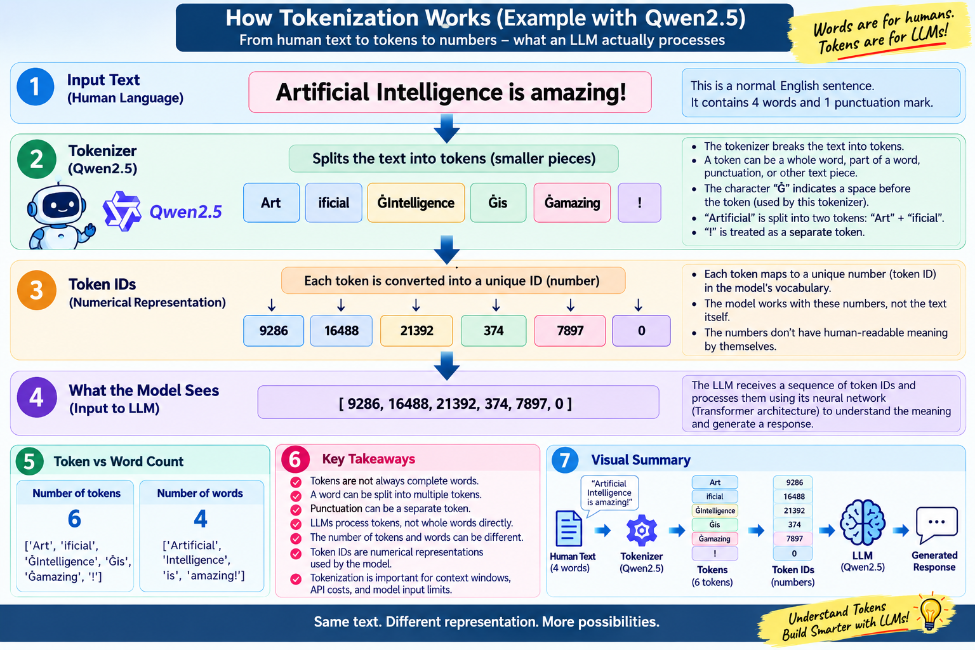

Embedding

from transformers import AutoTokenizer, AutoModel

model_name = "Qwen/Qwen2.5-0.5B-Instruct"

tokenizer = AutoTokenizer.from_pretrained(model_name)
model = AutoModel.from_pretrained(model_name)

text = "AI is useful."

inputs = tokenizer(text, return_tensors="pt")

outputs = model(**inputs)

# Last hidden state contains vector representations.
vectors = outputs.last_hidden_state

print("Input:", text)
print("Vector tensor shape:", vectors.shape)
print("\nEach token is represented internally using numbers.")
print("These numerical representations are called embeddings/hidden representations.")

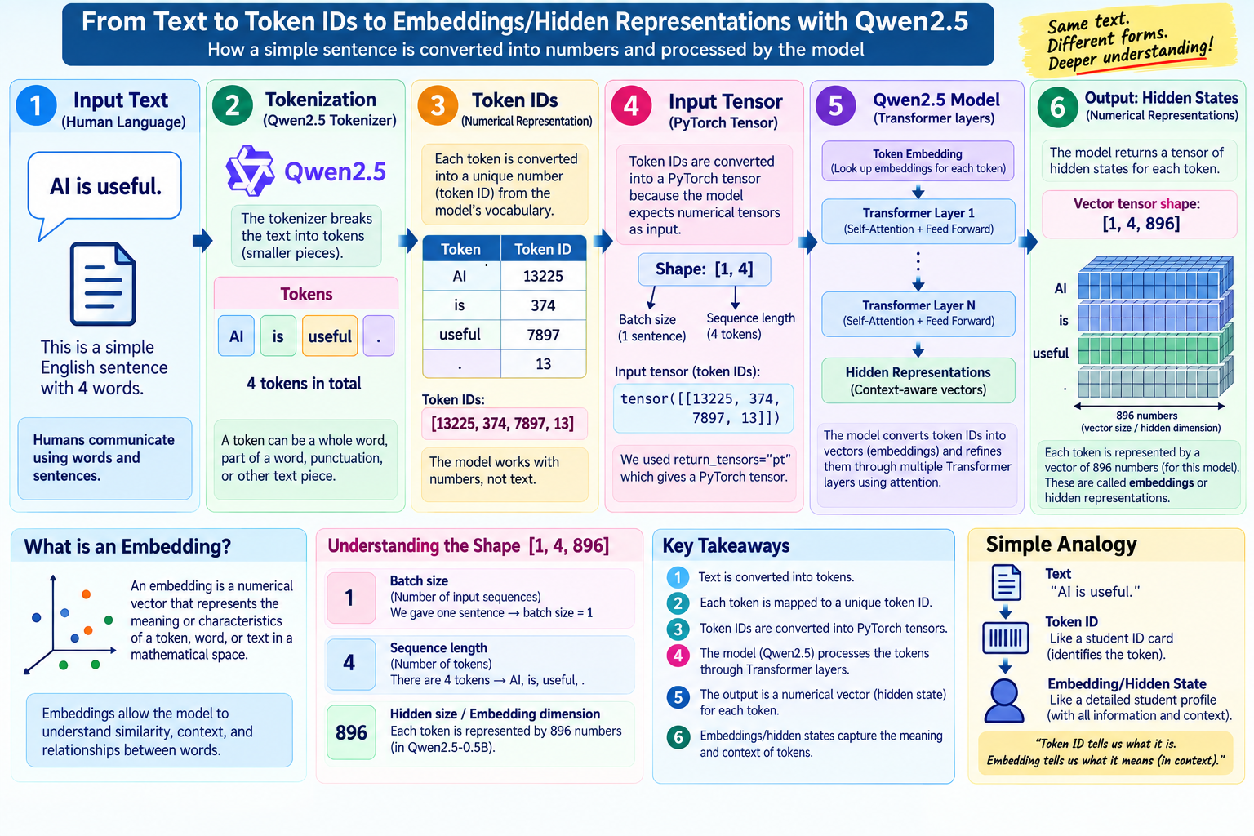

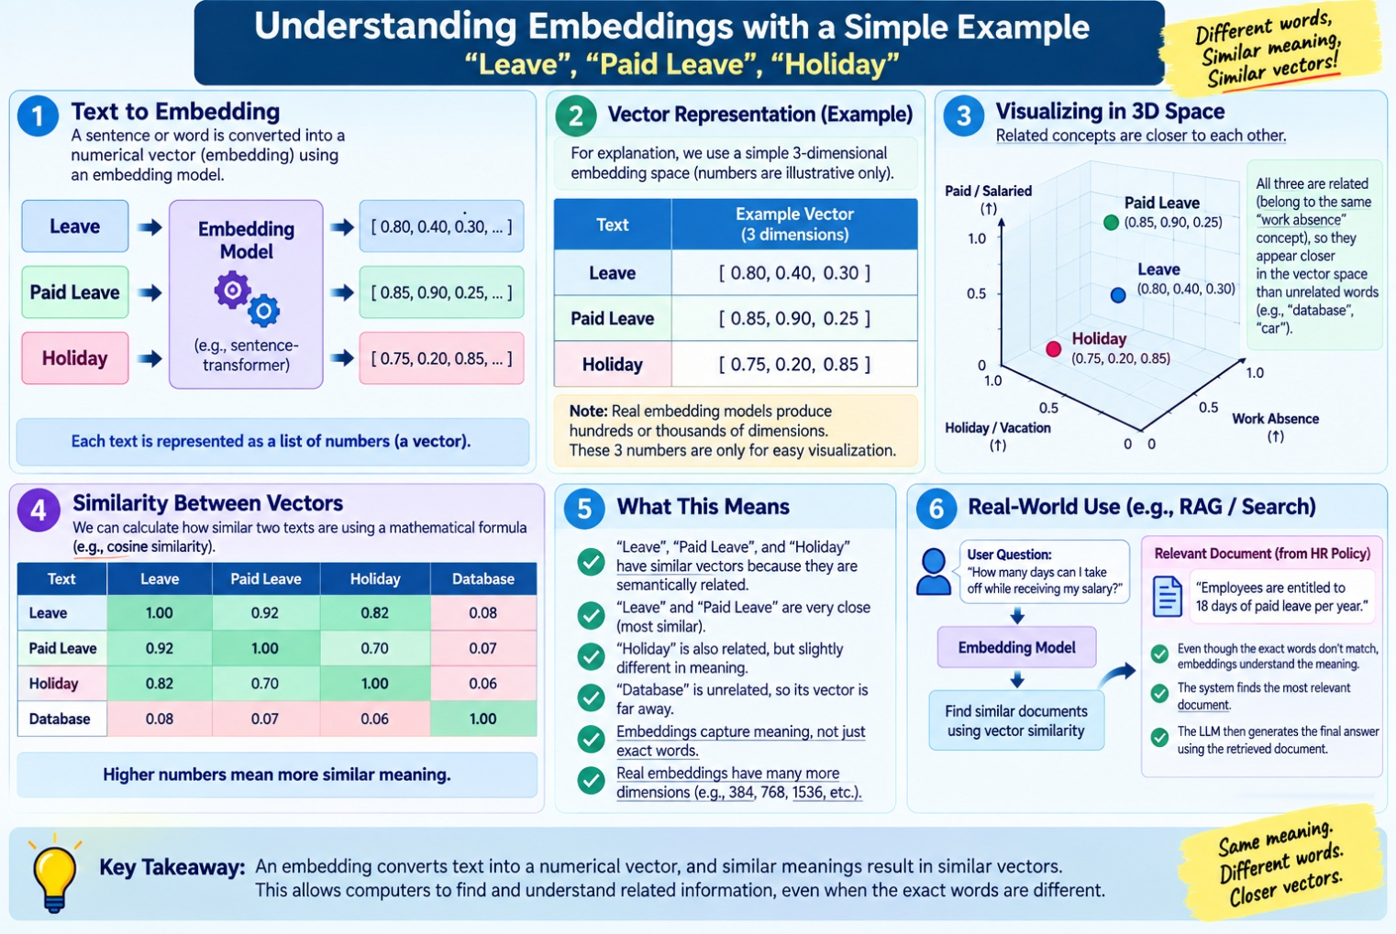

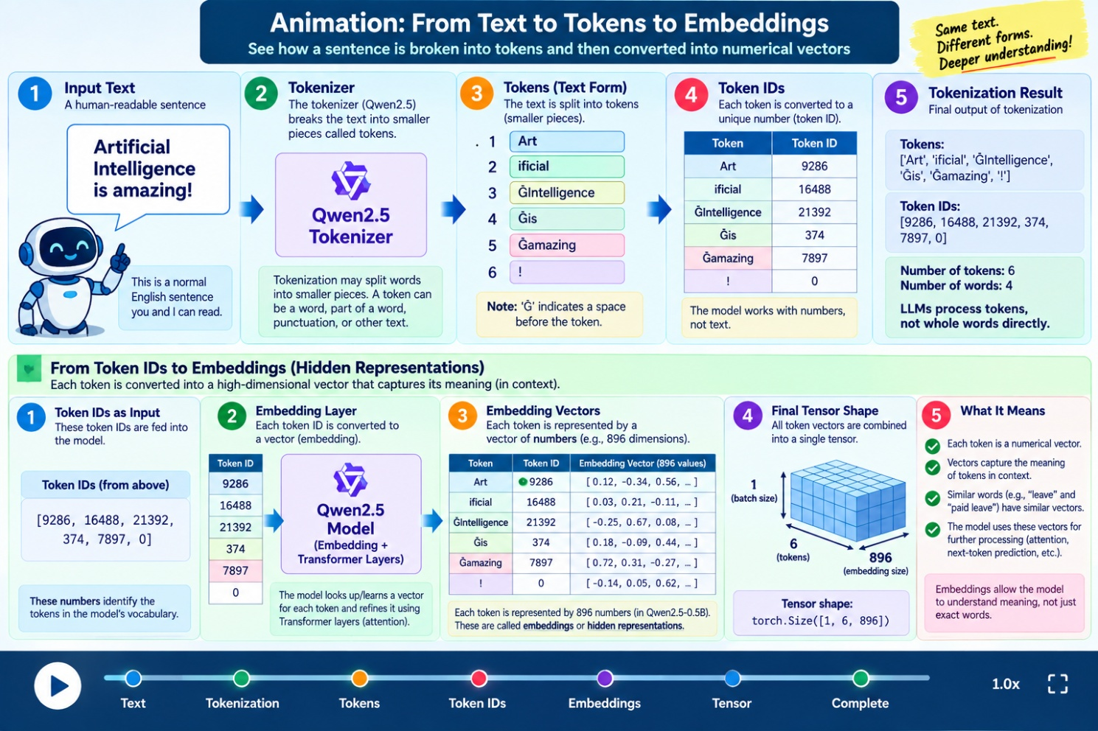

Sequence

from transformers import AutoTokenizer, AutoModelForCausalLM

#“In language, order matters. ‘The dog bites the man’ and
# ‘The man bites the dog’ contain almost the same words,
# but the sequence changes the meaning. Transformers use attention
# to understand relationships between tokens.”

# Qwen2.5 is a modern LLM based on the Transformer architecture.
model_name = "Qwen/Qwen2.5-0.5B-Instruct"

# Load the tokenizer.
tokenizer = AutoTokenizer.from_pretrained(model_name)

# Load the Qwen2.5 language model.
model = AutoModelForCausalLM.from_pretrained(model_name)

# Two sentences containing almost the same words,
# but with different word order.
sentences = [
"The dog bites the man.",
"The man bites the dog."
]

for text in sentences:

print("\n" + "=" * 50)
print("Sentence:", text)

# Convert the sentence into tokens.
tokens = tokenizer.tokenize(text)

print("\nTokens:")
print(tokens)

# Convert tokens into numerical IDs.
token_ids = tokenizer.encode(text)

print("\nToken IDs:")
print(token_ids)

# Convert the input into PyTorch tensors.
inputs = tokenizer(text, return_tensors="pt")

# Ask Qwen to continue the sentence.
generated_ids = model.generate(
**inputs,
max_new_tokens=20
)

# Convert the generated IDs back to text.
output = tokenizer.decode(
generated_ids[0],
skip_special_tokens=True
)

print("\nQwen Output:")
print(output)

print("\nKey Idea:")
print("The same words can have different meanings")
print("when their order and relationships change.")
print("Transformers use attention to understand these relationships.")

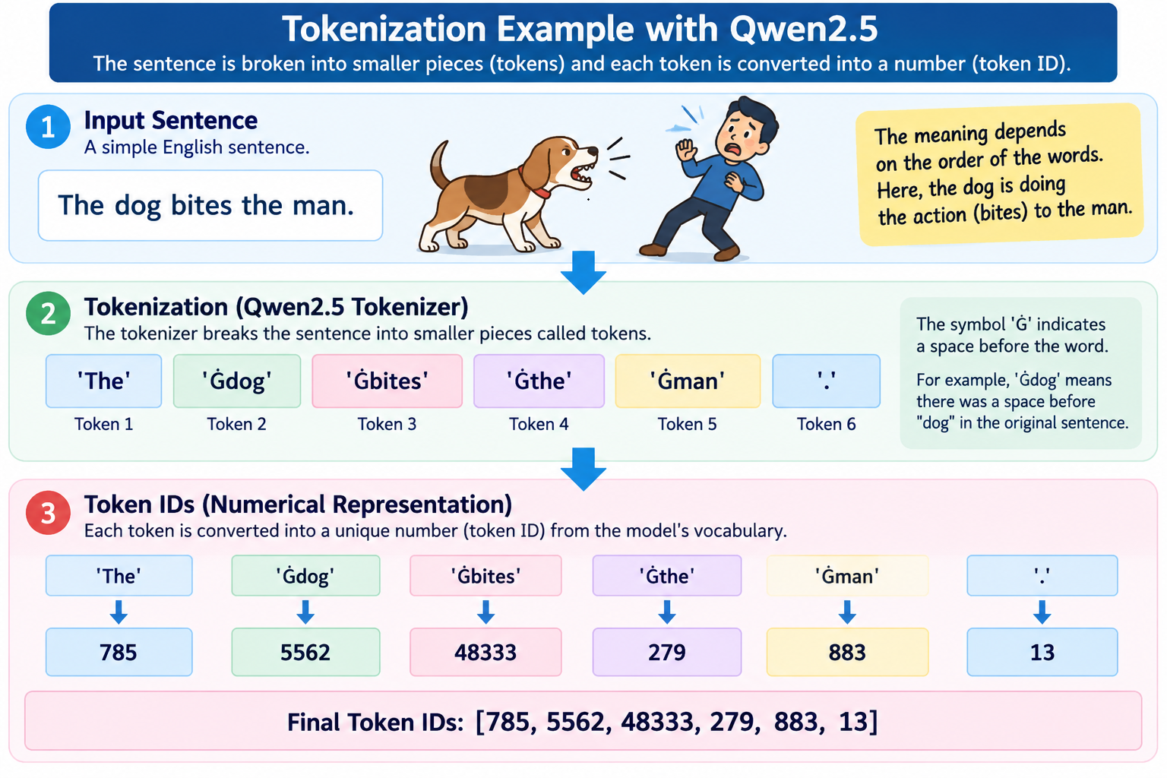

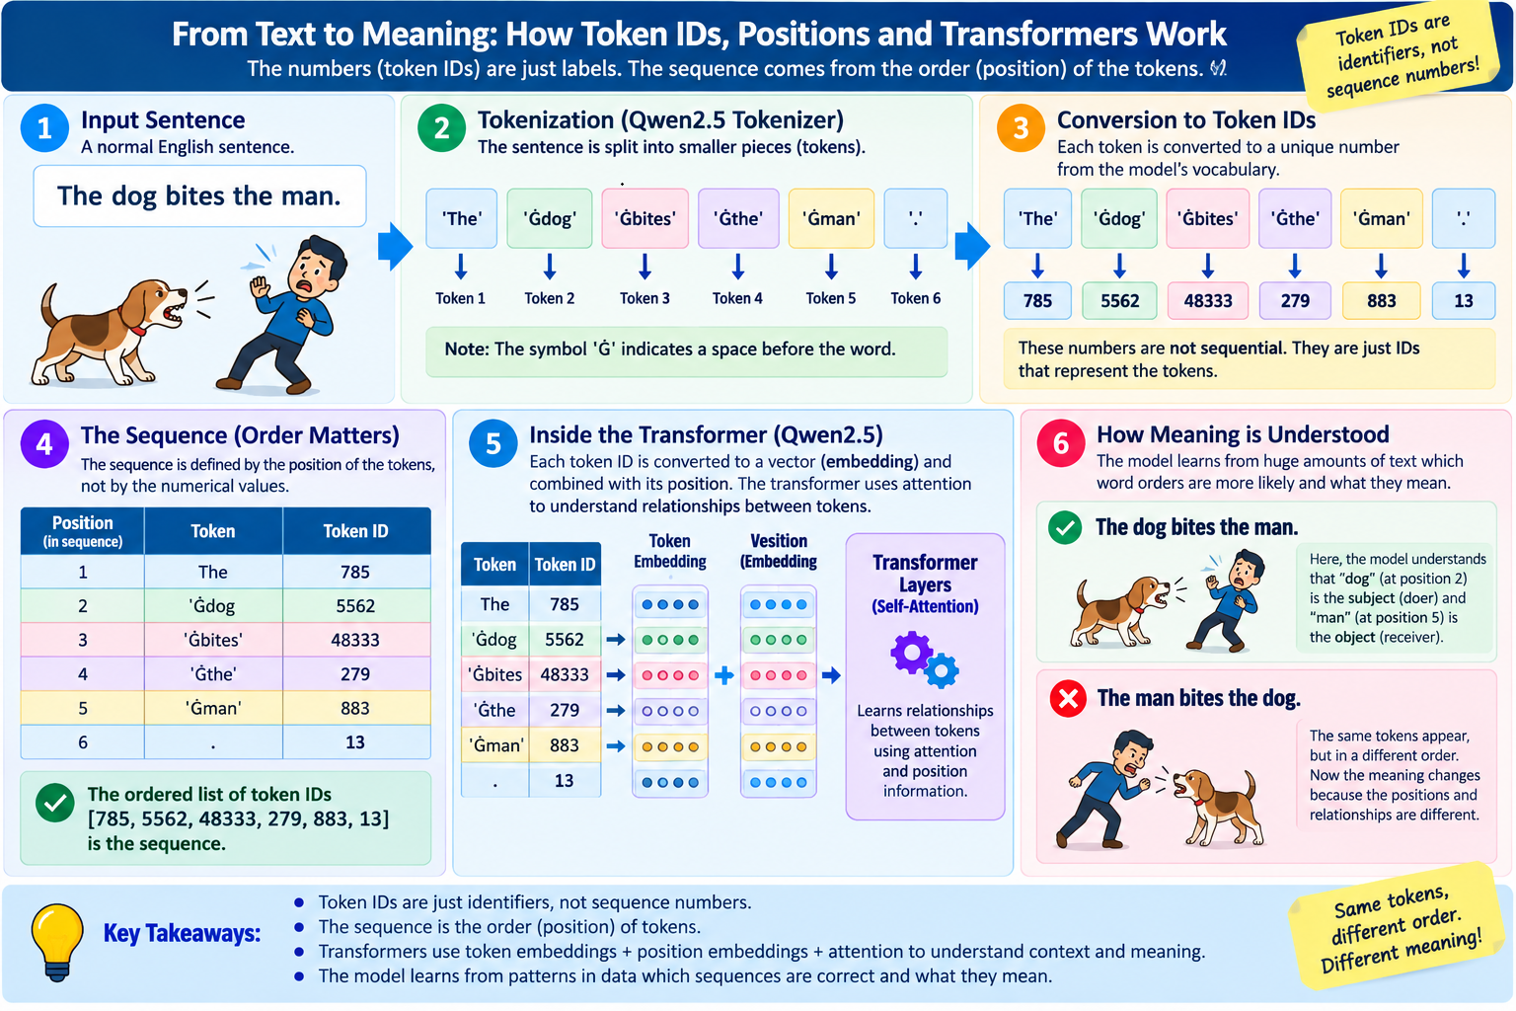

Attention

from transformers import AutoTokenizer, AutoModel

# Load Qwen2.5
model_name = "Qwen/Qwen2.5-0.5B-Instruct"

tokenizer = AutoTokenizer.from_pretrained(model_name)
model = AutoModel.from_pretrained(model_name)

# Our sentence
text = "The student opened the book."

# Convert text into tokens
inputs = tokenizer(text, return_tensors="pt")

print("Sentence:")
print(text)

print("\nTokens:")
print(tokenizer.convert_ids_to_tokens(inputs["input_ids"][0]))

# Run the sentence through Qwen
outputs = model(**inputs)

print("\nQwen processed the sentence.")

print("\nAttention idea:")
print("Query → What am I looking for?")
print("Key → What information does each token have?")
print("Value → What information can each token provide?")

print("\nExample:")
print("Query = student")
print("Keys = The, student, opened, the, book")
print("Values = information associated with those tokens")

print("\nAttention compares the Query with the Keys")
print("and gives more importance to relevant tokens.")

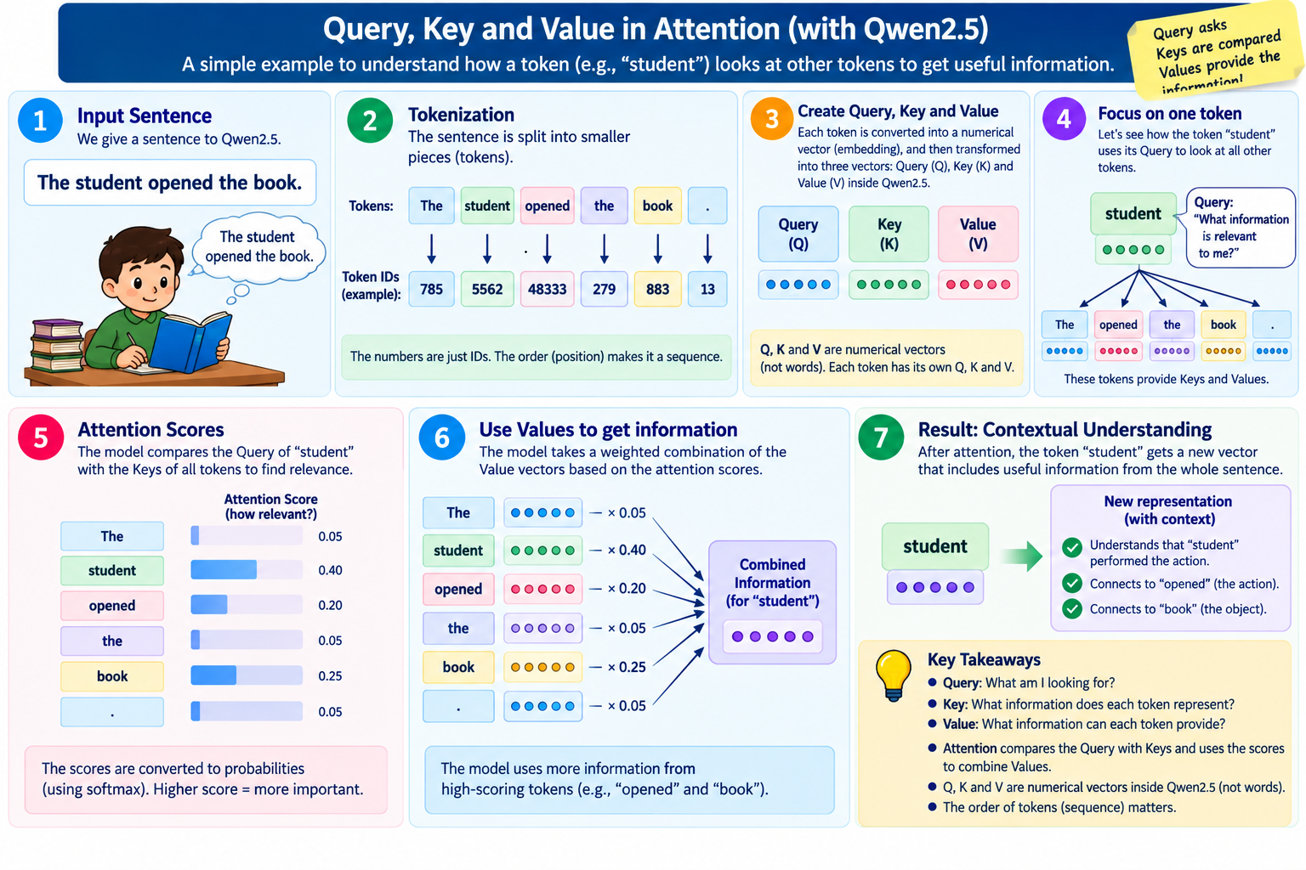

Pipeline (Project)

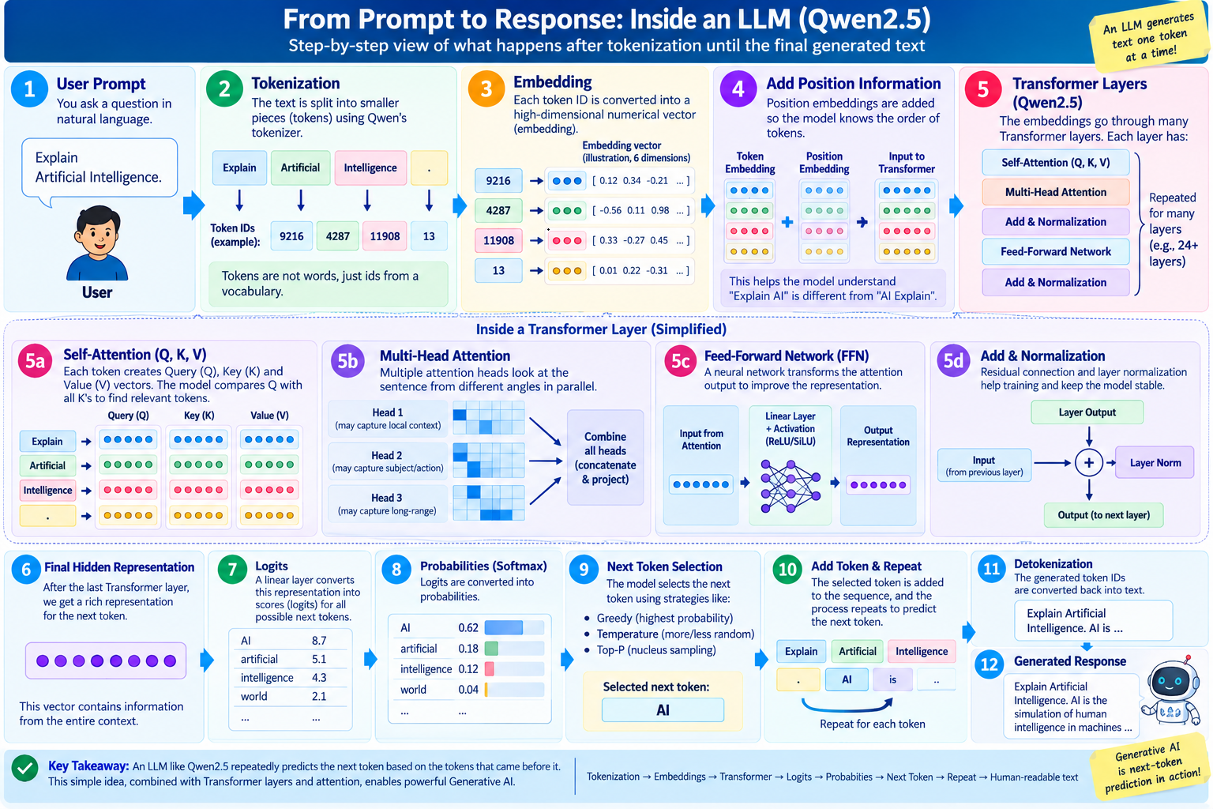

Output

