**Electromyography Signal Classification**

**BECE301L DIGITAL SIGNAL PROCESSING**

*By*

**Shwetank Shekhar-22BEC1204 Aakriti Singh-22BEC1416  
S. Jeyaraman-22BEC1180**

*Submitted to*

**Dr. R. RAMESH**



SCHOOL OF ELECTRONICS ENGINEERING

VELLORE INSTITUTE OF TECHNOLOGY

CHENNAI - 600127

*April 2024*

***Certificate***

This is to certify that the Project work titled “**Electromyography Signal Classification**” is being submitted by Shwetank Shekhar 22BEC1204, Aakriti Singh 22BEC1416 and S. Jeyaraman 22BEC1180, for the course B**ECE301L Digital Signal Processing** is a record of bonafide work done under my guidance. The contents of this project work, in full or in parts, have neither been taken from any other source nor have been submitted to any other Institute or University.

**Dr. R. RAMESH**

**Guide**

**ABSTRACT**

Electromyography (EMG) signals offer valuable insights into the health and function of muscles. By analysing these electrical signals, researchers can classify various neuromuscular disorders. This field holds immense potential for improving clinical diagnosis and decision-making.

The application of machine learning and computational techniques for EMG signal classification. The focus is on extracting informative features from EMG data and using Artificial Neural Networks (ANNs) algorithm to categorize these signals into specific neuromuscular disorders and detect if the patient is healthy or not. The success of this approach hinges on identifying the most discriminative features and employing robust classification methods.

This area of research holds promise for developing automated EMG analysis tools to aid clinicians in diagnosing neuromuscular disorders more accurately and efficiently. It could also pave the way for personalized treatment strategies based on the specific characteristics revealed by EMG signal analysis.

**ACKNOWLEDGEMENT**

We wish to express our sincere thanks and deep sense of gratitude to our project guide**,**

**Dr. R. Ramesh,** School of Electronics Engineering, for his consistent encouragement and valuable guidance offered to us in a pleasant manner throughout the course of the project work.

We are extremely grateful to **Dr. Susan Elias,** Dean of School of Electronics Engineering, VIT Chennai, for extending the facilities of the School towards our project and for his unstinting support.

We express our thanks to our Head of the Department **Dr. K. Mohanaprasad** for his support throughout the course of this project.

We also take this opportunity to thank all the faculty of the School for their support and their wisdom imparted to us throughout the course.

We thank our parents, family, and friends for bearing with us throughout the course of our project and for the opportunity they provided us in undergoing this course in such a prestigious institution.

**

**Shwetank Shekhar Aakriti Singh S.Jeyaraman**

**Table of contents**

**Chapter No Page No**

Abstract 3

Acknowledgement 4

List of figures 6

1.Introduction 7-8

1.1 Purpose 7

1.2 Scope 8

2.Literature Review 8-9

2.1 Time-frequency analysis 8

2.2 Machine Learning Methods 9

2.3 Summary 9

3.Implementation: Algorithm 9-11

3.1Pre-processing 9-10

3.2Feature Extraction 10

3.3Classification 11

4.Results 13-16

4.1Output 13-15

4.2Results and Discussion 16

5.References 17

6.Biodata 18-19

**List of figures**

**Fig No Title Page No**

1.3.1 System block diagram for EMG Classification 11

2.3.2 Function Fitting Neural Network 12

3.4.1 Indices of outliers 13

4.4.2 Validation Performance 13

5.4.3 Confusion Matrix 14

6.4.4 Error Histogram 14

7.3.5 Neural Network Training 15

**1.Introduction**

**1.1Purpose**

Electromyography (EMG) is a valuable diagnostic tool in the field of biomedical engineering and clinical neurophysiology. It involves the recording and analysis of electrical signals generated by skeletal muscles during voluntary or involuntary contractions. These signals, known as electromyographic signals, carry essential information about muscle activity, motor unit recruitment, and neuromuscular function.

The classification of EMG signals is of significant interest for various applications, particularly in the diagnosis and management of neuromuscular disorders. Neuromuscular disorders encompass a wide range of conditions affecting the peripheral nervous system, neuromuscular junction, and muscles, leading to impairments in movement, strength, and coordination. Examples include amyotrophic lateral sclerosis (ALS), muscular dystrophy, peripheral neuropathy, and myasthenia gravis.

EMG signal classification involves the extraction of relevant features from the recorded signals and the subsequent application of classification algorithms to distinguish between different types of muscle activity or pathological conditions. Traditional feature extraction methods include time-domain analysis, frequency-domain analysis, and time-frequency analysis, which capture various aspects of the signal's temporal and spectral characteristics. In recent years, machine learning and deep learning techniques have gained prominence in EMG signal classification, offering the potential for automated and more accurate diagnostic systems. These methods leverage the power of computational algorithms to learn discriminative patterns directly from the raw or pre-processed EMG data, thereby enhancing classification performance and robustness.

**1.2Scope**

Accurate classification of EMG signals can provide valuable insights into the underlying physiological processes and aid in the early detection, characterization, and monitoring of neuromuscular disorders. Furthermore, it can facilitate personalized treatment strategies and rehabilitation interventions tailored to individual patients' needs.

EMG classification facilitates the evaluation of treatment efficacy in patients with neuromuscular disorders. By comparing pre- and post-treatment EMG signals, clinicians can assess the impact of interventions such as medication, physical therapy, or surgical procedures on muscle activity, strength, and function.

**2.Literature Review**

**2.1Time-frequency analysis methods**

Electromyography (EMG) signal classification has emerged as a critical area of research in biomedical engineering and clinical neurophysiology. It plays a pivotal role in diagnosing and monitoring neuromuscular disorders by analysing the electrical activity of skeletal muscles. This literature review provides an overview of recent advancements in EMG signal classification techniques, highlighting methodologies, challenges, and applications in the context of neuromuscular disorders.

Historically, traditional approaches to EMG signal classification have focused on time-domain analysis, frequency-domain analysis, and time-frequency analysis [4]. Time-domain features include mean absolute value, waveform length, and zero-crossing rate, while frequency-domain features encompass power spectral density and spectral moments. Time-frequency analysis methods such as wavelet transform and short-time Fourier transform capture signal characteristics in both time and frequency domains, enabling enhanced feature extraction for classification purposes.

**2.2Machine Learning methods**

In recent years, machine learning techniques [1][2][3] have gained popularity in EMG signal classification due to their ability to automatically learn discriminative patterns from data. Supervised learning algorithms, including support vector machines (SVM), k-nearest neighbours (k-NN), and random forests, have been widely utilized for binary or multiclass classification of EMG signals. These algorithms leverage extracted features to classify signals into different categories, such as normal muscle activity or various neuromuscular disorders. Deep learning architectures, particularly convolutional neural networks (CNNs) and recurrent neural networks (RNNs), have shown remarkable performance in EMG signal classification tasks. CNNs are adept at learning spatial hierarchies of features from raw EMG data, while RNNs capture temporal dependencies within sequential EMG signals. Hybrid architectures, such as CNN-RNN hybrids, further enhance classification accuracy by combining spatial and temporal information.

**2.3Summary**

EMG signal classification holds great promise as a valuable tool for understanding neuromuscular physiology and diagnosing neuromuscular disorders. Advancements in signal processing techniques, machine learning algorithms, and deep learning architectures have significantly enhanced classification accuracy and robustness to tackle challenges including noise contamination, signal variability, electrode placement errors, and inter-subject variability. Future research efforts should focus on addressing remaining challenges, validating classification models in clinical settings, and translating research findings into real-world applications for improving patient care and outcomes in neuromuscular medicines.

**3.Implementation: Algorithm**

**3.1Pre-Processing Data**

The first step in the process of EMG classification is filtering the data to remove noise outside the relevant frequency range of EMG signals (typically between 20 Hz and 500 Hz). The sampling frequency (Fs), high pass and low pass filter cutoff frequencies of the EMG data are

defined. A Butterworth filter design (butter) to create high-pass (b_high, a_high) and low-pass (b_low, a_low) filter coefficients. The filtered EMG signal (filtered_emg) is obtained by applying both filters sequentially using filtfilt.

**3.2Feature Extraction**

Extraction of features is the most important step in creating an ANN network or making any sort of MATLAB classifier. An empty matrix (features) to store the extracted features for each EMG signal is defined. It iterates through each column (potentially representing an EMG channel) of the filtered data. Inside the loop, eight features are calculated for each channel and stored in the corresponding row of the features matrix.

These features include:

2.2.1Maximum Fractal Length (MFL): This function calculates a measure of the signal's complexity.

2.2.2Modified Mean Absolute Value (MMAV): This function calculates the average absolute value of the signal with optional filtering using a moving window. 2.2.3Difference Absolute Standard Deviation Value (DASDV): This function calculates the standard deviation of the absolute value of the difference between the signal and its mean. 2.2.4Average Amplitude Change (AAC): This function calculates the average absolute value of the differences between consecutive samples in the signal. 2.2.5Enhanced Wavelength (EWL): This function calculates a modified wavelength by modulating the signal with a carrier frequency and then analysing the changes. 2.2.6FFT Variance: This function calculates the variance of the power spectrum obtained from the Fast Fourier Transform (FFT) of the signal.

2.2.7FFT Maximum Intensity: This function finds the maximum value in the power spectrum obtained from the FFT.

2.2.8Variance of Normalized Energy Operator (NEO): This function calculates the variance of a transformed signal based on squared values and its neighbours.

**3.3Classification**

ANNs excel at identifying patterns in complex data like EMG signals. By training on a large dataset of EMG signals labelled with specific muscle activities or disorders, the ANN can learn to recognize these patterns and classify new signals accurately.

The pre-processed EMG data and corresponding labels are fed into the ANN. The network then iteratively adjusts the weights of the connections between neurons based on the difference between its predicted output and the actual label. This process minimizes the error and allows the ANN to learn the patterns within the EMG data for accurate classification.  
The number of neurons in the hidden layer are set to 1000. This determines the network's capacity to model complex relationships in the data. The data is divided into three sets: training set (70%)-used for training the network to learn patterns in the data, validation set (15%)-used to evaluate performance during training and prevent overfitting and testing set (15%)-used to assess the final performance of the trained network. The network evaluates performance using metrics like accuracy, precision, recall, etc.

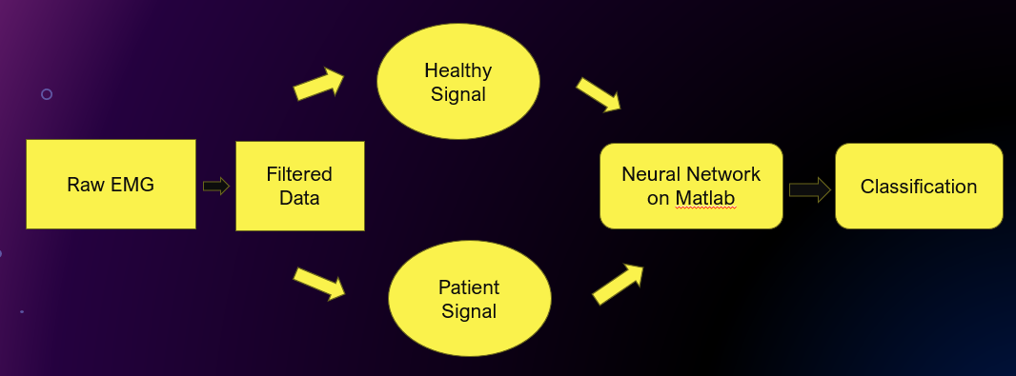

Figure1.3.1: System block diagram for EMG Classification

Figure2.3.2: Function Fitting Neural Network

**4.Results**

**4.1Output**

With the help of MATLAB, we have established an artificial neural network that distinguishes patients from healthy subjects. In short, we can tell if a person has neuromuscular disorder or is not using a network. After training the array we created, the network gives a matrix of confusion. This confusion matrix gives us the accuracy of our network.

The F1 score is a useful metric for evaluating the trade-off between precision and recall in classification tasks, making it valuable for assessing the overall performance of ANN models.

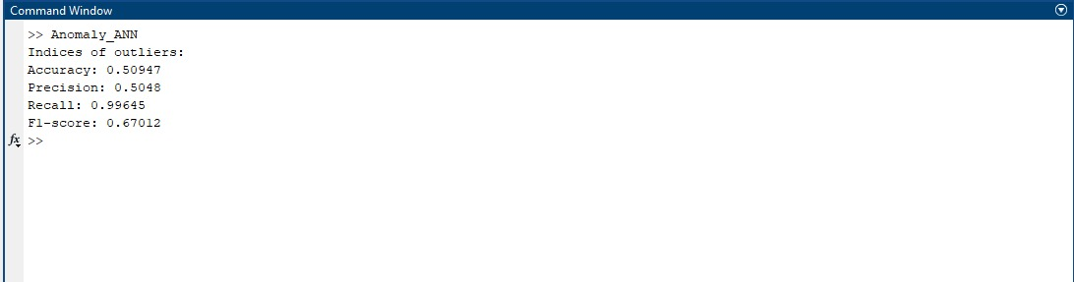

Figure3.3.1: Indices of outliers

Figure4.3.2: Validation Performance

Figure5.3.3: Confusion Matrix

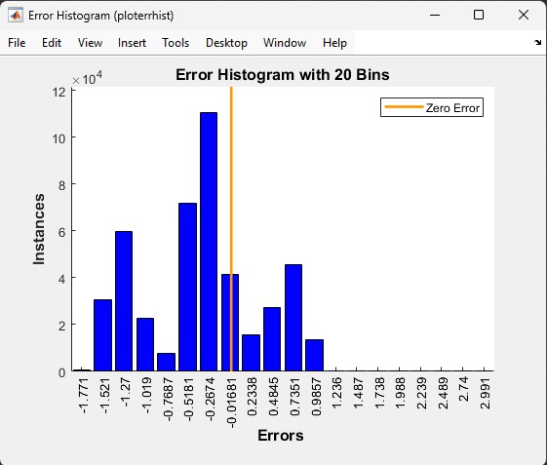

Figure6.3.4: Error Histogram

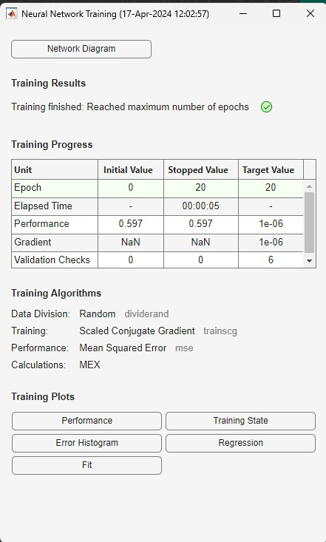

Figure7.3.5: Neural Network Training

**4.2Discussion**

Our research focussed on analysing muscle activity (EMG signals) using ANN architecture. This AI tool can effectively distinguish between healthy and patient signals, making it a valuable asset for medical diagnosis. We successfully fine-tuned the AI system to achieve this, and the initial results are satisfying.

More importantly, this research presents a general approach for analysing EMG signals. This approach can be applied in various settings, from medical research and clinical diagnosis to tools for patients and the development of new medical devices. The key lies in selecting the most informative features from the EMG data to ensure accurate analysis.

**5.References**

1. Ahmed, T. and Islam, M.K., 2021, May. EMG Signal classification for detecting neuromuscular disorders. In Journal of Physics: Conference Series (Vol. 1921, No. 1, p. 012043). IOP Publishing.
2. Sadikoglu, Fahreddin, Cemal Kavalcioglu, and Berk Dagman. "Electromyogram (EMG) signal detection, classification of EMG signals and diagnosis of neuropathy muscle disease." Procedia computer science 120 (2017): 422-429.
3. Chowdhury, R. H., Reaz, M. B., Ali, M. A. B. M., Bakar, A. A., Chellappan, K., & Chang, T. G. (2013). Surface electromyography signal processing and classification techniques. Sensors, 13(9), 12431-12466.
4. Too, J., Abdullah, A.R., Zawawi, T.T., Saad, N.M. and Musa, H., 2017. Classification of EMG signal based on time domain and frequency domain features. International Journal of Human and Technology Interaction (IJHaTI), 1(1), pp.25-30.

**6.BIO DATA**

**Name:** Shwetank Shekhar

**Email:** shwetank.shekhar2022@vitstudent.ac.in

**Mobile number:** 7200250179

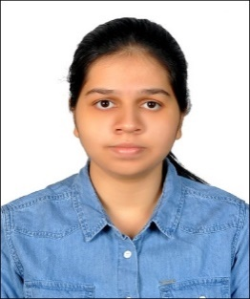

**Name:** Aakriti Singh

**Email:** aakriti.singh2022@gmail.com

**Mobile number:** 9121028104



**Name:** S.Jeyaraman

**Email:** jeyaraman.s2022@vitstudent.ac.in

**Mobile number:** 9025373117