REDUCIng Landing site Contamination USING 3-D TRAJECTorY OPTIMIZATION for surface HOPPERS

(Preprint) AAS XX-XXX

Philip C. Calhoun[1] and Alvin G. Yew[2]

Rocket-powered vehicles utilizing Vertical Take-off Vertical Landing (VTVL) are a compelling alternative to surface rovers for exploring planetary and lunar bodies. These so called “hoppers” provide enhanced mobility for accessing locations difficult to reach, and over a wider region of the surface. However, contamination and plume interactions from rocket exhaust deposited at landing sites is anticipated since landing approaches are typically along a vertical direction during the final descent. Consequently, exhaust products may alter the surface chemistry, potentially confounding compositional analysis for samples collected in the vicinity of the landing site or jeopardize mining efforts. There has been no rigorous study on flight maneuvers that can mitigate plume-to-surface interactions. A multi-objective optimization tool has been developed to simulate propulsive hops on a planetary body and minimize both fuel consumption and site alterations. Trajectories are derived by multi-objective optimization and include solutions with significant reduction in contamination for a modest increase in fuel consumption. For these solutions, surface-to-surface propulsive transfer is demonstrated, but the method can also be modified for orbit-to-surface transfers (e.g., landers).

Introduction

Planetary and lunar surface expeditions serve increasingly prevalent roles for robotic spaceflight missions, affording unique capabilities that cannot often be substituted by remote surveys. For example, orbital observations may only partially elucidate geological microstructures, seismic activity, and subsurface chemistry that can be more thoroughly characterized in situ. The demand for surface campaigns is further accelerated by plans for Artemis1, NASA’s program to establish a sustainable lunar presence. As part of the program, there are features of intense scientific and operational interest on the Moon that prompt further exploration including Permanently Shadowed Regions (PSRs)2. These PSRs reside most notably in craters that serve as cold traps containing records of volatiles from extra-lunar origins, and endogenic volatiles that have been transported, redistributed, and deposited over billions of years by exospheric dynamics. Prior observations suggest that water ice could be abundant in some PSRs and may also be rich in metals such as iron and titanium.

For mobility and access to sites such as PSRs, rovers traditionally provide limited surface-to-surface range and have difficulty reaching areas of rugged terrain, or traversing slopes of substantial grade such as crater walls. Alternatively, rotorcraft powered flight3 (e.g., Ingenuity and Dragonfly) may present a viable option to address these challenges, however, they require sufficiently dense atmospheres to operate, rendering them infeasible for tenuous exospheres like the Moon. A highly versatile mobility concept, rocket powered propulsive hoppers, can operate in both atmospheric and airless bodies, and offer kilometer-scale range that can easily overcome otherwise insurmountable geological hurdles. The only demonstrated propulsive hop in space was a short experiment performed on the Moon4 by Surveyor 6 engineers, who programmed a hop of approximately 2.5 m horizontal and 4 m vertical.

In addition to Surveyor 6, other propulsive hoppers have been conceptualized. Triton Hopper5 was developed to harvest and ingest in situ nitrogen ice on Triton’s surface and expel it in gaseous form as propellant. Comet Hopper6 and Mars Geyser Hopper7 were also propulsive vehicle concepts but did not perform any in situ resource utilization (ISRU). While rocket propulsion may be selected for its breadth of geographic access and for its relative efficiency, plume-to-regolith interactions may be undesirable. Surface chemistry and regolith structure could be significantly altered by rocket exhaust and might compromise sample integrity for science. Direct pluming could also volatilize valuable materials during a mining operation. Mechanical hopping could mitigate some contamination issues, but such systems have a much more limited range. MINERVA-II1A and MINERVA-II1B were attached to the Hayabusa2 mothership and demonstrated mechanical hopping on asteroid Ryugu8.

Besides contamination concerns posed by propulsive hoppers, landed missions utilizing retro burns may also introduce contamination. NASA’s OSIRIS-Rex9 provided a meticulous contamination control plan, motivated by the mission’s primary objective to retrieve a pristine sample from the surface of asteroid Bennu. OSIRIS-Rex10 performed a “touch-and-go” operation that contacted the surface briefly, similar to a landing. As part of the plan, it was the first surface mission to impose hydrazine contamination thresholds as a science requirement. This requirement was initially written in terms of the fraction of hydrazine to native sample collected. However, it was later revised to exclude any reference to the sample collected, or to the sampling site because predictions for regolith contamination would be highly sensitive to unknown material characteristics and therefore, could not be reliably verified. Some considerations were implemented to minimize site and sample contamination, including canting thrusters away from the sampling site.

Unreacted hydrazine is typically a minor constituent in the plume exhaust, comprising of less than 1%, but might pose a contamination concern since it can react with regolith organics and other native components to form spurious compounds that can be mistaken for native species. Other hydrazine combustion products (of larger or smaller fraction) can also potentially pose additional concern. Ammonia, for example, is especially “sticky” – as a highly non-polar molecule and may contaminate sampling of native isotopic ratios for nitrogen. Noble gases also play an important role in helping to understand the evolution and chemistry on various bodies, so exogenous sources of these species could be problematic for science.

In this paper, we present strategies to minimize plume-to-surface interactions (e.g., to reduce sample contamination at landing zones) by modifying flight trajectories for surface hoppers. The modified trajectories affect all phases of the flight: takeoff, mid “cruise”, and descent and landing. To accomplish this, the multi-objective optimization minimizes both fuel consumption and landing site contamination according to weighting coefficients in the objective function.

Methods

Optimal solutions for three-dimensional flight trajectories in a local horizontal planet-fixed reference frame are derived through simulated attitude and propulsive maneuvers. A state-space representation for these trajectories comprises of the downrange, vertical, and cross range positions ($P_{d} , P_{v} , P_{c}$) , respective velocities ($V_{d} , V_{v} , V_{c}$), thrust vector direction angles in local horizontal frame ($θ, ϕ$), vehicle wet mass ($m$), and plume contamination deposition at landing location ($C$).

$\dot{P_{d} }=V_{d}$ (1)

$\dot{V_{d}} = -T \frac{\sin\left(θ\right)}{m}$ (2)

$\dot{P_{v} }=V_{v}$ (3)

$\dot{V_{v}} = -T \frac{\cos\left(θ\right)\cos\left(ϕ\right)}{m}-g_{P}$ (4)

$\dot{P_{c} }=V_{c}$ (5)

$\dot{V_{c}} = -T \frac{\cos\left(θ\right)\sin\left(ϕ\right)}{m}$ (6)

$\dot{θ} =ω_{θ}$ (7)

$\dot{ϕ} =ω_{ϕ}$ (8)

$\dot{m}=-\frac{T}{g_{0} I_{sp}}$ (9)

$\dot{C} = T_{dc} C_{max}(d_{p}) \cos^{4}\left(α_{p}\right)$ (10)

In these equations, $g_{P}$ is the planetary local gravity, $g_{0}$ is the gravity constant, *T* is the effective thrust of the vehicle, and ( $ω_{θ}, ω_{ϕ})$ are the thrust vector direction rates.

The rocket plume geometry and density field used for assessing the surface contamination is modeled approximately, based on analytical models developed in the literature11. The plume model incorporated in this method (Eq. 10) is a notional model, representative of plume contamination deposition at the landing site, from spacecraft thrusters exhaust as projected onto a specified radius centered at the landing coordinates. The plume envelope (conceivably defined as Bird’s breakdown surface) takes the form of a cos4 function of the angle from the thrust plume centerline to the landing site ($α_{p}$), with a non-zero value from -pi to pi, fanning outward from the thrust direction with axis of symmetry along the thrust vector. Within this plume envelope, the maximum contamination rate ($C_{max}$) prescribed along the exit plume centerline, is a function of distance from exit plane to landing site ($d_{p}$) decreasing linearly to zero at a specified distance from the plume exit plane. The contamination rate is modulated by the thruster’s effective duty cycle ($T_{dc}$). While it is not a precise plume contamination representation, this qualitative model implemented serves as a sufficiently useful estimate to investigate relative comparisons of contamination at the landing site for different optimal trajectories. Precise plume contamination estimates require numerically intensive computational models and were considered unnecessary and beyond the scope of this study. Mission-specific plume characteristics could be substituted and may also include species-specific byproducts for the appropriate propellant in future studies of specific missions.

Optimization Framework

The optimization framework was implemented using Direct Collocation (DC) with implicit Simpson-Hermite integration to ensure the feasibility of optimized trajectory state solutions, as described in Pollicelli’s Thesis12. To enforce a dual minimization for both fuel consumption and surface contamination from the plume, the fitness function (i.e., objective function, a.k.a. cost function) was specified as a quadratic function of fuel and contamination mass, using a unit normalized weighting factor for contamination (*WC*), as shown in Eq. 11.

$f = {(1-W}_{C}) {fuel}^{2}{ + W}_{C} C^{2}$ (11)

The fuel estimate used in the fitness function is the sum of the fuel required for trajectory maneuvers, and for attitude maneuvers to implement thrust vectoring. To maintain a simplified model, the residual thrust and fuel mass from attitude maneuvers is neglected in the state equations. The primary purpose of adding the attitude maneuver fuel to the estimate is to penalize large changes in thrust vectoring when thrust magnitude is zero. Appropriate constraints and parameter bounds in the optimization framework for this problem expanded on those used in Pollicelli’s thesis12. The constraints are listed below:

* The final and initial position and velocity states were allocated a tolerance to enforce conditions at launch and landing
* A minimum altitude above ground constraint was imposed to prevent vehicle trajectories from breaching through a minimum height clearance above the ground during flight.
* Constraints imposed on Thrust angles and rates to enforce VTVL.
* A narrow vertical corridor was specified above takeoff and landing sites to independently ensure VTVL.
* Minimum thrust at lift-off promotes vehicle lift-off
* Maximum thrust magnitude, direction angles, direction angular rates, and direction angular accelerations, impose realistic limits on thruster and vehicle attitude control.

**Case Study**

The proposed trajectory optimization method is applied to a simple case study to demonstrate the usefulness of obtaining optimal solutions and compare performance when motion is restricted to two-dimensional flight (i.e., downrange, and vertical motion) with three dimensional trajectories that include crossrange. The parameters specified in this case study are intended to be representative of a lunar application. A 500 m downrange hop on flat ground in a lunar gravity environment is considered for vehicle with an initial wet mass of 170 kg, axial thrust of 1070 N, and propellent specific impulse of 150 sec. Additional constraints include VTVL, minimum altitude above ground during flight of 3 m, maximum thrust rotation rate of 20 deg/s and angular acceleration of 6 deg/s^2. A 15-node solution was specified with linear time distribution.

Results

To derive a baseline for fuel usage and landing site contamination the contamination weight was set to zero (i.e., fuel mass only was minimized) in an initial case study. The optimal solution found for this baseline case approximated a simple two-dimensional ballistic trajectory, even though the state variables included the out-of-plane states (crossrange and roll). As expected, when the contamination weight is zero, the trajectory appears very close to parabolic since only fuel utilization is optimized and no attempt is made to minimize landing site contamination. A slight lofting of the trajectory resulted from the imposed VTVL constraints. For this near ballistic trajectory, the fuel usage was found to be 7.6 kg, and the contamination was 36 mg.

A variety of agile trajectory solutions were obtained from a parametric sweep of various contamination weights in the fitness function. Each solution yielded a reduction in landing site contamination with only modest increases in fuel consumption. As the contamination weight is increased the optimization results shows trajectories with significant out-of-plane motion. The resulting optimal trajectory and thrust parameters for one such case, when the contamination weight is set to 0.4, is shown Figures 1 and 2. The trajectory is slightly depressed from the ballistic flight reference. An agile maneuver is performed on final descent to vector the thrust both in-plane and out-of-plane to minimize contamination while simultaneously avoiding excessive fuel usage. As shown in Figure 3, the contamination is reduced from 36 mg to 8 mg, a 78% reduction over the baseline near-ballistic trajectory.

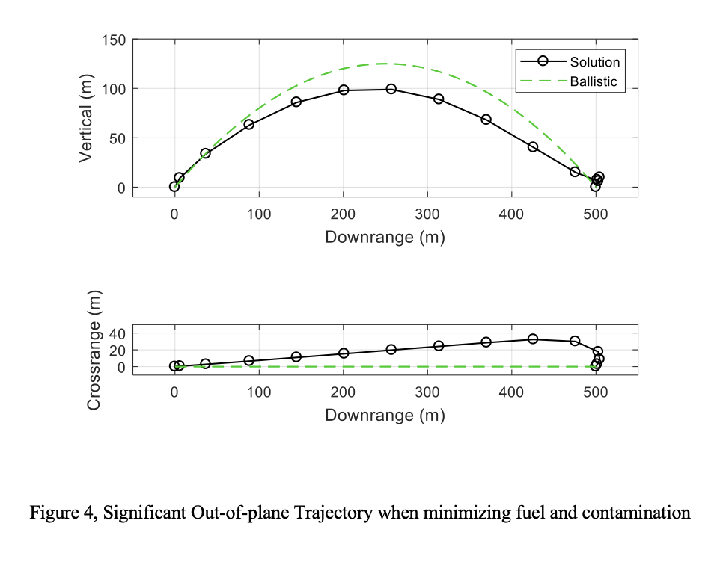

Figure 1, Significant Out-of-plane Maneuvers when Minimizing Fuel and Contamination

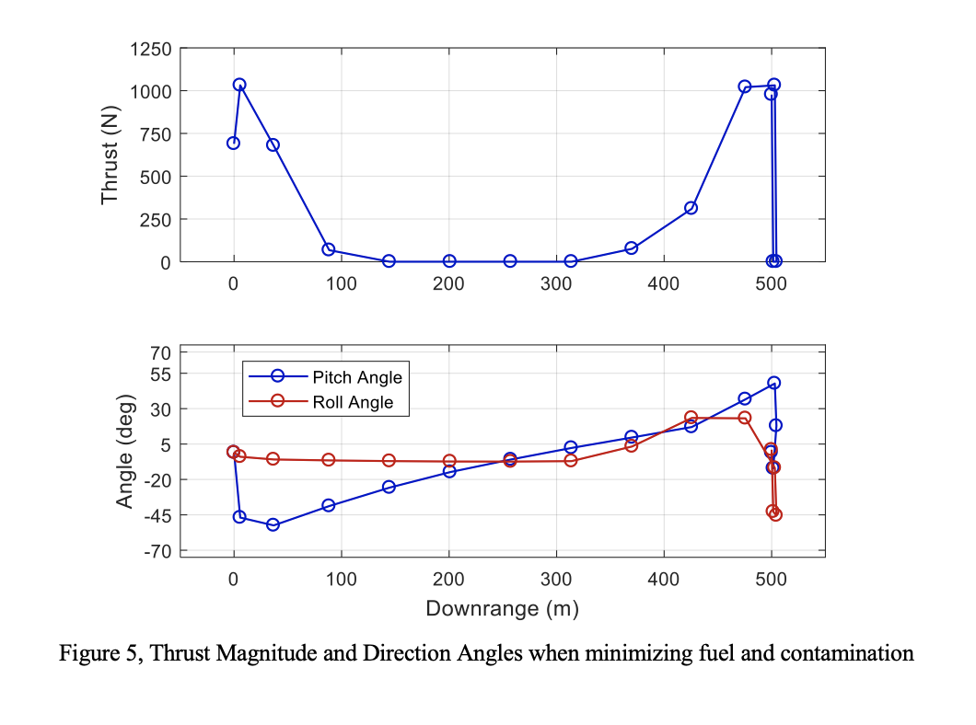

Figure 2, Thrust Magnitude and Direction Angles when Minimizing Fuel and Contamination

Significant contamination reduction is accomplished with only a relatively small increase in fuel usage from 7.6 kg to 9 kg, a 18.4% increase over the baseline trajectory. Close examination of the trajectory and thrust parameters near landing illustrate the agile maneuvers used to accomplish contamination reduction, as shown in Figure 4,

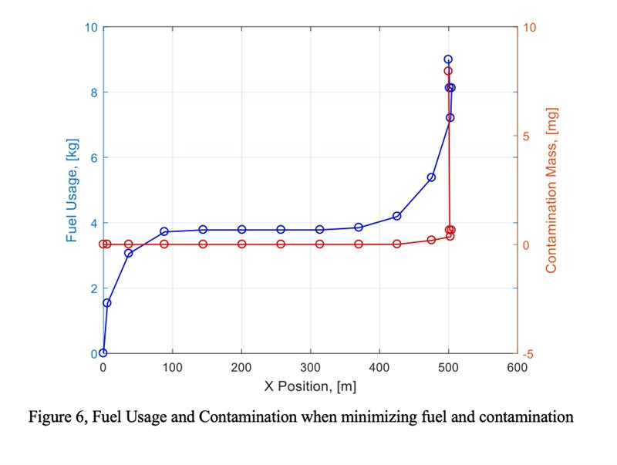

Figure 3, Fuel Usage and Contamination when Minimizing Fuel and Contamination

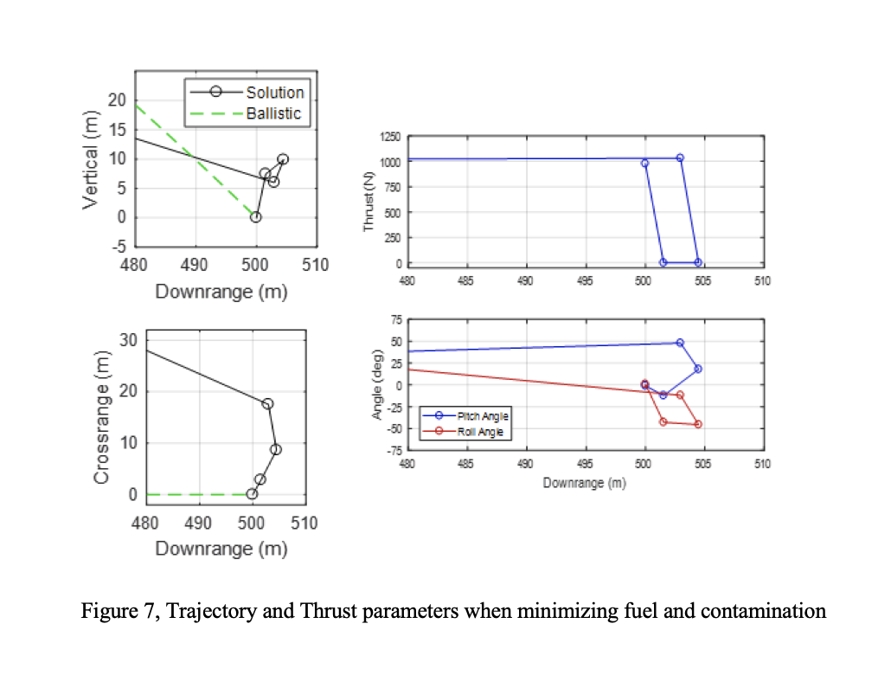

Figure 4, Trajectory/Thrust Parameters Near Landing When Minimizing Fuel and Contamination

Trajectory inflections are observed in the final descent phase, which manifests as hovering and an additional crossrange “mini hop” before the final touchdown. The trajectory continues downrange slightly past the landing point as it performs out-of-plane maneuvers during final descent. These maneuvers take advantage of the fact that the plume contamination function falls off as the 4th power of cosine while the thrust force component along the vertical descent drops as the cosine of the thrust vector maneuver angles. This allows the significant reduction of contamination while minimizing vertical thrust losses during final descent. A small fuel-efficient roll maneuver at the beginning of the trajectory is used to set up conditions for exploiting the out-of-plane maneuvers. A crossrange approach for final descent allows vectoring along crossrange direction away from the landing site to minimize plume contamination. Also, note that the restriction on thrust vector angular acceleration (6 deg/sec2) results in significant roll angle overshoot while thrust is turned off during final approach.

Optimization cases using in-plane only states (i.e., with crossrange position and velocity, and roll angles removed) where analyzed to investigate the impact of restricting the trajectory to in-plane only motion. The trajectory and thrust parameters for a selected two-dimensional case, with contamination weight set to 0.2, are shown in Figures 5 and 6. This case was selected to provide a good comparison with the previous three-dimensional case since it had the same fuel usage, as shown in Figure 7. In this case the trajectory is also depressed from the ballistic reference, but differs from the three-dimensional case by performing a second hop maneuver initiated at 435 m. This maneuver uses additional fuel to minimize the landing site contamination by reducing the altitude for the final descent. Excess downrange velocity is removed using a large angle pitch maneuver during the decent. This provides a means to reduce the contamination at the landing site at the expense of some loss in vertical thrust efficiency. The second hop is a typical trajectory solution when the optimization is restricted to in-plane only. However, this hop is less efficient in reducing contamination than typical three-dimensional agile maneuvers that can vector thrust out-of-plane and away from landing site prior to landing while more closely approximating the fuel optimal parabolic in-plane trajectory. The landing site contamination for the two-dimensional case is 13.5 mg, about 37.5% of the contamination found for fuel-optimal ballistic trajectories. However, this amount is a 68% increase over the contamination in the three-dimensional case for the same fuel usage.

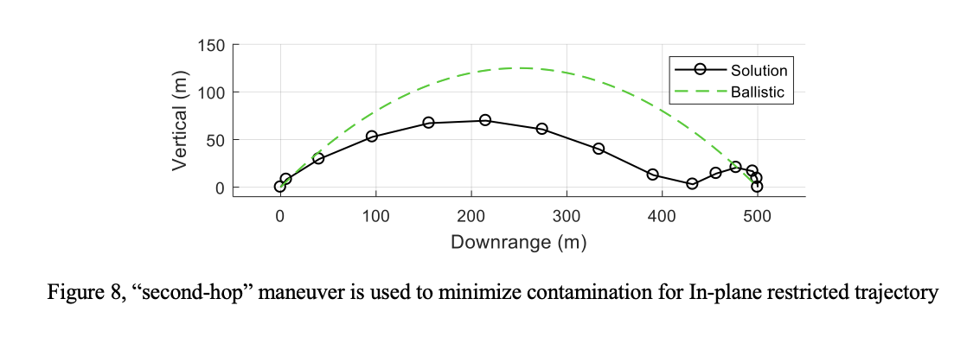

Figure 5, "Second Hop" Maneuver to Minimize Contamination for In-plane Restricted Trajectory

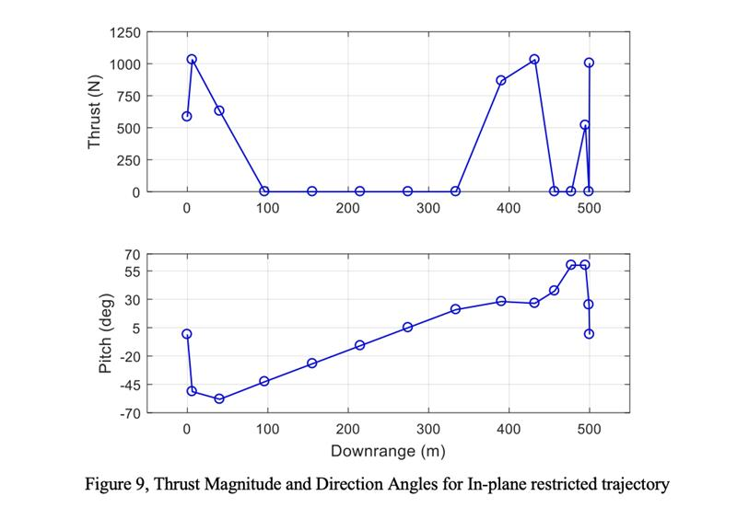

Figure 6, Thrust Magnitude and Direction Angles for In-plane Restricted Trajectory

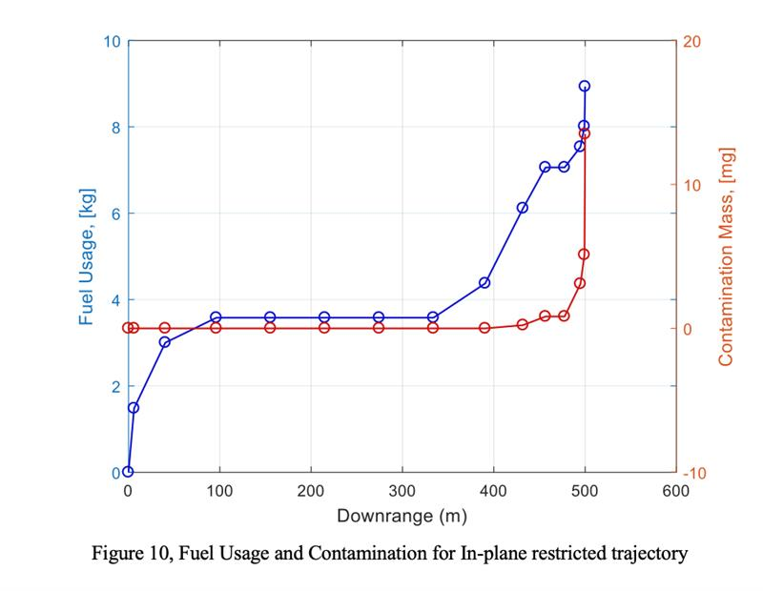

Figure 7, Fuel Usage and Contamination for In-plane Restricted Trajectory

**CONCLUSION**

We have developed a trajectory optimization method to simultaneously minimize fuel consumption and landing site contamination. The compromise between contamination reduction and additional fuel usage can be adjusted by changing the respective weighting coefficients in the fitness function. Prescribing a small value for the contamination weight requires a small fraction of additional fuel to perform the hop when compared to the ballistic reference, perturbing the descent trajectory to substantially reduce landing site contamination. However, larger increases in the contamination weight yields diminishing returns in contamination reduction while the fuel requirements increase. Out-of-plane maneuvers were found to be more effective in reducing landing site contamination for the same additional fuel usage. This is accomplished by vectoring the thrust out-of-plane while more closely maintaining the fuel optimal ballistic trajectory in the pitch plane. Our results show that feasible trajectories can be obtained with realistic constraints on vehicle parameters when some extra fuel is available and contamination minimization is paramount. Typically, these higher contamination weights produce more complex descent trajectories including hovering maneuvers, trajectory inflections, and target flyovers.

The trajectories explored in this work can also be applied to optimize a variety of other surface interactions that might be of interest for a mission. This would require modifying the state equations by either replacing the contamination mass rate or adding new equations to represent other modes of plume surface interaction.

REFERENCES

[1] Sweetser, T. H., Broschart, S. B., Angelopoulos, V., Whiffen, G. J., Folta, D. C., Chung, M. K., & Woodard, M. A. (2012). ARTEMIS mission design. In *The ARTEMIS Mission* (pp. 61-91). Springer, New York, NY.

[2] Sowers, G. F., & Dreyer, C. B. (2019). Ice mining in lunar permanently shadowed regions. *New Space*, *7*(4), 235-244.

[3] Tzanetos, T., Aung, M., Balaram, J., Grip, H. F., Karras, J. T., Canham, T. K., ... & Williford, K. H. (2022, March). Ingenuity mars helicopter: From technology demonstration to extraterrestrial scout. In *2022 IEEE Aerospace Conference (AERO)* (pp. 01-19). IEEE.

[4] Chmielewski, A. B., Barba, N., Romer, N., & Fulmer, N. (2019, March). Lessons from Surveyor VI: Hopping Spacecraft for Low-Cost Surface Mobility on Small Bodies. In *2019 IEEE Aerospace Conference* (pp. 1-11). IEEE.

[5] Oleson, S. R., & Landis, G. (2018). Triton Hopper: Exploring Neptune’s Captured Kuiper Belt Object. In *Outer solar system* (pp. 367-428). Springer, Cham.

[6] Clark, B. C., Sunshine, J. M., A’Hearn, M. F., Cochran, A. L., Farnham, T. L., Harris, W. M., ... & Veverka, J. (2008). Comet Hopper: A mission concept for exploring the heterogeneity of comets. *Asteroids, Comets, Meteors*, *1405*.

[7] Landis, G., Oleson, S., & McGuire, M. (2012). Design study for a Mars geyser hopper. In *50th AIAA aerospace sciences meeting including the new horizons forum and aerospace exposition* (p. 631).

[8] Tsuda, Y., Saiki, T., Terui, F., Nakazawa, S., Yoshikawa, M., Watanabe, S. I., & Hayabusa2 Project Team. (2020). Hayabusa2 mission status: Landing, roving and cratering on asteroid Ryugu. *Acta Astronautica*, *171*, 42-54.

[9] Lauretta, D. S., Balram-Knutson, S. S., Beshore, E., Boynton, W. V., Drouet d’Aubigny, C., DellaGiustina, D. N., ... & Sandford, S. A. (2017). OSIRIS-REx: sample return from asteroid (101955) Bennu. *Space Science Reviews*, *212*(1), 925-984.

[10] Berry, K., Sutter, B., May, A., Williams, K., Barbee, B. W., Beckman, M., & Williams, B. (2013, February). OSIRIS-REx touch-and-go (TAG) mission design and analysis. In *36th Annual AAS Guidance and Control Conference* (No. GSFC. CP. 7566.2013).

[11] Boyd, I. D., & Stark, J. P. W. (1990). Modeling of a small hydrazine thruster plume in the transition flow regime. *Journal of Propulsion and Power*, *6*(2), 121-126.

[12] Policelli, M.J. (2014) Vertical take-off vertical landing spacecraft trajectory optimization via direct collocation and nonlinear programming. *Master of Science Thesis*, Department of Aerospace Engineering, the Pennsylvania State University.

Acknowledgments

We are very grateful to our collaborators. Michael Policelli provided the underlying code and optimization framework. Mehdi Benna initially motivated this work with a lunar science concept.

1. Aerospace Engineer, Attitude Control Systems Branch, NASA GSFC, Greenbelt, MD 20771
2. Research Engineer, Instrument Systems & Technology Division, NASA GSFC, Greenbelt, MD 20771