Nikto

Introduction

In Kali Linux, Nikto is a free and open-source web server and web application scanner. Nikto is a pluggable web server and CGI scanner written in Perl, using rfp’s LibWhisker to perform fast security or informational checks. With the help of this popular Nikto Web Scanner tool, we can Scan your website and server immediately. This testing service can be used to test a Web Site, Virtual Host, and Web Server for known security vulnerabilities and misconfigurations. Nikto performs over 6000 tests against a website. A large number of tests for both security vulnerabilities and misconfigured web servers makes it a go-to tool for many security professionals and systems administrators. It can find forgotten scripts and other hard-to-detect problems from an external perspective. The Nikto web server scanner is a security tool that will test a website for thousands of possible security issues. Including dangerous files, misconfigured services, vulnerable scripts, and other issues. It is open source and structured with plugins that extend the capabilities. These plugins are frequently updated with new security checks. Nikto is by no means a stealthy tool. It will make over 2000 HTTP GET requests to the web server, creating a large number of entries in the web server’s log files. This noise is actually an excellent way to test an in-place Intrusion Detection System (IDS) that is in place. Any web server log monitoring, host-based intrusion detection (HIDS), or network-based intrusion detection (NIDS) should detect a Nikto scan. Custom scans can be initiated using IDS bypass methods from libwhisker, however, the current version of our online scan is a default (no evasion) scan.

Features

The following are the features of the Nikto:

* Easily updatable CSV-format checks database,
* Output reports in plain text or HTML,
* Available HTTP versions automatic switching,
* Generic as well as specific server software checks,
* SSL support (through libnet-ssLeay-perl),
* Proxy support (with authentication),
* Cookies support.

Installation

If you're using Kali Linux, Nikto comes preinstalled and will be present in the “Vulnerability Analysis” category. If you don't have Nikto on Kali (for some reason), you can get Nikto from GitHub or just use the following command which is given below:

Open your Kali Linux and then Open your Terminal. Use the following command to install the tool:

sudo apt-get update

After updating apt database, We can install goldeneye using apt-get by running the following command:

sudo apt install nikto

Usage

To check or scan the “demolaze.com” website and create an HTML report using the Nikto tool we can execute the following command:

Nikro –h <https://demolaze.com> –o /tmp/report.html –Format htm

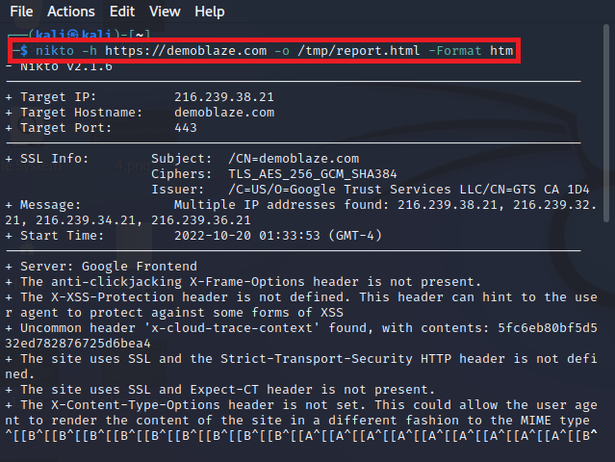

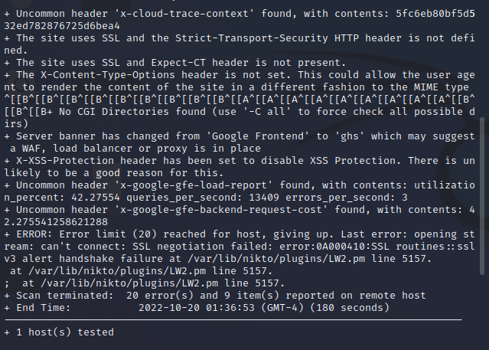

To generate HTML report in Firefox browser using the Nikto tool we can execute the following command:

Firefox /tmp/report.html

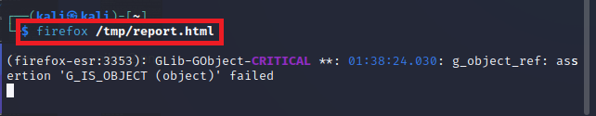

Generate report on above website given below:

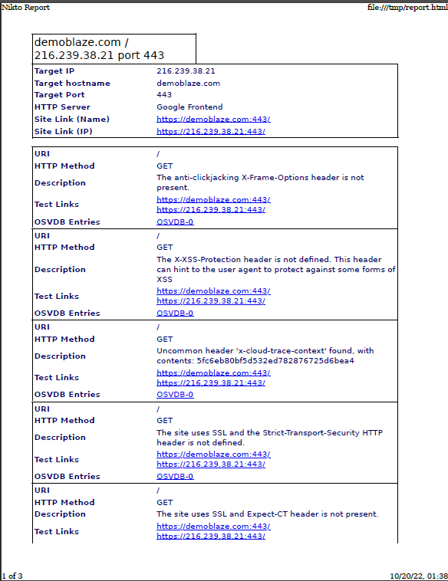

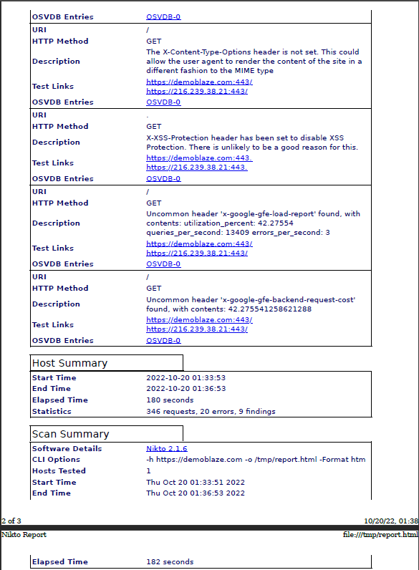

## References

1. https://hackertarget.com/nikto-website-scanner/
2. https://www.kali.org/tools/nikto/