**РЕШИТЕ ЗАДАЧИ:**

1. Найдите минимальный остов дерева представленного на рис. 2.33 графа.

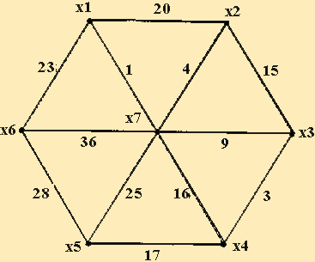

Рис. 2.33

|  |  |  |  |  |  |  |  |
| --- | --- | --- | --- | --- | --- | --- | --- |
|  | X1 | X2 | X3 | X4 | X5 | X6 | X7 |
| X1 | 0 | 20 | 0 | 017 | 0 | 23 | 1 |
| X2 | 20 | 0 | 15 | 0 | 029 | 0 | 4 |
| X3 | 0 | 15 | 0 | 3 | 0 | 045 | 9 |
| X4 | 017 | 029 | 3 | 0 | 17 | 0 | 16 |
| X5 | 0 | 0 | 0 | 17 | 0 | 28 | 25 |
| X6 | 23 | 0 | 045 | 0 | 28 | 0 | 36 |
| X7 | 1 | 4 | 9 | 16 | 25 | 36 | 0 |

|  |  |  |  |  |  |  |  |
| --- | --- | --- | --- | --- | --- | --- | --- |
|  | X1 | X2 | X3 | X4 | X5 | X6 | X7 |
| X1 |  |  |  |  |  |  |  |
| X2 | ~~20~~ |  |  |  |  |  |  |
| X3 | 0 | ~~15~~ |  |  |  |  |  |
| X4 | 0 | 0 | 3 |  |  |  |  |
| X5 | 0 | 0 | 0 | 17 |  |  |  |
| X6 | 23 | 0 | 0 | 0 | 28 |  |  |
| X7 | 1 | 4 | 9 | ~~16~~ | 25 | ~~36~~ |  |

Минимальный остров: 1+23+4+9+3+17+25+28=110

2. Найдите кратчайший путь на представленном графе (рис. 2.34).

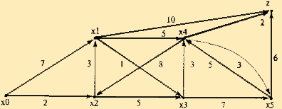

Рис. 2.34

|  |  |  |  |  |  |  |  |
| --- | --- | --- | --- | --- | --- | --- | --- |
|  | X0 | X1 | X2 | X3 | X4 | X5 | Z |
| X0 |  | 7 | 2 |  |  |  |  |
| X1 |  |  |  | 1 | 5 |  | 10 |
| X2 |  | 3 |  | 5 |  |  |  |
| X3 |  |  |  |  | 3 | 7 |  |
| X4 |  |  | 8 |  |  | 3 | 2 |
| X5 |  |  |  |  | 5 |  | 6 |

Г{X0}={X1,X2}

I(X1)=min[inf,0*+7]=7

I(X2)=min[inf,0*+2]=2

min[I(X1),I(X2)]=2

X2:I(X2)=2*, p=2

Г{X2}={X1, X3}

I(X1)=min[7,2*+3]=5

I(X3)=min[inf,2*+5]=7

min[I(X1),I(X3)]=5

X1:I(X1)=5*, p=5

Г{X1}={X3, X4,Z}

I(X3)=min[7,5*+1]=6

I(X4)=min[inf,5*+5]=10

I(Z)=min[inf,5*+10]=15

min[I(X3),I(X4),I(Z)]=6

X3:I(X3)=6, p=6

Г{X3}={X4, X5}

I(X4)=min[10,6*+3]=9

I(X5)=min[inf,6*+7]=13

min[I(X4),I(X5)]=9

X4:I(X4)=9, p=9

Г{X4}={X5, Z}

I(X5)=min[13,9*+3]=12

I(Z)=min[15,9*+2]=11

min[I(X5),I(Z)]=11

Z:I(Z)=11 p=11

Оптимальный путь:

X0=>X2=>X1=>X3=>X4=>Z = 11