

Here's a step-by-step guide to transfer files from your local Git repository to a GitHub repository:

**Prerequisites**

1. **Git Installed**: You already have Git installed (version 2.45.1.windows.1).
2. **GitHub Account**: Make sure you have a GitHub account.
3. **GitHub Repository**: Create a repository on GitHub where you want to push your local files.

# Generating a new SSH key and adding it to the ssh-agent

1. Open Git Bash.
2. Paste the text below, replacing the email used in the example with your GitHub email address.

**ssh-keygen -t ed25519 -C** [**your_email@example.com**](mailto:your_email@example.com)

1. This creates a new SSH key, using the provided email as a label.
2. > Generating public/private ALGORITHM key pair.

When you're prompted to "Enter a file in which to save the key", you can press **Enter** to accept the default file location. Please note that if you created SSH keys previously, ssh-keygen may ask you to rewrite another key, in which case we recommend creating a custom-named SSH key. To do so, type the default file location and replace id_ALGORITHM with your custom key name.

> Enter file in which to save the key **(/c/Users/YOU/.ssh/id_ALGORITHM):[**Press enter]

1. At the prompt, type a secure passphrase. (Leave it blank)
2. > Enter passphrase (empty for no passphrase): [Type a passphrase]

> Enter same passphrase again: [Type passphrase again]

Add the SSH public key to your account on GitHub as per below screenshots :

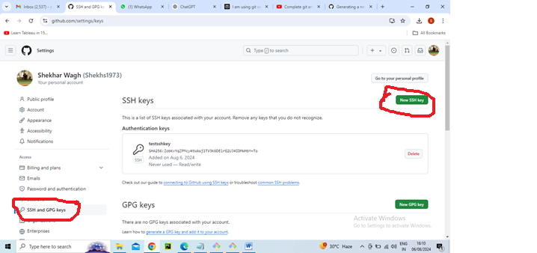

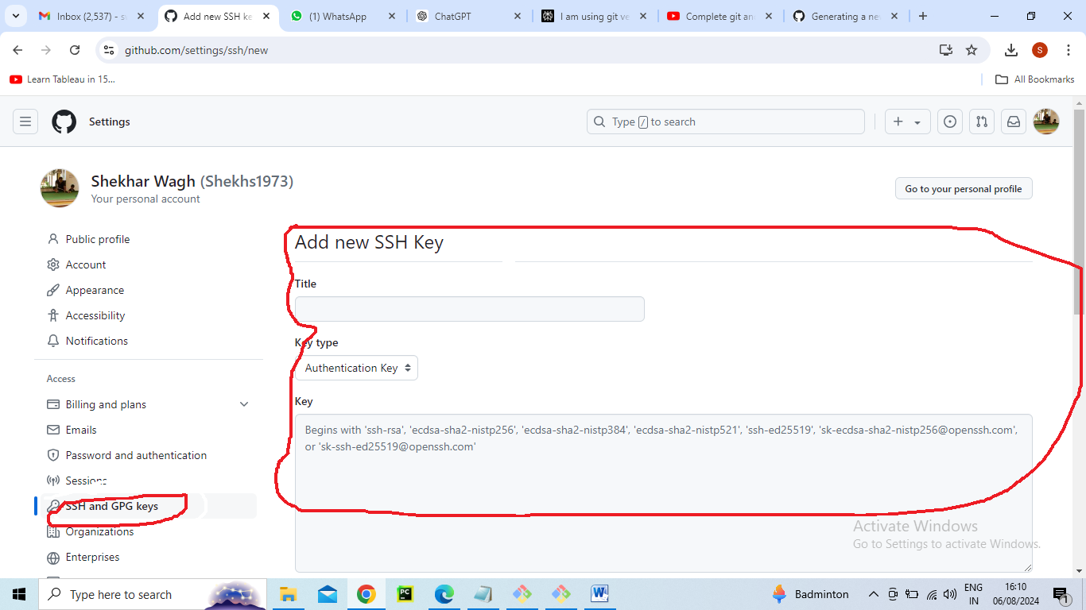

**Steps**

1. **Initialize Local Repository (if not already done)**

sh

Copy code

**git init**

1. **Stage Files for Commit**

sh

Copy code

**git add** .

1. **Commit Files**

sh

Copy code

**git commit -m "Initial commit"**

1. **Add Remote Repository**
   * Go to your GitHub repository page.
   * Copy the repository URL (HTTPS or SSH).

sh

Copy code

**git remote add origin https://github.com/yourusername/your-repository.git**

1. **Push Files to GitHub**

sh

Copy code

**git push origin master**

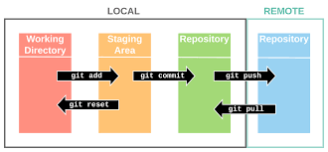

**Example Workflow**

1. **Open Command Prompt or Git Bash**:

sh

Copy code

cd path/to/your/local/repository

1. **Initialize Repository (if not already initialized)**:

sh

Copy code

git init

1. **Stage All Files**:

sh

Copy code

git add .

1. **Commit Changes**:

sh

Copy code

git commit -m "Initial commit"

1. **Add Remote Repository**:

sh

Copy code

git remote add origin https://github.com/yourusername/your-repository.git

1. **Push to GitHub**:

sh

Copy code

git push -u origin master

**Notes**

* If your repository uses a branch other than master, replace master with the name of your branch in the git push command.
* If you are asked for your GitHub username and password during the push, enter your credentials.

Now your local files should be pushed to your GitHub repository.