Tool Box

Python and Django

Python is an interpreted, high-level , general-purpose programming language , Python features a dynamic type system and automatic memory management. It supports multiple programming paradigms, including object-oriented, imperative, functional and procedural, and has a large and comprehensive standard library. The reference verion of Python , Cpython , is open source and has a community-based development model. It has vibrant developer community and following.
Django is an open source web development framework written in python. A web framework is a set of components that helps you to develop websites faster and easier. It comes with an object-relational mapper in which you describe your database layout in Python code. More than that, the data-model syntax provides many rich ways of representing your models. The migrate command glances over all available models and builds tables in your database for whichever ones that don’t exist. Its user authentication system provides a safe way to manage user accounts and passwords alongside ensuring developers stray away from making common mistakes such as: cross-site scripting, cross-site request, click jacking and forgery.
Flask(Python), Node.js(JavaScript), Express.js(JavaScript) etc.

SQLite
SQLite is a relational database management system contained in a C programming library. In contrast to many other database management systems, SQLite is not a client–server database engine. Rather, it is embedded into the end program.
SQLite is a popular choice as embedded database software for local/client storage in application software such as web browsers. It is arguably the most widely deployed database engine, as it is used today by several widespread browsers, operating systems, and embedded systems (such as mobile phones), among others. SQLite has bindings to many programming languages.

Arduino Uno R3
The Arduino Uno R3 is a microcontroller board based on the ATmega328 . It has 14 digital input/output pins (of which 6 can be used as PWM outputs), 6 analog inputs, a 16 MHz crystal oscillator, a USB connection, a power jack, an ICSP header, and a reset button. It contains everything needed to support the microcontroller; simply connect it to a computer with a USB cable or power it with a AC-to-DC adapter or battery to get started.
The Uno differs from all preceding boards in that it does not use the FTDI USB-to-serial driver chip. Instead, it features the Atmega16U2 (Atmega8U2 up to version R2) programmed as a USB-to-serial converter. It has 32Kb of flash memory and ADC on each of its analog pins with 10-bit resolution.
The Arduino IDE , provided by Arduino.cc, makes the job of programming the board easy. The board is programmed using a variant of C written for arduino.

Summary
Microcontroller | ATmega328
Operating Voltage | 5V
Input Voltage (recommended) | 7-12V
Input Voltage (limits) | 6-20V
Digital I/O Pins | 14 (of which 6 provide PWM output)
Analog Input Pins | 6
DC Current per I/O Pin | 40 mA
DC Current for 3.3V Pin | 50 mA
Flash Memory | 32 KB (ATmega328) of which 0.5 KB used by bootloader
SRAM | 2 KB (ATmega328)
EEPROM | 1 KB (ATmega328)
Clock Speed | 16 MHz

The Arduino Uno has a resettable polyfuse that protects your computer's USB ports from shorts and overcurrent. Although most computers provide their own internal protection, the fuse provides an extra layer of protection. If more than 500 mA is applied to the USB port, the fuse will automatically break the connection until the short or overload is removed.
The ATmega328 on the Arduino Uno comes preburned with a bootloader that allows you to upload new code to it without the use of an external hardware programmer. It communicates using the original STK500 protocol
ESP8266 WiFi Module
The Arduino Uno R3 does not have inbuilt wifi. In order to give our application the ability ro connect to a network , we add an ESP8266 WiFi module. As an aletrnative we could have used a NodeMCU microcontroller board which comes with built-in ESP8266. But it is not as robust as the arduino.
The ESP8266 is a low-cost Wi-Fi microchip with full TCP/IP stack and microcontroller capability produced by Shanghai-based Chinese manufacturer Espressif Systems.
The chip first came to the attention of western makers in August 2014 with the ESP-01 module, made by a third-party manufacturer Ai-Thinker. This small module allows microcontrollers to connect to a Wi-Fi network and make simple TCP/IP connections using Hayes-style commands. However, at the time there was almost no English-language documentation on the chip and the commands it accepted. The very low price and the fact that there were very few external components on the module, which suggested that it could eventually be very inexpensive in volume, attracted many hackers to explore the module, chip, and the software on it, as well as to translate the Chinese documentation.
The ESP8285 is an ESP8266 with 1 MiB of built-in flash, allowing for single-chip devices capable of connecting to Wi-Fi.
The successor to these microcontroller chips is the ESP32.
FEATURES:
- Processor: L106 32-bit RISC microprocessor core based on the Tensilica Xtensa Diamond Standard 106Micro running at 80 Mhz.
- Memory:
  - 32 KiB instruction RAM
  - 32 KiB instruction cache RAM
  - 80 KiB user-data RAM
  - 16 KiB ETS system-data RAM
- External QSPI flash: up to 16 MiB is supported (512 KiB to 4 MiB typically included)
- IEEE 802.11 b/g/n Wi-Fi
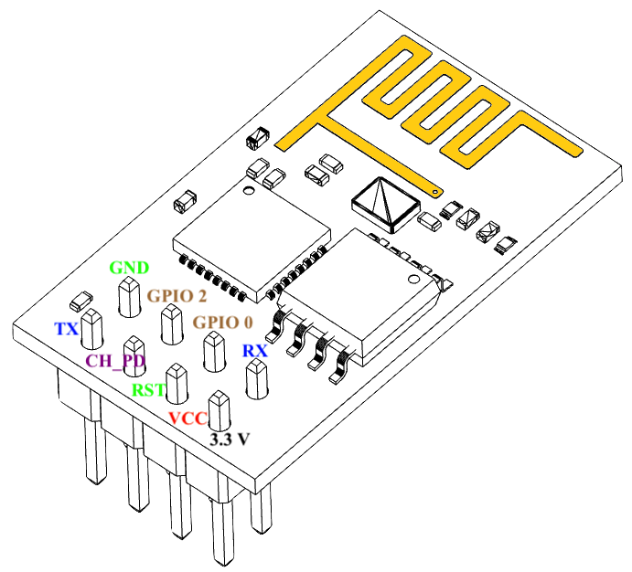
  - Integrated TR switch, balun, LNA, power amplifier and matching network
  - WEP or WPA/WPA2 authentication, or open networks
- 16 GPIO pins
- SPI
- I²C (software implementation)
- I²S interfaces with DMA (sharing pins with GPIO)
- UART on dedicated pins, plus a transmit-only UART can be enabled on GPIO2
- 10-bit ADC (successive approximation ADC)

RFID
Radio-Frequency Identification (RFID) is the use of radio waves to read and capture information stored on a tag attached to an object. A tag can be read from up to several feet away and does not need to be within direct line-of-sight of the reader to be tracked.
A RFID system is made up of two parts: a tag or label and a reader. RFID tags or labels are embedded with a transmitter and a receiver. The RFID component on the tags have two parts: a microchip that stores and processes information, and an antenna to receive and transmit a signal. The tag contains the specific serial number for one specific object.
To read the information encoded on a tag, a two-way radio transmitter-receiver called an interrogator or reader emits a signal to the tag using an antenna. The tag responds with the information written in its memory bank. The interrogator will then transmit the read results to an RFID computer program.
There are two types of RFID tags: passive and battery powered. A passive RFID tag will use the interrogator’s radio wave energy to relay its stored information back to the interrogator. A batter powered RFID tag is embedded with a small battery that powers the relay of information.
In a retail setting, RFID tags may be attached to articles of clothing. When an inventory associate uses a handheld RFID reader to scan a shelf of jeans, the associate is able to differentiate between two pairs of identical jeans based upon the information stored on the RFID tag. Each pair will have its own serial number.
With one pass of the handheld RFID reader, the associate can not only find a specific pair, but they can tell how many of each pair are on the shelf and which pairs need to be replenished. The associate can learn all of this information without having to scan each individual item.

