Shelby Simpson; CS205-01; Spring 2018

**Conceptual Schema(Version 4)**

The conceptual schema explains the entities and relationships.

Changes: Edited the For relationship into the ForPart relationship. Added the Assembly Card entity, the Creates relationship, two ForPart attributes, and the OrderTotal Order attribute. Removed the Exact Date attribute from Order and added it to AssemblyCard.

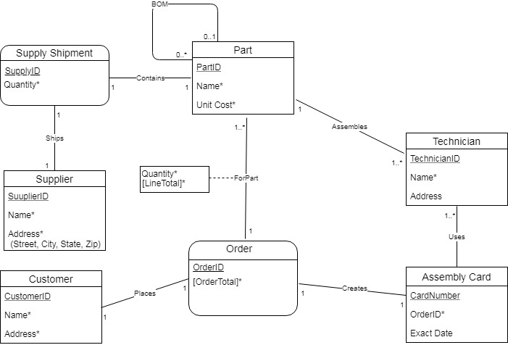

**Entities**

Technician: The technician is an entity. The technician assembles parts using the information on the order. The technician's attributes are EmployeeID, Name, and Address. EmployeeID is the technician's ID attribute.

Parts: The part is an entity. The part is shipped in a supply shipment, is ordered by a customer and is assembled into larger aircraft parts. The part's attributes are PartID, Name, and Unit Cost. PartID is the part's ID attribute.

Customer: The customer is an entity. The customer places the order. The customer's attributes are CustomerID, Name, and Address. CustomerID is the customer's ID attribute.

Supplier: The supplier is an entity. The supplier ships the supply shipment. The supplier's attributes are SupplierID, Name, and Address. SupplierID is the supplier's ID attribute.

Supply Shipment: The supply shipment is an associative entity. The supply shipment gets shipped by the supplier, contains parts, and gets received by the stock room. SupplyID and Quantity are the attributes of the supply shipment and SupplyID is its ID attribute.

Order: The order is an associative entity. The order is placed by the customer for parts and it creates an assembly card. OrderID and OrderTotal are the order’s attibutes. OrderID is the ID attribute while OrderTotal is a derived attribute computed from adding up LineTotal from every different part in the order.

Assembly Card: The assembly card is an entity. An order creates an assembly card and a technician uses an assembly card. Card Number, OrderID, and Exact Date are the assembly cards attributes and Card Number is its ID attribute.

**Relationships**

Places: Places is a relationship between the customer and the order. The customer places an order. Places does not have any attributes.

ForPart: ForPart is relationship between the parts and the order. An order is placed for parts. ForPart’s attributes are Quantity and LineTotal. Quantity is the quantity of a single part the customer wants and LineTotal is a derived attributes computed from Quantity x Unit Cost.

Assembles: Assembles is a relationship between the technician and the part. The technician assembles the parts that the customer ordered. This relationship does not have any attributes.

BOM: BOM is a relationship between two parts. BOM does not have any attributes.

Ships: Ships is a relationship between the supplier and the supply shipment. The supplier ships the supply shipment. Ships does not have any attributes.

Contains: Contains is a relationship between the part and the supply shipment. The supply shipment contains parts. Contains does not have any attributes.

Uses: Uses is a relationship between the technician and the assembly card. The technician uses the information on the assembly card to assemble the correct parts for the customer. Uses does not have any attributes.

Creates: Creates is a relationship between the order and the assembly card. An order creates an assembly card. Creates does not have any attributes.