<html>
<head> <title> Heading </title> </head>

<body bgcolor="lightgreen">

<h1 align="center">Heading h1</h1>
<h2 align="left">Heading h2</h2>
<h3 align="right">Heading h3</h3>
<h4>Heading h4</h4>
<h5>Heading h5</h5>
<h6>Heading h6</h6>

<hr color="orange">
<hr color="white">
<hr color="green">
<p align="center">
<b>Designed by
<i>S.Sudarshan</i></b>
</p>
</body>
</html>
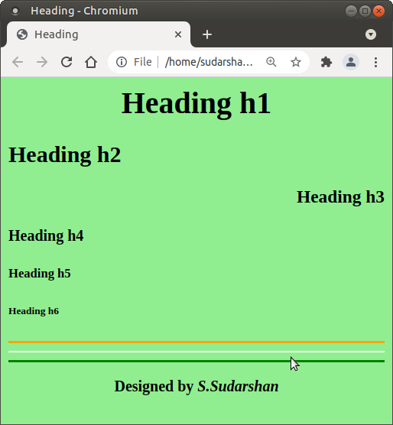

<html>
<head>
<title>
Formatting
</title>
</head>

<body>
<h1>Formatting</h1>
<br><b> Bold text</b>
<br><i> Italic text</i>
<br><u> Underline text</u>
<br><sub> Subscript text</sub>
<sup> Superscript text</sup>

<br><br><br>
H<sub>2</sub>O<br>
10<sup>3</sup>
</body>
</html>

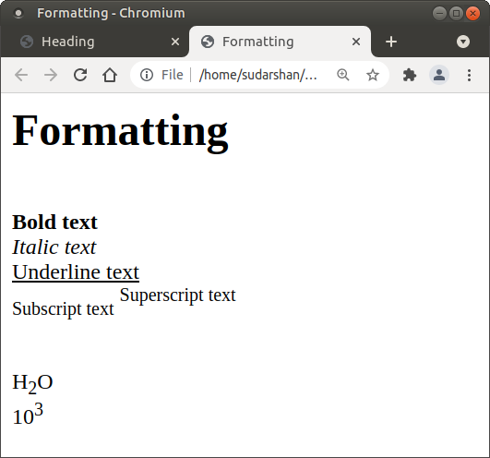
<html>
<head>
<title>
Welcome to List
</title>
</head>

<body>
<h1>List</h1>
There are two types of lists.<br>
<ul type="none">
<li>Unorder List
<li>Order List
</ul>

Unorder List Types
<ul type="square">
<li> Circle
<li> Disk
<li> Square
<li> none
</ul>

Order List Types
<ol type="A">
<li> 1
<li> A
<li> a
<li> I
<li> i
</ol>
<pre> S . S U D A R S H A N</pre>

</body>
</html>

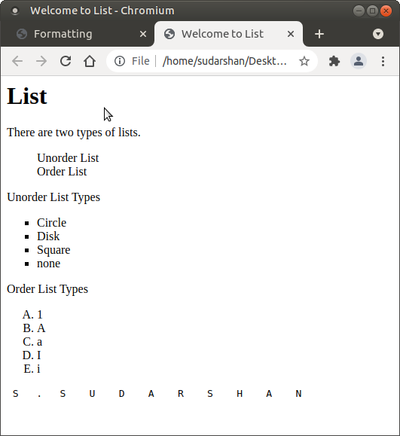
<html>
<head> <title> Color World </title> </head>

<body>
<center>
<h1>Ramaiah Polytechnic</h1>
<h2>Department of Civil Engineering</h2>
<h3>IT Skill</h3>
<h4>Color World by S.Sudarshan</h4>
</center>

<h1 style="background-color:blue;">H1 Background Color</h1>

<h1 style="border:2px solid Tomato;">H1 Border</h1>

<h1 style="background-color:rgb(255, 99, 71);">rgb(255, 99, 71)</h1>

<h1 style="background-color:#ff6347;">#ff6347</h1>
<font color="red" size="20">
<p style="background-color:powderblue">Paragraph Background Color</p>
</font>
</body>
</html>

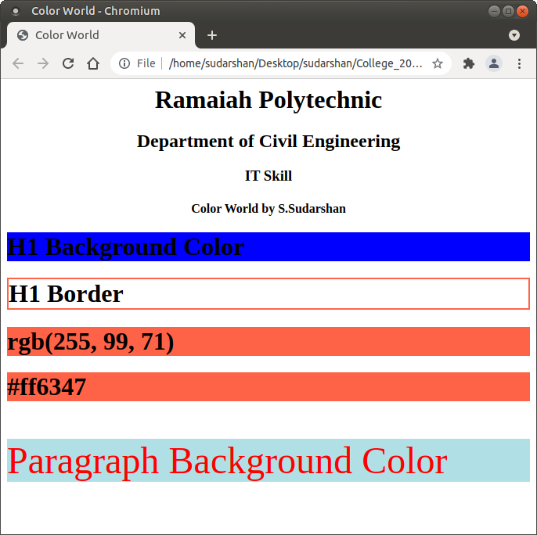
<html>
<head>
<title>
Marks Card
</title>
</head>

<body bgcolor="powderblue">
<center>
<img src="logo.jpg" alt="Govt. of Karnataka">
<h1>Department of Technical Education</h1>
</center>
<hr>

Student Name : <b>S.Samuel</b><br>
Program : <b>Civil Engineering</b><br>
Register No. : <b>476CE21045</b>

<table width="500" align="center" bgcolor="lightyellow" border="3">
<tr bgcolor="red">
<th width="75">Sl. No.
<th width="175">Subject / Course
<th>Max Marks
<th>Marks Obtained
<tr>
<td>1
<td>IT Skill
<td align="right">100
<td align="right">75
<tr>
<td>2
<td>Drawing
<td align="right">100
<td align="right">77
<tr>
<td>3
<td>Mathematic
<td align="right">100
<td align="right">65
<tr bgcolor="green">
<td>
<td>Total
<td align="right">300
<td align="right">217

</table>
<hr color="red" width="50%">
</body>
</html>

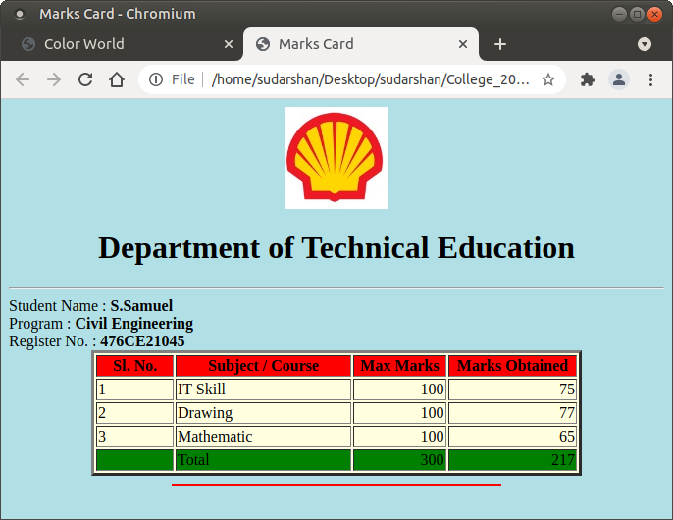

<html>
<head>
<title>
Link
</title>
</head>

<body bgcolor="lightblue">
<ul type="none">
<li><a href="IT_00_head.html">Heading</a>
<li><a href="IT_02_list.html">List</a>
<li><a href="IT_03_formating.html">Formatting</a>
<li><a href="IT_03_formating.html"> <img src="logo.jpg"></a>

</ul>

<br> Designed by <b>S.Sudarshan</b>
</body>
</html>
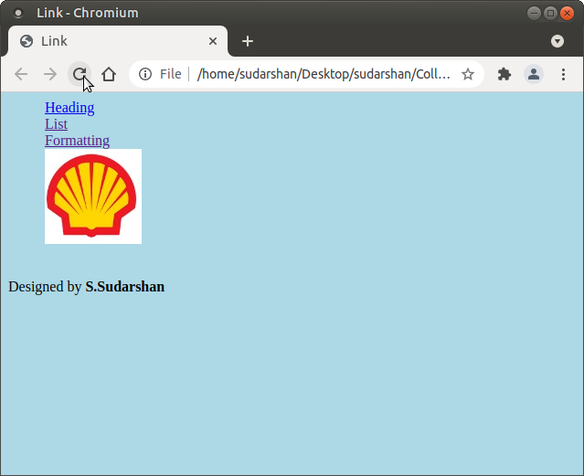
<html>
<head>
<title>
iFrame
</title>
</head>

<body bgcolor="orange">
<ul type="none">
<li><a href="IT_01_heading.html" target="my_frame">Heading</a>
<li><a href="IT_02_formating.html" target="my_frame">Formatting</a>
<li><a href="IT_03_list.html" target="my_frame">List</a>
<li><a href="IT_02_formating.html" target="my_frame"> <img src="logo.jpg"></a>

</ul>

<iframe src="IT_01_heading.html" name="my_frame" width="100%" height="400px"> </iframe>

</body>
</html>

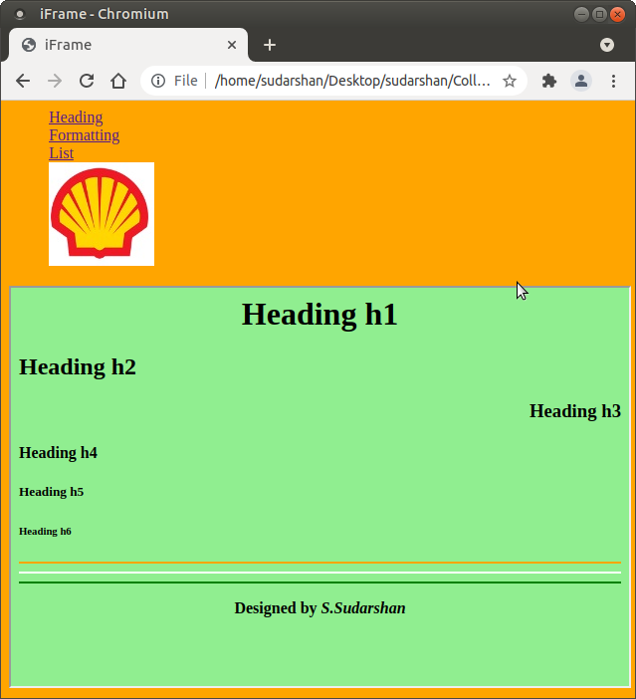
<html>
<head>
<style>
.myDiv {
border: 5px outset red;
background-color: lightblue;
text-align: center;
}
</style>
</head>
<body>

<div class="myDiv">
<h2>This is a heading in a div element</h2>
<p>This is some text in a div element.</p>
</div>
<br>S.Sudarshan
</body>
</html>

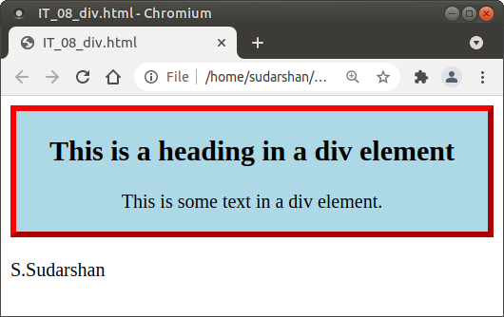
<html>
<head>
<title>
Forms
</title>
</head>

<body>
<center>
<font style="color:red;">
<h1>Ramaiah Polytechnic</h1></font>
<h2>Department of Civil Engineering</h2>
<h3>Forms</h3>
</center>

<form>

Student Name :
<input type="text"><br><br>
Studing in : <br>
<input type="radio" name="sem"> 1 Year</input><br>
<input type="radio" name="sem"> 2 Year</input><br>
<input type="radio" name="sem"> 3 Year</input><br>
<br>Hobies : <br>
<input type="checkbox">Singing </input><br>
<input type="checkbox">Painting </input><br>
<input type="checkbox">Sports </input><br>
<hr>
<input type="submit">

</form>

Designed by S.Sudarshan
</body>
</html>

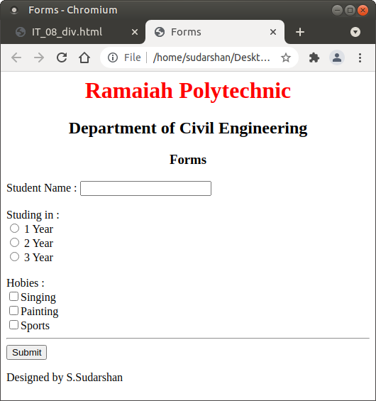
<html>
<head>
<title>CSS (inline style)</title>
</head>
<body>

<h1 style="color:blue;text-align:center;">This is a heading (inline style)</h1>
<p style="color:red;">This is a paragraph. (inline style)</p>

<br>Designed by <b><i>S.Sudarshan</i></b>

</body>
</html>

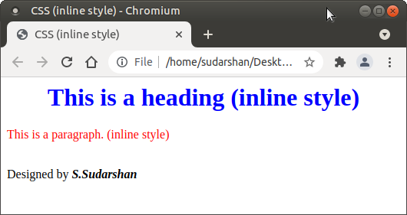
<html>
<head>
<script>
function dis(val)
{
document.getElementById("result").value+=val

}

function solve()
{
x = document.getElementById("result").value
y = eval(x)
document.getElementById("result").value = y
}

function clr()
{
document.getElementById("result").value = ""
}
</script>
<title>Calculator</title>
<!--
<style>

input[type="button"]
{
background-color:powderblue; color: black;
border: solid black 2px; width:100%;
}
</style>
-->
</head>

<body>
<h1>MY CALCULATOR</h1>
<font size="20">
<input type="text" id="result">

<table border="1">
<tr>
<td><input type="button" value="C" onClick="clr()"></td>
</tr>

<!-- create button and assign value to each button -->
<!-- dis("1") will call function dis to display value -->
<td><input type="button" value="1" onClick="dis('1')"/> </td>
<td><input type="button" value="2" onClick="dis('2')"/> </td>
<td><input type="button" value="3" onClick="dis('3')"/> </td>
<td><input type="button" value="/" onClick="dis('/')"/> </td>
</tr>
<tr>
<td><input type="button" value="4" onClick="dis('4')"/> </td>
<td><input type="button" value="5" onClick="dis('5')"/> </td>
<td><input type="button" value="6" onClick="dis('6')"/> </td>
<td><input type="button" value="-" onClick="dis('-')"/> </td>
</tr>
<tr>
<td><input type="button" value="7" onClick="dis('7')"/> </td>
<td><input type="button" value="8" onClick="dis('8')"/> </td>
<td><input type="button" value="9" onClick="dis('9')"/> </td>
<td><input type="button" value="+" onClick="dis('+')"/> </td>
</tr>
<tr>
<td><input type="button" value="." onClick="dis('.')"/> </td>
<td><input type="button" value="0" onClick="dis('0')"/> </td>
<!-- solve function call function solve to evaluate value -->
<td><input type="button" value="=" onClick="solve()"/> </td>
<td><input type="button" value="*" onClick="dis('*')"/> </td>
</tr>
</table>
</font>
<br>Designed by <b><i>S.Sudarshan</i></b>

</body>
</html>
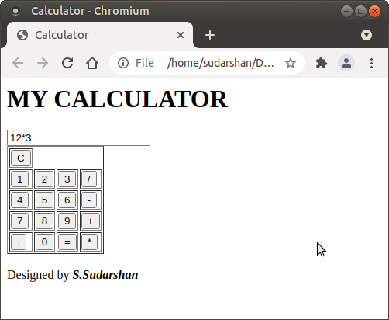

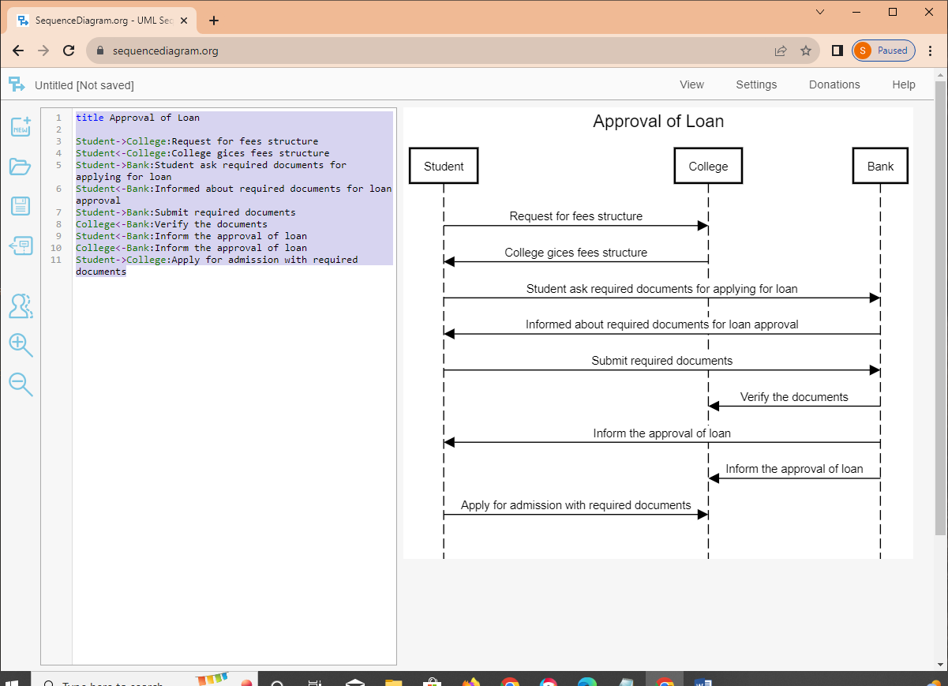

title Approval of Loan

Student->College:Request for fees structure
Student<-College:College gices fees structure
Student->Bank:Student ask required documents for applying for loan
Student<-Bank:Informed about required documents for loan approval
Student->Bank:Submit required documents
College<-Bank:Verify the documents
Student<-Bank:Inform the approval of loan
College<-Bank:Inform the approval of loan
Student->College:Apply for admission with required documents

