Progress Report 11-5-2020

Team Name: Windows cannot find “Paint”

Members: Sheldon Smith, Joseph Yu

Roles / Responsibilities

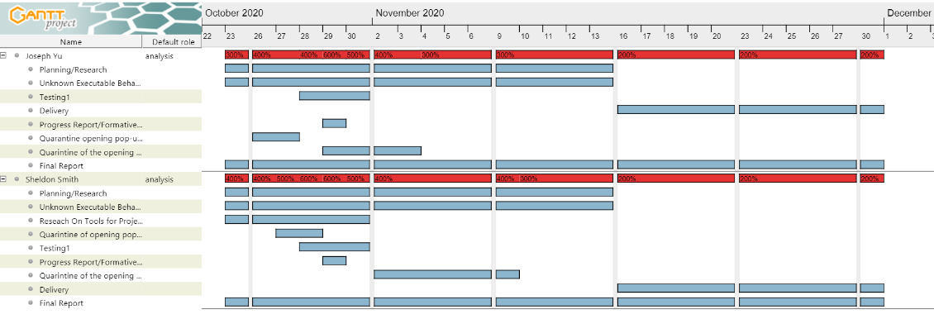

Statement of Work

The purpose of this project is to identify what the provided unknown executable ECS.exe does when opened. To aid in our investigation, we will find and use online reverse engineering tools, including disassemblers and decompilers. After using them, we will compile a list with the tools used, in which we describe where to find them, their ease of use, advantages, disadvantages, and lessons learned using the program. Our initial investigation has led us to believe that this executable is a mix of a simple calculator function intermixed with malicious code. We will make the add, subtract, multiply, divide, power, natural log, compound interest, factorial, combination, permutation, and the guessing game work correctly. To do this, we will isolate the dangerous code in the file. We will modify the guessing game to allow the user to automatically win when a secret key is entered. To complete this project, we will meet both online as well as in person. To safety analyze the executable, we will use a Windows 10 virtual machine so that we do not risk infecting our own systems. We will start the project on October 21, 2020 and will finish by December 1, 2020.

We submitted a Progress Report to our client on October 29, 2020, documenting our initial findings and project plan. We will submit our final executable, final report, and present our findings, on December 1, 2020.

Reverse Engineering Tools

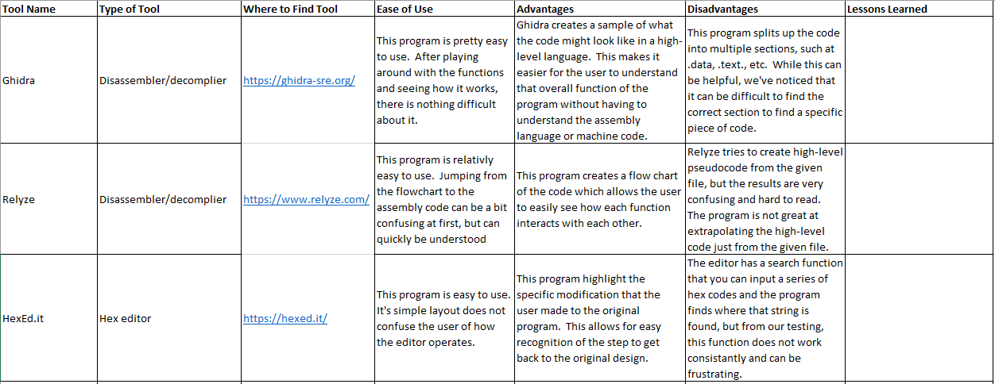

Project Plan

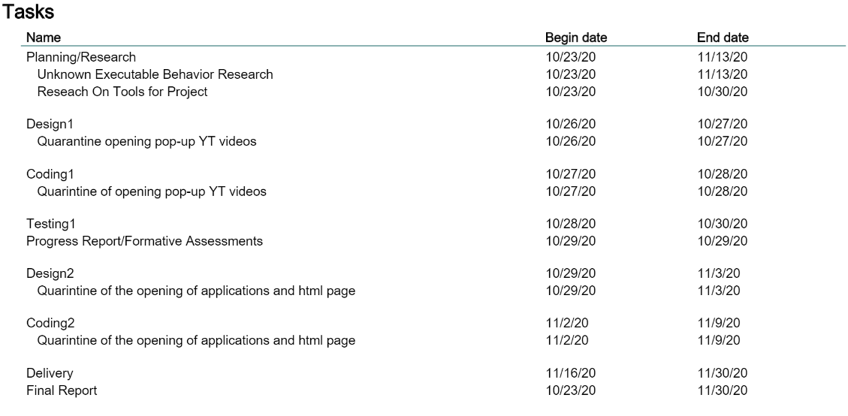

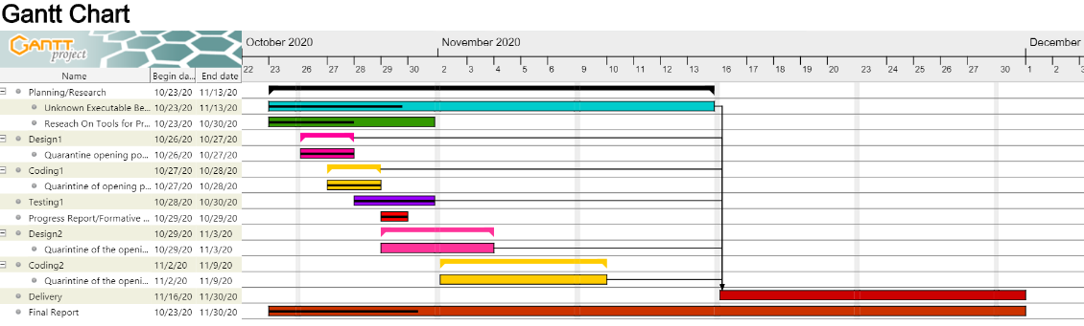

Preliminary Description of Executable’s Behavior

This unknown executable appears to be a calculator with multiple options to select from that also has malicious code intermixed with the main code. There are multiple stages of the malicious code. Upon execution in a Windows 10 VM, the program first starts a repetitive cycle of opening a YouTube video 19 times on both Microsoft Edge and Google Chrome. The program then shows the menu options, prompting the user for input (example: “1.”, “2.” Etc.) The calculator section contains 10 mathematical functions options and one guessing game mode for the user to select. Upon entering the valid instructions the program will then print out “wrong answer” 500 times. The program then reprints the menu options, and then automatically inputs “-1” while printing “choice = -1”. The program again displays “wrong answer” 500 times. The process repeats until in the fourth iteration, the program prints “don’t do it again” 1,000 times to the screen after reprinting the menu. The program automatically inputs “-1” once more while printing “choice = -1”, and again outputs “wrong answer” 500 times. On the next iteration, after printing the menu, the words “I warned you” are output 1000 times. The executable then starts to open the programs Outlook, Paint, Photos, Notepad, along with html page of corndogs floating on Microsoft Edge and Google Chrome on the user’s computer that loops for 1000 times.

Github Repository

CSI-2334-Group-Project

<https://github.com/legomansps/CSI-2334-Group-Project>