**Q3:**

a) From the lecture, we know that computing the inverse of a $n×n$ matrix needs $n^{3}$ flops to calculate. Therefore, $B^{-1}$ and $C^{-1}$ will each take $n^{3}$ flops to compute. In the first bracket, 2A + 1 takes $n^{2}$ flops to compute. Finally, it took $n^{3}$ flops to compute the product of $B^{-1}$ with the result from the first bracket. The content in the second bracket will took $n^{3}+n^{2}$ to compute ( $n^{3}$ for computing the inverse and $n^{2}$ for adding two matrices). Multiply the result in bracket 2 with everything before it also takes $n^{3}$ flops to compute (both are $n×n$ matrices). Finally, the product of everything before b with b will need $n^{2}$ flops ( $n×n$ matrix with $n×1$ vector). Therefore, the total amount of flops needed is ${4n}^{3}+3n^{2}$ flops.

b) First, we will rewrite the equation into $Bx=(2A+1){(C}^{-1}b+Ab)$. Our algorithm requires us to first solve $C^{-1}b$ with out explicitly calculate $C^{-1}$. Therefore, we need to solve for $Cy=b$ to calculate the result of $C^{-1}b$. This linear system will need $\frac{n^{3}}{3}+\frac{{3n}^{2}}{2}+n$ flops to solve (from course note). Now we just need to solve $Bx=(2A+1)(y+Ab)$. From part a), we know that $(2A+1)$ will take $n^{2}$ to compute. Then, $(y+Ab)$ will take $n^{2}+n$ to compute (vector addition will take n flops to compute). The multiplication between to two brackets will take $n^{2}$ flops. The total flops for calculating the right-hand side is: $\frac{n^{3}}{3}+\frac{{3n}^{2}}{2}+{3n}^{2}+2n$ flops. Finally, we have to solve x, by the lecture notes this process will take $\frac{n^{3}}{3}+\frac{{3n}^{2}}{2}+n$ flops to finish. Therefore, the total flops needed to compute x for algorithm 2 is: $\frac{2n^{3}}{3}+6n^{2}+3n$ flops.

c) The for this question is in a2.py, the result of my experiment is shown below. Note that algorithm 1 is the algorithm that explicitly calculate the matrix inverses and algorithm 2 is the algorithm that compute the solution without explicitly calculate the matrix inverse.

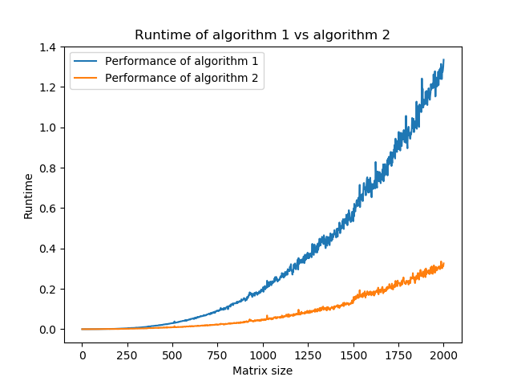

d) The plot from part c) agree with the analytic flops bound in part a) and b). In the plot, we can see that algorithm in part b) finishes in 1/6 the time than the algorithm in a). These values agree with our theoretical bound because for the $n^{3}$ terms in the analytic bound for both algorithms, there is a factor difference of 6, which we can observe in the plot.