**Q1):**

**a)** For monomial basis, the matrix and vectors needed are as follows:

We need to solve the linear system Ba = f to solve this interpolation problem. The vector satisfying the above linear system is trivail, where a = . Therefore, the final result is f(x) = x2.

**b)** For lagrange basis, we have the following equation:

Our final result is: f(x) = x2.

**c)** For Newton’s basis, we have:

And we can get the coefficent by solving the following linear systems:

The vector satisfying the above linear system is trivail, where a = .

Then we have:

Which agree with the other methods.

**Q2):**

The generated plot is shown below: since the error bound is small, they appear as a single line on the plot. Therefore, I choose a few point to show that his bound is valid:

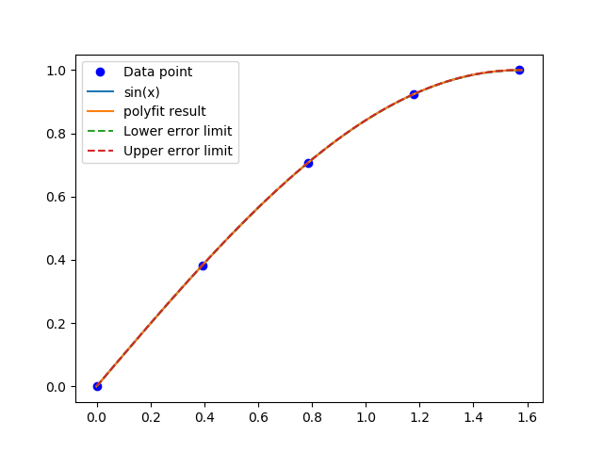

The first point is at 0.52 and the poly fit error is 7.352505e-05 and the error bound is 0.00032599, the second point is at 0.86, the poly fit error is 4.249043e-05 and the error bound is 0.00032599. The final point is at 1.0103 where the poly fit error is 7.338592e-05 and ther error bound is 0.00032599. And finally, we need 35 at least point to achieve the accuracy of 1e-10.

**Q3):**

Compare to polynomial fit, Cubic Spline have a much higher accuracy since in the plot it is nealy indisguishable from the original function. Notice that ploy fit performs well in for points in the middle but starts to diverge near the ends of our interval. But in general, more points will make the fit more accurate.

