**Q1):**

b) The quadratic spline interpolation result is shown below:

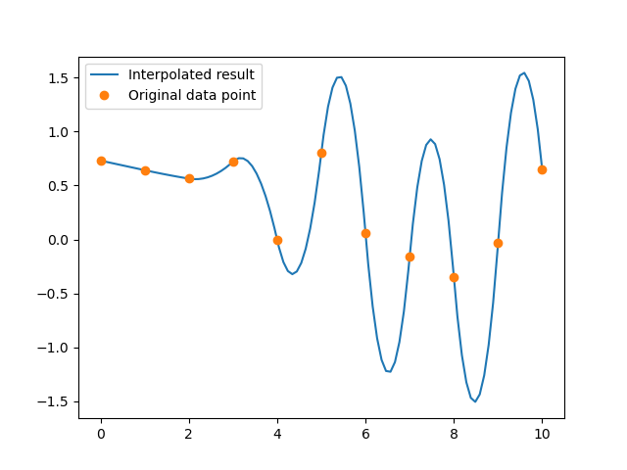

c) Quadratic spline interpolation for same data points except the first data point is increased by 0.5:

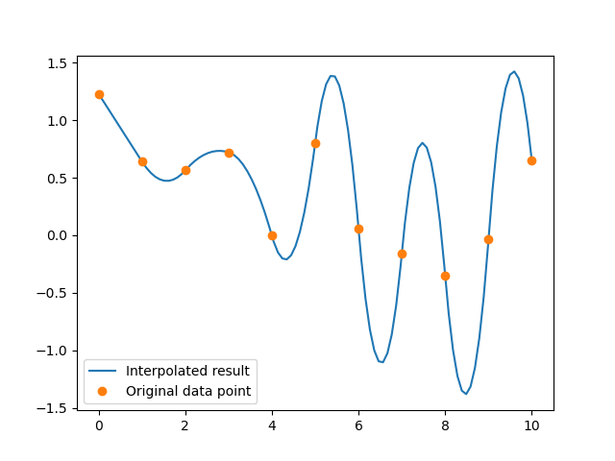

Compare with b), the far end of the graph did not change a lot. However, we observe that the value of spline in c is greater than the interpolation for b whenever the interval index is even (starting from 0)

d) The proof for this question is shown below:

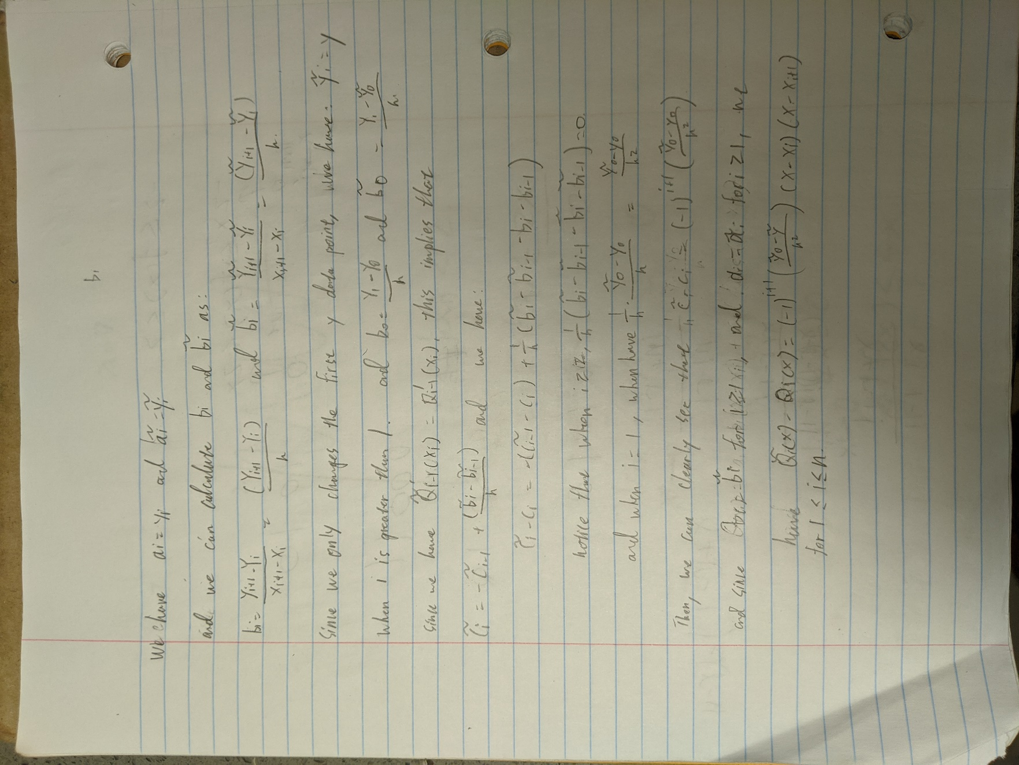

Since the value of c will get inverted every iteration, this explain why our interpolation result for c is greater than the value for b whenever the interval is even since c is inverted for each iteration.

**Q2):**

a) Please refer to HW8 for the code.

b) The interpolation result for Natural spline are shown below:

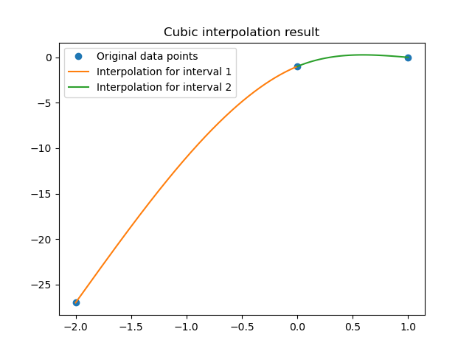

And its first and second derivative is also shown below:

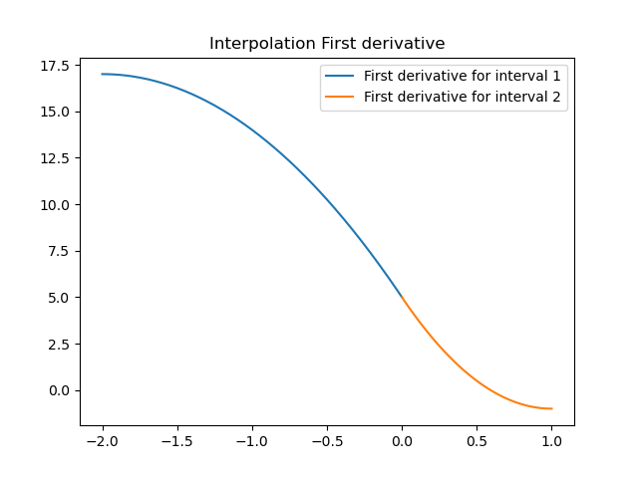

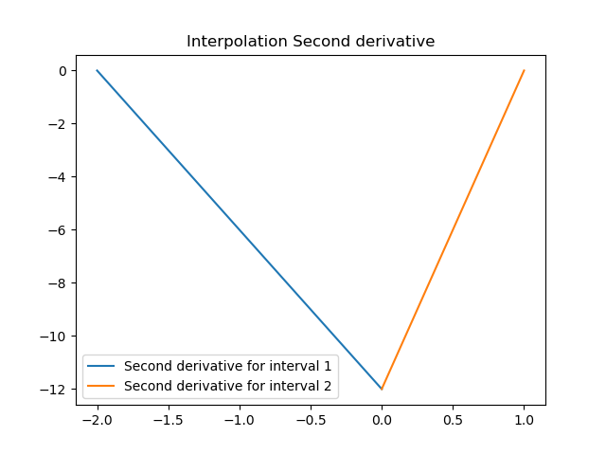

We can see that the interpolation result satisfies our constrain. Where the first derivative is continuous along the interior data points and the second derivative are equal to zero on the two end points.

**Q3):**

a) Please refer to hw8.py for code.

b) The result for Clamp cubic interpolation is shown below along with its first and 2nd derivative:

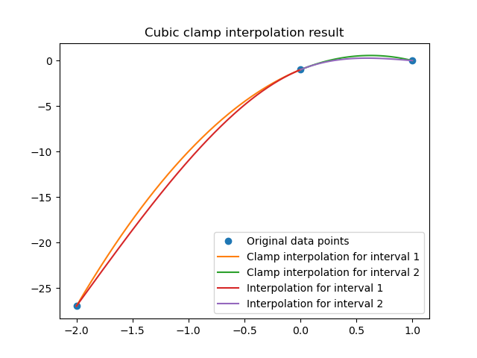

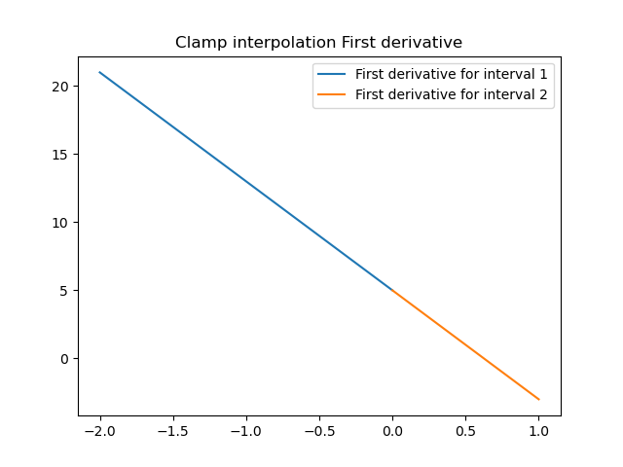

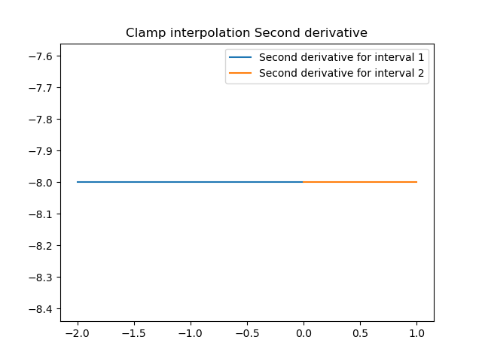

The clamp result have a steeper slope for the fisrt srgment compare to natrual spline. When we llok at the 1st derivative, we can see that it satisfy the constrain of the endpoint (I used a qudratic fit on all three point with y = -4x2 + 5x - 1).