Website_bot Documentation
Project Description:
The Website Bot application extracts data from given website URLs using a data science embedding scraping service, stores the extracted content in a database through a Scrape API, and retrieves the stored data using Rag API. The retrieved data is processed using RAG-based AI logic to generate chatbot responses for user queries.

Website_Bot Data Processing Workflow

Rag API Inputs
- Text
- Domain
- Sub_domain
Scrape API inputs
- URL
- User_name
- Domain
- Sub_domain

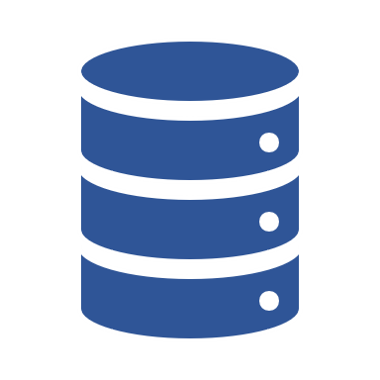
Database
Scrape.py
Here, we scrape the URL and store it into database table
rag.py
Here, based on the text given by user we retrieve the response from the database.
Website_bot Endpoint: https://website-bot-b-439987973057.us-east4.run.app/
For scrape :
URL: https://website-bot-b-439987973057.us-east4.run.app/wb/website_scrape
Payload : {
"url":" ",
"user_name": " ",
"domain":" ",
"sub_domain":" "
}

For Rag :
URL : https://website-bot-b-439987973057.us-east4.run.app/wb/website_rag
Payload : {
"domain":" ",
"sub_domain":" ",
"text":" "
}

