**Data Transformation**

|  |
| --- |
|  |

1. On Premises Database Tables

1. Azure Data Factory (ADF)

To Create Azure data factory resource, please follow the Microsoft Documentation : <https://learn.microsoft.com/en-us/azure/data-factory/tutorial-copy-data-portal#create-a-data-factory>

1. Create and run Azure data factory pipeline, to pull all database tables from OnPrem to Azure Blob Storage in parquet format

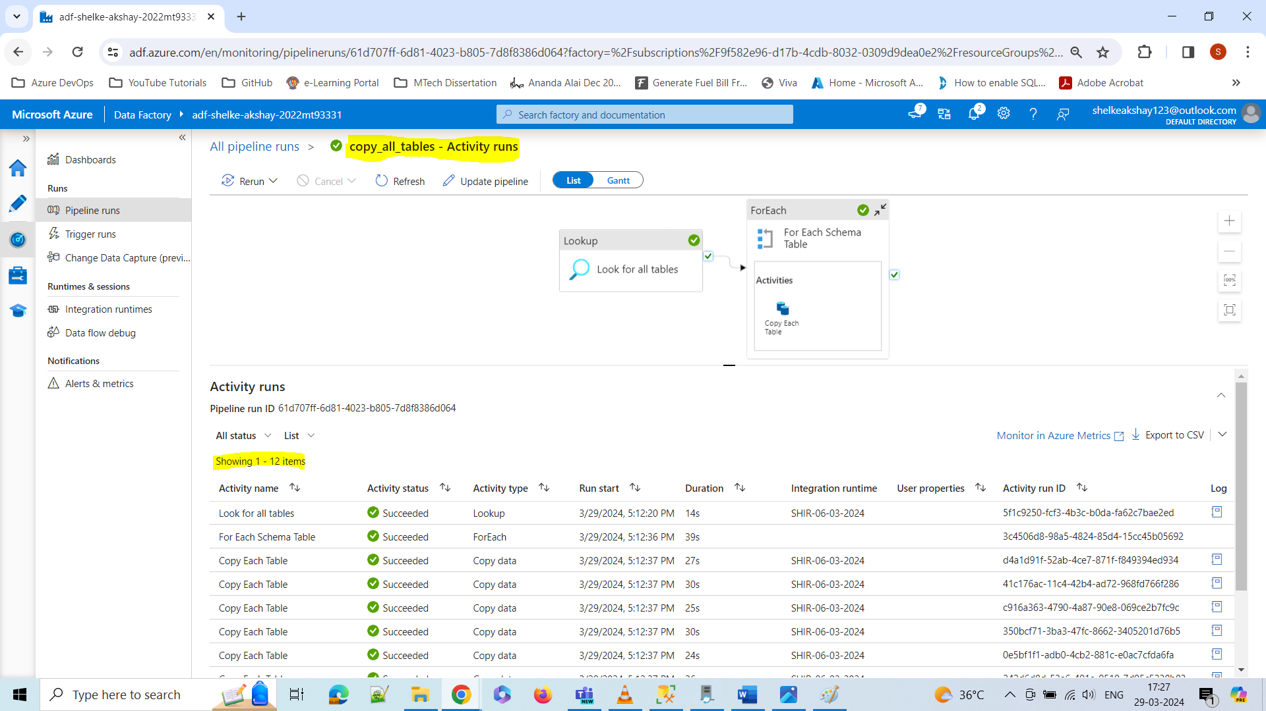

1. Storing all tables from on premises database to AZURE BLOB STORAGE in parquet file format

