**Data Loading**

|  |
| --- |
|  |

1. Azure Synapse Analytics Pipeline

1. Get The table names of GOLD Database from Azure Data Lake Gen2
2. For Each table names, run Stored Procedure
3. 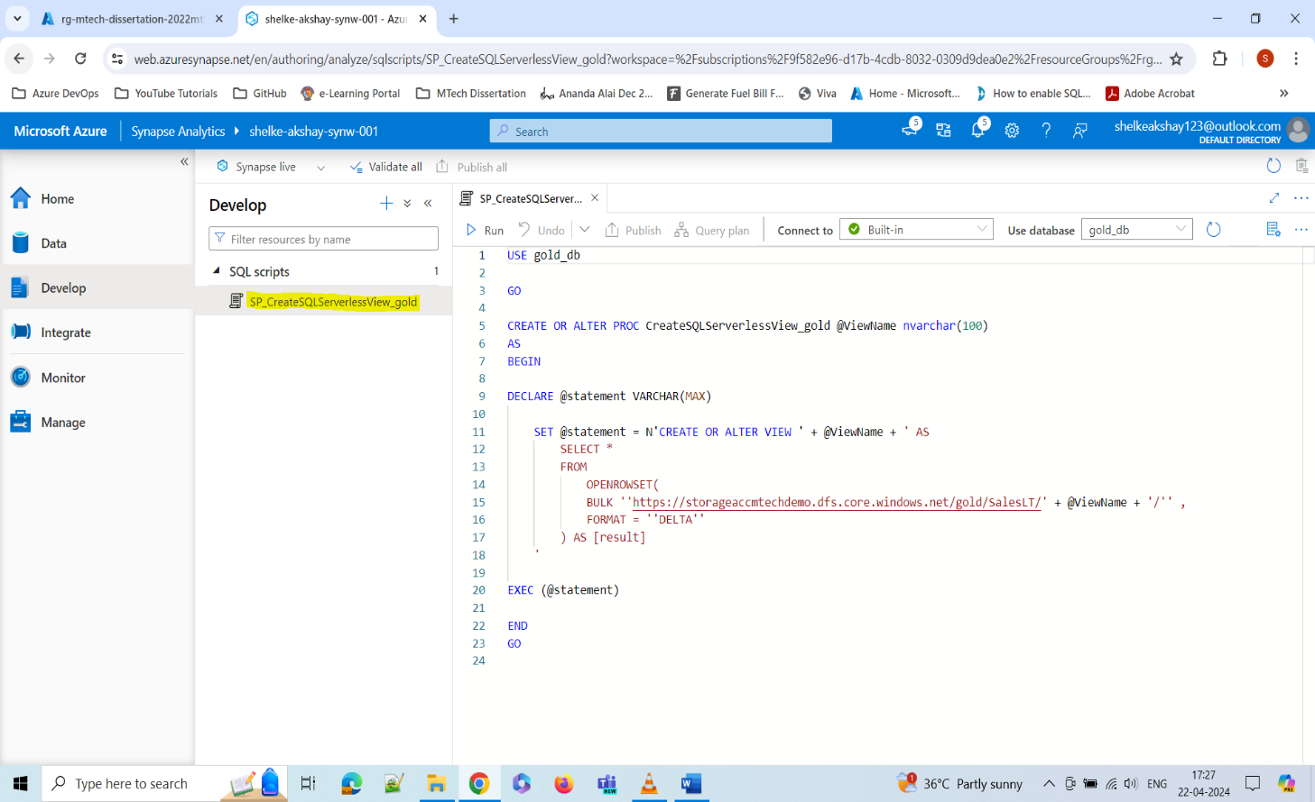Stored procedure creates view of all tables.
4. Data Loading Completed

