**Data Reporting**

|  |
| --- |
|  |

1. Connect to Azure Synapse Analytics via

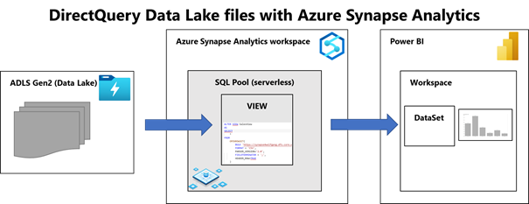

1. PowerBI Dashboard Page 1

1. PowerBI Dashboard Page 2

