Edge Node System

Design Brief

Version Table
Version No. | Contents | Author | Date
V0.0.1 | The Initial Version |  | March 20, 2025

Table of Contents
PREFACE 3
1. System Topology 4
2. MainPB Architecture 5
2.1 Bus Lane Overview 6
2.2 Bus Lane Configuration 6
2.2.1 Downloading(1) and Uploading(5) 6
2.2.2 Downloading Work Principle 7
2.2.3 Uploading Work Principle 7
2.4 Bandwidth Consideration 7
2.5 Time Synchronization 8
2.6 Status Indication 8
3. PrePB Architecture 8
3.1 PrePB Requirement 8
3.2 Bandwidth Consideration 9
3.3 Channel Status Indication 9
4. Power Supply Unit 9
4.1 Key Parameters 9
4.2 Power Consumption Estimation 9
5. Backplane Board 11
5.1 Connector Pin Assignment 11
5.2 ID Allocation 12

PREFACE
This document describes the comprehensive details of Edge Node System design. This hardware system is a platform for bionic vision algorithms. It supports fast full-view imaging inside GIS device, also voice-prints data and other sensor data can be processed. More than 100 sensors are supported concurrently. Software prototypes, including Communication-Sensing-Storage-Calculation combined software module, supports images and voice-prints data analysis, nanosecond processing speed, data compressed ratio is greater than 80%. Dynamic bionic vision algorithms supports data processing in different intensity, dynamic range up to 80dB.

For applications, like partial discharging, overheating inside GIS, researching multi spectral pulse and visualization model. Researching event-driven bionic eyes sensing, transferring, processing mechanism, researching interior visualization detecting algorithms. Analyzing optics distribution, reflection and blocking factors, researching how to improve multi spectral imaging frame rate.

All personnel involved in this project, including engineers, researchers, and project managers, should refer to this document for comprehensive design details and implementation guidelines.

Abbreviation Table
No. | Abbreviation | Full Spelling
1 | MainPB | Main Processing Board
2 | PrePB | Pre-Processing Board
3 | PSU | Power Supply Unit
4 | TU | Terminal Unit
5 | BPB | Backplane Board
6 | ID | Identification
7 | SDR | Single Date Rate
8 | DDR | Double Date Rate

1. System Topology
The entire Edge Node system is split into four parts, one BPB board, one PSU board, one MainPB and 12 PrePBs. All boards will be installed on BPB. BPB servers electrical connection and physical reinforcement.

PSU distributes power supply to all boards. PrePB Board receives all data uploading from TUs. Each PrePB has 10 receive channels, all PrePB boards are capable of handling 120 TUs. The function of PrePB is to pre-process data, apply different algorithms then transfer to MainPB. BPB features all transmit and receive LVDS channels and distributes power supply, it also support physical connection.

MainPB aims to collect all PrePB data and transfer out via 100/1000Base-T Ethernet. PrePB has responsibility of collecting all raw data from terminal units, apply various of pre-processing algorithms then upload the result to MainPB.
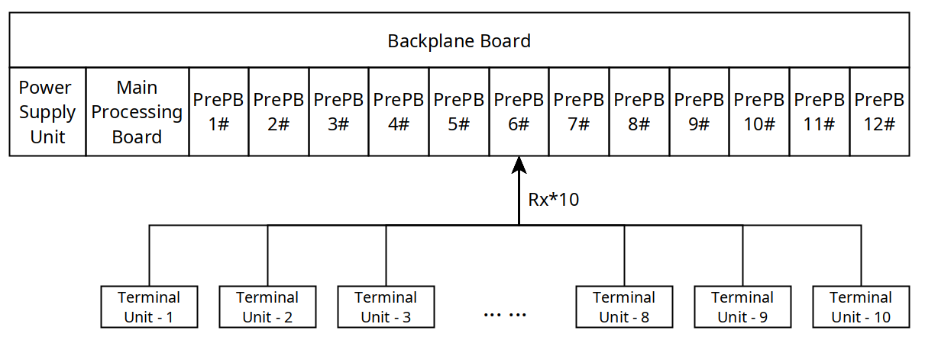

2. MainPB Architecture

Following figure shows the brief architecture of MainPB board. The main controller we use is Microchip PolarFire SoC FPGA, model type is MPFS250T-ECVG484EES. We expand an LPDDR4 SDRAM with memory size 16Gb onboard, the MAC PHY chip VSC8662 has two built-in MAC layers to support two RJ45 sockets for 10/100/1000Mbps Ethernet, an eMMC chip with memory size 8Gb is used for MSS subsystem. We also design 12 LEDs to indicate the status of respective channel. Six independent LVDS channels, bidirectional transceiver. With this feature, MainPB can broadcast data to all PrePBs and recall data from each PrePB.
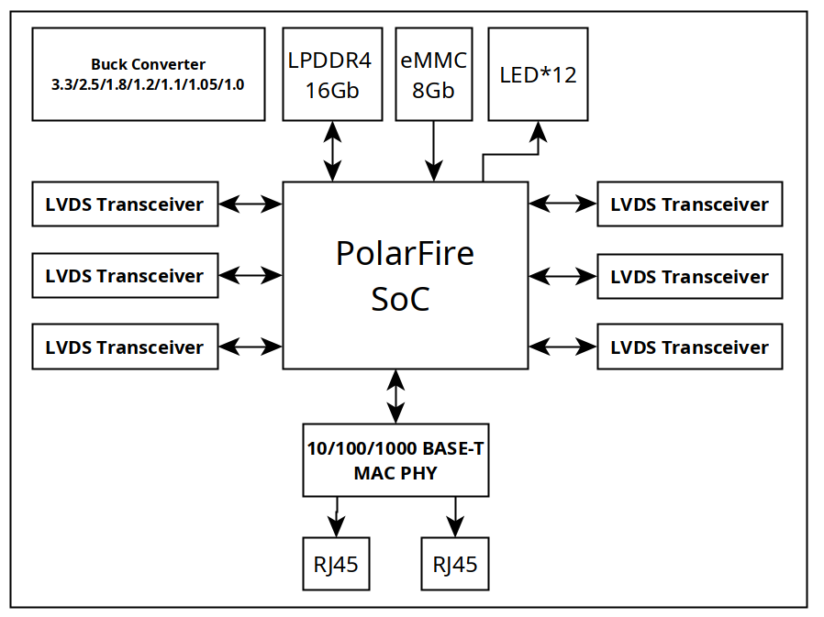

2.1 Bus Lane Overview
There are six bus lanes on board. They support bidirectional communication, but only work in half-duplex mode. The direction can be configured by software to suit different application needs. Each lane contains 10 differential signals, CS, CLK and D0~D7. All data are synchronized to CLK.
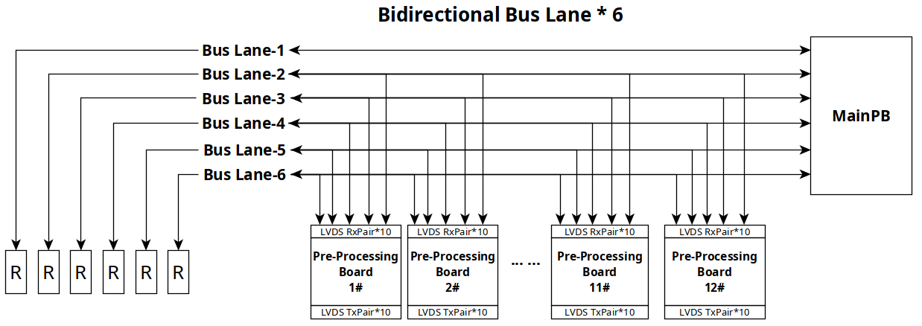

2.2 Bus Lane Configuration
From hardware design view, all bus lanes are bidirectional. Each lane is half-duplex, it only can be used as transmit or receive at the same time. For special applications that the requirement of uploading bandwidth is higher than downloading, users can configure five bus lanes as uploading, one bus lane as downloading. When the downloading finishes, the bus lane also can be switched to uploading. Here are some possible configurations.

2.2.1 Downloading(1) and Uploading(5)
Direction | Bus Lane | Data Flow | MainPB | PrePB | Communication
Downloading | Bus Lane-1 | MainPB  →  All PrePBs | Tx | Rx | Broadcast  or  Point to Point
Uploading | Bus Lane-2 | PrePB(1/6/11)  →  MainPB | Rx | Tx | Poll each device sequentially
Uploading | Bus Lane-3 | PrePB(2/7/12)  →  MainPB | Rx | Tx | Poll each device sequentially
Uploading | Bus Lane-4 | PrePB(3/8)  →  MainPB | Rx | Tx | Poll each device sequentially
Uploading | Bus Lane-5 | PrePB(4/9)  →  MainPB | Rx | Tx | Poll each device sequentially
Uploading | Bus-Lane-6 | PrePB(5/10)  →  MainPB | Rx | Tx | Poll each device sequentially

2.2.2 Downloading Work Principle
Downloading Bus Lane can works in SDR or DDR mode. In SDR mode, each clock period it carries 8-bits. In DDR mode, each clock period it carries 16-bits. During download period, MainPB transmit data, all PrePBs that connected on download bus can receive data simultaneously. Since each PrePB has its own unique address, it can recognize whether the data on Downloading Bus Lane belongs to it or not.

There are two types of address on protocol layer, Broadcast Address and Device Address. If MainPB sends data with broadcast address, all PrePBs could receive and process. But if MainPB sends data with a specific device address, only the corresponded PrePB could take action, others stay idle.

2.2.3 Uploading Work Principle
The Uploading Bus Lane is a synchronous and time-shared bus. In above configuration, three PrePBs use it to upload data, so how to prevent the bus arbitration is a critical problem. In this design, we intend to use Request/Response communication mechanism which is also well-known as Master/Slave. MainPB plays the master role, it issues command over Downloading Bus. On Downloading Bus, Only MainPB is the master, all PrePBs are slaves. Once master sends command, all slaves could receive command simultaneously. All slaves receive commands and compare the address field contained in command to itself unique ID, if they’re matched, the addressed slave takes action. If not matched, abandon this command and be ready to receive next command.

Since the uploading bus is multiple nodes shared, MainPB uses polling mechanism to request data from each PrePB. Normally, the addressed PrePB responses commands and uploads data, it uploads a fixed series bytes to mark the end. MainPB receives and recognizes the end mark, then poll next PrePB. In some applications, TU data are not needed to be pre-processed, TU transmits data to PrePB directly. Therefore, the FPGA located on PrePB board can be bypassed to reduce latency and complication.

MainPB also have timeout mechanism to prevent abnormal circumstances, likely PrePB does not work well, or it’s missed. This prevents MainPB enters a dead-waiting state.

In some applications, TU data are not needed to be pre-processed, TU transmits data to PrePB directly. Therefore, the FPGA located on PrePB board can be bypassed to reduce latency and complication.

2.4 Bandwidth Consideration
MainPB must have performance to handle 12 input channels concurrently. In this design, we assume the date rate of each channel is up to 10Mbps. If all channels data come simultaneously, the input date rate will be 120Mbps, MainPB must receive all data and store in LPDDR4 SDRAM temporarily. The capacity is 16Gbits, adequate for data buffering. After FPGA logic writes all data to SDRAM, it notifies RISC-V to transfer data out via Ethernet.

Since all data have been processed on PrePB boards, the stress suffered on MainPB declined. In order to double the bandwidth, the bus lanes can work in DDR mode. Following table shows the comparison of Six Bus Lanes bandwidth working in different mode.

Bus | Work Mode | Clock (MHz) | Data width (bits) | Bandwidth (Mbps)
Bus Lane | SDR | 10 | 8 | 80
Bus Lane | SDR | 20 | 8 | 160
Bus Lane | SDR | 25 | 8 | 200
Bus Lane | DDR | 10 | 8 | 160
Bus Lane | DDR | 20 | 8 | 320
Bus Lane | DDR | 25 | 8 | 400

2.5 Time Synchronization
The time synchronization is designed to ensure accurate and consistent timekeeping across all distributed nodes in this system. This mechanism will enable precise coordination, logging and event sequencing for nodes that require time accuracy.
MainPB works as the master node, it receives time information from RS-485 interface, then broadcast time information to all PrePBs. This achieves precise time synchronization across all slave nodes. Support for PTP(Precision Time Protocol), NTP(Network Time Protocol), and GNSS-based synchronization. On board, FPGA or microcontroller for time stamping and synchronization management. Each board has a high stability oscillator to minimize synchronization drift and latency.

2.6 Status Indication
MainPB should indicate the status of all PrePBs through LED Flashing. The FPGA Logic should control the flashing frequency of LED to assist with maintenance. Likely, slow flashing, fast flashing, continuous on and off.

Limited by mechanical front panel size, only 12 LEDs are provided on board. Each LED indicates respective channel status by different flashing combination.

Comprehensive LED status will be defined in software design document.

3. PrePB Architecture

3.1 PrePB Requirement
PrePB must support up to 10 input channels. The maximum date rate is 10Mbps. And considering all channels data may come simultaneously. So the bandwidth of output port should be 10Mbps*10=100Mbps at least. If PrePB can’t transfer data out in date rate of 100Mbps, data will lose. The bandwidth between input port and output port are not match. A better way to solve this problem is adding an external DDR SDRAM.

Following table shows single frame data size of different image sensors. This table offers a reference approximately, it determines the capacity of DDR SDRAM that we need. Bigger resolution, more capacity. Here one frame of Visible-Light Image, the data size is 75Mbits. For 10 channels, we need 75Mbits*10=750Mbits. So strongly recommend to place a 2Gb DDR SDRAM on board.

/ | Visible-Light Image | Infrared Image |  | Ultraviolet Image
Resolution | 2560*1920 | 640*512 | 256*192 | 1280*1024
Data Depth | 16-bits | 14-bits | 14-bits | 8-bits
Total (in bits) | 75Mbits | 5Mbits | 0.75Mbits | 20Mbits
Total (in Bytes) | 9.37MBytes | 0.62MBytes | 0.09MBytes | 2.5MBytes

3.2 Bandwidth Consideration
The ideal situation is the output bandwidth matched to input bandwidth, so no data will lose. In this design, each PrePB has 10 input channels data stream and the date rate is up to 10Mbps, that means if all channels data come in simultaneously, the input bandwidth will be 100Mbps. But we only have one output port with 20MHz in SDR mode. Even if we operate it in DDR mode, the bandwidth is 40Mbps. Not matched perfectly.
So pre-processing data is essential to reduce bandwidth cost. With less data size, PrePB can transfer data out in time.

3.3 Channel Status Indication
PrePB should indicate the status of all channels through LED Flashing. The FPGA Logic will control the flashing frequency of LED to assist with maintenance. Likely, slow flashing, fast flashing, continuous on and off.

Comprehensive LED status will be defined in software design document.

4. Power Supply Unit
The PSU board supplies power to all electric components. It accepts 180VAC~230VAC input, converts AC to DC, outputs 12V power rails with 25A maximum current. The PSU board has over-current protection, thermal protection and smart fan controller.

4.1 Key Parameters
Following table shows key parameters of power supply unit.
Item | Parameter | Memo
Topology | AC/DC
Input Voltage Range | 180VAC~230VAC 50Hz
Output Voltage | 12V
Output Current (Max.) | 25A
Ripple and Noise
Power Efficiency | 90%
Load Regulation
Line Regulation
Overload Protection | Support | Alarm
Thermal Protection | Support | Alarm and shutdown when overheated.

4.2 Power Consumption Estimation
Following table shows the power supply requirement of each board. This is the maximum estimation, at least 20% safety margins are acceptable.
Board Name | Power Consumption
MainPB | 12 Watts | 12V/1A
PrePB

5. Backplane Board

5.1 Connector Pin Assignment
The aim of BPB is to distribute power supply and route bus signals. And also LVDS terminate resistors on board. In this design, BPB has 14 sockets totally, each socket integrates two connectors, the top connector is used to distribute power supply and LVDS pairs. For the bottom connector, it routes ID allocation and LVDS pairs. Following table shows pin assignment.

There are 60 LVDS pairs totally in the back plane board. LVDS transceivers we use only work in half-duplex mode, software layers determine the direction. The minimum swing is only 460mV, PCB layout must be very careful to reduce impact from impedance match.

Normally, 30% safety margins are acceptable, for the connector we’re using, current capacity of each pin is 200mA approximately. We assign 9 pins to distribute 12V voltage, the maximum current capacity is calculated by the equation, 200mA*9=1.8A. The numbers of GND pin is twice times of 12V.
Current carrying capacity of PCB vias are described as below for a reference guideline.

Via Diameter | Max Current
0.15mm | 0.5A
0.2mm | 0.7A
0.3mm | 1A
0.4mm | 1.5A
0.5mm | 2A
0.6mm | 2.5A
0.8mm | 4A
1.0mm | 6A

No. | Top Connector – 3x32P |  |  |  |  |  | Bottom Connector – 3x32P
1 | A1 | 12V | A2 | 12V | A3 | 12V | A1 | GND | A2 | GND | A3 | GND
2 | B1 | 12V | B2 | 12V | B3 | 12V | B1 | TR25_P | B2 | TR13_P | B3 | TR1_P
3 | C1 | 12V | C2 | 12V | C3 | 12V | C1 | TR25_N | C2 | TR13_N | C3 | TR1_N
4 | D1 | GND | D2 | GND | D3 | GND | D1 | TR26_P | D2 | TR14_P | D3 | TR2_P
5 | E1 | GND | E2 | GND | E3 | GND | E1 | TR26_N | E2 | TR14_N | E3 | TR2_N
6 | F1 | GND | F2 | GND | F3 | GND | F1 | GND | F2 | GND | F3 | GND
7 | G1 | GND | G2 | GND | G3 | GND | G1 | TR27_P | G2 | TR15_P | G3 | TR3_P
8 | H1 | GND | H2 | GND | H3 | GND | H1 | TR27_N | H2 | TR15_N | H3 | TR3_N
9 | I1 | GND | I2 | GND | I3 | GND | I1 | TR28_P | I2 | TR16_P | I3 | TR4_P
10 | J1 | TR53_P | J2 | TR45_P | J3 | TR37_P | J1 | TR28_N | J2 | TR16_N | J3 | TR4_N
11 | K1 | TR53_N | K2 | TR45_N | K3 | TR37_N | K1 | GND | K2 | GND | K3 | GND
12 | L1 | GND | L2 | GND | L3 | GND | L1 | TR29_P | L2 | TR17_P | L3 | TR5_P
13 | M1 | TR54_P | M2 | TR46_P | M3 | TR38_P | M1 | TR29_N | M2 | TR17_N | M3 | TR5_N
14 | N1 | TR54_N | N2 | TR46_N | N3 | TR38_N | N1 | TR30_P | N2 | TR18_P | N3 | TR6_P
15 | O1 | GND | O2 | GND | O3 | GND | O1 | TR30_N | O2 | TR18_N | O3 | TR6_N
16 | P1 | TR55_P | P2 | TR47_P | P3 | TR39_P | P1 | GND | P2 | GND | P3 | GND
17 | Q1 | TR55_N | Q2 | TR47_N | Q3 | TR39_N | Q1 | TR31_P | Q2 | TR19_P | Q3 | TR7_P
18 | R1 | GND | R2 | GND | R3 | GND | R1 | TR31_N | R2 | TR19_N | R3 | TR7_N
19 | S1 | TR56_P | S2 | TR48_P | S3 | TR40_P | S1 | TR32_P | S2 | TR20_P | S3 | TR8_P
20 | T1 | TR56_N | T2 | TR48_N | T3 | TR40_N | T1 | TR32_N | T2 | TR20_N | T3 | TR8_N
21 | U1 | GND | U2 | GND | U3 | GND | U1 | GND | U2 | GND | U3 | GND
22 | V1 | TR57_P | V2 | TR49_P | V3 | TR41_P | V1 | TR33_P | V2 | TR21_P | V3 | TR9_P
23 | W1 | TR57_N | W2 | TR49_N | W3 | TR41_N | W1 | TR33_N | W2 | TR21_N | W3 | TR9_N
24 | X1 | GND | X2 | GND | X3 | GND | X1 | TR34_P | X2 | TR22_P | X3 | TR10_P
25 | Y1 | TR58_P | Y2 | TR50_P | Y3 | TR42_P | Y1 | TR34_N | Y2 | TR22_N | Y3 | TR10_N
26 | Z1 | TR58_N | Z2 | TR50_N | Z3 | TR42_N | Z1 | GND | Z2 | GND | Z3 | GND
27 | AA1 | GND | AA2 | GND | AA1 | GND | AA1 | TR35_P | AA2 | TR23_P | AA1 | TR11_P
28 | AB1 | TR59_P | AB2 | TR51_P | AB1 | TR43_P | AB1 | TR35_N | AB2 | TR23_N | AB1 | TR11_N
29 | AC1 | TR59_N | AC2 | TR51_N | AC1 | TR43_N | AC1 | TR36_P | AC2 | TR24_P | AC1 | TR12_P
30 | AD1 | GND | AD2 | GND | AD1 | GND | AD1 | TR36_N | AD2 | TR24_N | AD1 | TR12_N
31 | AE1 | TR60_P | AE2 | TR52_P | AE1 | TR44_P | AE1 | GND | AE2 | GND | AE1 | ID1
32 | AF1 | TR60_N | AF2 | TR52_N | AF1 | TR44_N | AF1 | ID2 | AF2 | ID3 | AF1 | ID4

5.2 ID Allocation
Since we have 12 PrePB boards connected in parallel, so there’s ID allocation circuit designed special for PrePB boards recognition. Initially, PrePBs has no fixed ID. Once it’s plugged into BPB, BPB allocates a unique ID to it. Later, PrePB read this ID to transfer data and response command from MainPB. MainPB distinguishes each PrePB by unique ID accurately.

Here, 4 bits can address 2^4=16 boards, adequate for our needs. ID[4:1]=1111 is the broadcast ID, it means that the command will be send to all PrePBs.

Place these circuit beside each socket on In some applications, TU data are not needed to be pre-processed, TU transmits data to PrePB directly. Therefore, the FPGA located on PrePB board can be bypassed to reduce latency and complication. BPB, and soldering respective resistors in fabrication. Duplicated IDs could cause confusion and data collision.
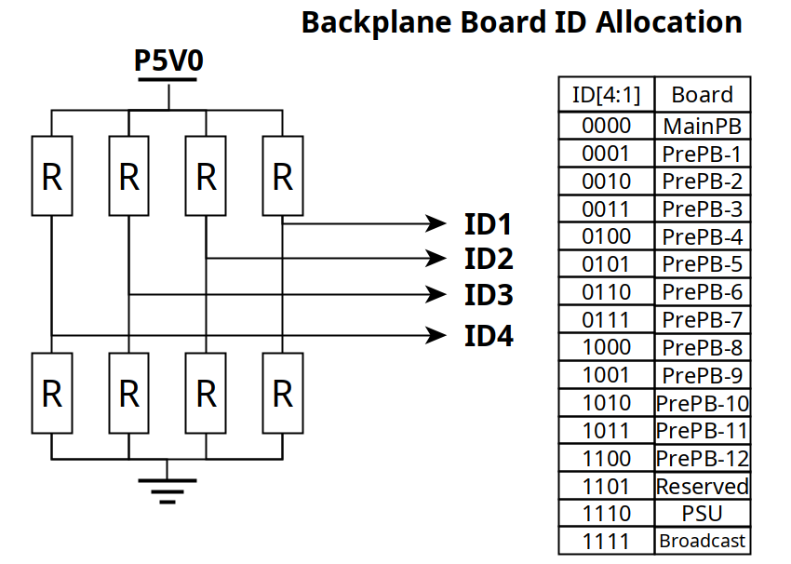

*************** The End of File ***************

