Edge Node System

Design Brief

Version Table
Version No. | Contents | Author | Date
V0.0.1 | The Initial Version | Anonymous | March 20, 2025
V0.0.2 | Append more contents. | Anonymous | April 2, 2025

Table of Contents
PREFACE 3
1. System Topology 4
1.1 Block Diagram 4
1.2 Optical Partial Discharging Sensor Board 5
1.3 Camera Sensor Board 5
1.4 Ultrasonic Sensor Board 6
1.5 Magnetic-field Voltage Sensor Board 6
2. 4U Rack mount Case 7
3. Data Aggregation Board 8
3.1 Bus Lane Overview 8
3.2 Bus Lane Configuration 9
3.2.1 Downloading(1) and Uploading(5) 9
3.2.2 Downloading Work Principle 9
3.2.3 Uploading Work Principle 10
3.3 LVDS Transceiver 10
3.4 Bandwidth Consideration 11
3.5 Time Synchronization 12
3.6 Power Rails Consumption 13
3.6.1 PolarFire SoC FPGA 13
3.6.2 LPDDR4 13
3.6.3 Ethernet PHY 14
3.6.4 eMMC Memory Chip 16
3.6.5 LVDS Transceiver 16
3.7 Status Indication 16
4. DPPB Architecture 17
4.1 DPPB Requirement 17
4.2 Bandwidth Consideration 17
4.3 Channel Status Indication 18
5. Power Supply Unit 19
5.1 Key Parameters 19
5.2 Power Consumption Estimation 19
6. Backplane Board 20
6.1 Connector Pin Assignment 20
6.2 ID Allocation 21

PREFACE
This document describes the comprehensive details of Edge Node System design. This hardware system is a platform for bionic vision algorithms. It supports fast full-view imaging inside GIS device, also voice-prints data and other sensor data can be processed. More than 100 sensors are supported concurrently. Software prototypes, including Communication-Sensing-Storage-Calculation combined software module, supports images and voice-prints data analysis, nanosecond processing speed, data compressed ratio is greater than 80%. Dynamic bionic vision algorithms supports data processing in different intensity, dynamic range up to 80dB.

For applications, like partial discharging, overheating inside GIS, researching multi spectral pulse and visualization model. Researching event-driven bionic eyes sensing, transferring, processing mechanism, researching interior visualization detecting algorithms. Analyzing optics distribution, reflection and blocking factors, researching how to improve multi spectral imaging frame rate.

All personnel involved in this project, including engineers, researchers, and project managers, should refer to this document for comprehensive design details and implementation guidelines.

Abbreviation Table
No. | Abbreviation | Full Spelling
1 | DAB | Data Aggregation Board
2 | DPPB | Data Pre-Processing Board
3 | PSU | Power Supply Unit
4 | SB | Sensor Board
5 | BPB | Backplane Board
6 | ID | Identification
7 | SDR | Single Date Rate
8 | DDR | Double Date Rate

1. System Topology

1.1 Block Diagram
The entire Edge Node system is split into four parts, 1 BPB board, 1 PSU board, 1 DAB and 10 DPPBs. All boards will be installed on BPB. BPB servers electrical connection and physical reinforcement.
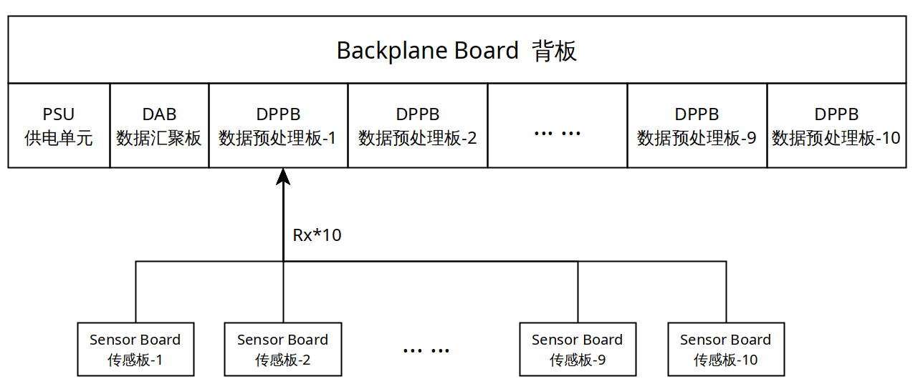
PSU distributes power supply to all boards. The DPPB Board receives all data uploading from various sensor boards. Each DPPB has 10 receive channels, all DPPB boards are capable of handling up to 100 sensors. The function of DPPB is to pre-process data, apply different algorithms then transfer results to DAB. BPB features all transmit and receive high speed LVDS channels and distributes power supply, it also supports physical connection.

DAB aims to collect all DPPB data and transfer out via 100/1000Base-T Ethernet. DPPB has responsibility of collecting all raw data from sensor boards, apply various of pre-processing algorithms then upload the result to DAB.

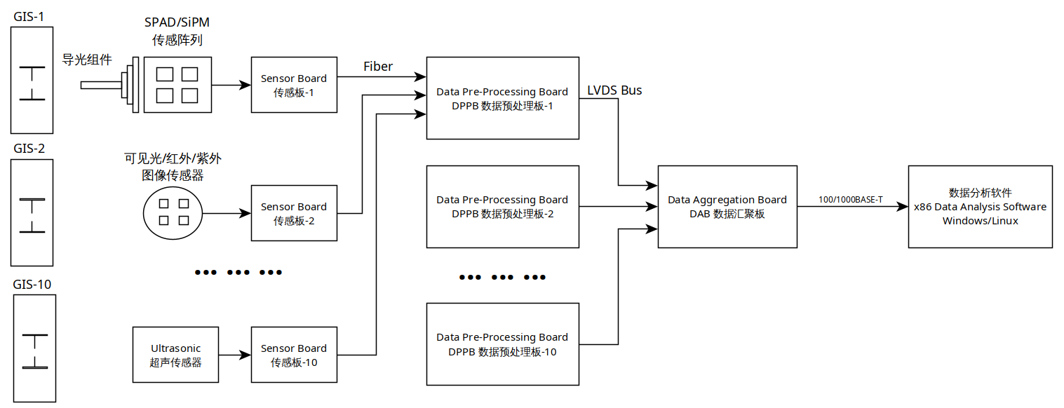

1.2 Optical Partial Discharging Sensor Board

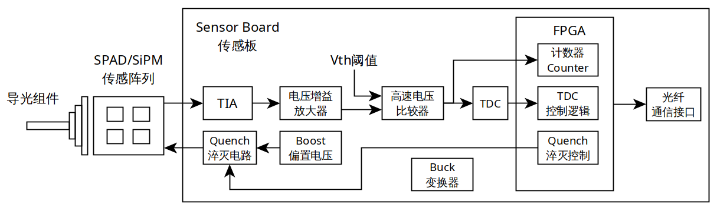

1.3 Camera Sensor Board

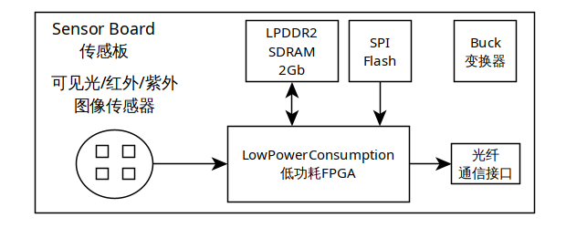

1.4 Ultrasonic Sensor Board

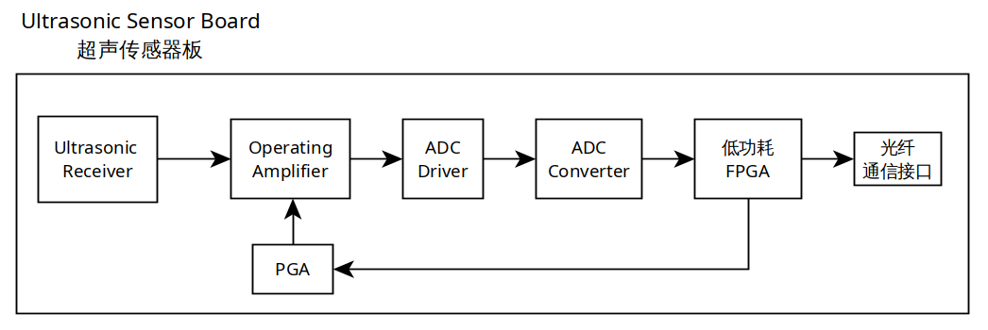

1.5 Magnetic-field Voltage Sensor Board

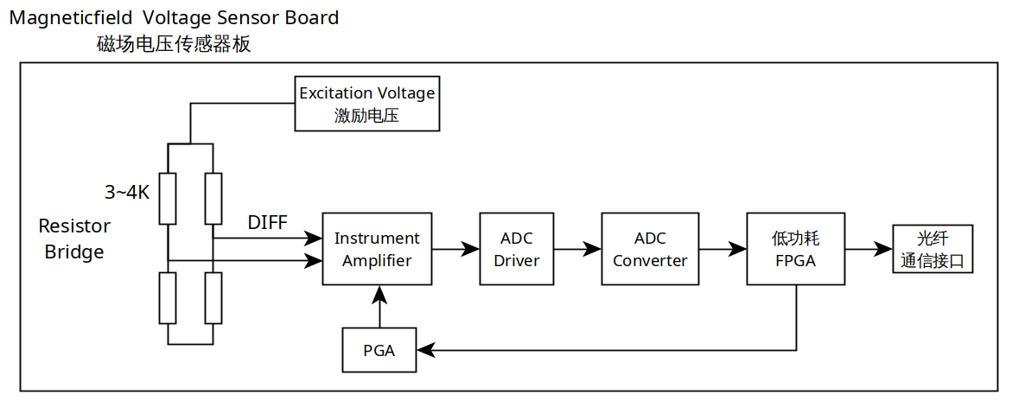

2. 4U Rack mount Case
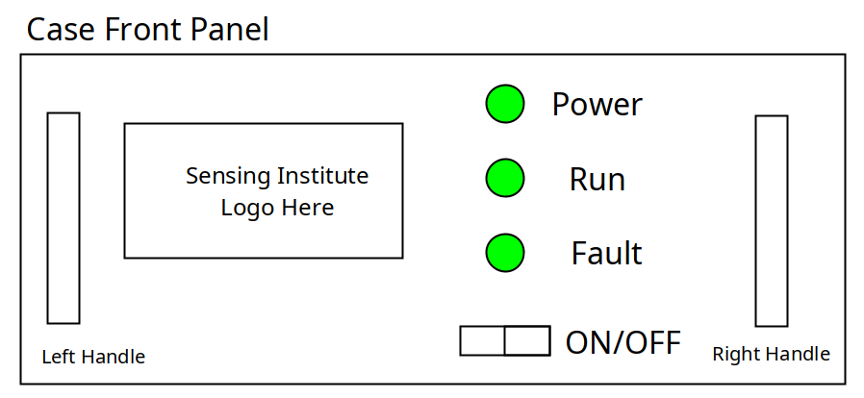
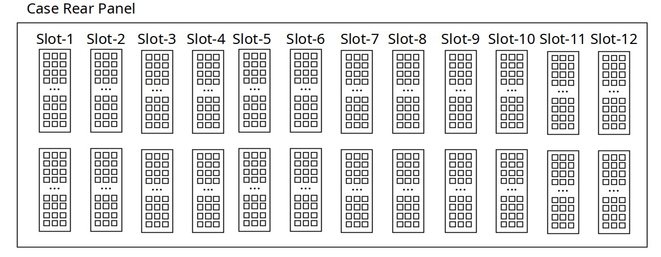
The above block diagram shows briefly the front view of case front panel. Two handles are located at left and right. We design 3 LEDs to indicate system working status. The 1st LED labeled Power indicate the whole system gets power supply and the main power rail turns on. The 2nd LED labeled Run is driven by Data Aggregation Board to show the working status by flashing it in different frequency. And Data Aggregation Board also drive the 3rd LED to flash in case of fault occurs. There’s also a switch used to turn on or turn off the Power Supply Unit. The three LEDs and switch are located on a tiny PCB that is installed on front panel with screws. An external wires cable connects the tiny board and DAB.
For the rear panel, there are 12 slots available for plugging in different types of board. Attention here, PSU and DAB have fixed location, please plug in correct slots. The DPPB board has no fixed ID, it reads a unique ID once it’s plugged in slot randomly.

3. Data Aggregation Board

Following figure shows the brief architecture of DAB board. The main controller we use is Microchip PolarFire SoC FPGA, model type is MPFS250T-ECVG484EES. We expand an LPDDR4 SDRAM with memory size 16Gb onboard, the MAC PHY chip VSC8662 has two built-in MAC layers to support two RJ45 sockets for 10/100/1000Mbps Ethernet, an eMMC chip with memory size 8Gb is used for MSS subsystem. We also design 10 LEDs to indicate the status of respective channel. Six independent high speed LVDS buses, bidirectional transceiver, each channel supports up to 10 signals. With this feature, DAB can broadcast data to all DPPBs and recall data from each DPPB.
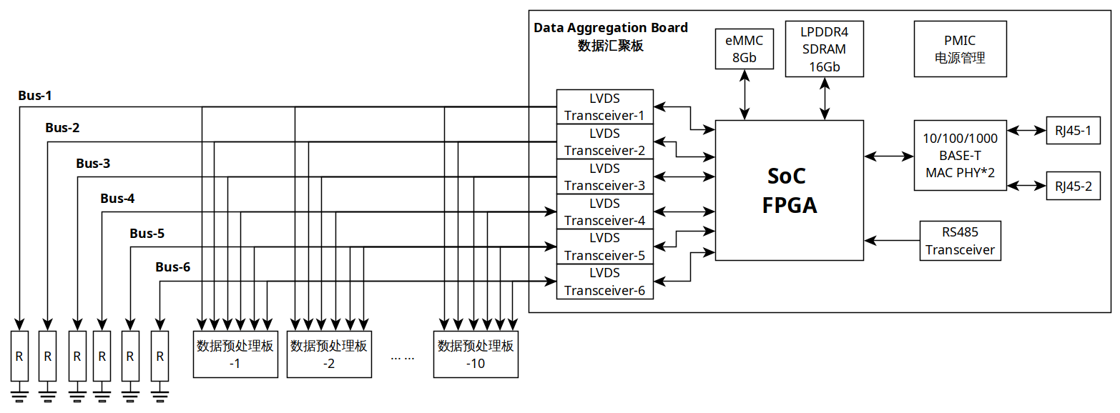

3.1 Bus Lane Overview
There are six bus lanes on board. They support bidirectional communication, but only work in half-duplex mode. The direction can be configured by software to suit different application needs. Each lane contains 10 differential signals, CS, CLK and D0~D7. All data are synchronized to CLK.
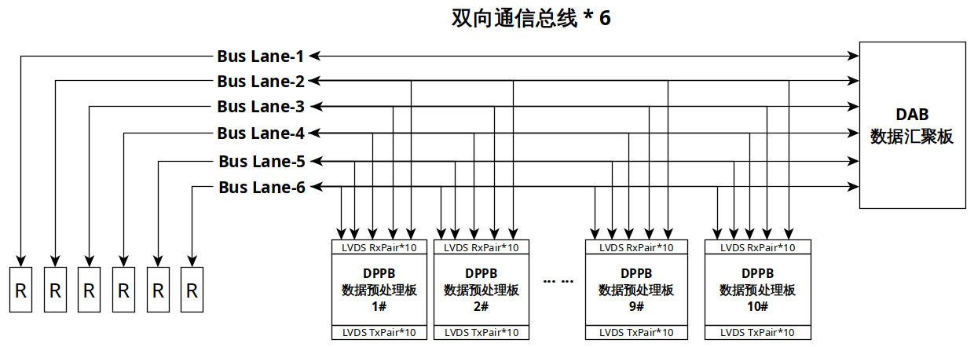

3.2 Bus Lane Configuration
From hardware design view, all bus lanes are bidirectional. Each lane is half-duplex, it only can be used as transmit or receive at the same time. For special applications that the requirement of uploading bandwidth is higher than downloading, users can configure five bus lanes as uploading, one bus lane as downloading. When the downloading finishes, the bus lane also can be switched to uploading. Here are some possible configurations.

3.2.1 Downloading(1) and Uploading(5)
Direction | Bus Lane | Data Flow | DAB | DPPB | Communication
Downloading | Bus Lane-1 | DAB  →  All DPPB | Tx | Rx | Broadcast  or  Point to Point
Uploading | Bus Lane-2 | DPPB(1/6/11)  →  DAB | Rx | Tx | Poll each device sequentially
Uploading | Bus Lane-3 | DPPB(2/7/12)  →  DAB | Rx | Tx | Poll each device sequentially
Uploading | Bus Lane-4 | DPPB(3/8)  →  DAB | Rx | Tx | Poll each device sequentially
Uploading | Bus Lane-5 | DPPB(4/9)  →  DAB | Rx | Tx | Poll each device sequentially
Uploading | Bus-Lane-6 | DPPB(5/10)  →  DAB | Rx | Tx | Poll each device sequentially

3.2.2 Downloading Work Principle
Downloading Bus Lane can work in SDR or DDR mode. In SDR mode, each clock period it carries 8-bits. In DDR mode, each clock period it carries 16-bits. During download period, DAB transmit data, all DPPBs that connected on download bus can receive data simultaneously. Since each DPPB has its own unique address, it can recognize whether the data on Downloading Bus Lane belongs to it or not.

There are two types of address on protocol layer, Broadcast Address and Device Address. If DAB sends data with broadcast address, all DPPBs could receive and process. But if DAB sends data with a specific device address, only the corresponded DPPB could take action, others stay idle.

DAB sends data at rising edge of clock, DPPB latches data in at falling edge of clock. CS remains low during the single progress, CS pulls high to ends single transferring.
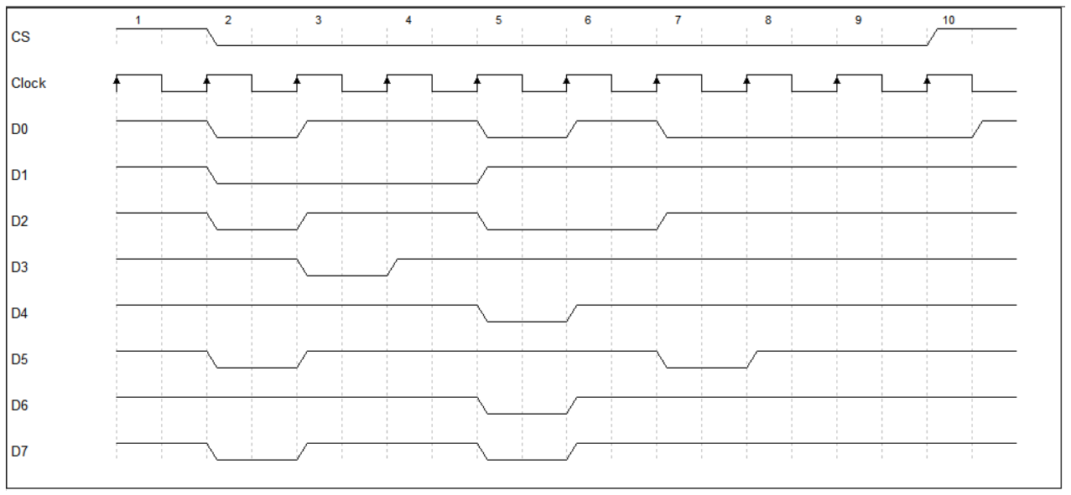

3.2.3 Uploading Work Principle
The Uploading Bus Lane is a synchronous and time-shared bus. In above configuration, three DPPBs use it to upload data, so how to prevent the bus arbitration is a critical problem. In this design, we intend to use Request/Response communication mechanism which is also well-known as Master/Slave. DAB plays the master role, it issues command over Downloading Bus. On Downloading Bus, Only DAB is the master, all DPPBs are slaves. Once master sends command, all slaves could receive command simultaneously. All slaves receive commands and compare the address field contained in command to itself unique ID, if they’re matched, the addressed slave takes action. If not matched, abandon this command and be ready to receive next command.

Since the uploading bus is multiple nodes shared, DAB uses polling mechanism to request data from each DPPB. Normally, the addressed DPPB responses commands and uploads data, it uploads a fixed series bytes to mark the end. DAB receives and recognizes the end mark, then poll next DPPB. In some applications, sensing data are not needed to be pre-processed, Sensor board transmits data to DPPB directly. Therefore, the FPGA located on DPPB board can be bypassed to reduce latency and complication.

DAB also have timeout mechanism to prevent abnormal circumstances, likely DPPB does not work well, or it’s missed. This prevents DAB enters a dead-waiting state.

3.3 LVDS Transceiver
In our design, we use DS91M040 LVDS Transceiver. The DS91M040 is a quad Multipoint LVDS transceiver designed for driving/receiving clock or data signals to/from to four multipoint networks. A single channel is a half-duplex transceiver that accepts LVTTL/LVCMOS signals at the driver inputs and converts them to differential M-LVDS signal levels. The receiver inputs accept low voltage differential signals (LVDS, BLVDS, M-LVDS, LVPECL and CML) and covert them to 3V LVCMOS signals.

The DS91M040 supports up to 125MHz, maximum date rate is 250Mbps in DDR mode. Its differential output voltage magnitude is between 480mV and 650mV at the condition of load 50-ohms and 5pF.

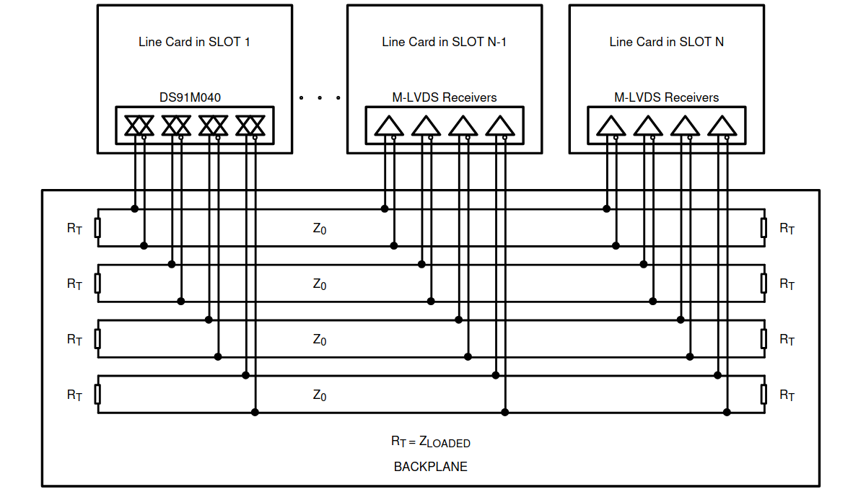

3.4 Bandwidth Consideration
DAB must have performance to handle 12 input channels concurrently. In this design, we assume the date rate of each channel is up to 10Mbps. If all channels data come simultaneously, the input date rate will be 120Mbps, DAB must receive all data and store in LPDDR4 SDRAM temporarily. The capacity is 16Gbits, adequate for data buffering. After FPGA logic writes all data to SDRAM, it notifies RISC-V to transfer data out via Ethernet.

Since all data have been processed on DPPB boards, the stress suffered on DAB declined. In order to double the bandwidth, the bus lanes can work in DDR mode. Following table shows the comparison of Six Bus Lanes bandwidth working in different mode.

Bus | Work Mode | Clock (MHz) | Data width (bits) | Bandwidth (Mbps)
Bus Lane | SDR | 10 | 8 | 80
Bus Lane | SDR | 20 | 8 | 160
Bus Lane | SDR | 25 | 8 | 200
Bus Lane | DDR | 10 | 8 | 160
Bus Lane | DDR | 20 | 8 | 320
Bus Lane | DDR | 25 | 8 | 400

3.5 Time Synchronization
The time synchronization mechanism is designed to ensure accurate and consistent timekeeping across all distributed nodes in this system. This mechanism will enable precise coordination, logging and event sequencing for nodes that require time accuracy.
DAB works as the master node, all DPPBs works as slave nodes. Master node receives timestamps from RS-485 interface, then broadcast timestamps to all slave nodes, slave nodes calculate delay and adjust their clock accordingly. This achieves precise time synchronization across all slave nodes. Support for PTP(Precision Time Protocol), NTP(Network Time Protocol), and GNSS-based synchronization. On board, FPGA or micro-controller for time stamping and synchronization management. Each board has a high stability oscillator to minimize synchronization drift and latency.

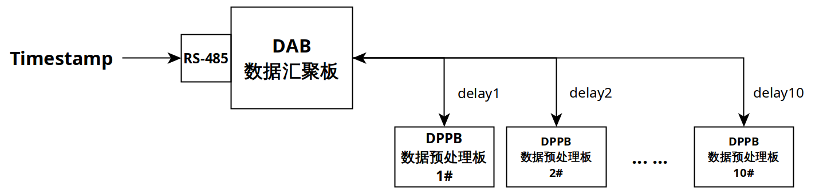

3.6 Power Rails Consumption
Following table lists power rails requirement of key components in this system, involves the main hybrid SoC, LPDDR4 SDRAM, SGMII network interface, eMMC and LVDS transceivers. After merged, 3.3V 2.5V 1.8V 1.2V 1.1V are needed. It’s better to use a Power Management IC that supports five power rails rather than several discrete chips. A PMIC is a great choice for reducing board space and improve efficiency.
No. | Component | Power Rails Requirement | Power Consumption
1 | FPGA  MPFS250T | 3.3V 2.5V  1.8V 1.1V | To be continued...
2 | LPDDR4 | 1.8V 1.1V | 0.5 Watts
3 | Ethernet PHY  VSC8662 | 3.3V 1.2V | 1.0 Watts
4 | eMMC | 3.3V 1.8V | 0.66 Watts
5 | LVDS  Transceiver | 3.3V | 1.482 Watts

3.6.1 PolarFire SoC FPGA
Static Power Consumption and Dynamic Power Consumption.
To be continued….

3.6.2 LPDDR4
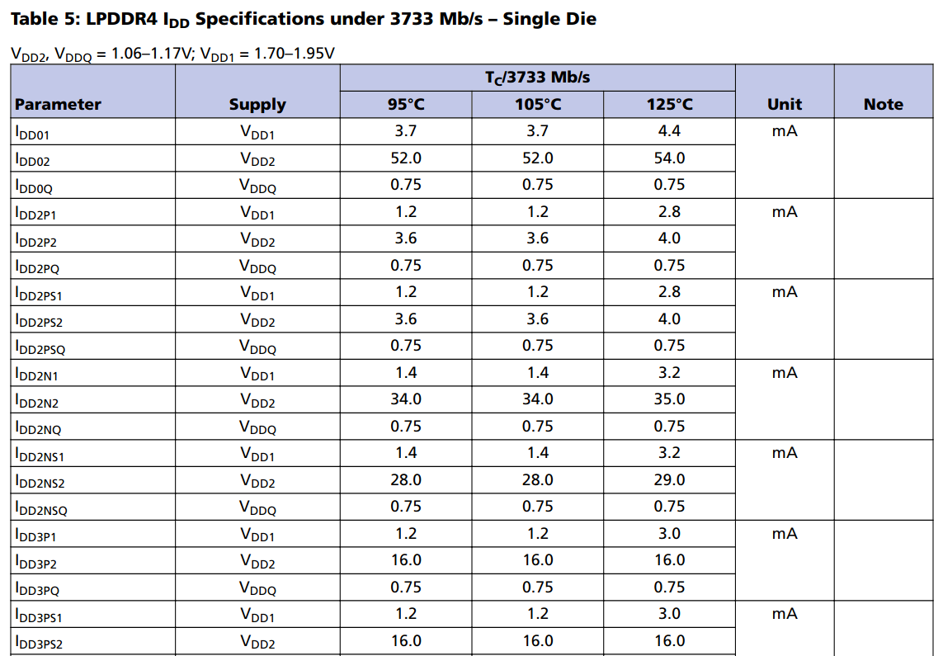

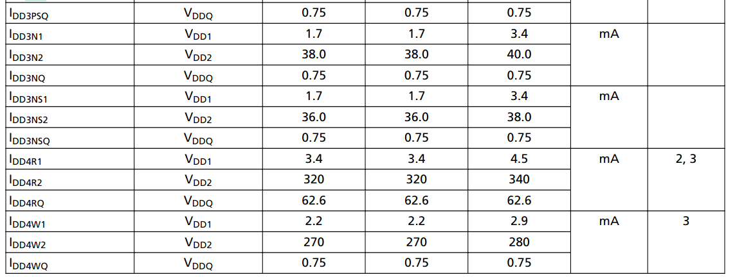
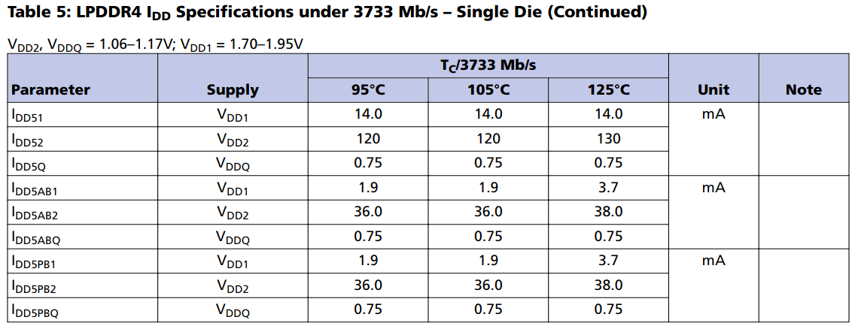
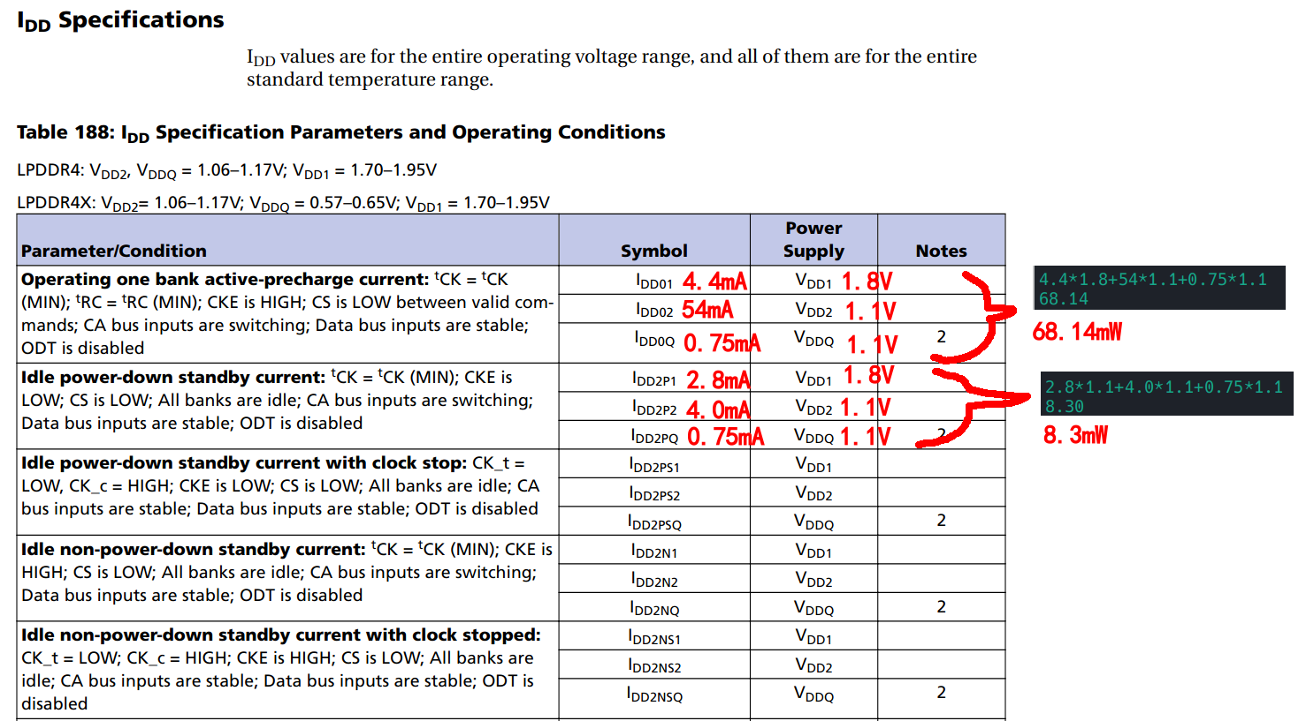
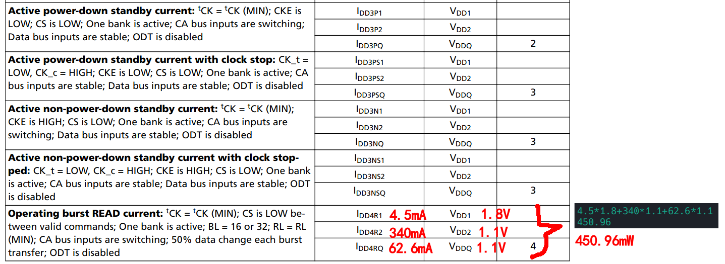
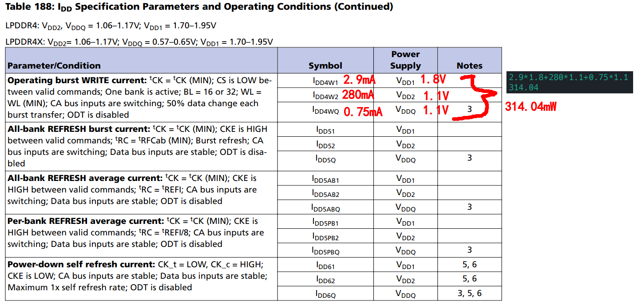

3.6.3 Ethernet PHY
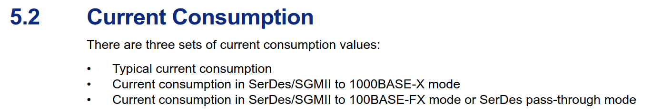
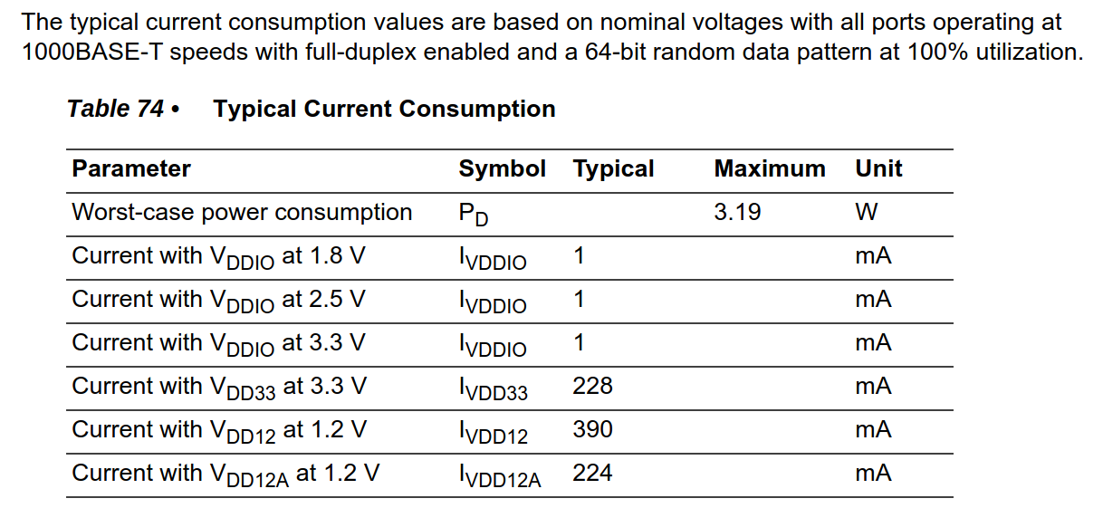

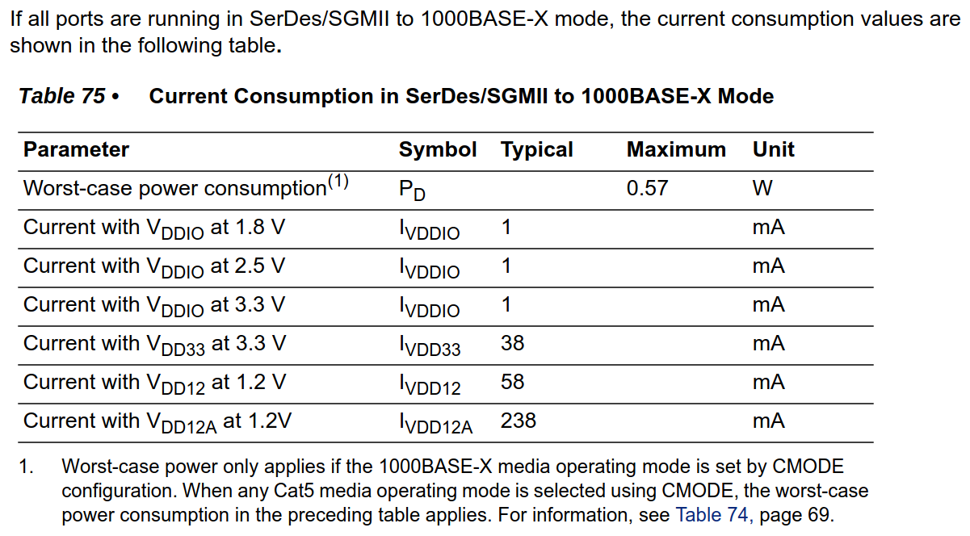
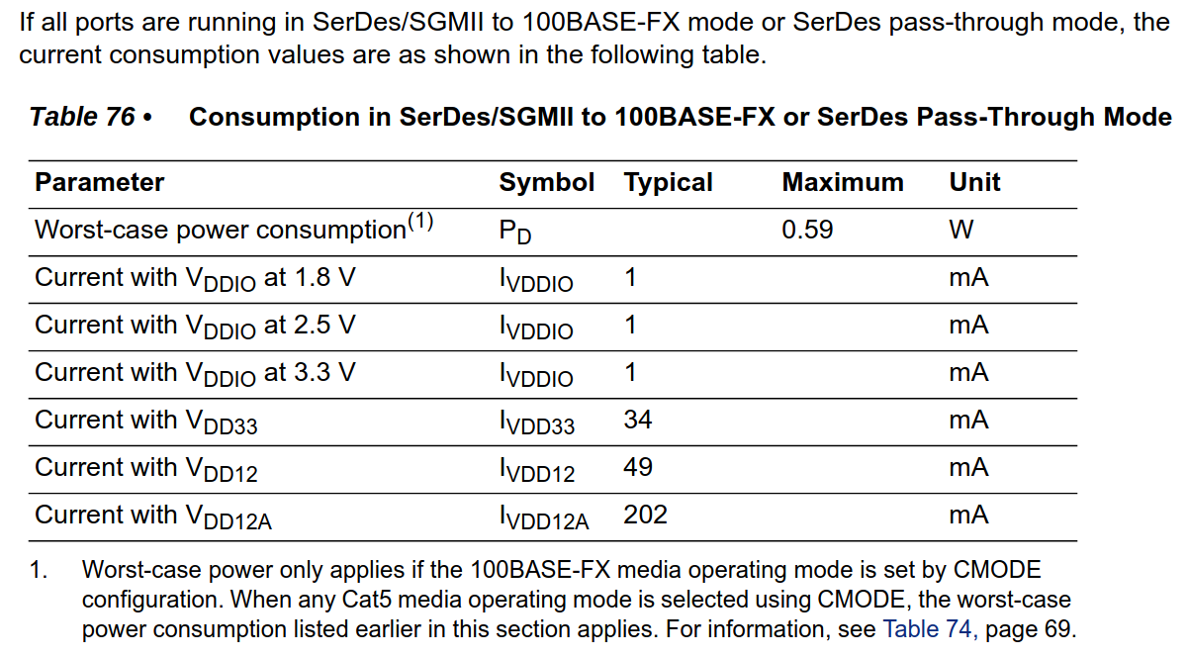

3.6.4 eMMC Memory Chip
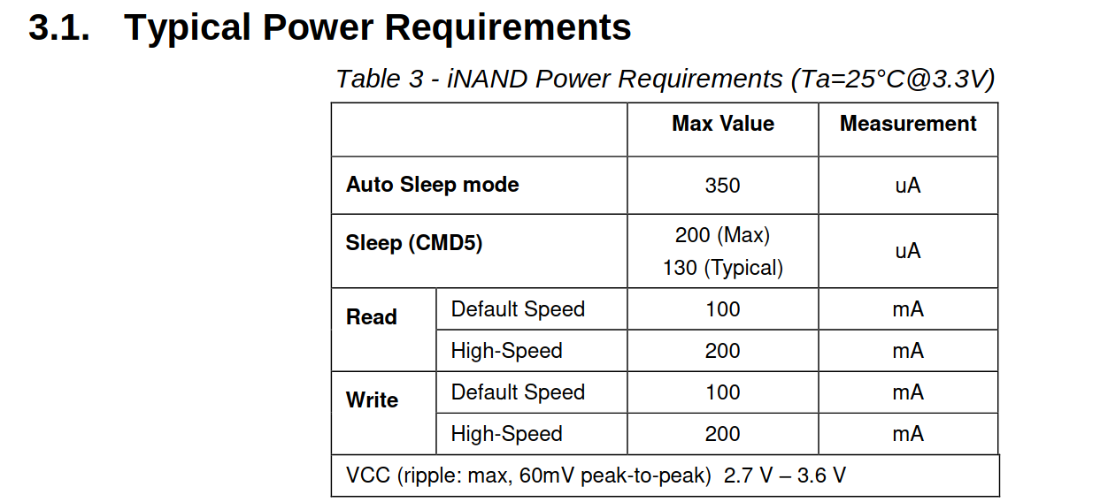
200MA * 3.3V = 0.66 Watts

3.6.5 LVDS Transceiver
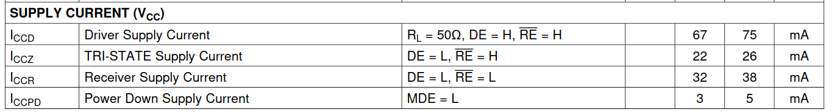
From this table, we know DS91M040 consumes 75mA maximum in driving mode, 38mA maximum in receiving mode. Since there are 6 transceivers on board, we assume they all work in driving mode, so the total current consumed is calculated by following equation,
75mA * 3.3V * 6 = 1.482 Watts.

3.7 Status Indication
DAB should indicate the status of all DPPBs through LED Flashing. The FPGA Logic should control the flashing frequency of LED to assist with maintenance. Likely, slow flashing, fast flashing, continuous on and off.

Limited by mechanical front panel size, only 12 LEDs are provided on board. Each LED indicates respective channel status by different flashing combination.

Comprehensive LED status will be defined in software design document.

4. DPPB Architecture
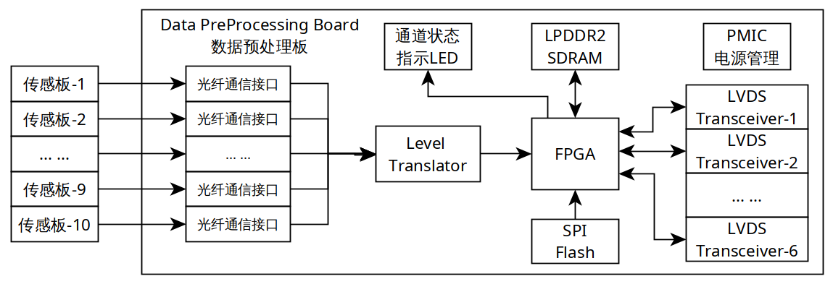

4.1 DPPB Requirement
DPPB must support up to 10 input channels. The maximum date rate is 10Mbps. And considering all channels data may come simultaneously. So the bandwidth of output port should be 10Mbps*10=100Mbps at least. If DPPB can’t transfer data out in date rate of 100Mbps, data will lose. The bandwidth between input port and output port are not match. A better way to solve this problem is adding an external DDR SDRAM.

Following table shows single frame data size of different image sensors. This table offers a reference approximately, it determines the capacity of DDR SDRAM that we need. Bigger resolution, more capacity. Here one frame of Visible-Light Image, the data size is 75Mbits. For 10 channels, we need 75Mbits*10=750Mbits. So strongly recommend to place a 2Gb DDR SDRAM on board.

/ | Visible-Light Image | Infrared Image |  | Ultraviolet Image
Resolution | 2560*1920 | 640*512 | 256*192 | 1280*1024
Data Depth | 16-bits | 14-bits | 14-bits | 8-bits
Total (in bits) | 75Mbits | 5Mbits | 0.75Mbits | 20Mbits
Total (in Bytes) | 9.37MBytes | 0.62MBytes | 0.09MBytes | 2.5MBytes

4.2 Bandwidth Consideration
The ideal situation is the output bandwidth matched to input bandwidth, so no data will lose. In this design, each DPPB has 10 input channels data stream and the date rate is up to 10Mbps, that means if all channels data come in simultaneously, the input bandwidth will be 100Mbps. But we only have one output port with 20MHz in SDR mode. Even if we operate it in DDR mode, the bandwidth is 40Mbps. Not matched perfectly.
So pre-processing data is essential to reduce bandwidth cost. With less data size, DPPB can transfer data out in time.

4.3 Channel Status Indication
DPPB should indicate the status of all channels through LED Flashing. The FPGA Logic will control the flashing frequency of LED to assist with maintenance. Likely, slow flashing, fast flashing, continuous on and off.

Comprehensive LED status will be defined in software design document.

5. Power Supply Unit
The PSU board supplies power to all electric components. It accepts 180VAC~230VAC input, converts AC to DC, outputs 12V power rails with 25A maximum current. The PSU board has over-current protection, thermal protection and smart fan controller.

5.1 Key Parameters
Following table shows key parameters of power supply unit.
Item | Parameter | Memo
Topology | AC/DC
Input Voltage Range | 180VAC~230VAC 50Hz
Output Voltage | 12V
Output Current (Max.) | 25A
Ripple and Noise
Power Efficiency | 90%
Load Regulation
Line Regulation
Overload Protection | Support | Alarm
Thermal Protection | Support | Alarm and shutdown when overheated.

5.2 Power Consumption Estimation
Following table shows the power supply requirement of each board. This is the maximum estimation, at least 20% safety margins are acceptable.
Board Name | Power Consumption
DAB | 6 Watts | 12V/0.5A
DPPB

6. Backplane Board
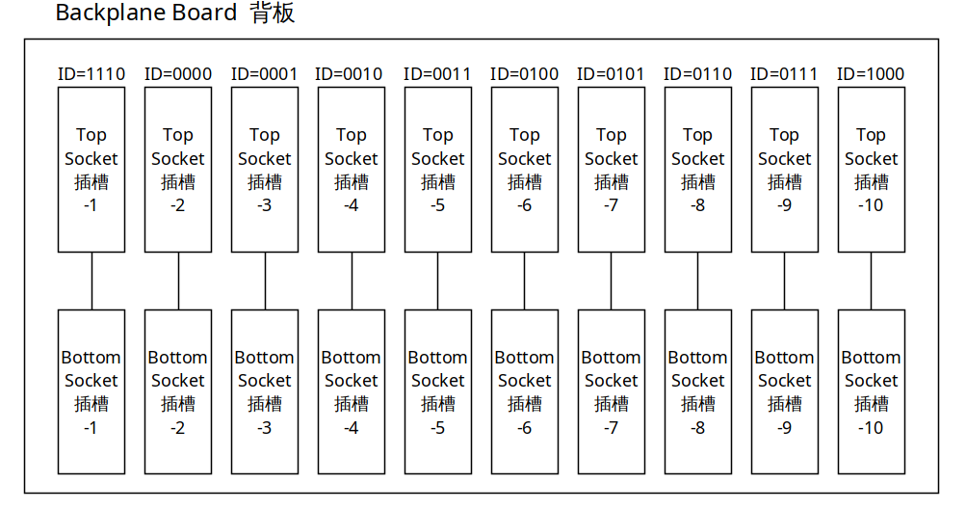

6.1 Connector Pin Assignment
The aim of BPB is to distribute power supply and route bus signals. And also LVDS terminate resistors on board. In this design, BPB has 14 sockets totally, each socket integrates two connectors, the top connector is used to distribute power supply and LVDS pairs. For the bottom connector, it routes ID allocation and LVDS pairs. Following table shows pin assignment.

There are 60 LVDS pairs totally in the back plane board. LVDS transceivers we use only work in half-duplex mode, software layers determine the direction. The minimum swing is only 460mV, PCB layout must be very careful to reduce impact from impedance match.

Normally, 30% safety margins are acceptable, for the connector we’re using, current capacity of each pin is 200mA approximately. We assign 9 pins to distribute 12V voltage, the maximum current capacity is calculated by the equation, 200mA*9=1.8A. The numbers of GND pin is twice times of 12V.
Current carrying capacity of PCB vias are described as below for a reference guideline.

Via Diameter | Max Current
0.15mm | 0.5A
0.2mm | 0.7A
0.3mm | 1A
0.4mm | 1.5A
0.5mm | 2A
0.6mm | 2.5A
0.8mm | 4A
1.0mm | 6A

No. | Top Connector – 3x32P |  |  |  |  |  | Bottom Connector – 3x32P
1 | A1 | 12V | A2 | 12V | A3 | 12V | A1 | GND | A2 | GND | A3 | GND
2 | B1 | 12V | B2 | 12V | B3 | 12V | B1 | TR25_P | B2 | TR13_P | B3 | TR1_P
3 | C1 | 12V | C2 | 12V | C3 | 12V | C1 | TR25_N | C2 | TR13_N | C3 | TR1_N
4 | D1 | GND | D2 | GND | D3 | GND | D1 | TR26_P | D2 | TR14_P | D3 | TR2_P
5 | E1 | GND | E2 | GND | E3 | GND | E1 | TR26_N | E2 | TR14_N | E3 | TR2_N
6 | F1 | GND | F2 | GND | F3 | GND | F1 | GND | F2 | GND | F3 | GND
7 | G1 | GND | G2 | GND | G3 | GND | G1 | TR27_P | G2 | TR15_P | G3 | TR3_P
8 | H1 | GND | H2 | GND | H3 | GND | H1 | TR27_N | H2 | TR15_N | H3 | TR3_N
9 | I1 | GND | I2 | GND | I3 | GND | I1 | TR28_P | I2 | TR16_P | I3 | TR4_P
10 | J1 | TR53_P | J2 | TR45_P | J3 | TR37_P | J1 | TR28_N | J2 | TR16_N | J3 | TR4_N
11 | K1 | TR53_N | K2 | TR45_N | K3 | TR37_N | K1 | GND | K2 | GND | K3 | GND
12 | L1 | GND | L2 | GND | L3 | GND | L1 | TR29_P | L2 | TR17_P | L3 | TR5_P
13 | M1 | TR54_P | M2 | TR46_P | M3 | TR38_P | M1 | TR29_N | M2 | TR17_N | M3 | TR5_N
14 | N1 | TR54_N | N2 | TR46_N | N3 | TR38_N | N1 | TR30_P | N2 | TR18_P | N3 | TR6_P
15 | O1 | GND | O2 | GND | O3 | GND | O1 | TR30_N | O2 | TR18_N | O3 | TR6_N
16 | P1 | TR55_P | P2 | TR47_P | P3 | TR39_P | P1 | GND | P2 | GND | P3 | GND
17 | Q1 | TR55_N | Q2 | TR47_N | Q3 | TR39_N | Q1 | TR31_P | Q2 | TR19_P | Q3 | TR7_P
18 | R1 | GND | R2 | GND | R3 | GND | R1 | TR31_N | R2 | TR19_N | R3 | TR7_N
19 | S1 | TR56_P | S2 | TR48_P | S3 | TR40_P | S1 | TR32_P | S2 | TR20_P | S3 | TR8_P
20 | T1 | TR56_N | T2 | TR48_N | T3 | TR40_N | T1 | TR32_N | T2 | TR20_N | T3 | TR8_N
21 | U1 | GND | U2 | GND | U3 | GND | U1 | GND | U2 | GND | U3 | GND
22 | V1 | TR57_P | V2 | TR49_P | V3 | TR41_P | V1 | TR33_P | V2 | TR21_P | V3 | TR9_P
23 | W1 | TR57_N | W2 | TR49_N | W3 | TR41_N | W1 | TR33_N | W2 | TR21_N | W3 | TR9_N
24 | X1 | GND | X2 | GND | X3 | GND | X1 | TR34_P | X2 | TR22_P | X3 | TR10_P
25 | Y1 | TR58_P | Y2 | TR50_P | Y3 | TR42_P | Y1 | TR34_N | Y2 | TR22_N | Y3 | TR10_N
26 | Z1 | TR58_N | Z2 | TR50_N | Z3 | TR42_N | Z1 | GND | Z2 | GND | Z3 | GND
27 | AA1 | GND | AA2 | GND | AA1 | GND | AA1 | TR35_P | AA2 | TR23_P | AA1 | TR11_P
28 | AB1 | TR59_P | AB2 | TR51_P | AB1 | TR43_P | AB1 | TR35_N | AB2 | TR23_N | AB1 | TR11_N
29 | AC1 | TR59_N | AC2 | TR51_N | AC1 | TR43_N | AC1 | TR36_P | AC2 | TR24_P | AC1 | TR12_P
30 | AD1 | GND | AD2 | GND | AD1 | GND | AD1 | TR36_N | AD2 | TR24_N | AD1 | TR12_N
31 | AE1 | TR60_P | AE2 | TR52_P | AE1 | TR44_P | AE1 | GND | AE2 | GND | AE1 | ID1
32 | AF1 | TR60_N | AF2 | TR52_N | AF1 | TR44_N | AF1 | ID2 | AF2 | ID3 | AF1 | ID4

6.2 ID Allocation
Since we have 12 DPPB boards connected in parallel, so there’s ID allocation circuit designed special for DPPB boards recognition. Initially, DPPBs has no fixed ID. Once it’s plugged into BPB, BPB allocates a unique ID to it. Later, DPPB read this ID to transfer data and response command from DAB. DAB distinguishes each DPPB by unique ID accurately.

Here, 4 bits can address 2^4=16 boards, adequate for our needs. ID[4:1]=1111 is the broadcast ID, it means that the command will be send to all DPPBs.

Place these circuit beside each socket on In some applications, TU data are not needed to be pre-processed, TU transmits data to DPPB directly. Therefore, the FPGA located on DPPB board can be bypassed to reduce latency and complication. BPB, and soldering respective resistors in fabrication. Duplicated IDs could cause confusion and data collision.

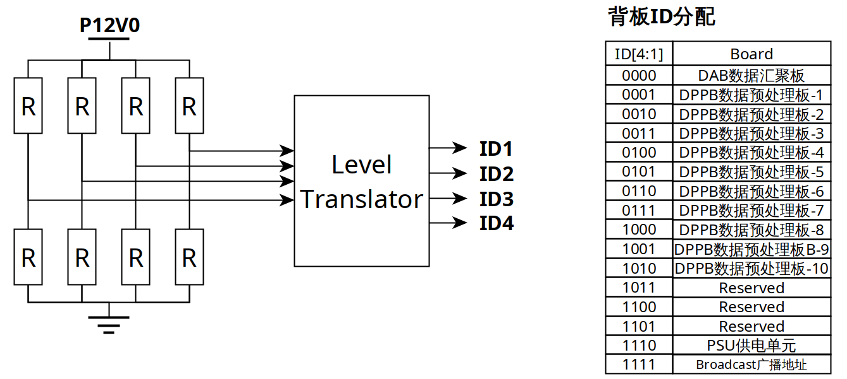

*************** The End of File ***************

