**Development Progress of Partial Discharge Detecting Device**

|  |  |  |
| --- | --- | --- |
| No. | Task Name | Task Status & Description |
| 1 | Photons Counter | Done.  See Figure ZPulseCounter_Adapter Module. |
| 2 | Realtime Histogram Drawing | In progress.  Draw accumulated photon counts within a fixed time interval in a 4.3’’ TFT LCD Screen.  See Figure 4.3’’ TFT LCD Display Effect  & Figure ZTFT43_Adapter Module. |
| 3 | UART Upload | Done.  See Figure ZUpload_Adapter Module. |
| 4 | TCP Upload | Done. |
| 5 | System Integration | In progress.  We need to integrate all sub-modules into one PCB and consider assembling them in a plastic or metal box.  **Attention Here!**  **It possibly takes more time than we think.** |

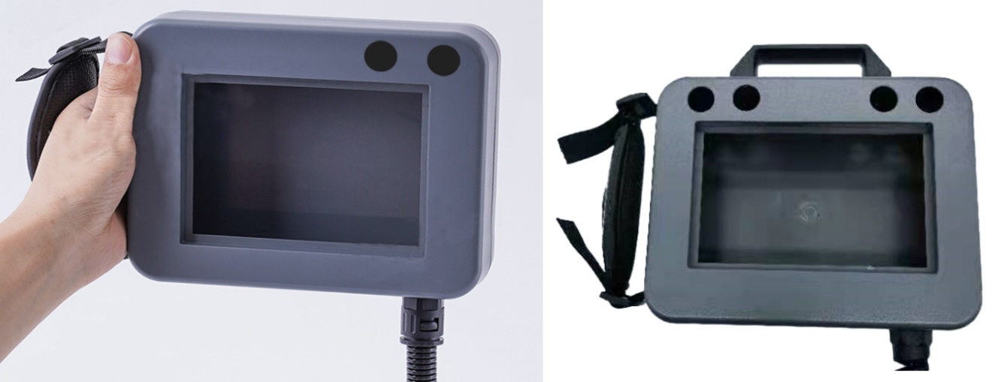

**The appropriate plastic box I found in Taobao.com**

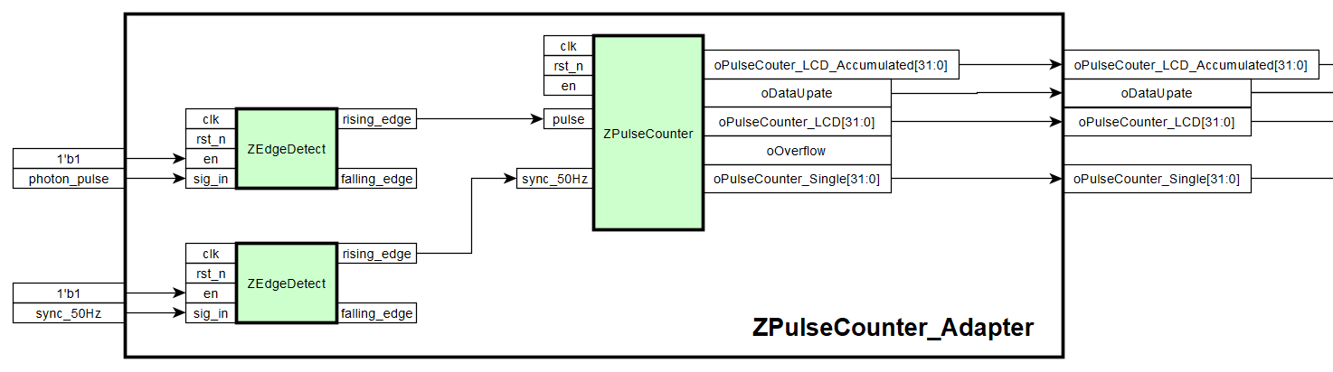

Figure ZPulseCounter_Adapter Module

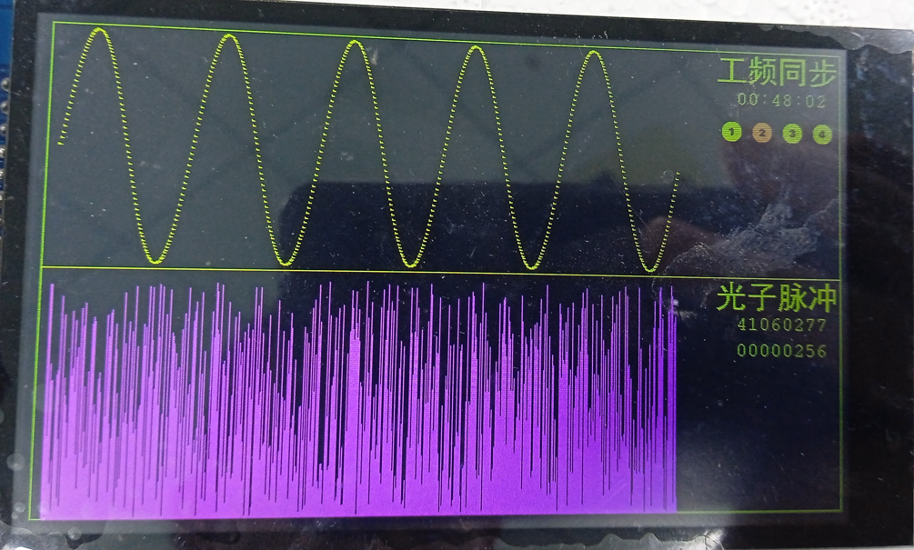

Figure 4.3’’ TFT LCD Display Effect

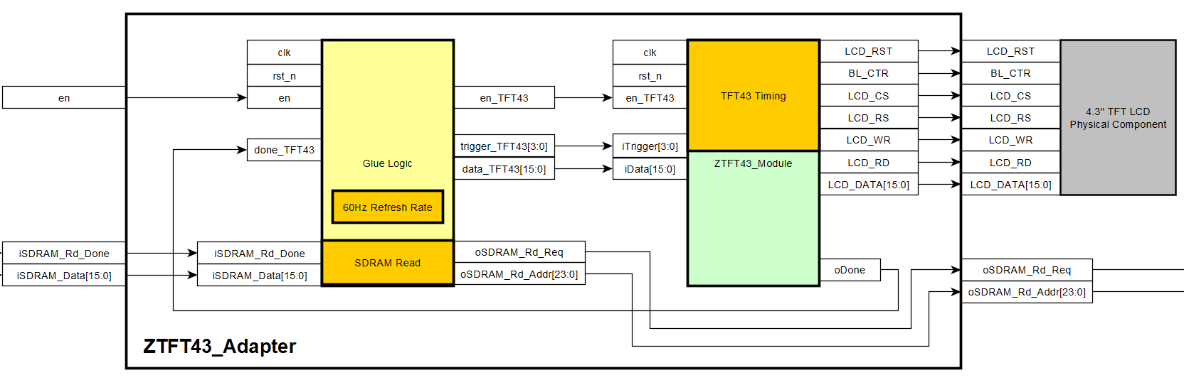

Figure ZTFT43_Adapter Module

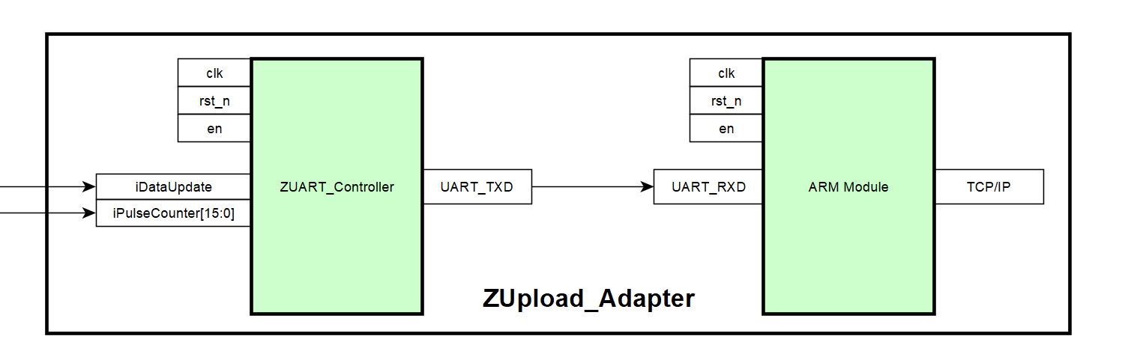

See Figure ZUpload_Adapter Module

April 20, 2023

________________THE END OF THIS FILE________________