**GIS PD Detector Communication Protocol V0.1**

1. Basic Topology

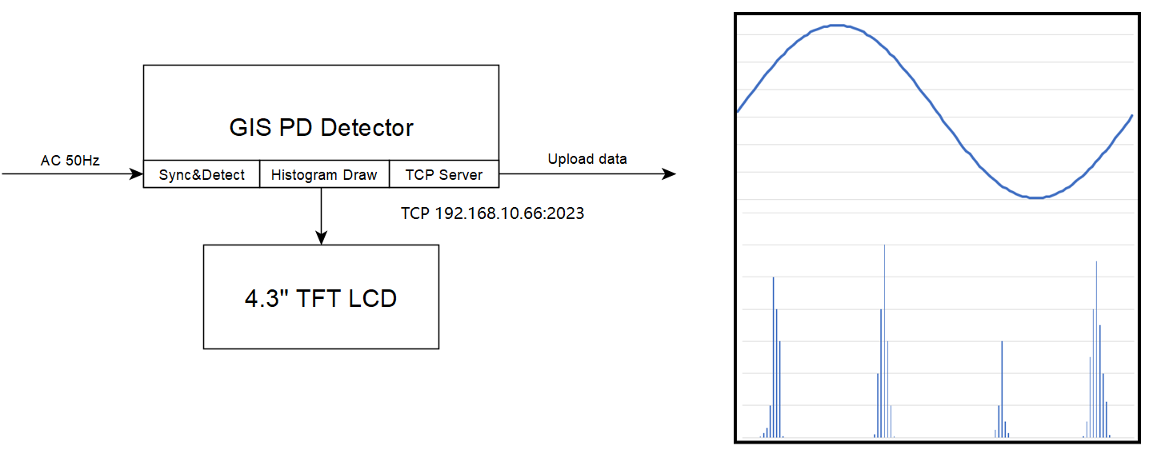

1. UART over TCP

UART Packet Structure

|  |  |  |  |  |  |  |  |
| --- | --- | --- | --- | --- | --- | --- | --- |
| **Sync Head** | **Packet Length** | **AC 50Hz**  **Phase Difference** | **Accumulated  Photons Count** | **Total Gaps No.** | **Sub Gap No.** | **Time Interval** | **Checksum** |
| 2 bytes | 2 bytes | 2 bytes | 2 bytes | 2bytes | 2 bytes | 1 byte | 1 byte |

Description:

**Sync Head:**

Fixed data, 0x55 0xAA.

**Packet Length:**

The total length in byte units involves “AC 50Hz Phase Difference” + “Photons Count” + “Checksum”. (2 bytes length for future extension.)

**AC 50Hz Phase Difference:**

The phase difference of one period, see more in the following figure.

For wide gaps, the possible values are 0°, 90°, 180°, 270°, and 360°.

For narrow gaps, the possible values are 0°, 45°, 90°, 135°, 180°, 225°, 270°, 315°, and 360°.

The entire 360°C can be divided indefinitely according to our needs.

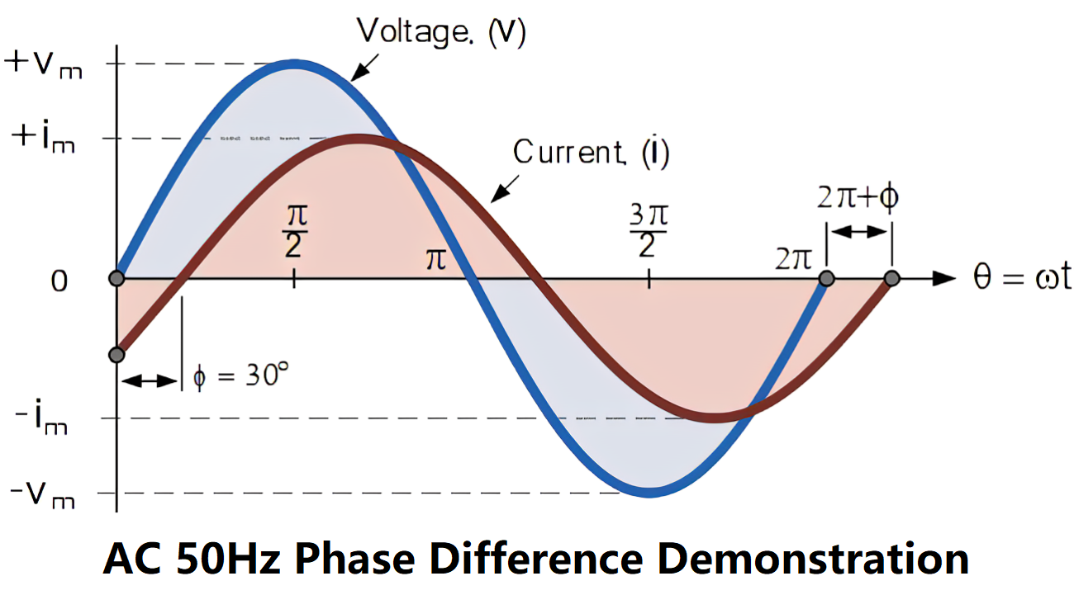

**Accumulated Photons Count:** The photon pulse count accumulated in a fixed time interval.

**Total Gaps No:** Indicate how many gaps one sine wave contains.

**Sub Gap No:** Show sub gap number, range 0 ~ Total Gaps No. -1.

**Time Interval:** How long the accumulated Photons Count takes up, it’s maybe 100uS, 1mS, 10mS, 100mS, 1S, etc.

**Checksum:** The checksum value of “Sync Head” + “Packet Length” +”AC 50Hz Phase Difference” + “Accumulated Photon Count”.

April 18, 2023