MPFS Updating Tutorial

This tutorial teaches you how to update MPFS-ICICLE-KIT-ES to latest software version based on my successful experience. The original firmware on board was too old to support the new linux image booting. Kernel panics while booting. I spend three days succeeding. Attempted different combinations with HSS and Image. Discussing topis about PolarFireSoC are few online. Therefore, I made this document to guide newbies.

1. Program the latest HSS(1st stage bootloader) to PolarFire SoC.
(1). Download Official job file. MPFS_ICICLE_KIT_BASE_DESIGN_ES_2026_04.tar
https://github.com/polarfire-soc/icicle-kit-reference-design/releases
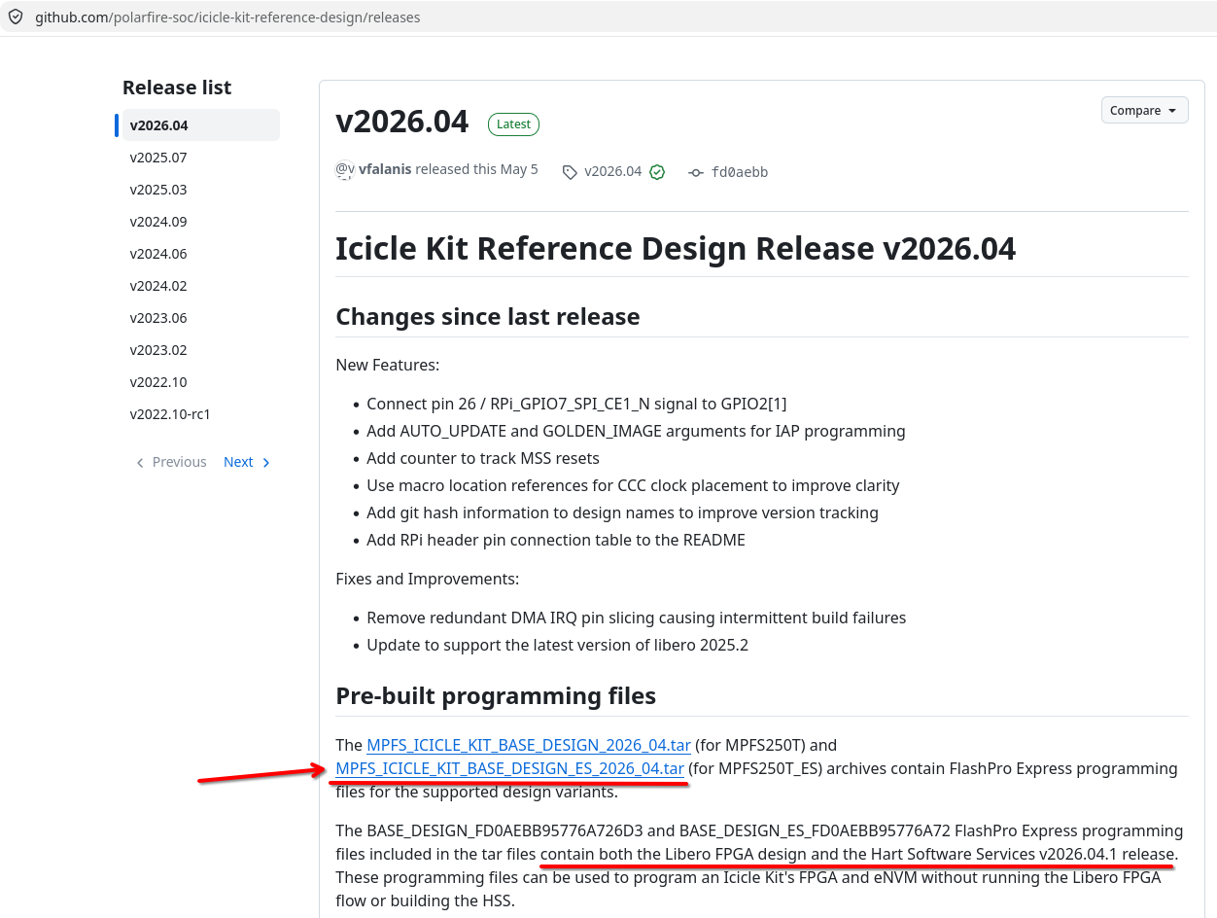
(2). Decompress the file and extract the job file.

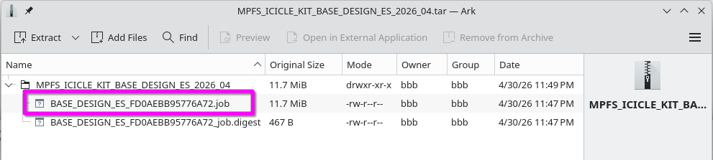

(3). Connect USB cable (J33) to Windows Operating System USB port.

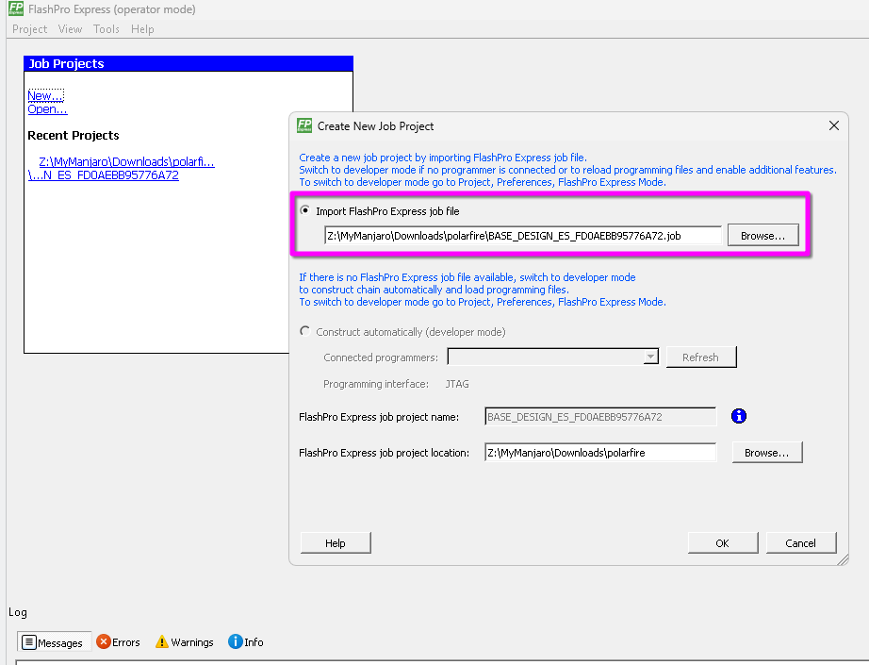
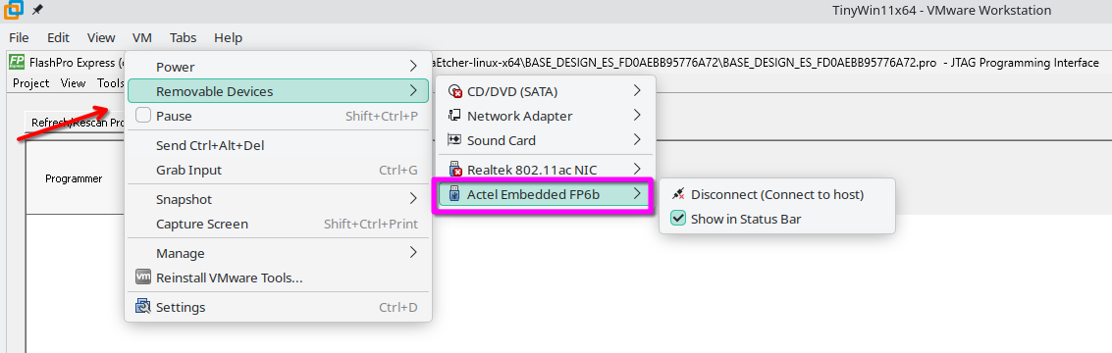

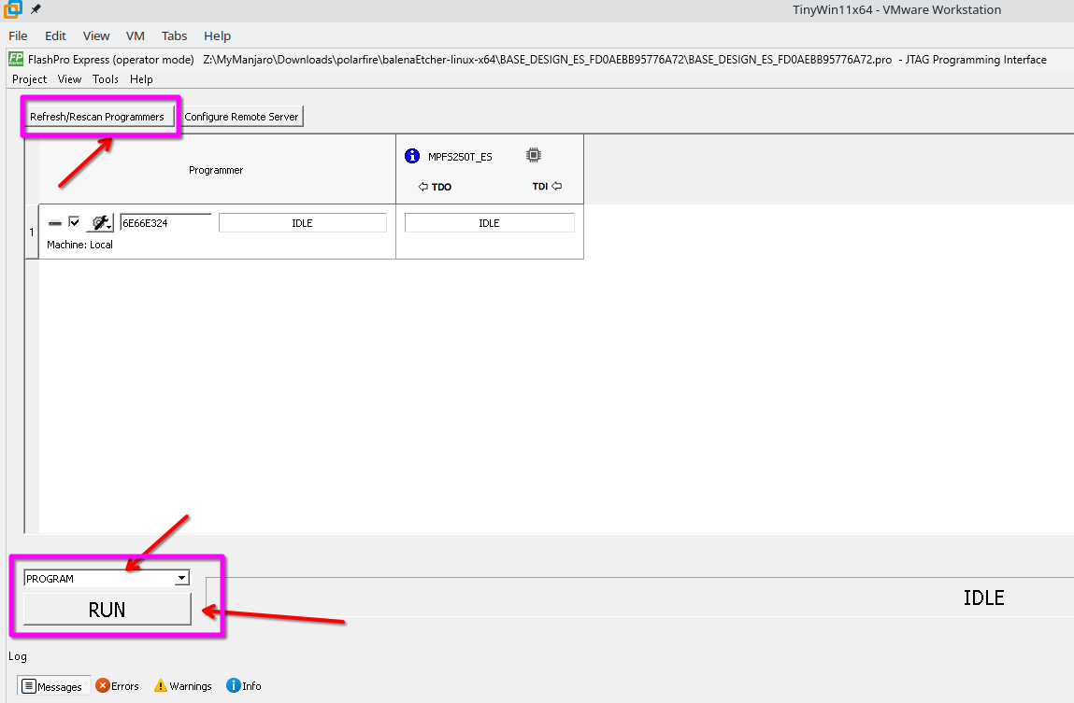

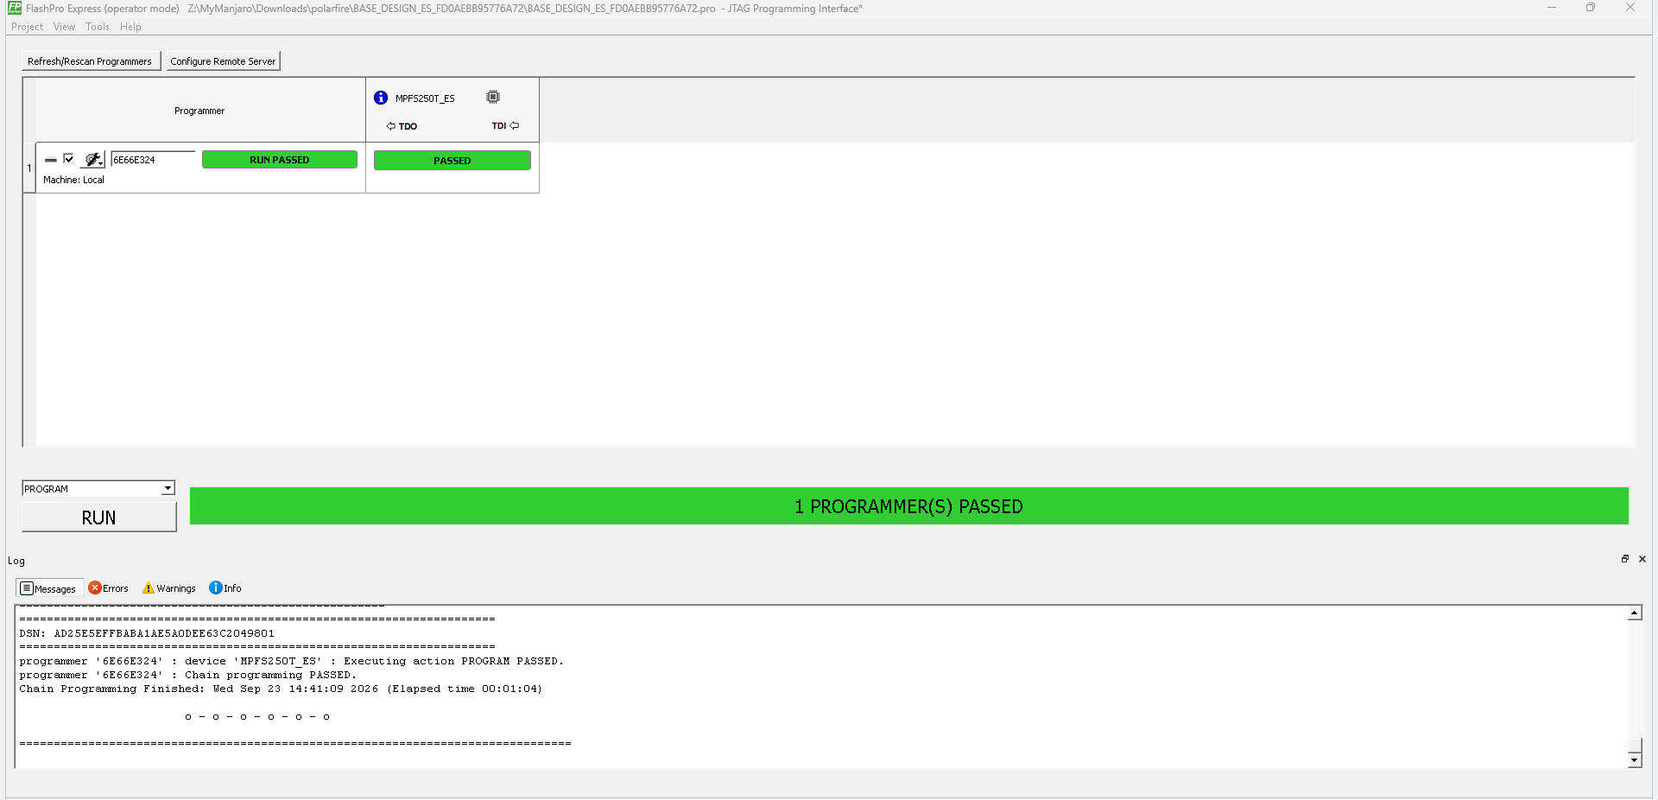
2. Program the latest linux system (u-boot+kernel+filesystem).
(1). Download the latest image.
mchp-base-image-mpfs-icicle-kit.rootfs-20251030150503.wic.gz
https://github.com/linux4microchip/meta-mchp/releases
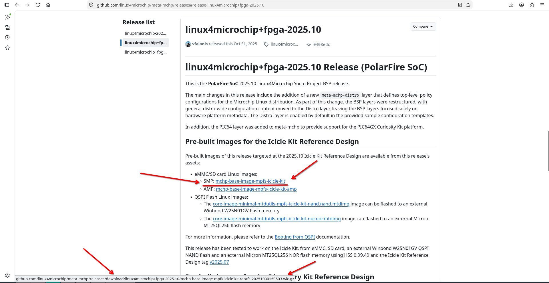
(2). Decompress the pack, remove .gz suffix.
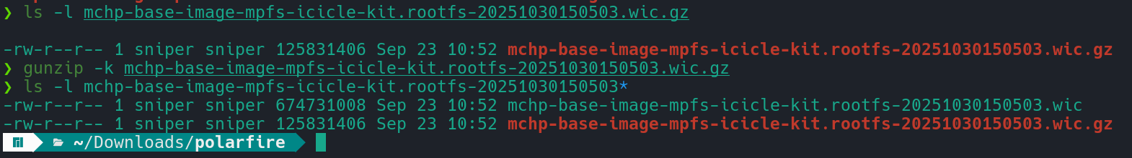
(3). Power ON the board, press any key to interrupt HSS starting up.

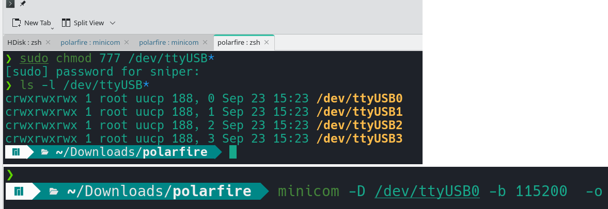

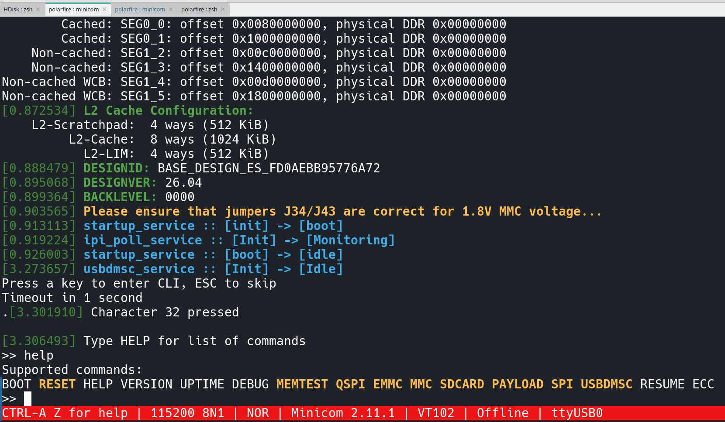

(4). Type command mmc and then usbdmsc to expose eMMC as a USB storage device to Linux Host.

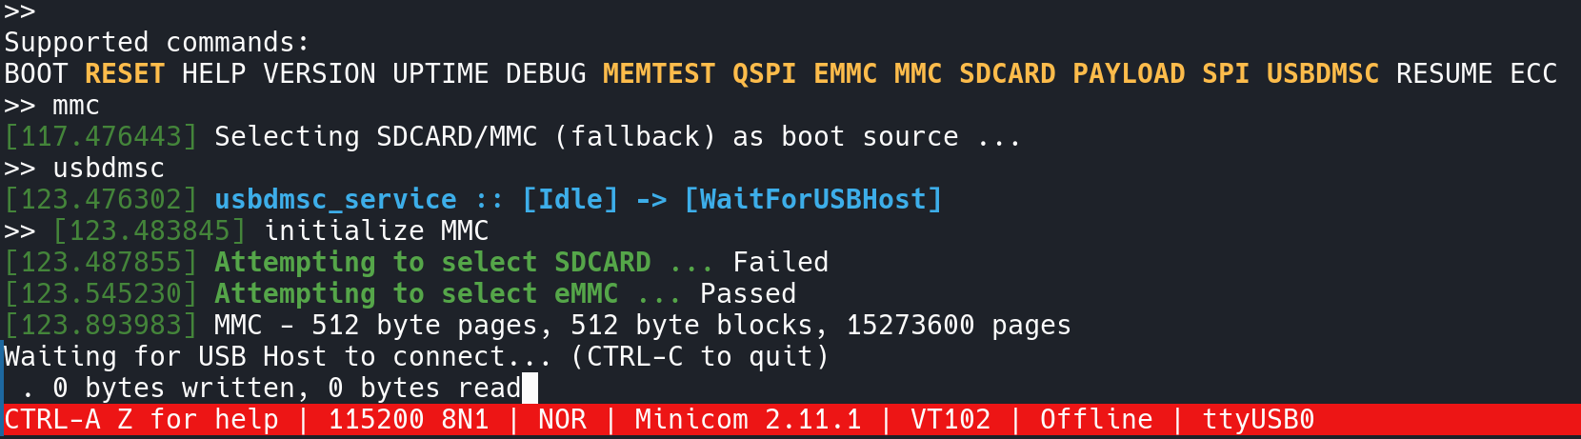

(5). Move USB cable from J11 to J16. Hotplug is okay, a new USB device is detected by Linux Host.

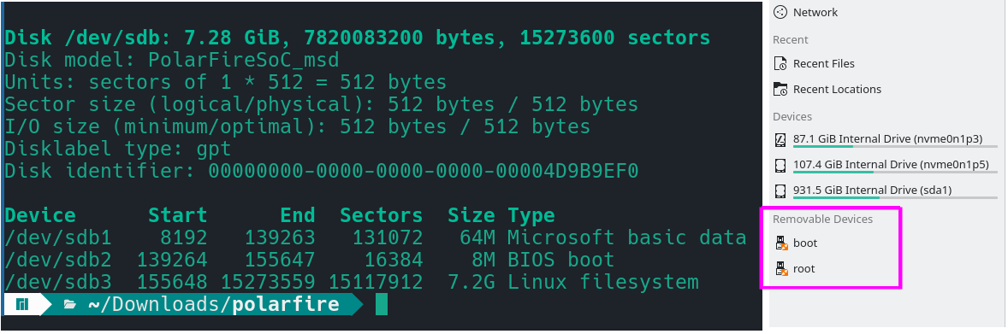

(6). Use dd command to flush image to eMMC.

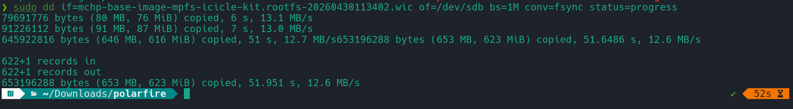

(7). Re-power on the board, open two minicom terminals, one for HSS(1st stage bootloader), another for uboot(2nd stage bootloader)+linux.

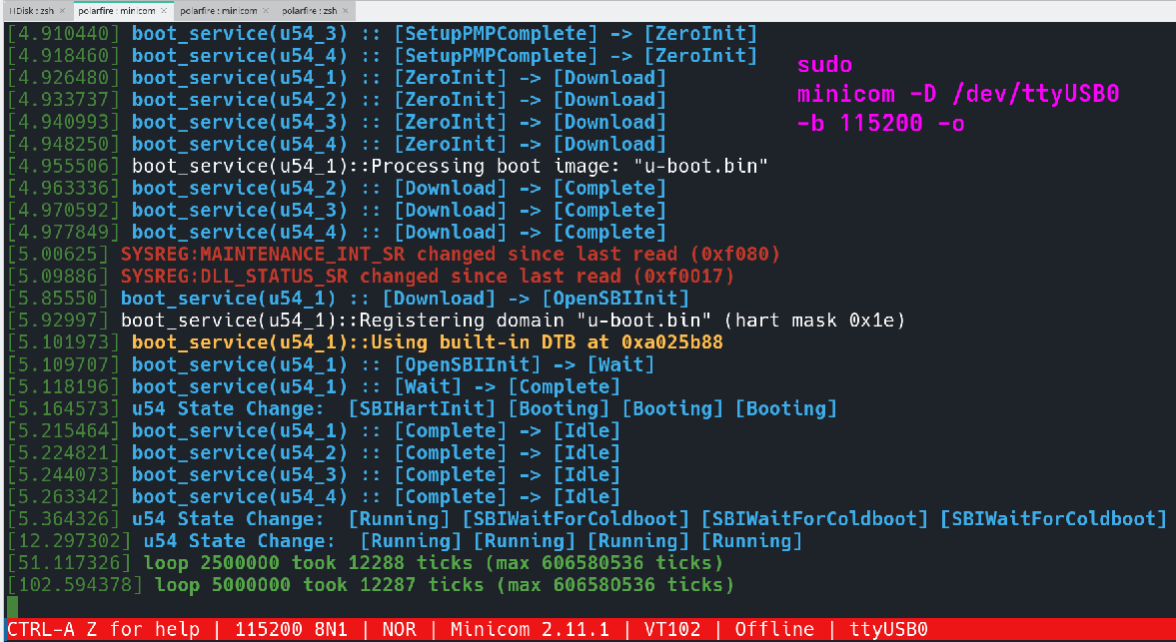
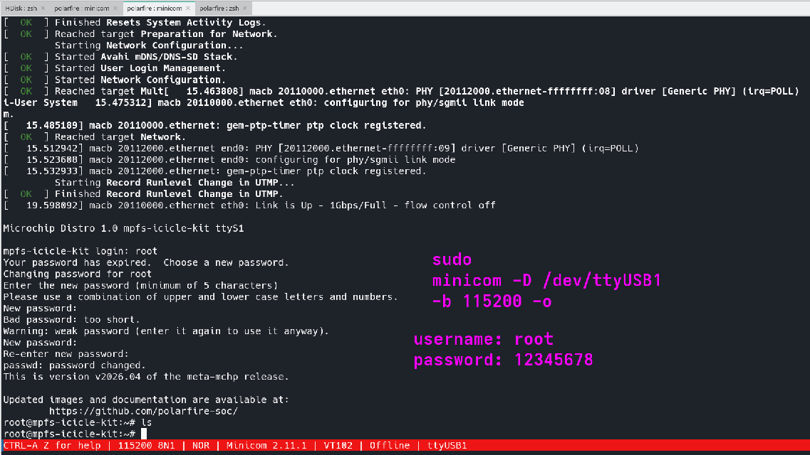

(8). Configure IP address and ping Linux Host to check the network connection.
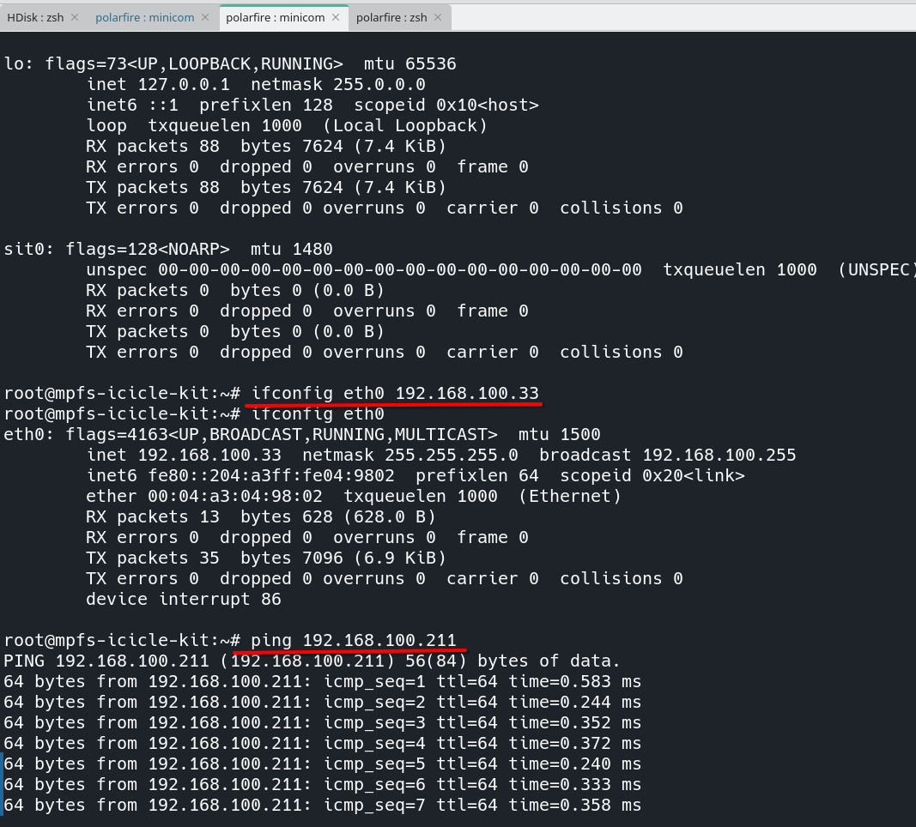
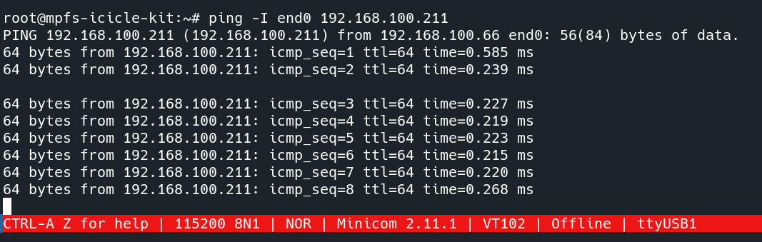

September 23, 2026
Anonymous

