HTTP Protocol
Specification

for

TMR Current Sensing Terminal

Table of Contents
Preface 2
/index.html 3
/TMR/Dev_Info 4
/TMR/Run_Log 5
/TMR/Phase_Curve?Ph=A&Type=Image 6
/TMR/Phase_Curve?Ph=A&Type=RawData 7
/TMR/Phase_Curve?Ph=A&Type=RawData_CSV 8
/TMR/Phase_Curve?Ph=ABC&Type=Image 9
/TMR/Phase_Curve?Ph=ABC&Type=RawData 10

Date | Version | Memo
June 18, 2026 | V0.0.1 | Initial Version
June 25, 2026 | V0.0.2 | Add more GET methods

Preface

This comprehensive specification is drafted to align software developers, hardware engineers and system integrators on end-to-end workflows for TMR Current Sensing terminals. All data retrieval operations are implemented via the standard HTTP GET method. Important note for the current development phase: only unsecure HTTP is supported, HTTPS is not available for use right now, and no authentication steps are needed to get valid data responses.

Currently supported GET list (Will extend if needed)

URL | Description
/index.html | The home page.
/TMR/Dev_Info | Get basic information of the terminal.
/TMR/Run_Log | Get running log since starts.
/TMR/Phase_Curve?Ph=A&Type=Image | Get Phase A rendering curve image.
/TMR/Phase_Curve?Ph=A&Type=RawData | Get Phase A raw data.
/TMR/Phase_Curve?Ph=A&Type=RawData_CSV | Get Phase A raw data in CSV format.
/TMR/Phase_Curve?Ph=B&Type=Image | Get Phase B rendering curve image.
/TMR/Phase_Curve?Ph=B&Type=RawData | Get Phase B raw data.
/TMR/Phase_Curve?Ph=B&Type=RawData_CSV | Get Phase B raw data in CSV format.
/TMR/Phase_Curve?Ph=C&Type=Image | Get Phase C rendering curve image.
/TMR/Phase_Curve?Ph=C&Type=RawData | Get Phase C raw data.
/TMR/Phase_Curve?Ph=C&Type=RawData_CSV | Get Phase C raw data in CSV format.
/TMR/Phase_Curve?Ph=ABC&Type=Image | Get Phase A+B+C layered rendering curve image.
/TMR/Phase_Curve?Ph=ABC&Type=RawData | Get Phase A+B+C mixed raw data.

/index.html
Description
Return the home page of the device. In this page, it displays the basic performance parameters of the terminal.

Screenshot
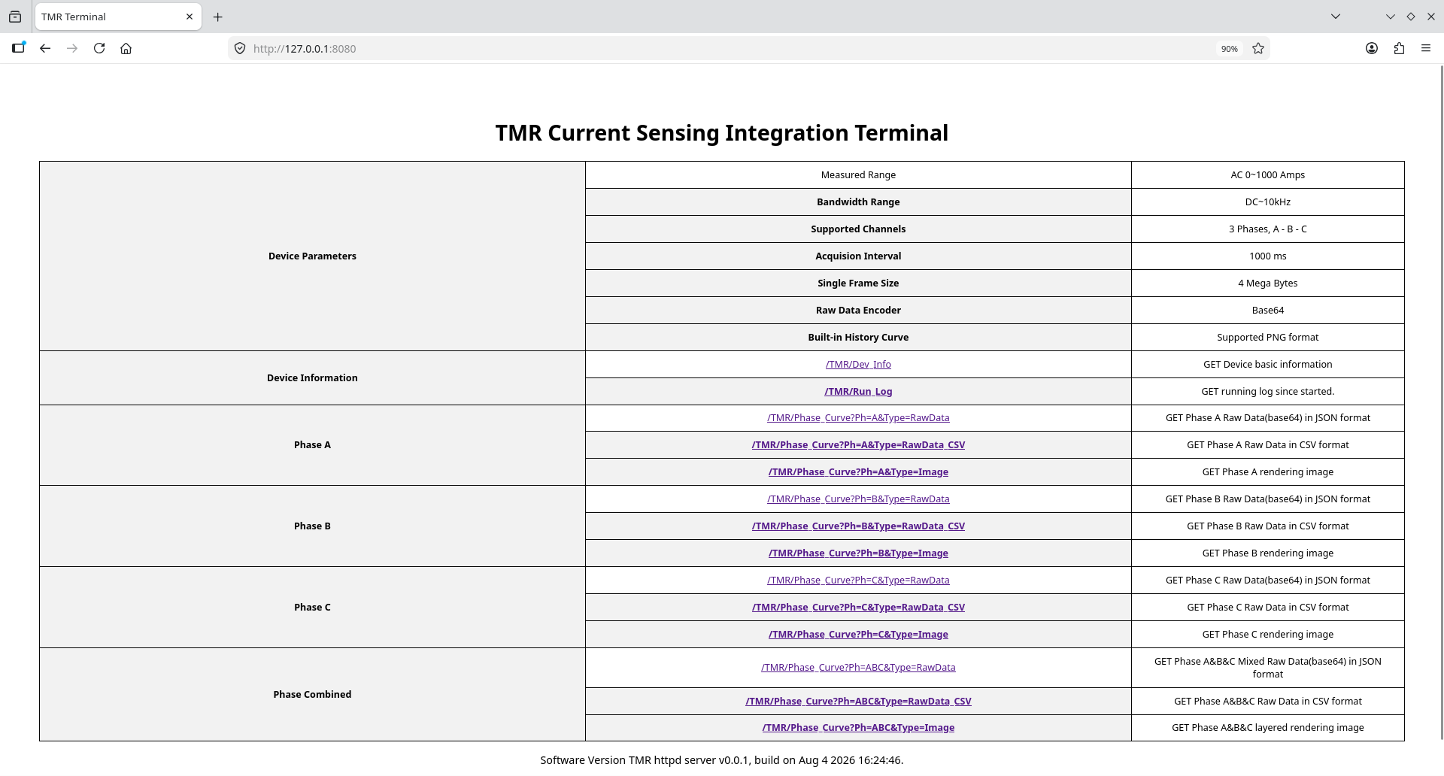

/TMR/Dev_Info
Description
To view the basic terminal details, issue a GET request to /TMR/Dev_Info, which returns a summary table of static device information.

Screenshot

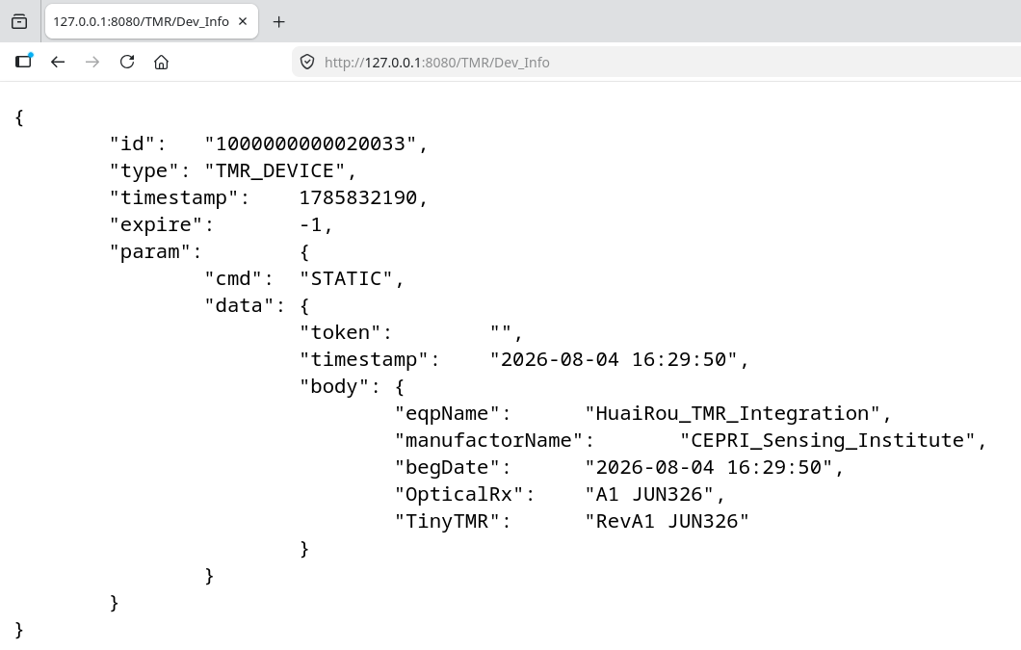

/TMR/Run_Log
Description
Send a GET request to /TMR/Run_Log to retrieve the full running log generated since device startup. The endpoint is designed to assist in rapid troubleshooting when errors occur.

Screenshot

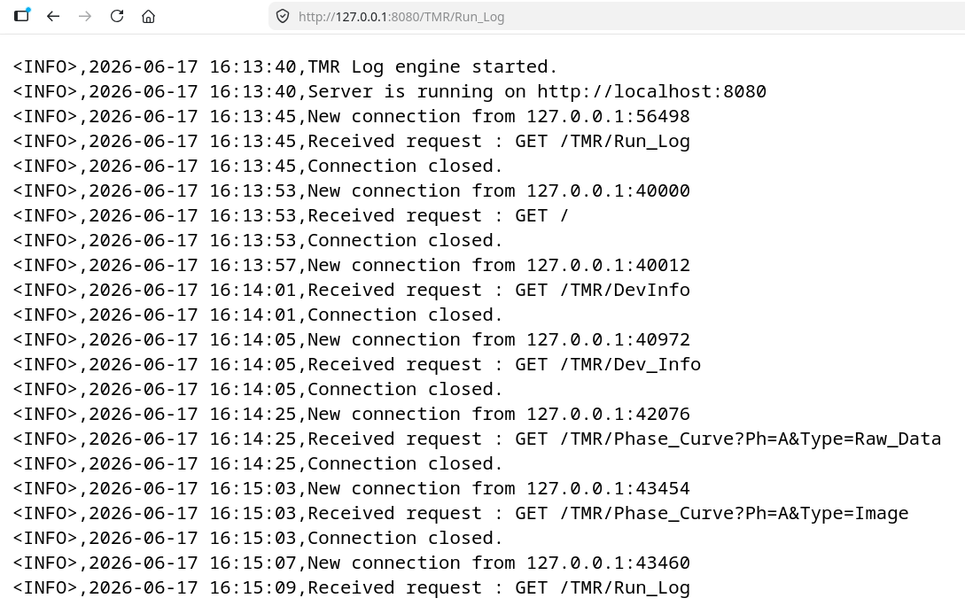

/TMR/Phase_Curve?Ph=A&Type=Image
Description
Retrieve the rendered curve image for phase A. By default, the terminal outputs the curve in PNG format, and the total number of sampling points is configurable during the deployment phase.

Screenshot
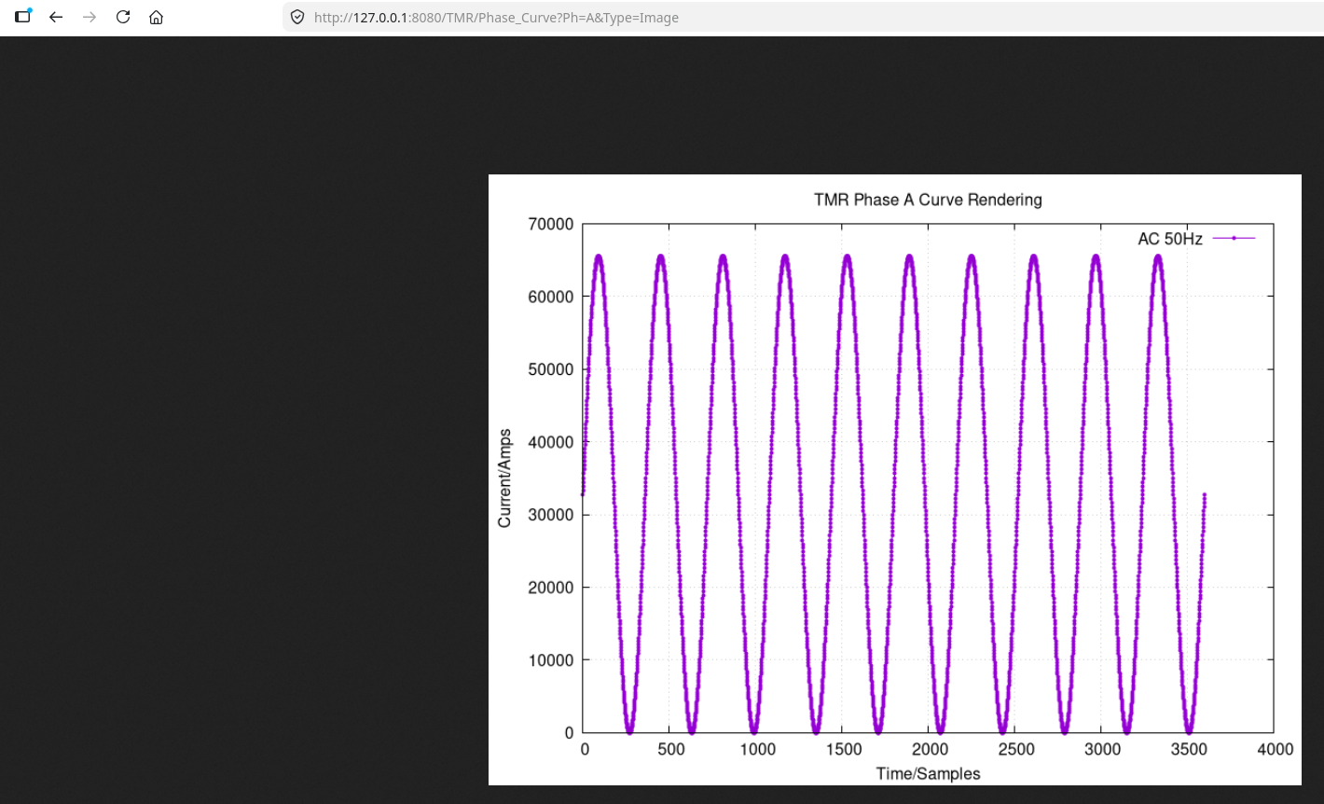

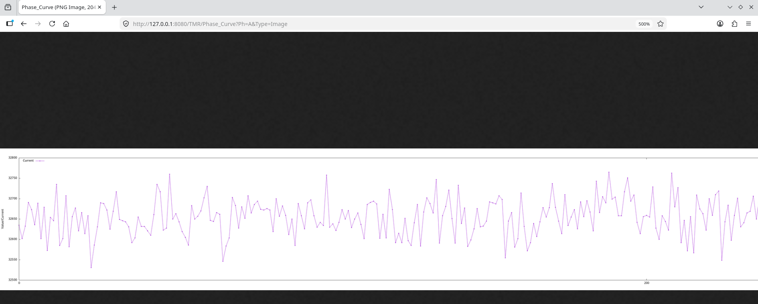

/TMR/Phase_Curve?Ph=A&Type=RawData
Description
Retrieve the raw data for phase A. The terminal acquires specified numberss of bytes of data, which is encoded via Base64 algorithm since HTML does not support binary data format. All data points are 4 bytes floating point values.

Screenshot

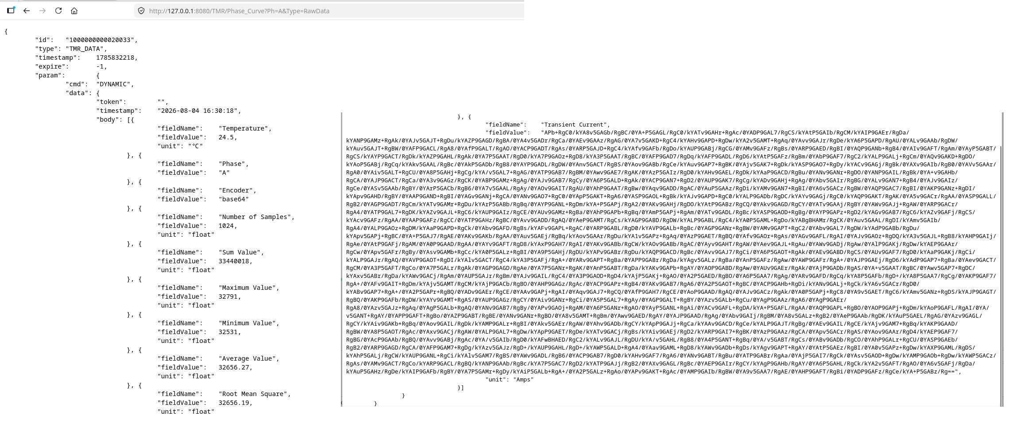

/TMR/Phase_Curve?Ph=A&Type=RawData_CSV
Description
Retrieve the CSV (Comma-Separated Values) raw data for phase A. This is used to verify the base64 decoder’s functionality. These data also factilities curve plotting in Excel, making it a valuable resource during the debugging stage.

Screenshot

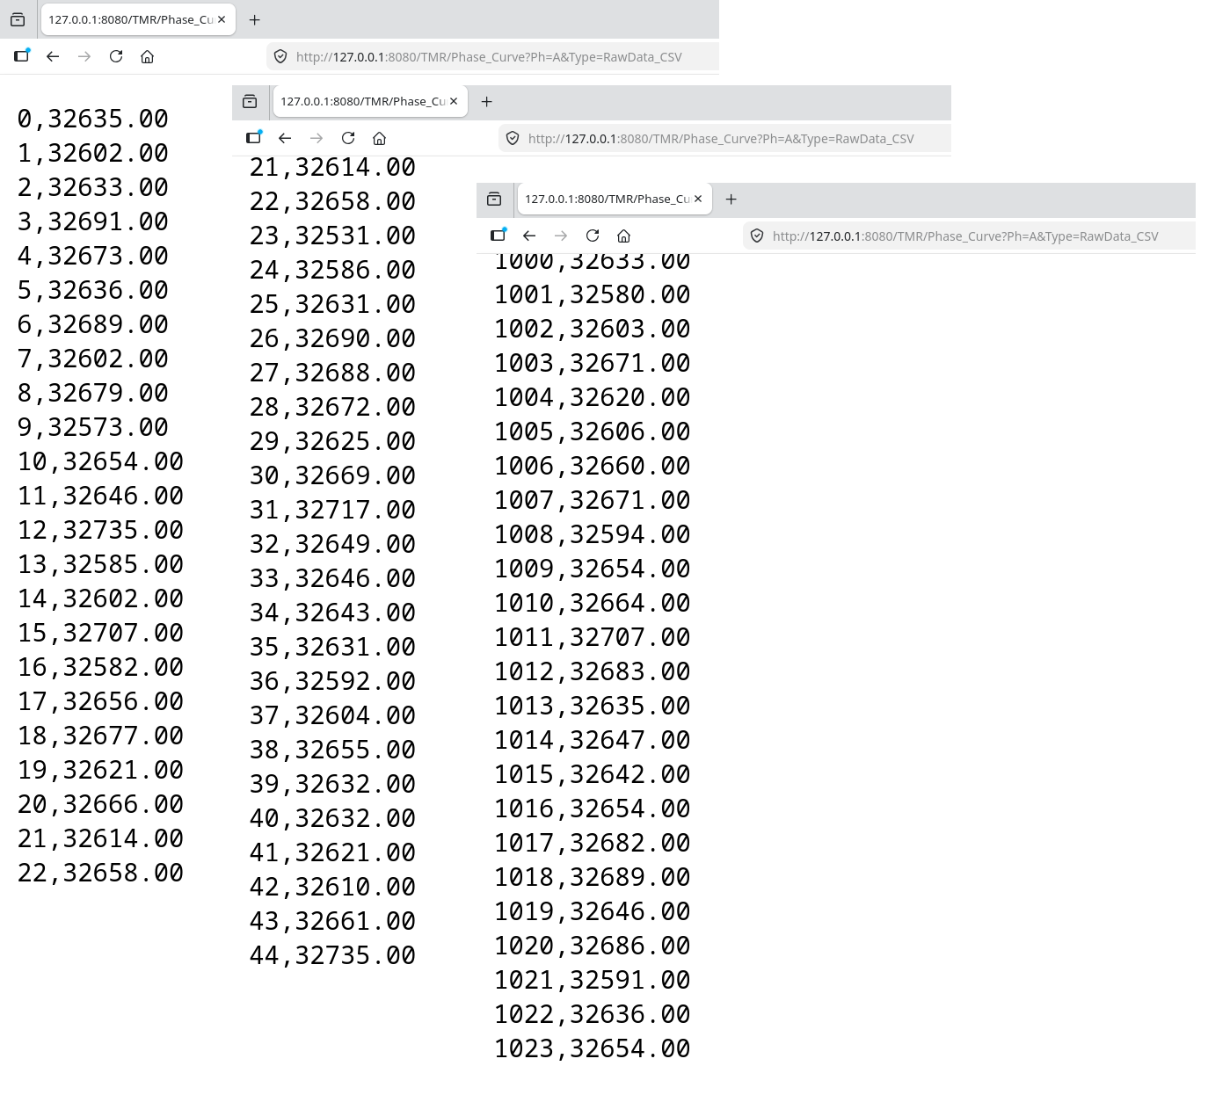

/TMR/Phase_Curve?Ph=ABC&Type=Image

Description
Retrieve the combined rendered curve image for phase A, B and C. By default, the terminal outputs the curve in PNG format, and the total number of sampling points is configurable during the deployment phase.

Screenshot
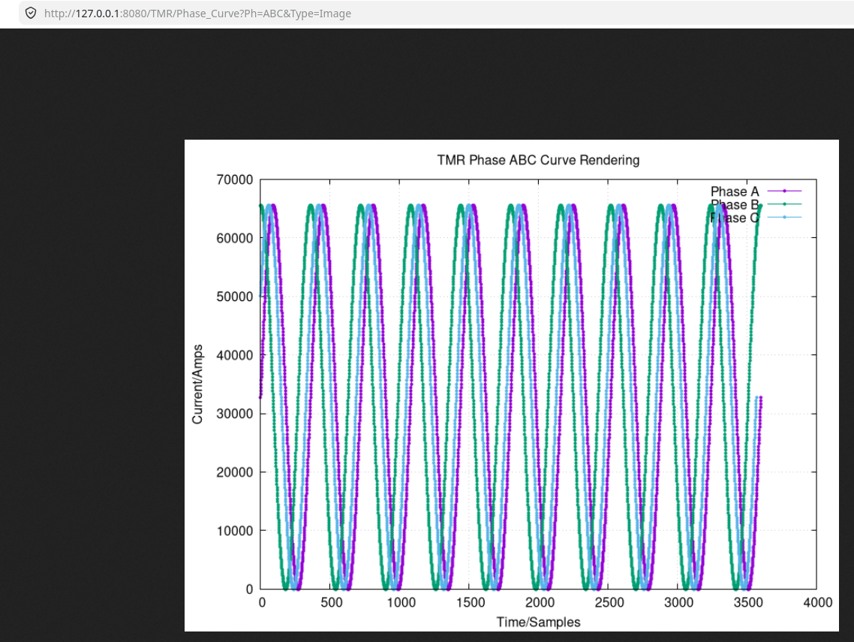

/TMR/Phase_Curve?Ph=ABC&Type=RawData
Description
Retrieve the raw data for phase A, B and C. The terminal acquires specified numberss of bytes of data, which is encoded via Base64 algorithm since HTML does not support binary data format. All data points are 4 bytes floating point values.

Screenshot

