**Task 10**

**Date:** 6 Dec 2020

**Author:** Shelley Zhao

**Application:** BlogEngine.NET version 3.2

**Environment:** Test Environment

**Test Environment configuration:**

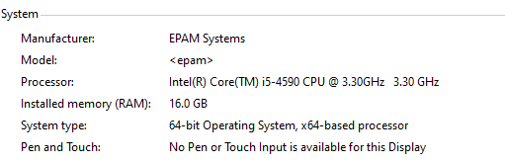

1. **Goals:**

* Get an experience on durable/longevity/stability testing.
* Get an experience on load parameters definition for the long-time testing.
* Learning how to identify bottlenecks and possible issues for long-time running systems.

1. **Prerequisites:**

* Generated 1000 posts

1. **Test script description**

**Anonymous**

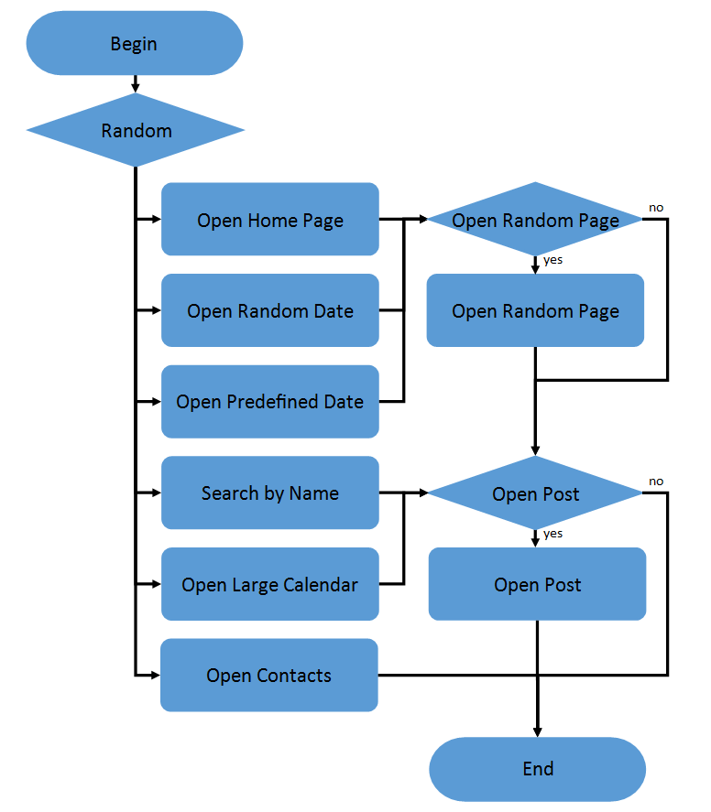 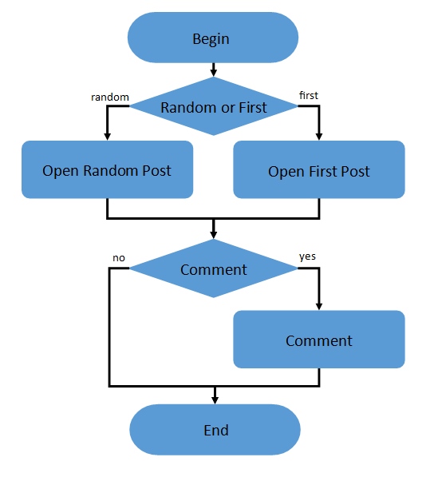

1. Home Page: 15%

2. Open Random Date: 10%

3. Open Predefined Date: 30%

4. Search by Name: 30%

5. Open Large Calendar: 10%

6. Open Contacts: 5%

Open Random page (yes/no):

50% / 50%

Open post (yes/no):

80% / 20%

Random or First (yes/no):

65% / 35%

Comment (yes/no):

20% / 80%

**Admin**

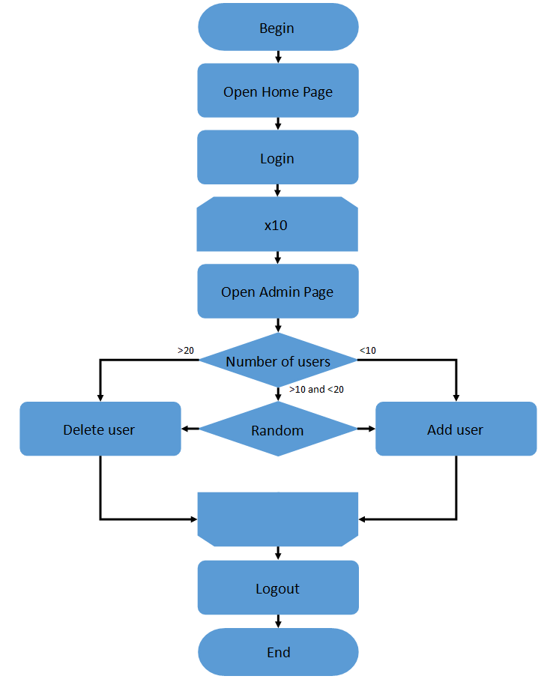

**Editor**

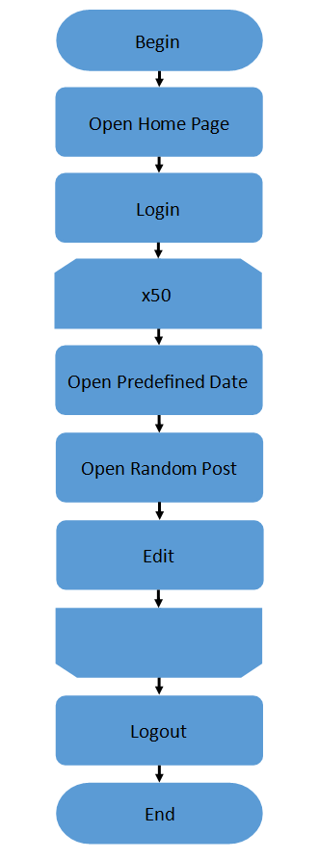

1. **Tests:**
   1. **Long Time Testing**

**Settings:**

|  |  |  |  |
| --- | --- | --- | --- |
| **Script** | **Number of users** | **Ramp-up(s)** | **Duration(s)** |
| Main | 10 | 30 | 3600 |
| Admin | 2 | 5 | 3600 |
| Editor | 2 | 5 | 3600 |

**Result**

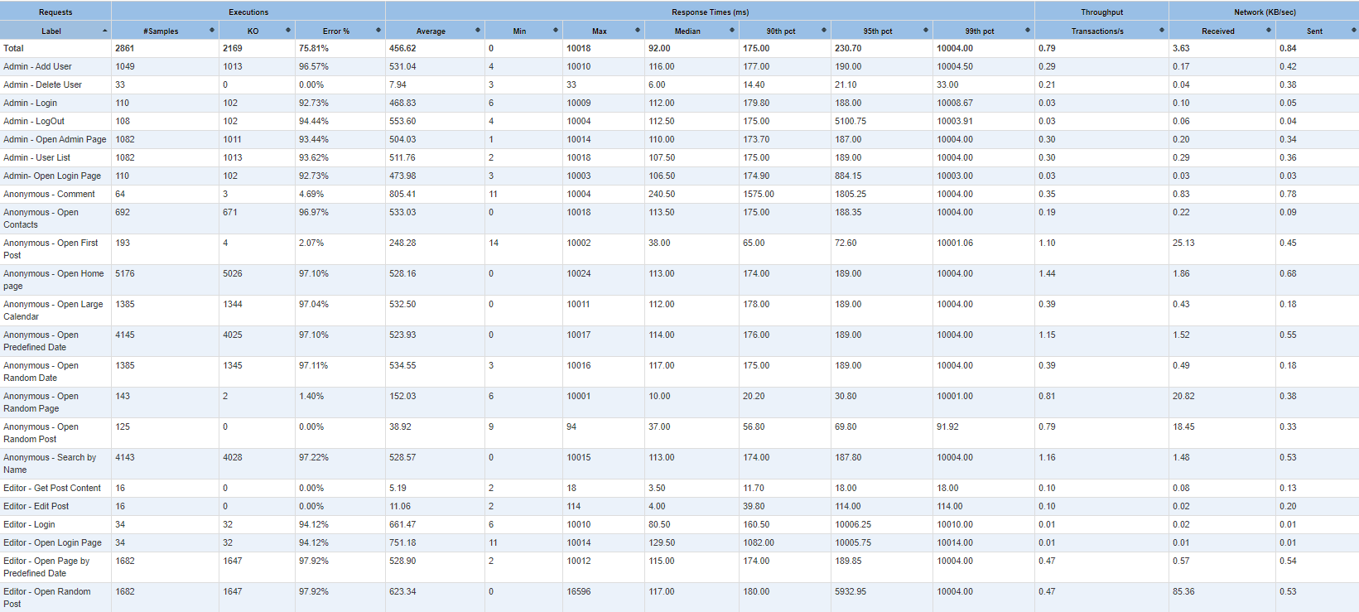

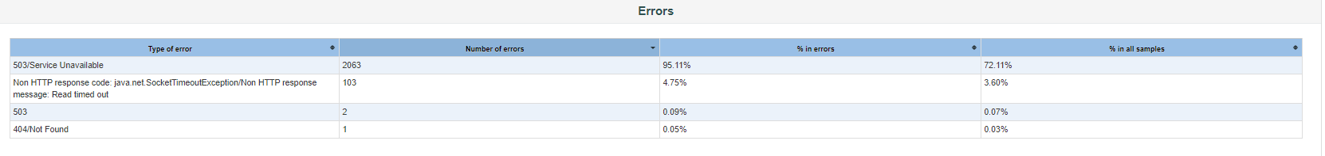

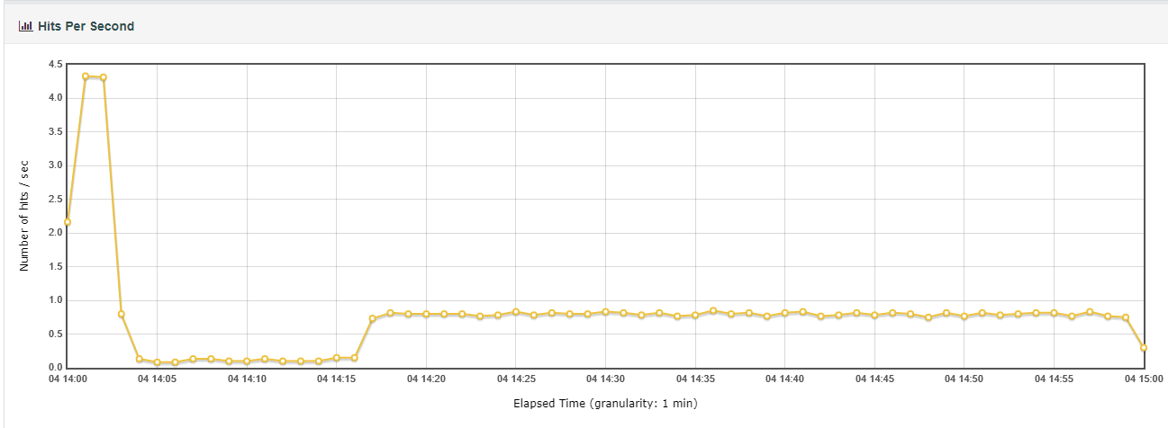

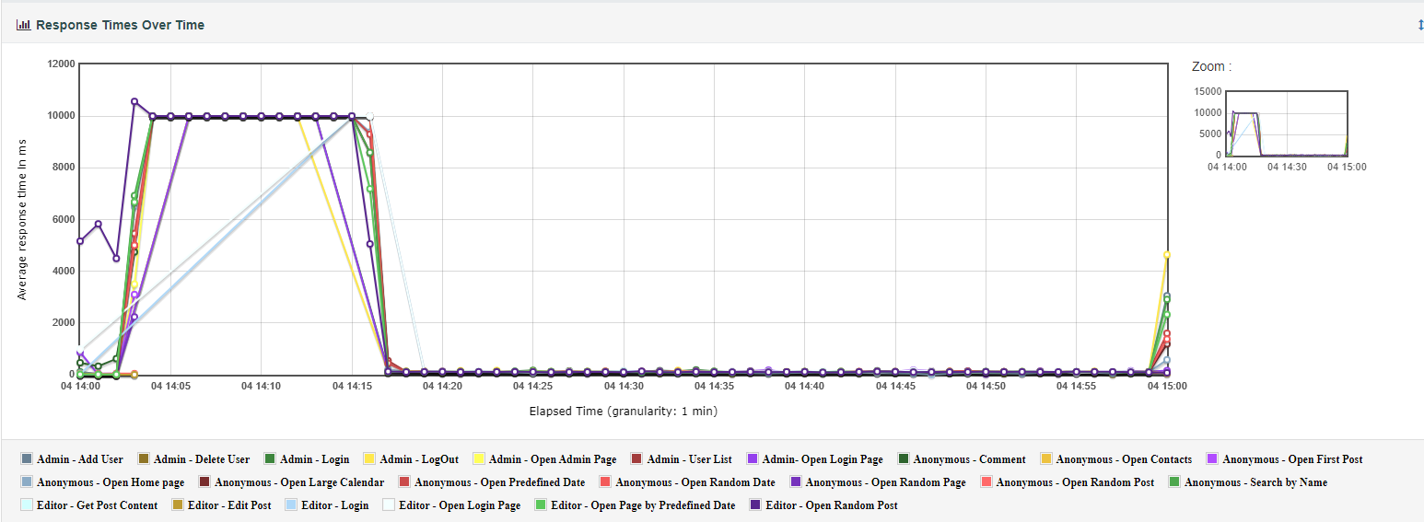

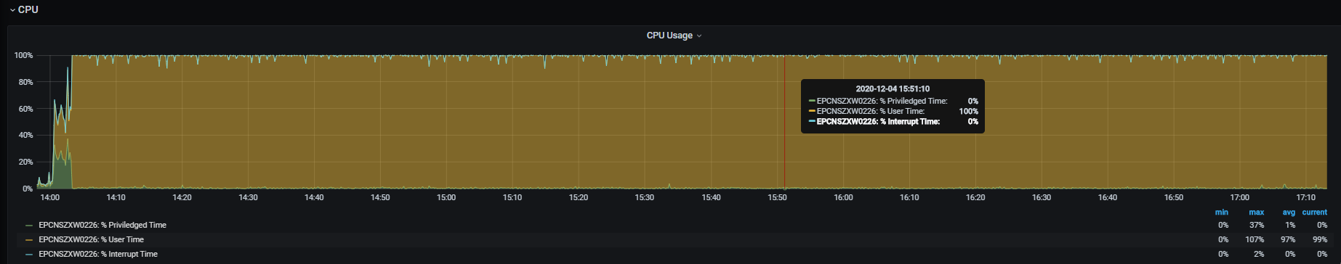

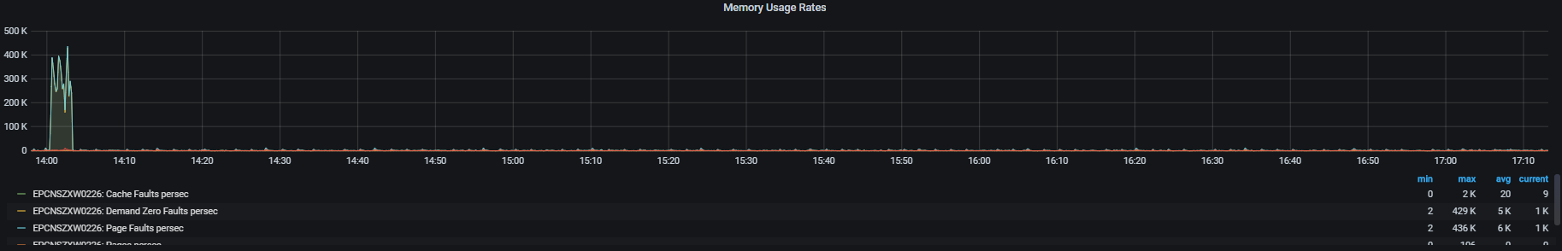

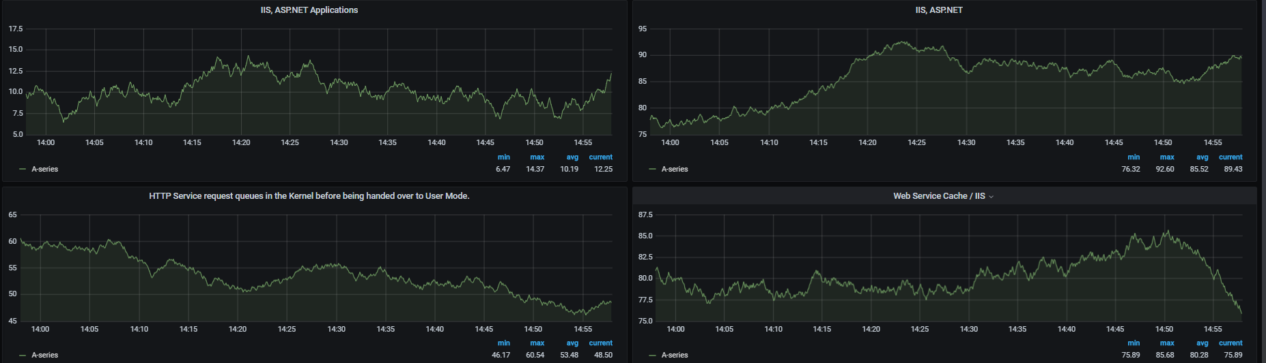

**Conclusion**

Unfortunately, during the long-time load testing the application occur error after 15min with the CPU 100% which IIS process take 98% usage. The load is just 25% for the system capacity. So, there are some issues for IIS setting or application. The further investigation need support from devops and dev.