**Task 2**

**Date:** 28 Aug 2020

**Author:** Shelley Zhao

**Application:** BlogEngine.NET version 3.2

**Environment:** Test Environment

**Test Environment configuration:**

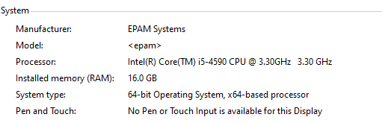

1. **Goals:**

Testing was conducted to generate test data(post) with 100,1000,2000.

* Get data generator
* Script login procedure
* Get experience of test data preparation
* Get estimated time needed for data generation

1. **Prerequisites:**

Create edit user with proper permission

1. **Test script description**

The test script implemented editor scenario. Diagram is attached below.

1. **Tests:**
   1. **Test Run #1 Generate 100 post with date list and random text**

**Create post request body:**

{"Id":"","Title":"test post random date","Author":"editor","Content":"<p>${__RandomString(100,abcdefghijklmmopqrstuvwxyz,Text)}</p>","DateCreated":"${datelist} 12:05","Slug":"test-post-1","Categories":[],"Tags":[],"Comments":"","HasCommentsEnabled":true,"IsPublished":true}

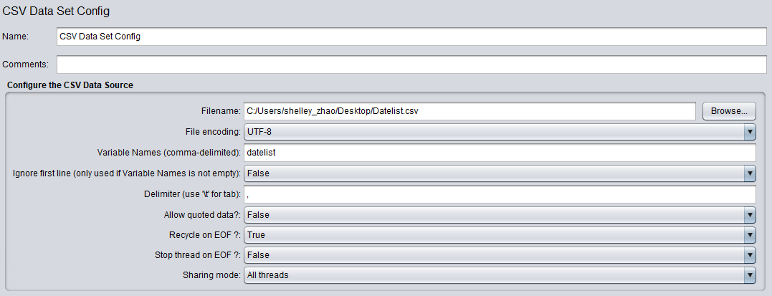

**Result**

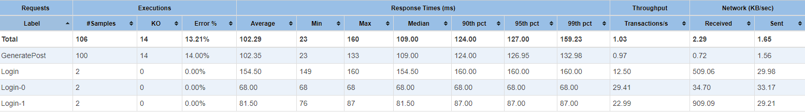

* 1. **Test Run #2 Generate 1000 post with random and random text**

**Create post request body:**

{"Id":"","Title":"test post random date","Author":"editor","Content":"<p>${__RandomString(100,abcdefghijklmmopqrstuvwxyz,Text)}</p>","DateCreated":"${__RandomDate(,2020-08-01,2020-08-31,,)} 12:05","Slug":"test-post-1","Categories":[],"Tags":[],"Comments":"","HasCommentsEnabled":true,"IsPublished":true}

**Result**

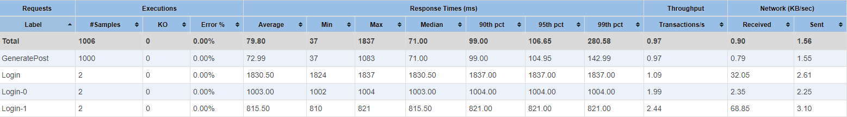

* 1. **Test Run #3 Generate 2000 post with random and random text**

**Create post request body:**

{"Id":"","Title":"test post random date","Author":"editor","Content":"<p>${__RandomString(100,abcdefghijklmmopqrstuvwxyz,Text)}</p>","DateCreated":"${__RandomDate(,2020-08-01,2020-08-31,,)} 12:05","Slug":"test-post-1","Categories":[],"Tags":[],"Comments":"","HasCommentsEnabled":true,"IsPublished":true}

**Result**

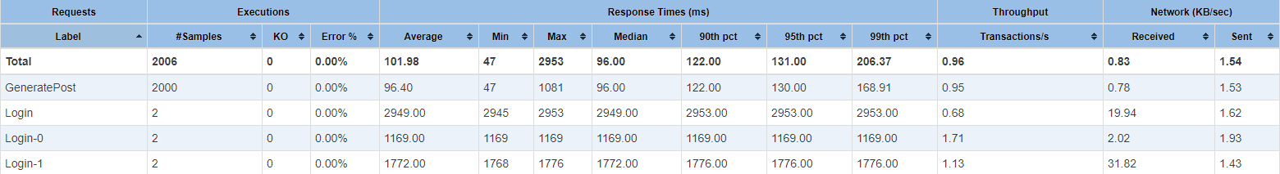

1. **Conclusion**

* There are 20% errors if no thinking time added in script
* There are 14% errors when using date list which need further investigation the root cause.
* Data generate time estimation
* 100 post : 1min
* 1000 post:17 min
* 2000 post:35 min