**Task 3**

**Date:** 9 Sep 2020

**Author:** Shelley Zhao

**Application:** BlogEngine.NET version 3.2

**Environment:** Test Environment

**Test Environment configuration:**

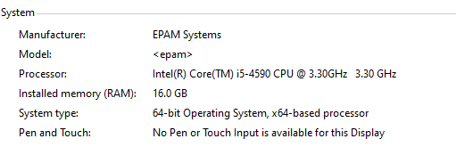

1. **Goals:**

Implement Anonymous user scenario (see Main script, Anonymous script, Open post script algorithms).

* Perform Smoke testing.
* Perform Capacity testing.
* Document results.

1. **Prerequisites:**

Generated 100 posts.

1. **Test script description**

Main script

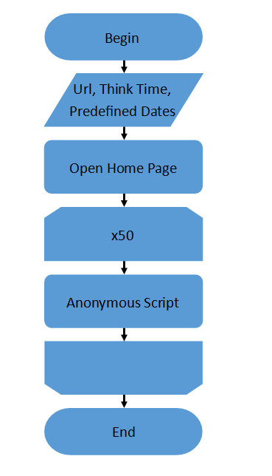

Anonymous script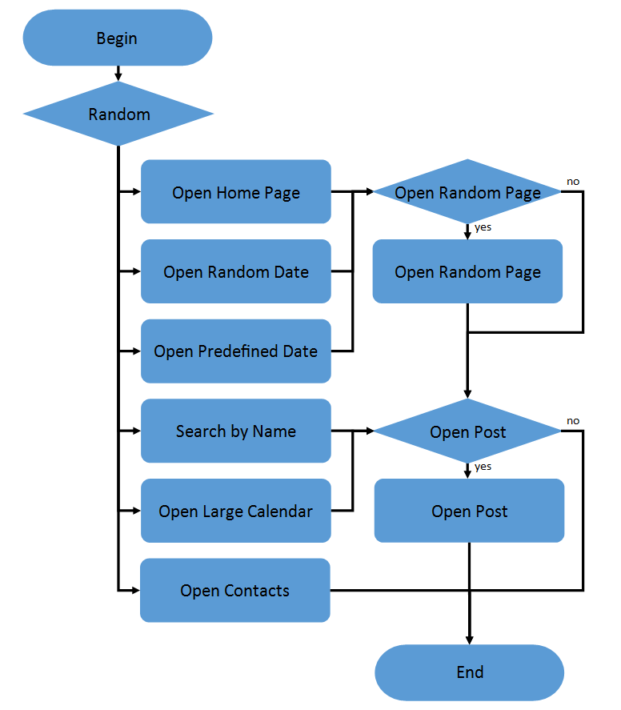

Open Post script

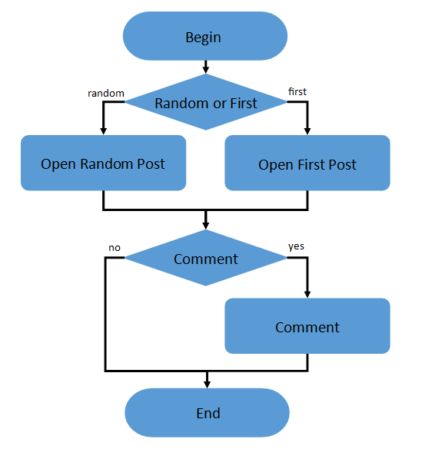

1. **Tests:**

**User Defined Variables**

* CommentName John
* CommentEmail abc@abc.com
* CommentText This is the comment from perf testing
* predefined_date 2020/06/05
* searchByNamePage 06-09
* host epcnszxw0226.princeton.epam.com
  1. **Smoke Testing**

**Settings:**

* Random Delay Max=1s
* Constant Delay Offset=1s
* Number of Threads =1
* Ramp up period=10s
* Duration=300s

**Result**

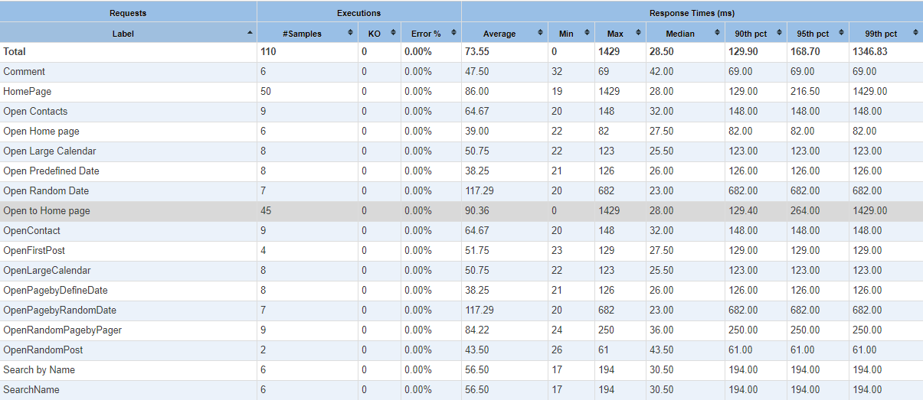

**Conclusion**

All the requests have been executed in proper response time without error there the smoke testing **PASSED.**

* 1. **Capacity testing**

**Settings:**

* Random Delay Max=2s
* Constant Delay Offset=1s
* Number of Threads =25
* Ramp up period=900s
* Duration=900s

**Result**

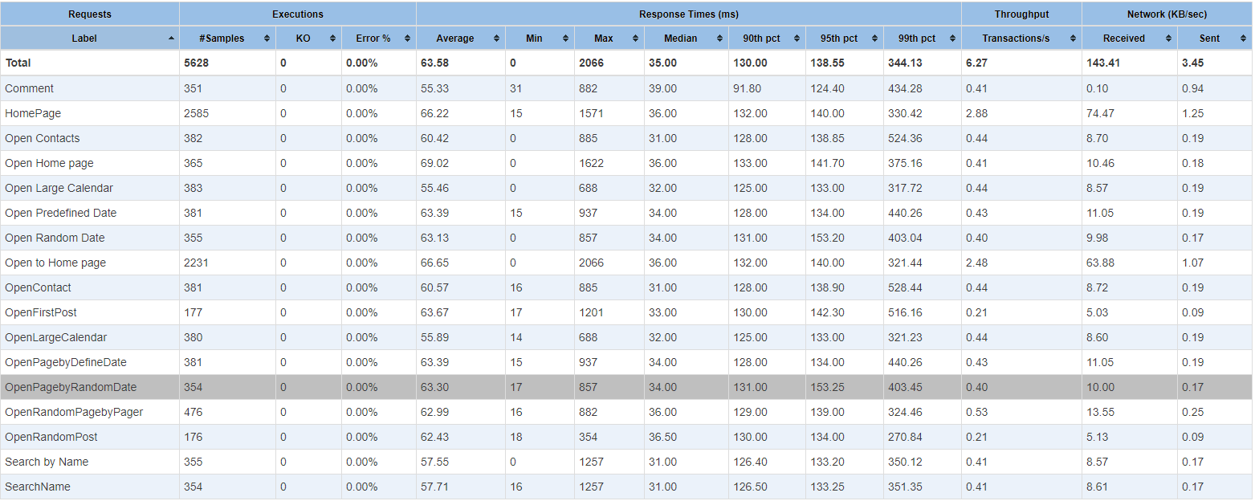

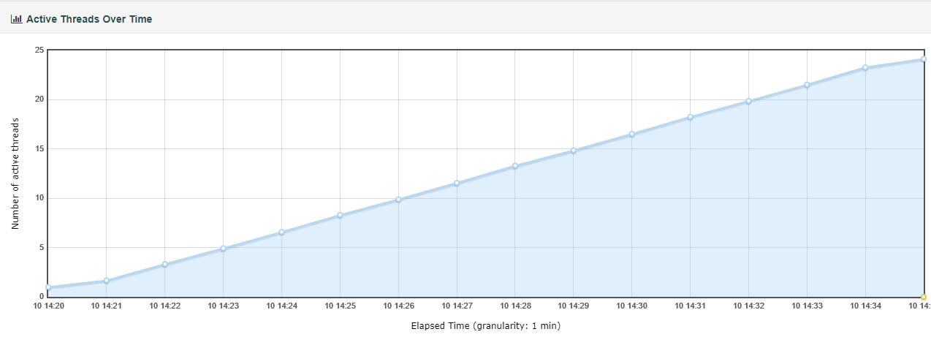

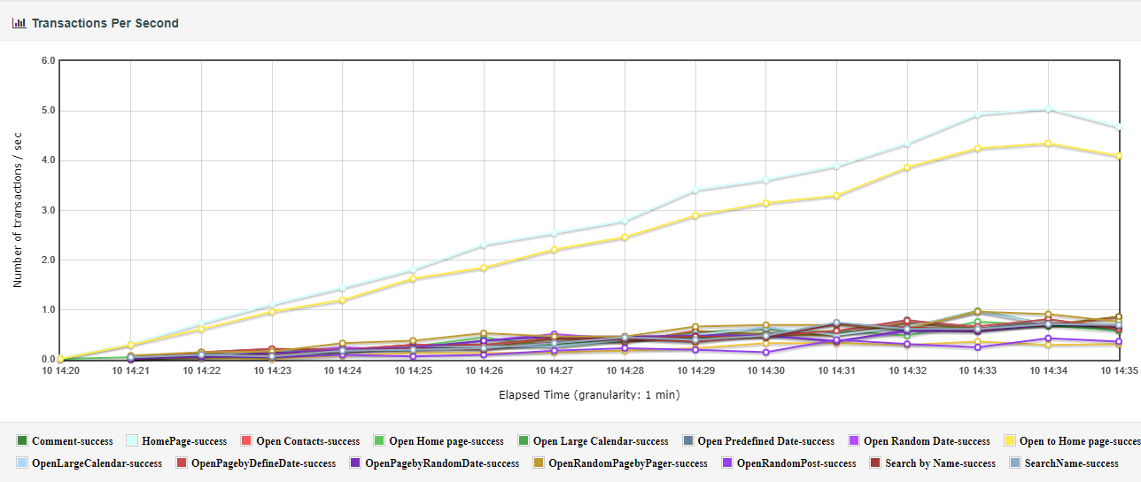

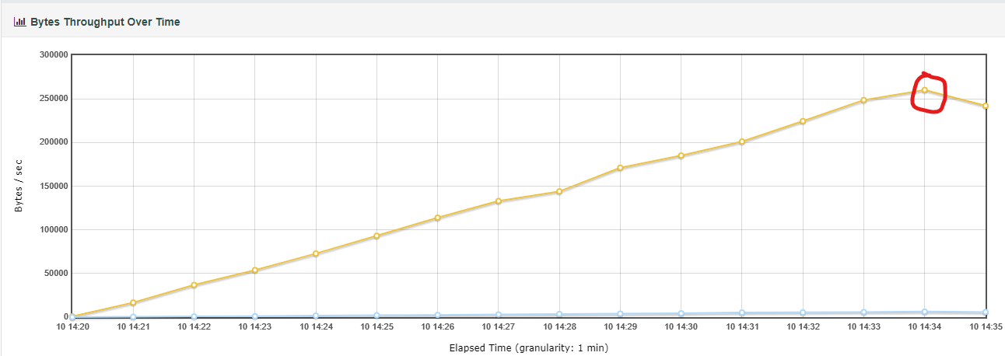

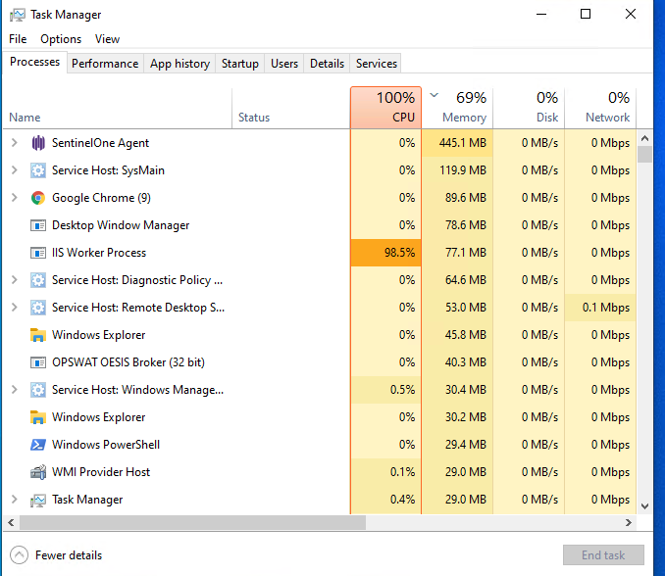

**Conclusion**

* From the throughput chart the line is drop down @14:34.
* From the task statistics board the CPU is reach 100% at the same time.
* So the system capacity is 24